Concurrent quad-band low noise amplifier (QB-LNA)

using multisection impedance transformer

**Teguh Firmansyah\*, Anggoro Suryo Pramudyo\*, Siswo Wardoyo\*, Romi Wiryadinata\*, Alimuddin\***

\*Departement of Electrical Engineering,University of Sultan Ageng Tirtayasa. Indonesia.

|  |  |  |
| --- | --- | --- |
| **Article Info** |  | **ABSTRACT** |
| ***Article history:***  Received Jun 12th, 201x  Revised Aug 20th, 201x  Accepted Aug 26th, 201x |  | A quad-band low noise amplifier (QB-LNA) based on multisection impedance transformer designed and evaluated in this research. As a novelty, a multisection impedance transformer was used to produce QB-LNA. A multisection impedance transformer is used as input and output impedance matching because it has higher stability, large Q factor, and low noise than lumpedcomponent.The QB-LNA was designed on FR4 microstrip substrate with εr= 4.4, thickness h=0.8 mm, and tan δ= 0.026. The proposed QB-LNA was designed and analyzed by Advanced Design System (ADS).The simulation has shown that QB-LNA achieves gain (S21) of 22.91 dB, 16.5 dB, 11.18 dB, and 7.25 dB at 0.92 GHz, 1.84 GHz, 2.61 GHz, and 3.54 GHz, respectively.The QB-LNA obtainreturn loss (S11) of -21.28 dB, -31.87 dB, -28.08 dB, and -30.85 dB at 0.92 GHz, 1.84 GHz, 2.61 GHz, and 3.54 GHz, respectively. It also achieves a noise figure (nf) of 2.35 dB, 2.13 dB, 2.56 dB, and 3.55 dB at 0.92 GHz, 1.84 GHz, 2.61 GHz, and 3.54 GHz, respectively. This research also has shown that the figure of merit (FoM) of the proposed QB-LNA is higher than that of another multiband LNA. |
| ***Keyword:***  Gain  Impedance transformer  Low noise amplifier  Noise figure |
| *Copyright © 201x Institute of Advanced Engineering and Science.  All rights reserved.* |
| ***Corresponding Author:***  Teguh Firmansyah,  Departement of Electrical Engineering,  University of Sultan Ageng Tirtayasa,  Jl. Jenderal Sudirman. Km. 3. Cilegon. Banten. 42435. Indonesia.  Email: teguhfirmansyah@untirta.ac.id | | |

1. **INTRODUCTION**

High demand for various types of wireless communications, encourage the research and development of multiband transceiver [1]. The multiband transceiver accommodate multiple types of wireless technologies simultaneously, making it cheaper, more efficient, and compact [2]. A subsystem of multiband transceiver consists of a multiband antenna (MA) [3-4], a multiband power amplifier (MPA) [5-6], a multiband mixer (MM) [7], a multiband band-pass filter (MBPF) [8-10] and multiband low noise amplifier (MLNA) [11-13], A low noise amplifier (LNA) is necessary to amplify a signal without increasing the noise and interference at several frequencies simultaneously [14].

There are several method frequenly used for MLNAdesign such as; wideband matching [15], switch method [16], and concurrent multiband [17][18][19]. The wideband method can produce LNA with wide frequency operating. However, this method has drawbacks such as high interference signal, because the unneeded signal is also strengthened.Meanwhile, switch method has the advantage of low interference but a switch-LNA works optimally at a single frequency. In addition, the switch method also requires additional switch with a good performance.A concurrent method could produce LNA with low interference and good performance at multiple frequencies simultaneously. The employment of concurrent multiband can be done by using lumped components as input and output matching impedances, but it makes the design of MLNA be more complex.

As novelty, a concurrent quad-band low noise amplifier (QB-LNA) using multisection impedance transformer was proposed in this paper. A multisection impedance transformer (MIT) was used to produce a multiband matching circuit. MIT has many advantages including low noise, high stability, simple, and easy in fabrication. The QB-LNA has frequencies 0.92 GHz, 1.84 GHz, 2.61 GHz, and 3.54 GHz, for GSM900, WCDMA1800, LTE2600, and LTE3500 application respectively. The QB-LNA was designed on FR4 microstrip substrate with εr= 4.4, h=0.8 mm, and tan δ = 0.0265. The QB-LNA was simulated by using Schematic Simulation Advanced System Design (ADS). This research also was shown that the figure of merit (FoM) of the proposed QB-LNA is higher than that of another multiband LNA.

1. **THE PROPOSED METHOD**

A subsystem of QB-LNA consist of bias transistor, input impedance maching (IIM), and output impedance matching (OIM) [12][14] as shown in figure 2. The FET NE321S01 with a low power source of bias VCC = 5 V was used. A multi-section impedance transformer (MIT) as IIM and OIM was proposed in this research to produce four-band LNAas shown in figure 2.

****

ΓS

ΓL

Figure 1. A subsystem of multiband LNA



Figure 2.A multi-section impedance transformer (MIT) as IIM and OIM

with termination port (RS and RL), bias circuit resistance RN (N=1,2,3), power supply (VCC), coupling capacitor CN (N=1,2,3), RF choke (L1), the impedance of transmission line ZN(N=1,2,3,4,5,6,7,8,9), electrical length θN(N=1,2,3,4,5,6,7,8,9), and input impedance ZIN.

**2.1. Small Signal and Resonant Conditions Analysis**

Figure 3 shows a small signal analysis of bias circuit of figure 2. The input impedance ZIN is given by equation (1) with transconductance (gm), source inductance (LS), gate inductance (LG), and gate-source capacitance (CGS).



Figure 3. Small signal analysis of bias circuit

A relation of cutoff frequency and transconductance is given by:

$$\frac{g_{m}}{C_{gs}}L_{s}=ω_{T}L_{s} → \frac{g_{m}}{C_{gs}}=ω_{T} (2)$$

and ZIN at cutoff frequency is given by:

$$Z_{IN}=jω\left(L_{s}+L_{g}\right)+\frac{1}{jωC_{gs}}+ω_{T}L_{s} (3)$$

At a resonant frequency, the ZIN can be found as follows:

$$Im \left(Z_{IN}\right)=0 (4)$$

$$Re \left(Z_{IN}\right)=\frac{g_{m}}{C_{gs}}L_{s} (5)$$

At maching condition, ZIN and return loss are given by:

$$Z_{IN}= {Z_{S}}^{*}=R_{S}=\frac{g_{m}}{C_{gs}}L_{s}=ω_{T}L_{s} (6)$$

$$S_{11}={}_{11}=\frac{Z_{IN}-R_{S}}{Z_{IN}+R_{S}}$$

$$=\frac{\left(jω\left(L_{s}+L_{g}\right)+\frac{1}{jωC_{gs}}+\frac{g_{m}}{C_{gs}}L_{s}\right)-\left(\frac{g_{m}}{C_{gs}}L_{s}\right)}{\left(jω\left(L_{s}+L_{g}\right)+\frac{1}{jωC_{gs}}+\frac{g_{m}}{C_{gs}}L_{s}\right)+\left(\frac{g_{m}}{C_{gs}}L_{s}\right)}$$

$$=\frac{jω\left(L_{s}+L_{g}\right)+\frac{1}{jωC_{gs}}}{jω\left(L_{s}+L_{g}\right)+\frac{1}{jωC_{gs}}+2\frac{g_{m}}{C_{gs}}L_{s}}$$

$$=\frac{{\left(jω\right)}^{2}+\frac{1}{C_{gs}\left(L_{s}+L_{g}\right)}}{{\left(jω\right)}^{2}+2\frac{jω}{\left(L_{s}+L_{g}\right)}\frac{g_{m}}{C_{gs}}L_{s}+\frac{1}{C_{gs}\left(L_{s}+L_{g}\right)}} (7)$$

With *jω = s*at resonant frequency (ω0), the equation (7) could be simplified;

$$S_{11}=\frac{s^{2}+{ω_{o}}^{2}}{s^{2}+Bs+{ω_{o}}^{2}} (8)$$

with

$${ω_{o}}^{2}=\frac{1}{C_{gs}\left(L_{s}+L_{g}\right)}$$

$$B=2\frac{1}{\left(L_{s}+L_{g}\right)}\frac{g_{m}}{C_{gs}}L_{s}$$

A bandwidth of LNA could be found at S11 lower than -10 dB, the S11 is formulated by:

$$20 log\left|S_{11}\right|≤ -10 dB$$

$$\log\left|S_{11}\right|≤ -0.5$$

$$\left|S_{11}\right|≤ 3.16 (9)$$

The upper and lower threshold is followed by:

$$\frac{-B+\sqrt{B^{2}+{ω_{o}}^{2}}}{6}≤ω≤\frac{B+\sqrt{B^{2}+{ω_{o}}^{2}}}{6} (10)$$

**2.2. Single-section Impedance Transformer (SIT)**

Figure 4 shows a single section impedance transformer.



Figure 4. Single-section Impedance Transformer

The partial reflection coefficients ΓN (N=1,2,3) and partial transmission coefficients TN (N=1,2) are given by:

$${}_{1}=\frac{Z_{2}-Z_{1}}{Z_{2}+Z_{1}} (11)$$

$${}_{2}=-{}_{1} (12)$$

$${}_{3}=\frac{Z_{L}-Z_{2}}{Z_{L}+Z_{2}} (13)$$

$${T_{21}=1+}_{1}=\frac{2Z_{2}}{Z_{1}+Z_{2}} (14)$$

$${T_{12}=1+}_{2}=\frac{2Z_{1}}{Z_{1}+Z_{2}} (15)$$

A total reflection can be calculated as follows:

$$={}_{1}+T_{12}T_{21}T_{3}e^{-2jθ}\sum_{n=0}^{∞}{{}_{2}^{n}}{}_{3}^{n}e^{-2jθ} (16)$$

A geometry series was used for simplifying equation (16), then the total reflection can be found as follows:

$$={}_{1}+\frac{T_{12}T_{21}T_{3}e^{-2jθ}}{1-{}_{1}{}_{3}e^{-2jθ}} (17)$$

**2.3. Multi-section Impedance Transformer (MIT)**

To produce QB-LNA with quad-bandimpedance matching circuit at IMM and OIM, a multisection impedance transformer (MIT) was used, as shown in Figure 5. MIT has many advantages including low noise, high stability, simple, and easy in fabrication. The ZIN is given by (16) with $i=1,…M$, propagations constant (β), and electrical length ($l_{i}$).



$$Z_{i}^{'}=Z_{i}\frac{Z_{i+1}^{'}+jZ_{i}tan⁡(βl_{i})}{Z_{i}+Z_{i+1}^{'}tan⁡(βl_{i})} (18)$$

Figure 5. Multisection impedance transformer

with low frequency dispersion and $θ\left(f\right)=\frac{f}{f_{0}}θ_{0}$, input impedance (Zi’) is given by:

$$Z_{i}^{'}(f)=Z_{i}\frac{Z_{i+1}^{'}+jZ_{i}\tan\left(\frac{f}{f_{0}}θ_{0}\right)}{Z_{i}+Z_{i+1}^{'}\tan\left(\frac{f}{f_{0}}θ_{0}\right)} (19)$$

At maching condition, return loss is given by:

$$\left\{\begin{aligned}{\left.Γ(\left(\frac{f}{f_{0}}\right),θ_{0},Z_{L}\left(f\right),Z_{1}Z_{2}….Z_{M})\right|}_{f=f_{1}}=0 \\ {\left.Γ\left(\left(\frac{f}{f_{0}}\right),θ_{0},Z_{L}\left(f\right),Z_{1}Z_{2}….Z_{M}\right)\right|}_{f=f_{2}}=0 \\ . \\ . \\ . \\ \begin{matrix}. \\ {\left.Γ(\left(\frac{f}{f_{0}}\right),θ_{0},Z_{L}\left(f\right),Z_{1}Z_{2}….Z_{M})\right|}_{f=f_{N}}=0\end{matrix}\end{aligned}\right\} (20)$$

1. **DESIGN AND SIMULATION**

To show the applicability of proposed concept of QB-LNA, a multisection impedance transformer (MIT) was used as shown in figure 6. The QB-LNA has been designed with frequencies 0.92 GHz, 1.84 GHz, 2.61 GHz, and 3.54 GHz, for GSM900, WCDMA1800, LTE2600, and LTE3500 application respectively. The QB-LNA was designed on FR4 microstrip substrate with εr= 4.4, h=0.8 mm, and tan δ = 0.0265. The QB-LNA was designed on FR4 microstrip substrate with εr= 4.4, h=0.8 mm, and tan δ = 0.0265. The width and length of transmission line are w1 = 22.4 mm, w2 = 15.4 mm, w3 = 6.3 mm, w4 = 1.6 mm, w5 = 0.3 mm, w6 = 2.0 mm, w7 = 1.0 mm, w8 = 3.0 mm, w9 = 1.0 mm and l1= 23.8 mm, l2 = 8.1 mm, l3 = 12.56 mm, l4 = 18 mm, l5 = 21 mm, l6 = 0.3 mm, l7 = 0.5 mm, l8 = 1.5 mm, l9 = 20 mm. The lumped component are VCC = 5 V, L1 = 47 nH (as a RF Choke), R1 = 475 Ω, R2 = 3 kΩ, R3 = 51 Ω, C3 = 30 pF, RS = 50 Ω (as an input termination), and RL = 50 Ω (as an output termination).



Figure 6. QB-LNA using multisection impedance transformer (MIT)

The extracted center frequency with varied w4/w3, a return loss (S11) with varied w4/w3, gain (S21) with varied w4/w3, are shown in figure 7a, 7b, and 7c, respectively. It shows that the center frequency of f1, f3, and f4 are still stablewith varied w4/w3. However, the center frequency of f2has decreased. As shown in figure 7b, the increase of of w4/w3 an effect on the return loss (S11), and it does not produce the resonant frequency at f1, and f3. Fig 7c illustrated the extraction of gain(S21) with varied w4/w3. A gain(S21) of frequency f1, f3, and f4 vary slightly, but a gain at frequency of f3 falls dramatically. In general, the variation of w4/w3 only affects the performances of the second frequency (f2), but it does slightly affect to performances of frequency f1, f3, and f4.

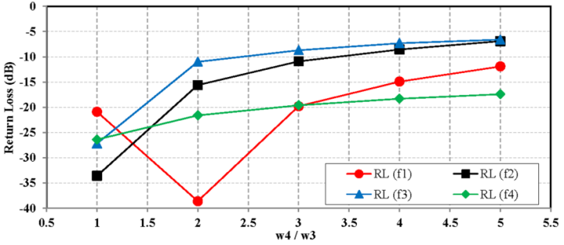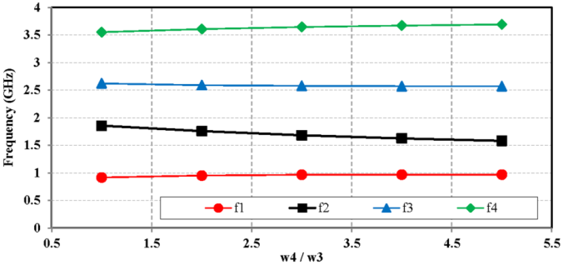

(a) (b)

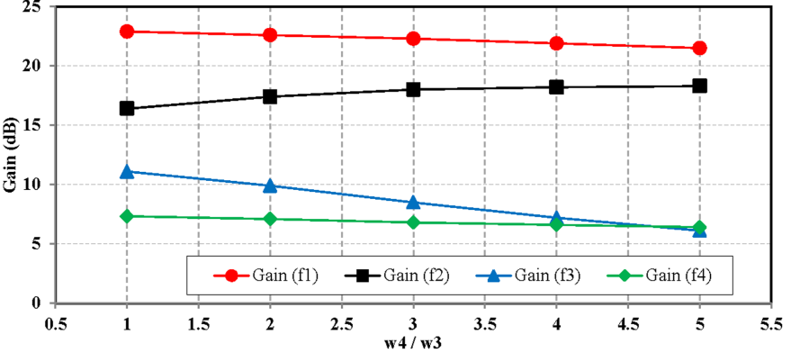

(c)

Figure 7. (a) The extracted center frequency with varied w4/w3, (b) the extracted of return loss (S11) with varied w4/w3, (c) the extracted of gain (S21) with varied w4/w3

Figure 8(a-b) show the extracted return loss (S11) and gain (S21) with varied power supply (VCC). It is useful for demonstrating the consistency performance of QB-LNA. The return loss of frequency f1, f2, f3, and f4 remains constant. However, the value of gain (S21) and noise figure shifted because a varied of power supply (VCC).

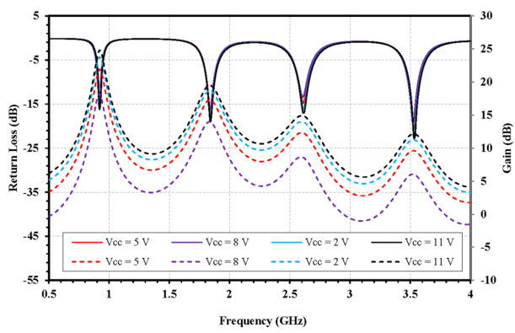

**Noise Figure (dB)**

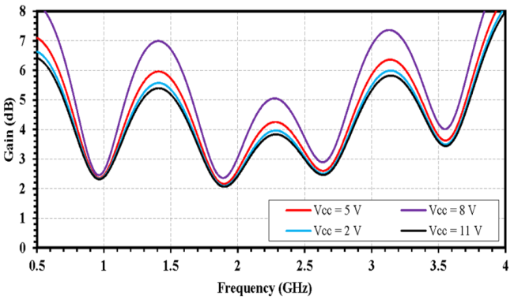

(a) (b)

Figure 8. (a) The extracted of return loss (S11) and gain (S21), (b) Noise figurewith varied VCC

Figure 7a. shows the extracted return loss (S11) and gain (S21) with varied l1. The chart shows that a return loss (S11) and gain (S21) of f1 has not changed. However, the center frequency of f2, f3, and f4 are shifted by varied of l1. Figure 6b. shows the extracted return loss (S11) and gain (S21) with varied w2. The results are similar, a return loss (S11) of f1 has not changed and the center frequency of f2, f3, and f4 are shifted because variation of w2.

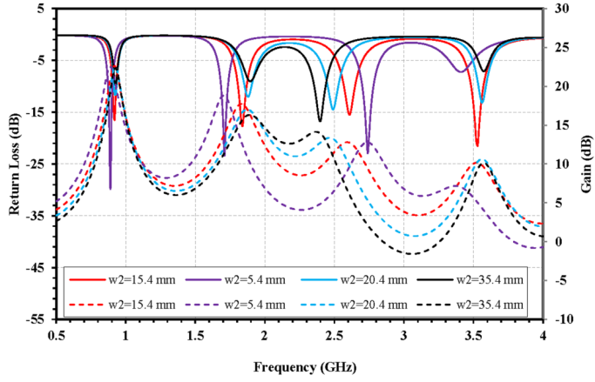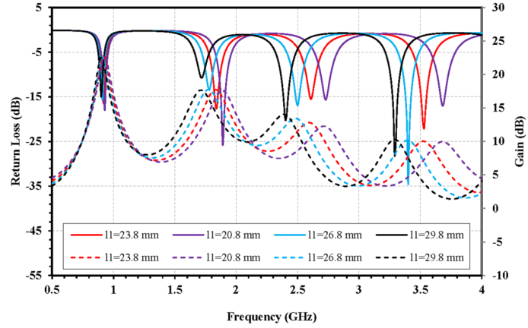

(a) (b)

Figure 9. (a) The extracted return loss (S11) and gain (S21) with varied l1(a). The extracted return loss (S11) and gain (S21) with varied w2

1. **RESULTS AND ANALYSIS**

The QB-LNA was designed on FR4 microstrip substrate with εr= 4.4, thickness h=0.8 mm, and tan δ= 0.026. The proposed QB-LNA was designed and analyzed by Advanced System Design (ADS). Figure 10 shows the performance of return loss (S11) and gain (S21) of QB-LNA.

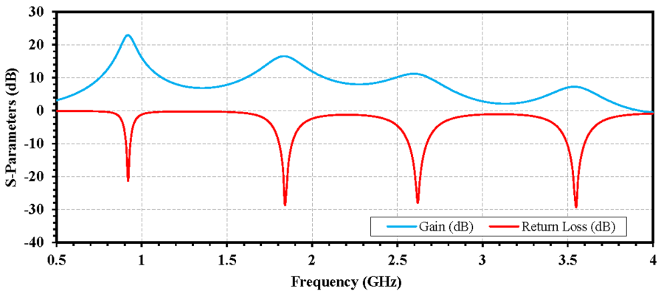

Figure 10. The performance of return loss (S11) and gain (S21) of QB-LNA

The simulation has shown that QB-LNA achieves gain (S21) of 22.91 dB, 16.5 dB, 11.18 dB, and 7.25 dB at 0.92 GHz, 1.84 GHz, 2.61 GHz, and 3.54 GHz, respectively. The QB-LNA obtain return loss (S11) of -21.28 dB, -31.87 dB, -28.08 dB, and -30.85 dB at 0.92 GHz, 1.84 GHz, 2.61 GHz, and 3.54 GHz, respectively. Figure 11. shows in the performance of noise figure (dB) and stability factor (K) of QB-LNA. This QB-LNA achieves a noise figure (nf) of 2.35 dB, 2.13 dB, 2.56 dB, and 3.55 dB at 0.92 GHz, 1.84 GHz, 2.61 GHz, and 3.54 GHz, respectively.Furthermore, the stability factor of all bands above 1.0 is also depicted in Figure 11.

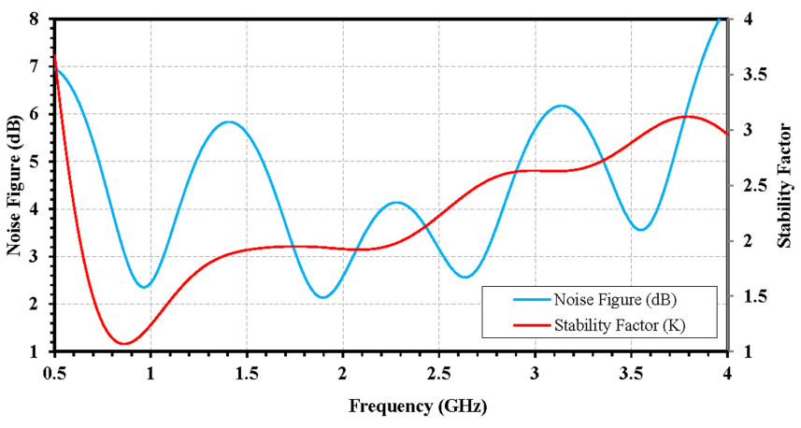

Figure 10. The performance of noise figure (dB) and stability factor (K) of QB-LNA

This research has shown that the figure of merit (FoM) of the proposed QB-LNA is higher than another multiband LNA, as shown in Table 1.A FoM is given by [20]

$$FoM \left[mW^{-1}\right]=\frac{Gain \left[abs\right]}{\left(NF-1\right)\left[abs\right].P_{DC}\left[mW\right]} (21)$$

Table 1. The figure of merit (FoM) of the proposed QB-LNA

|  |  |  |  |  |  |  |  |  |  |  |
| --- | --- | --- | --- | --- | --- | --- | --- | --- | --- | --- |
| **Parameter** | **Reference** | | | | | | **This work** | | | |
| **[17]** | | **[18]** | | **[19]** | |
| Method | Concurrent multiband | | Concurrent multiband | | Concurrent multiband | | Concurrent multiband | | | |
| f0 (GHz) | 1,80 | 2,45 | 2,40 | 5,20 | 2,20 | 4,60 | 0.92 | 1.84 | 2.61 | 3.54 |
| S21 (dB) | 9,20 | 12,00 | 15,00 | 6,50 | 10,80 | 8,80 | 22.91 | 16.5 | 11.18 | 7.25 |
| NF (dB) | 5,70 | 6,40 | 2,50 | 2,40 | 3,53 | 2,52 | 2.35 | 2.13 | 2.56 | 3.55 |
| PDC (mW) | 8.00 | | 10 | | 7.76 | | 5.01 | | | |
| Gain/ PDC  (dB/mW) | 1,15 | 1,50 | 1,50 | 0,65 | 1,38 | 1,13 | 4.51 | 3.29 | 2.23 | 1.44 |
| FoM  (mW-1) | 0,38 | 0,59 | 4,07 | 0,61 | 1,21 | 1,24 | **3.34** | **2,91** | **1,44** | **0.56** |

1. **CONCLUSION**

A multisection impedance transformer was used to produce QB-LNA. The QB-LNA has been designed with frequencies 0.92 GHz, 1.84 GHz, 2.61 GHz, and 3.54 GHz, for GSM900, WCDMA1800, LTE2600, and LTE3500 application respectively.The QB-LNA was designed on FR4 microstrip substrate with εr= 4.4, thickness h=0.8 mm, and tan δ= 0.026. The proposed QB-LNA was designed and analyzed by Advanced System Design (ADS). The simulation has shown that QB-LNA achieves gain (S21) of 22.91 dB, 16.5 dB, 11.18 dB, and 7.25 dB at 0.92 GHz, 1.84 GHz, 2.61 GHz, and 3.54 GHz, respectively. The QB-LNA obtain return loss (S11) of -21.28 dB, -31.87 dB, -28.08 dB, and -30.85 dB at 0.92 GHz, 1.84 GHz, 2.61 GHz, and 3.54 GHz, respectively. It also achieves a noise figure (nf) of 2.35 dB, 2.13 dB, 2.56 dB, and 3.55 dB at 0.92 GHz, 1.84 GHz, 2.61 GHz, and 3.54 GHz, respectively. This research also has shown that the figure of merit (FoM) of the proposed QB-LNA is higher than that of another multiband LNA.

**ACKNOWLEDGEMENTS**

The work was supported by the Ministry of Research, Technology and Higher Education, Indonesian Government as a part of Penelitian Kerjasama Perguruan Tinggi (Grant No. 267/UN43.9/PL/K/2016).

**REFERENCES**

1. S. Shreyas, *et al.,* “A Multiband Transceiver System in 45-nm CMOS for Extended Data Rate through Notchy Wireline Channels,” *IEEE Transactions on Circuits and Systems II: Express Briefs*, vol. 58, pp. 545 – 549, 2011.
2. G. David,*et al.,* "A Fully Integrated Multiband MIMO WLAN Transceiver RFIC," *IEEE Journal of Solid State Circuit*, vol. 50, pp. 1629 – 1641, August 2005.
3. Y. Hemn, et al., “Small Multi-Band Rectangular Dielectric Resonator Antennas for Personal Communication Devices,” *International Journal of Electrical and Computer Engineering* (IJECE),vol. 4, pp. 1-6, February 2014.
4. C. Arnau Cabedo, *et al* ,“Multiband Handset Antenna Combining a PIFA, Slots, and Ground Plane Modes,” *IEEE Transactions on Antennas and Propagation*, vol.57, pp. 2526 - 2533, September. 2009.
5. L. Geunyong Lee, *et al.,* “A Multiband Power Amplifier With a Reconfigurable Output-Matching Network for 10-MHz BW LTE Mobile Phone Applications,” *IEEE Transactions on Circuits and Systems II: Express Briefs*, vol 62, pp. 558 – 562, 2015.
6. A. Fukuda, et al., “Novel multiband matching scheme for highly efficient power amplifier,” in *Proc. 39th EuMC*, Sept.2009, pp. 1086-1089.
7. Kim, V, “A Resistively Degenerated Wide-Band Passive Mixer with Low Noise Figure and +60dBm IIP2 in 0.18um CMOS,” *IEEE RFIC Symposium*, Jun 2008, pp. 185-188.
8. W. Gunawan, *et al.,* “Design of triple-band bandpass filter using cascade tri-section stepped impedance resonators,” *Journal of ICT Research and Applications*, vol. 10, pp. 43-56, 2016.
9. C. Quendo, *et al.,* “Planar tri-band filter based on dual behavior resonator,” in *European Microwave Conference*. Oct 2005. vol.1, pp. 269–272.
10. W. Gunawan, *et al.,* “Multiband bandpass filter (BPF) based on folded dual crossed open stubs,” *International Journal of Technology*, vol. 5, pp. 32-39. 2014.
11. F. Teguh*, et al.,* “Multiband RF low noise amplifier (LNA) base on multi section impedance transformer for multi frequency application” *International Journal of Applied Engineering Research*, vol. 11, pp. 3478-3483, 2016.
12. W. Gunawan and F.Teguh, “Concurrent multiband low noise amplifier with multisection impedance transformer”. in *Asia Pacific Microwave Conference Proceedings* (APMC). 2012. pp. 914-916.
13. Kamil P., *et al.*, “Design and Analysis High Gain PHEMT LNA for Wireless Application at 5.8 GHz,” *International Journal of Electrical and Computer Engineering* (IJECE)*,* vol. 5, pp. 611-620, 2015.
14. A. Ibrahim, *et al*., “Low Noise Amplifier at 5.8GHz with Cascode and Cascaded Techniques Using T-Matching Network for Wireless Applications,” *International Journal of Electrical and Computer Engineering* (IJECE). vol.1, pp. 1-8. September 2011.
15. Lv. Juncai, et al., “Wideband low noise amplifier using a novel equalization,” *Progress in Electromagnetic Research Symposium (PIERS)*2016, pp. Pages: 609 – 614.
16. S. Rahul, et al., “A 3/5 GHz reconfigurable CMOS low-noise amplifier integrated with a four-terminal phase-change RF switch,” *IEEE International Electron Devices Meeting* (IEDM)2015, pp. 25.3.1 - 25.3.4.
17. H.-S. Jhon, et al., “8mW 1,7/2,4 GHz dual-band CMOS low-noise amplifier for ISM-band application," *IEEE Electronics Letters*, vol. 44, pp. 1353-1354, Nov. 2008.
18. E. Kargaran, and Madadi B, “Design of a novel dual-band concurrent CMOS LNA with current reuse topology," *Int. Conf. on Networking and Information Technology*, Jun. 2010, pp. 386-388.
19. C.-L. Hsiao, and Y.-L. Huang, ”A low supply voltage dualband low noise amplifier design,"*13th IEEE Int. Symp. on Consumer Electronics*, May 2009, pp. 339-341.
20. H. Okazaki, *et al*., “Reconfigurable amplifier towards enhanced selectivity of future multi-band mobile terminals,” *International Microwave Workshop Series on RF Front-ends for Software Defined and Cognitive Radio Solutions*, 2010, pp. 1–4,

**BIBLIOGRAPHY OF AUTHORS**

|  |  |
| --- | --- |
| DSC_0002 copy | **Teguh Firmansyah** was born in Subang, Indonesia. He received B.Eng (S.T) degree in electrical engineering and M.Eng (M.T) degree in telecommunication engineering from Department of Electrical Engineering Universitas Indonesia in 2010 and 2012, respectively. In 2012, he joined the Department of Electrical Engineering Universitas Sultan Ageng Tirtayasa as a researcher and lecturer. He has authored or coauthored over 20 papers published in refereed journals and conferences. He holds two patents for wideband antenna and multiband antenna. His research interests include microstrip antenna and microwave circuit for various applications.  Email : teguhfirmansyah@untirta.ac.id |
|  |  |
| F:\dokumen\foto\foto34.png | Anggoro Suryo Pramudyo was born in 1984. He received BCS (S.Kom.) from Universitas Bina Darma in 2006 and MCS (M.Kom) from Universitas Gadjah Mada in 2006. He is interested in Artificial Intelligence included Computational Intelligence. Since 2010, he had become a lecturer and reseacher at Departement of Electrical Engineering Universitas Sultan Ageng Tirtayasa. Currently his researches are about intelligent disigner for antenna.  Email : pramudyo@untirta.ac.id |
|  |  |
|  | **Siswo Wardoyo** received the Bachelor Engineering (S.T.) in Electric Engineering from Diponegoro University of Indonesia, in 2002. Master of Engineering (M.Eng) degree, received from Electrical Engineering Department, Gadjah Mada University in 2008. Currently, He lecturer at Electrical Engineering Department, University of Sultan Ageng Tirtayasa. His reseach interests are My research interest are in TVET, ANN, Image Processing, Computer Vision, and Control.  Email : siswo@untirta.ac.id |
| **wiryadinata 2011-pictedit** | **Romi Wiryadinata** received the Bachelor Engineering (S.T.) in electrical engineering from Islamic University of Indonesia, in 2005. Master of Engineering (M.T.) degree, was received from Electrical Engineering Dept., Gadjah Mada University in 2007. He received Doctor (Dr.) degree from Electrical Engineering Dept., Gadjah Mada University in 2015. Currently, he is a lecturer at Electrical Engineering Dept., University of Sultan Ageng Tirtayasa. His research interests are in artificial neural network, sensor technology, guidance-control and navigation, and robotic.  Email : wiryadinata@untirta.ac.id |
| Alimuddin | **Alimuddin** is Associate Prof. Dr. specialization Control, Computer, Power Stability System and Energy Conversion, Telecommunication, SMART ICT and Lecture and Researcher at the Department of Electrical Engineering on Faculty of Engineering, Sultan Ageng Tirtayasa University (UNTIRTA), Banten, Indonesia, Master Engineering Informatics and Magister Information Management Graduate Binus University (BINUS) Jakarta, Master electrical engineering, Graduate Mercubuana University (UMB) Jakarta, Master computer science graduate STIMIK Nusa Mandiri Jakarta, He received B.S.and Master Management from Indonesia Moeslem University and Master Engineering for Electrical Engineering from Hasanuddin University., Indonesia in 1999, 2002 and 2003 respectively. He graduated a Doctor (PhD) Degree at the Bio-Informatics and Control, Instrumentation Engineering, Conversion Energy Bogor Agricultural University,Indonesia and Research Collaboration University of Tsukuba, Japan, 2009, Program research in Grant in sponsored by Government of Indonesia (the Ministry of Education and the State Ministry of Indonesia)., He has more than 11 years of experience in teaching at several Universities. His research interests include Control System, Telecommunication, ICT, Model and Simulation, Artificial Intelligent and its application. optimization and information system, Power Stability System and Energy Conversion System, Information Technology and Computer, Distribution System, Power System Control and optimization, Transportation. He has published more than ten papers in national Journal. He has also presented more than twelve research articles in national and international conferences. He is currently with few projects sponsored by government of Indonesia (the Ministry of Education and the State Ministry).  Email : alimudy@yahoo.com |