**Design of a New Backstepping Controller for Control of Microgrid Sources Inverter**

**Mahmoud Zadehbagheri\*1, Mohammad Javad Kiani\*1 , Tole Sutikno2,3, Rasoul Arvin Moghadam4**

1 Department of Electrical Engineering, Islamic Azad University, Yasooj Branch,Yasooj,Iran

2 Department of Electrical Engineering, Universitas Ahmad Dahlan, Yogyakarta, Indonesia

3 Embedded System and Power Electronics Research Group, Yogyakarta, Indonesia

4 Department of Biomedical Engineering, Yasouj University of Medical Sciences, Yasooj, Iran

|  |  |  |
| --- | --- | --- |
| **Article Info** |  | **ABSTRACT** |
| ***Article history:***  Received August 11, 2021  Revised December 20, 2021  Accepted Jan 09, 2022 |  | Emergency power supply is becoming an important capability for many home or industrial electronic and computer devices. Computer, chemical, medical or aeronautics equipment and facilities are highly sensitive to network disturbances ,such programs, in the presence of various and nonlinear loads, require sine wave with fixed frequency and magnitude. Given the advances in recent years in the field of electronics power and digital electronics, it is observed that the functions of static converters are gradually improving and their use is expanding. Therefore, the performance of the designed UPS inverters has low distortion at the output voltage. Initially, such inverters were controlled by PI control classic rules based on linear rules of control. This method is difficult to understand the limitations of stability and to apply transient response to strong external disturbances. In this paper, an inverter is simulated and offered for single-phase and three-phase voltage controlled by a non-linear controller. For this purpose, a comparison has been made between the controller performance and the PI controller. In the first step, there is a Backstepping regulator that uses the stability tool next to the Lyapunov function. And the other regulator operates according to the PI method. The performance of these two regulators is simulated during a change in reference or a load change in MATLAB software. Also a method of feedback voltage control based on the Lyapunov theory for controlling of the DG unit independent Inverter is presented. The proposed controller is not only simple, but also against the sudden changes in load and the unspecified system is resistant. |
| ***Keywords:***  Backstepping Controller,  Nonlinear Loads,  Inverter,  Lyapunov Stability,  Microgrid,  Distributed Generation (DG) |
| *This is an open access article under the* [*CC BY-SA*](https://creativecommons.org/licenses/by-sa/4.0/) *license.* |
| ***Corresponding Author\*:***  Mahmoud Zadehbagheri,Mohammad Javad Kiani  Department of Electrical Engineering  Islamic Azad University, Yasooj Branch, Yasooj, Iran Email: [M.zadehbagheri@iauyasooj.ac.ir](mailto:M.zadehbagheri@iauyasooj.ac.ir) , Kianiph@iauyasooj.ac.ir | | |

1. **INTRODUCTION**

Distributed generation sources have enormous advantages so that it is expected to play an important role in the operation and planning of power systems in the near future. The status is changing, economic stimuli, technology growth, and environmental issues are shifting the configuration and current view of the power grid from generation to distribution [1]. Every microgrid is consisted number of new energy sources that require a voltage source or inverter to manage the voltage and power of each source to use the power output of these resources and to connect to the network. Converters such as a voltage source inverter (VSI) are commonly used as power interfaces in many applications including UPS and UPS systems (solar cells, wind turbines [2]. To connect to the network. Transmitters such as a voltage source inverter (VSI) are commonly used as power interfaces in many applications including UPS and UPS systems (solar cells, wind turbines, etc.). Also, the good performance of the inverter independently and connected in the network, requires accurate voltage and frequency control to maintain the function and control the output power. The proper control of the voltage and frequency for the operation of the inverter in systems such as emergency power systems (UPS) and micro-grid systems are required. Different control schemes for control of inverters in the grid are provided in the relevant literature. In [3], a PD controller with a PI controller structure for the photovoltaic PV system is presented. The controller detects a voltage reference that shows with the specified error and the algorithm for maximum detection of the P, Q point of power. The main problem with the maximum power tracking algorithm is that in the steady state, the operating point varies around the maximum power point. [4] Emphasizes the control of a single-phase DC-AC compensator used to provide uninterrupted power supply. The control goal in this field is to produce a sine voltage at the output of the system with amplitude and frequency fixed by the reference signal. [5] Has proposed the application of hierarchical fuzzy logic controllers for UPS applications. The proposed control scheme consists of two fuzzy controllers implemented in a nesting mode to create two control loops. Sustainability has a fundamental role in the theory and engineering of systems. There are various sustainability issues that are being studied in the study of dynamical systems. Usually the stability of points of equilibrium is checked by Lyapunov. [6] In this paper, we intend to control the output voltage of an inverter of distributed generation source in island condition by using a backstepping controller under ohmic, inductive and nonlinear load conditions, and the stability of the system is studied according to Lyapanov theory.Finally,it is compared with classic controllers. Inverter output voltage control is a distributed generation (DG) unit under different load conditions such as ohmic load, ohmic-inductive load, nonlinear load and no-load. The backstepping controller has a steady state error close to zero in following the reference signal. Backstepping controller is resistant to unmodulated dynamics and disturbances and noise.

# 2. THE STRUCTURE OF A SINGLE-PHASE INVERTER AND MATHEMATICAL MODELING

The PWM single-phase inverter shown in Fig.1 consists of two arms with bi-directional couplings (IGBTs or MOSFETs with reverse parallel diodes) that operate complementarily.The control signal μ is generated by the PWM generator and has a value between {1, -1} and in summary the binary commands μ1 and μ2 are of the two switching parts: [7-9]

*μ = μ1 – μ2*

$μ=\left\{\begin{aligned}: μ_{1}=1 and μ_{2}=0 →\left(k_{1},k_{2}^{'}\right)ON and \left(l_{2}, k_{1}^{'}\right)OFF \\ -1: μ_{1}=0and μ_{2}=1→\left(l_{2}.l_{1}^{'}\right)ON and \left(k_{1}, k_{2}^{'}\right)OFF\end{aligned}\right.$ (1)

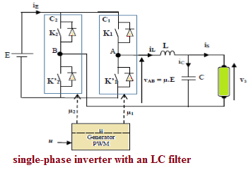

**Figure 1.** Design of a single-phase inverter with an LC filter [7]

For mathematical modeling of the inverter with a LC filter, uses Mesh law and the mathematical equations node:

$L\frac{di_{L}}{dt}=v_{AB}-V_{s}$ (2)

$c\frac{avs}{dt}=i_{L}-i_{s}$ (3)

The output voltage of the inverter 𝑣𝐴𝐵, depending on the switch state (μ control signal), can have two value:

$v_{AB}=\left\{\begin{aligned}E when only \left(k_{1},k_{2}^{'}\right)are ON ie μ=1 \\ -E when only \left(k_{2},k_{1}^{'}\right)are ON ie μ=-1 \end{aligned}\right.$ (4)

Therefore, one can conclude:

$$v_{AB}=μE \left(5\right)$$

This model is a system with variable structure: 𝑣𝐴𝐵 is not a continuous variable and can be two discrete values of E and -E, so it is inappropriate to design a continuous control rule. To overcome this problem, we often have to use the average model (widely used for modeling static converters) [7-8] the switching period in this case6 is assumed to be much smaller than the dynamic system. In our study, this is very acceptable. We have:

$C{\dot{x}}_{1}=x_{2}-i_{s}$ (6)

$L{\dot{x}}_{2}=uE-x_{1}$ (7)

Here, 𝒙𝟏 and $x_{2}$ represent the average value of sampling period of the Vs output voltage across the capacitor C and current iL in the inductor L.The control variable $u ϵ [-1,1]$ has between values -1 and 1,and represents the Average value of the control signal μ which is formed by rectangular pulse width modulation [11].It can be shown that a three-phase four-leg inverter (TPFLI) is equivalent to three independent single-phase inverters. It makes sense to design a voltage and current controller for single-phase parallel inverters instead of a direct controller design four-leg inverters. Then apply the same controllers to the four-leg parallel system using the T\_(4\_qdo) conversion matrices and vice versa. The noteworthy point here is that all the controllers are designed and implemented in the stationary device and the conversion is used only for modeling a four- leg inverter to three single-phase inverters. Figure 2 shows the proposed control structure for a four-leg inverter. In this figure, the two blocks of conversion from the abc to qdo and vice versa are the same transformations $T_{4_qdo}$ ${and T}_{4_qdo} ^{-1}$ [22].

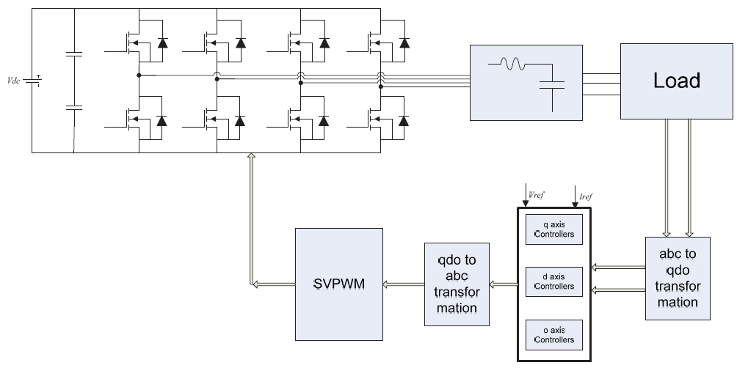

**Figure 2.** Block diagram of control strategy of a four-leg inverter [11].

Here, the voltage loop reference of a harmonic-free sinusoidal signal is considered. In the control block, there are three independent controllers of parallel single-phase inverters whose design method we have described, which are used to apply to the content of d, q and o voltage and current signals. Each of these sections has two voltage controllers and a current divider. The three outputs of the axes d, q and o are returned to the abc device by the reverse conversion $T_{4_qdo} ^{-1}$.The output of the controllers in the abc device, as a reference, enters the SVPWM modulation block, which cannot be addressed in this section [11].

# 3. CONTROLLER DESIGN

**3.1. Design of Backstepping Controller**

The proposed controller allows the converter to provide a fully sine voltage with constant amplitude and frequency independent of load. The output voltage should follow the reference signal [12-18].

$x_{1}^{*}\left(t\right)=V\sqrt{2}\sin\left(ωt\right)$ (8)

In which, v=230, $f=50Hz(ω=2πf)$, the value of the RMS voltage and the reference sine wave frequency, respectively In control theory, Backstepping is a technique developed in 1990 by P.V. Kokotovic et al. Were developed to design stability control for dynamic systems. These systems are made up of irreducible subsystems that can be stabilized by other methods. Due to this recursive structure, the designer can start the design process at the known-stable system and "back out" new controllers that progressively stabilize each outer subsystem. The process terminates when the final external control is reached [7].Hence, this process is known as backstepping. We consider $Z_{1}$ as tracking error and we define it:

$Z_{1}=C\left(x_{1}-x_{i}\right)$ (9)

The dynamics is as follows:

${\dot{z}}_{1}=C({\dot{x}}_{1}-{\dot{x}}_{1}^{*})$ (10)

${\dot{Z}}_{2}=x_{2}-i_{s}-C{\dot{x}}_{1}^{*}$ (11)

The proposed Lyapunov function is defined as follows:

$v_{1}=\frac{1}{2}z_{1}^{2}$ (12)

Derived from time:

${\dot{V}}_{1}={\dot{Z}}_{1}{\dot{Z}}_{1}^{ }$ (13)

By choosing:

${\dot{Z}}_{1}=-k_{1}z_{1}→z_{1}\left(τ\right)=z_{1}\left(0\right)e^{-k_{1}τ}$ (14)

Here, $k_{1}$ is a positive constant. This leads to a candidate function of Lyapunov, which has a completely negative dynamics. So get it:

${\dot{V}}_{1}=-k_{1}z_{1}^{2}$ (15)

As a result, the asymptotic stability is achieved and $Z_{1}$ ultimately aspires to zero [19-21]. in the system $X2(7)$, it's like a virtual control input. So $Z_{1}$ can be set to zero if: $x_{2}=x_{2}^{*}$

$x_{2}^{*}=-k_{1}z_{1}+i_{s}+C{\dot{x}}_{1}^{*}$ (16)

Here, $X_{2}$ is called constant stability. A new variable error is defined between the virtual value and the desired value.

$z_{2}=x_{2}+x_{2}^{*}$ (17)

This can be deduced from equations (10), (16), and (17).

${\dot{Z}}_{1}=-k_{1}z_{1}+z_{2}$ (18)

The Z2 time derivative is calculated as follows:

${\dot{x}}_{2}^{*}={\dot{x}}_{2}^{ }-{\dot{x}}_{2}^{*}$ (19)

${\dot{Z}}_{2}=\frac{1}{L}\left(uE-x_{1}\right)-{\dot{x}}_{2}^{*}$ (20)

The actual control system should be considered. The system stability problem presented in (18) and (21) can be understood by the following Lyapunov function: [7-20-23].

$v_{2}=\frac{1}{2}z_{1}^{2}+\frac{1}{2}z_{2}^{2}$ (21)

${\dot{V}}_{2}={\dot{Z}}_{1}Z_{1}+{\dot{Z}}_{2}Z_{2}$ (22)

${\dot{v}}_{2}=-k_{1}z_{1}^{2}+z_{2}\left(z_{1}+{\dot{Z}}_{2}\right)$ (23)

Applying the equation below:

$\left(z_{1}+{\dot{Z}}_{2}\right)=-k_{2}z_{2}^{ }$ (24)

We get:

${\dot{V}}_{2}=-k_{1}z_{1}^{2}-k_{2}z_{2}^{2}$ (25)

Therefore, equations (20) and (24) lead to the development of a Backstepping controller.

$u=-\frac{L}{E}\left(z_{1}+k_{2}z_{2}-\frac{x_{1}}{L}-{\dot{x}}_{2}^{*}\right)$ (26)

The control rule is chosen so that V2 <0 and allows the $(Z_{1} , Z_{2})$ system to be asymptotically stable. [24-25].

**4. SIMULATION AND RESULTS**

In this section, the system and the simulation results are expressed under different conditions such as ohmic load, inductive load and non-linear. Simulation is based on MATLAM software. Simulation to determine the response of supposed controllers relative to the transient state and the steady state under four the following is done:

1) Symmetrical resistive load (transient behavior from% 0 to%100).

2) Symmetrical resistive load (transient behavior from 100% to 0%).

3) Inductive ohmic load.

4) Nonlinear load.

The parameters of the simulated inverter are expressed in Table 1 are expressed in terms of the frequency of the switching of the system.

$f_{S}$: System switching frequency.

**Table 1.**Parameters of simulated single-phase inverter

|  |  |
| --- | --- |
| 100 V | $$V_{DC}$$ |
| 50 peak | $$V_{out}$$ |
| 15000 | $$f_{S}$$ |
| 50 | F |
| 200 | R (full load) |

Single-phase nonlinear load is designed according to IEC62040-3 standard, shown in Figure 3. Also, the reference signal with amplitude 50 and frequency 50Hz is shown in Figure 4.

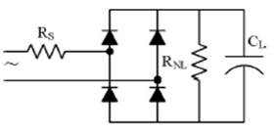

**Figure 3.**Single-phase nonlinear load according to IEC62040-3

**Table 2.** Parameters of single-phase non-linear load

|  |  |
| --- | --- |
| $$2Ω$$ | $$R_{s}$$ |
| $$18 Ω$$ | $$R_{NL}$$ |
| $$8200μF$$ | $$C_{L}$$ |

The crest factor (CF) and power factor (PF) of nonlinear load are 2.75 and +0.7, respectively.

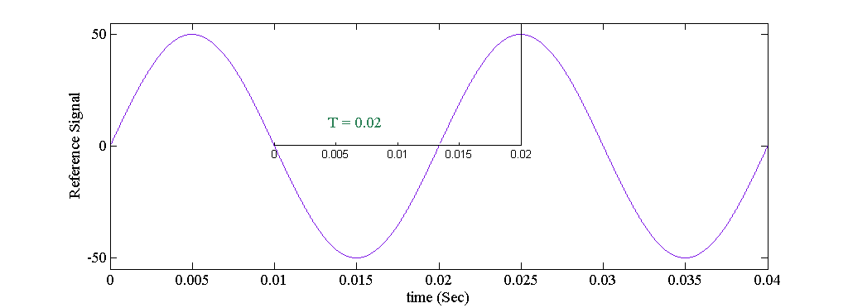

**Figure 4.**  Waveform of the reference signal

Figure 5 shows the schematic diagram of the controller.

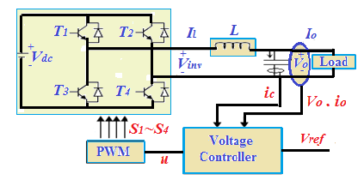

**Figure 5.** General block diagram of the assumed control system

As shown in Fig. 4, the capacitor current (ic), the load output voltage (vo) and the output current (io) are considered as inputs of the control system.

H:\moslem\arshad\tez\tez_print\V_1ph\SMC\Vout.tif (a)

H:\moslem\arshad\tez\tez_print\V_1ph\SMC\Iout.tif (b)

H:\moslem\arshad\tez\tez_print\V_1ph\SMC\Sec_a.tif (c)

H:\moslem\arshad\tez\tez_print\V_1ph\SMC\Sec_b.tif (d)

**Figure 6.** (a) Output voltage (v) (b) Output current (A) (c) Transient response to the inductive ohmic load

(d)Transient response to resistance load

H:\moslem\arshad\tez\tez_print\V_1ph\SMC\Sec_c.tif (a)

H:\moslem\arshad\tez\tez_print\V_1ph\SMC\Sec_d.tif (b)

H:\moslem\arshad\tez\tez_print\V_1ph\adaptive\error_adaptive.tif (c)

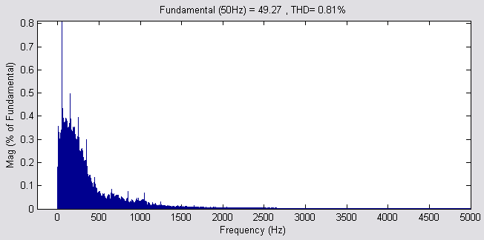

(d)

**Figure 7.** (a) Transient response (all load is dicconnected) (b) Transient response of a nonlinear load (c) Error between output voltage and reference signal (d) Harmonic analysis of steady state

Figure (8) illustrates the schematic of a three-phase dc / ac inverter with an LC filter. This schematic includes a three-phase inverter, an LC output filter connected to local loads. The LC filter function eliminates the harmonic components of the inverter output voltage due to the high frequency switching operation. So, this filter is an essential part of circuit and non-removable



**Figure 8.** Schematic of a three-phase dc / ac inverter with LC filter

The system model (fig.8) can be reduced to the unit's single-phase equivalent circuit according to Fig. 5. So, based on the previous section, for each phase, the dynamically model is extracted and a controller is designed. The proposed controller is investigated in a three-phase system under conditions of symmetric ohmic load, asymmetric ohmic load, inductive ohmic load, and nonlinear load to control the voltage of a distributed generation (DG) unit in island mode. Simulation to specify the controller response Assumed to be transient and steady state under the following four conditions: 1) Symmetrical resistance load (2) Asymmetrical resistive load (3) Inductive ohmic load (4 nonlinear load. The parameters of each phase of the inverter simulated are given in Table .1. Three phase nonlinear load is designed according to IEC62040-3, as shown in Fig. 9. Also, a three-phase reference signal with amplitude 50 and a frequency of 50Hz is shown in Fig.11(a), that each phase has a phase difference of 120 degrees with two other phases.



**Figure 9.** Three phase nonlinear load according to IEC62040-3

**Table 3.**Parameters of three-phase non-linear load

|  |  |
| --- | --- |
| $$500Ω$$ | $$R_{dc}$$ |
| $$3300μF$$ | $$C_{dc}$$ |

In this section, the circuit of Fig. 10 is simulated in MATLAB software.

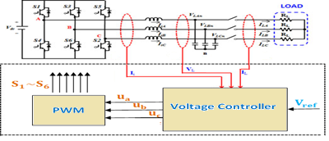

**Figure 10.** Block diagram of the three-phase voltage control system

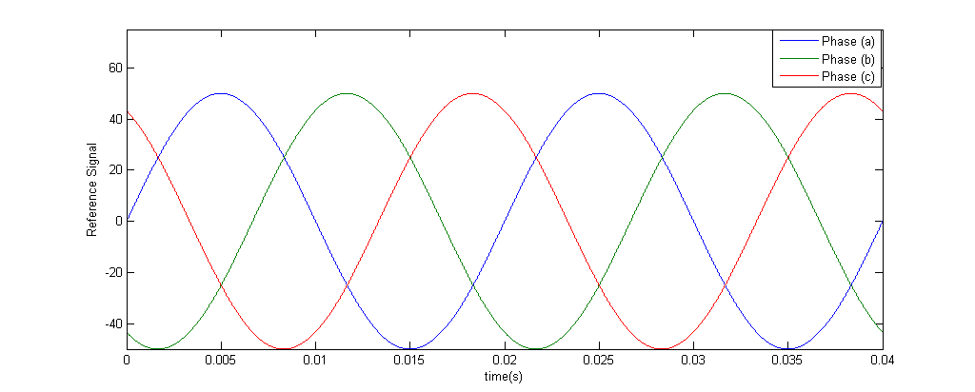

(a)

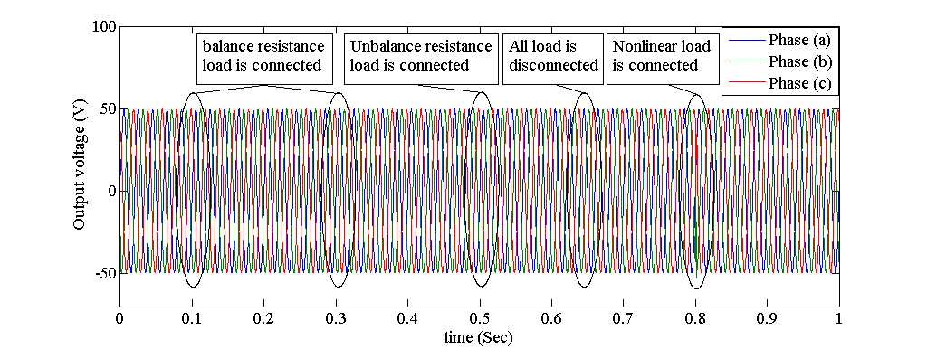

(b)

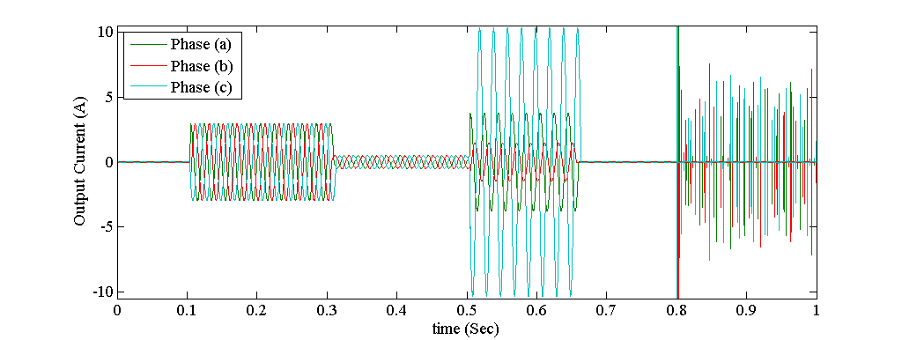

(c)

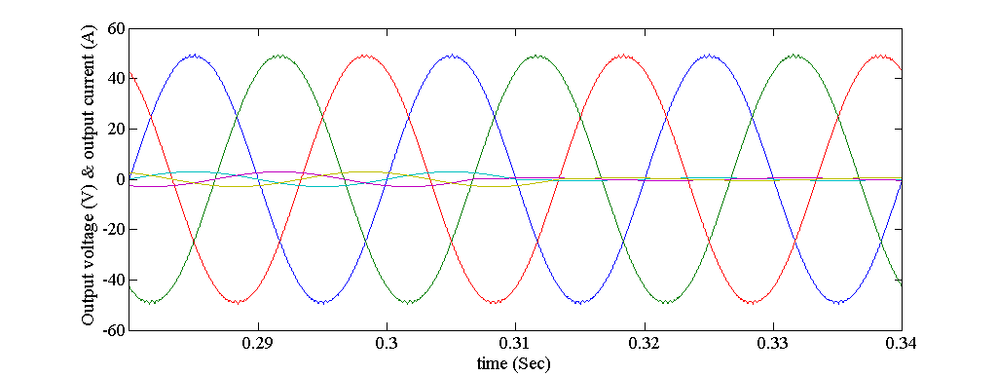

(d)

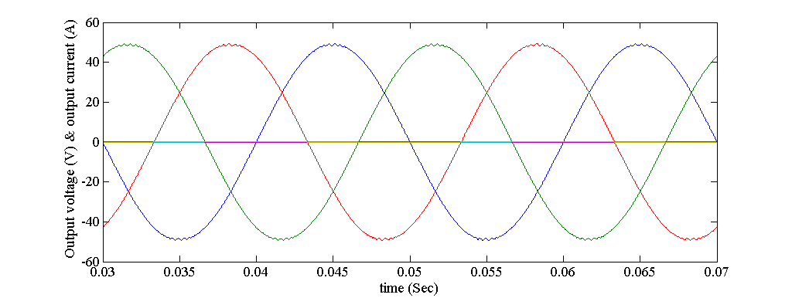

(e)

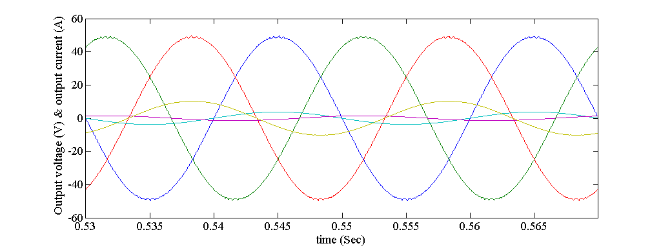

(f)

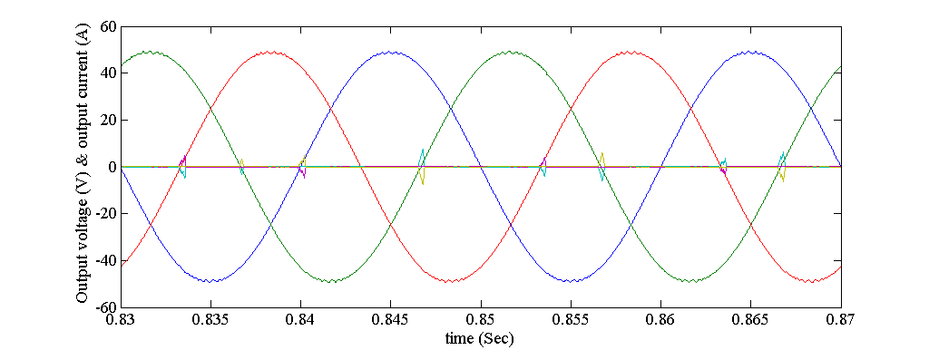 (g)

**Figure 11.** Simulation results of controller. (a) Three-phase reference signal (b) Load voltage (c) Load current (d) Voltage during resistive load (e) Voltage under no-load (f) Voltage resistive load during asymmetric resistive load (g) Voltage during nonlinear load.

**Table 4.** Results of steady state analysis of phase (a)

|  |  |  |  |  |  |  |  |  |
| --- | --- | --- | --- | --- | --- | --- | --- | --- |
| Load type | Output voltage peak | Effective output voltage | THD (%) | 2th harmonic | 3th  harmonic | 4th  harmonic | 5th  harmonic | Robustness |
| No load | 47.82 | 33.82 | 0.49 | 0.22 | 0.09 | 0.25 | 0.17 | **Robust to parameters** |
| Symmetric resistance load | 47.74 | 33.76 | 0.55 | 0.15 | 0.21 | 0.28 | 0.10 |
| Asymmetric resistance load | 47.69 | 33.72 | 0.76 | 0.25 | 0.35 | 0.41 | 0.16 |
| Nonlinear load | 47.28 | 33.43 | 3.02 | 1.37 | 1.58 | 1.34 | 0.96 |

**4.1. Simulation results of PI controller**

In the following, the simulation results are expressed with the PI controller for the single-phase system.

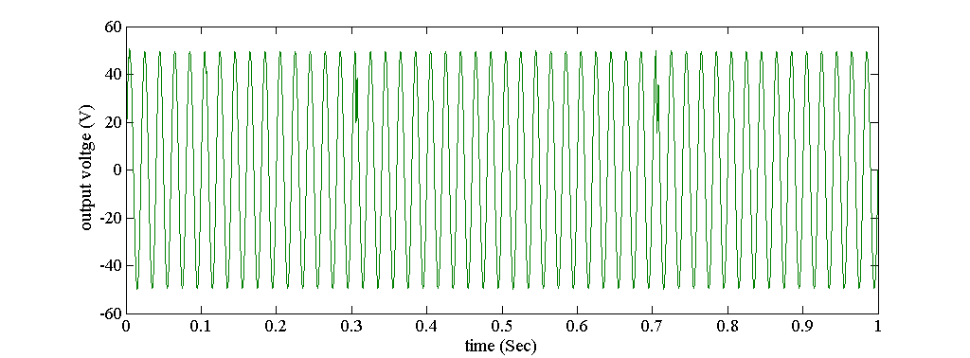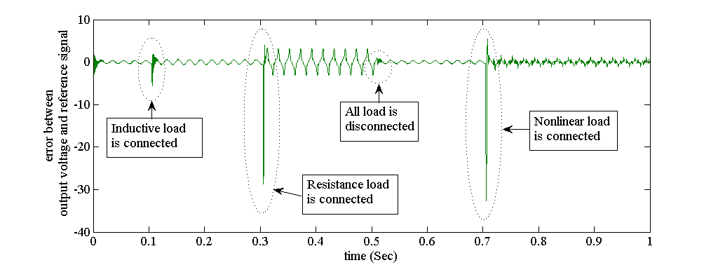

1. (b)



(c)

**Figure 12.** Voltage control based on the PI controller a) Output voltage. b) Error between output voltage and reference signal. c) Harmonic analysis of the steady state.

The simulation results show that the PI controller is sensitive to load variations and its steady state error varies in different conditions, as the proposed controller is a robust controller.

# Conclusion

In this paper, a method of feedback voltage control based on the Lyapunov theory for controlling of the DG unit independent Inverter is presented. The proposed controller is not only simple, but also against the sudden changes in load and the unspecified system is resistant. In addition, the stability of the control system of the closed loop is also proven by the method of the Lyapunov. To provide validation of the proposed control method, simulations are provided through the MATLAB software. Finally, the simulation results have shown that the proposed control method provides convincing voltage regulation, such as fast dynamics, lower steady state error, and low THD for various loads, including linear and nonlinear loads. It is also shown by changing the amplitude of the reference signal that follows the reference signal controller and causes the steady state error between the output voltage signal and the reference signal of the voltage to zero.

**REFERENCES**

1. Singh, Devender, and R. K. Misra. "Effect of load models in distributed generation planning." Power Systems, IEEE Transactions on 22, no. 4: 2204-2212, 2007.
2. Yang, M. J., F. Zhuo, X. W. Wang, H. P. Guo, and Y. J. Zhou. "Research of seamless transfer control strategy of microgrid system." In Power Electronics and ECCE Asia (ICPE & ECCE), 2011 IEEE 8th International Conference on, pp. 2059-2066. IEEE, 2011.
3. MOCAMBIQUE, Nilton Eufrázio Martinho; MACHADO, Ricardo Q.; OLIVEIRA, Vilma A. A fuzzy PD-PI control strategy to track the voltage references of photovoltaic arrays. In: Control and Automation (ICCA), 2011 9th IEEE International Conference on. IEEE. p. 1162-1167, 2011.
4. C. Chapuis, E. Bideaux, X. Brun and N. Minoiu-Enache, "Comparison of feedback linearization and flatness control for anti-slip regulation (ASR) of an hybrid vehicle: From theory to experimental results," 2013 European Control Conference (ECC), 2013, pp. 446-451, doi: 10.23919/ECC.2013.6669127.
5. ABDEL-RAHIM, Naser M.; ELSHAFEI, Abdel Latif. Hierarchical fuzzy-logic control for a single-phase voltage-source UPS inverter. In: IECON 02 [Industrial Electronics Society, IEEE 2002 28th Annual Conference of the]. IEEE. p. 262-267, 2002.
6. LAZZARIN, Telles B.; BAUER, Guilherme AT; BARBI, Ivo. A control strategy for parallel operation of single-phase voltage source inverters: analysis, design and experimental results. Industrial Electronics, IEEE Transactions on, 60.6: 2194-2204, 2013.
7. R. Majdoul, E. Abdelmounim, M. Aboulfatah and A. Abouloifa, "The Performance comparative of Backstepping, Sliding Mode and PID controllers designed for a single-phase inverter UPS," 2014 International Conference on Multimedia Computing and Systems (ICMCS), 2014, pp. 1584-1589, doi: 10.1109/ICMCS.2014.6911310.
8. Shah, A.A.; Han, X.; Armghan, H.; Almani, A.A. A Nonlinear Integral Backstepping Controller to Regulate the Voltage and Frequency of an Islanded Microgrid Inverter. Electronics 2021, 10, 660. https://doi.org/10.3390/electronics10060660
9. R. Majdoul, A. Abouloifa, E. Abdelmounim, M. Aboulfatah, A. Touati and A. Moutabir, "Backstepping controller of five-level three-phase inverter", EDP Sciences, vol. 16, no. 06003, May 2014.
10. Vasquez, Juan C., Josep M. Guerrero, Mehdi Savaghebi, Joaquin Eloy-Garcia, and Remus Teodorescu. "Modeling, analysis, and design of stationary-reference-frame droop-controlled parallel three-phase voltage source inverters." Industrial Electronics, IEEE Transactions on 60, no. 4 (2013): 1271-1280.
11. Zeeshan Ahmad Arfeen, Azhar B. Khairuddin, Raja Masood Larik, Mohammad Salman Saeed, ”Control of distributed generation systems for microgrid applications: A technological review”, Int Trans Electr Energ Syst. 2019;29:e12072.https://doi.org/10.1002/2050-7038.12072. 2019.
12. A.H. Syed, M.A. Abido,”An Optimization Approach to Design Robust Controller for Voltage Source Inverters,” 2017 Elsevier Ltd. All rights reserved. http://dx.doi.org/10.1016/B978-0-08-101753-1.00006-1.
13. Tao Li, Qiming Cheng,” Structure analysis and sliding mode control of new dual quasi‐Z‐source inverter in microgrid”, *Int Trans Electr Energ Syst*. 2018; e2662. wileyonlinelibrary.com/journal/etep. © 2018 John Wiley & Sons, Ltd. https://doi.org/10.1002/etep.2662.
14. Guzman, Cristina, Alben Cardenas, and Kodjo Agbossou. "Control of voltage source inverter using FPGA implementation of ADALINE-FLL." In IECON 2012-38th Annual Conference on IEEE Industrial Electronics Society, pp. 3037-3042. IEEE, 2012.
15. Juan F. Patarroyo-Montenegro, Jesus D. Vasquez-Plaza and Fabio Andrade, “A State-Space Model of an Inverter-Based Microgrid for Multivariable Feedback Control Analysis and Design”, www.mdpi.com/journal/energies, Energies 2020, 13, 3279; doi: 10. 3390/en13123279.
16. Yaqian Yang, Chang Li*,* Jiazhu Xu, Frede Blaabjerg, Tomislav Dragicevic*,”* Virtual Inertia ControlStrategy for Improving Damping Performanceof DC Microgridwith Negative Feedback Effect “,IEEE Journal of Emerging and Selected Topics in Power Electronics. DOI 10.1109/JESTPE.2020.2998812, 2020.
17. Dristi Datta, Md. Rafiqul Islam Sheikh, Subrata Kumar Sarkar, Sajal Kumar Das,” Robust Positive Position Feedback Controller for Voltage Control of Islanded Microgrid”, International Journal of Electrical Components and Energy Conversion 2018; 4(1): 50-60. http://www.sciencepublishinggroup.com/. doi: 10.11648/j.ijecec.20180401.16.
18. MENG Hao, XIE Zhen, “A Control Strategy for Voltage Source Inverter adapted to Multi – mode Operation in Microgrid,” Proceedings of the 36th Chinese Control Conference, July 26-28, 2017, Dalian, China.2017.
19. Mohammad Noor Bin Shaheed, Sifat Chowdhury, Yilmaz Sozer. J. Alex De Abreu-Garcia,” Enhanced Voltage Droop Control Strategy for DC Microgrid System with State Variable Feedback”, 978-1-7281-0395-2/19/$31.00 ©2019 IEEE. ECCE.2019.8912834.
20. Islam Ziouani, Djamel Boukhetala, Abdel-Moumen Darcherif, Bilal Amghar , Ikram El Abbassi ,” Hierarchical control for flexible microgrid based on three-phase voltage source inverters operated in parallel”, Electrical Power and Energy Systems 95 (2018) 188–201, journal homepage: [www.elsevier.com/locate/ijepes](http://www.elsevier.com/locate/ijepes). 0142-0615/\_ 2017 Elsevier Ltd. All rights reserved.http://dx.doi.org/10.1016/j.ijepes.2017.08.027.
21. Jiao Yuqiao, Ding Min, Li Danyun, Wang Qingyi, Fang Zhijian,” A state feedback voltage controller for inverter-based islanded microgrid”, 39th Chinese control conference(ccc), Doi: 10.23919/CCC50068.2020.9188876.
22. Hakeem, Ahmed, A. Elserougi, Amr El Zawawi, Shehab Ahmed, and Ahmed Mohamed Massoud. "A modified capacitor voltage control algorithm for suppressing the effect of measurement noise on grid-connected Z-source inverters controllers." In Industrial Electronics Society, IECON 2013-39th Annual Conference of the IEEE, pp. 204- 209. IEEE, 2013.
23. YARAMASU, Venkata, et al. Model Predictive Approach for a Simple and Effective Load Voltage Control of Four-Leg Inverter with an Output LC Filter. 2014.
24. Basak, Prasenjit, A. K. Saha, S. Chowdhury, and S. P. Chowdhury. "Microgrid: Control techniques and modeling." In Universities Power Engineering Conference (UPEC), 2009 Proceedings of the 44th International, pp. 1-5. IEEE, 2009.
25. Yang, Wang, Ai Xin, and Gao Yang. "Microgrid's operation-management containing distributed generation system." In Electric Utility Deregulation and Restructuring and Power Technologies (DRPT), 2011 4th International Conference on, pp. 703-707. IEEE, 2011.
26. Hong, Zheng Jing, Wang YanTing, Wang ZhongJun, Zhu Shouzhen, Wang Xiaoyu, and Shen Xinwei. "Study on microgrid operation modes switching based on eigenvalue analysis." In Advanced Power System Automation and Protection (APAP), 2011 International Conference on, vol. 1, pp. 445-450. IEEE, 2011.

**BIOGRAPHIES OF AUTHORS**

|  |  |
| --- | --- |
|  | **Mahmoud Zadehbagheri**     was born in Yasouj, Iran in October 1989. In 2003 he received his B.S. in Electrical Engineering from Kashan University and in 2008 he received his M.S. in Electrical Engineering from the Islamic Azad University, Najafabad Branch. He received the PhD degree in Electrical Engineering from Hakim Sabzvari University & Universiti Teknologi Malaysia (UTM), Johor, Skudai, Malaysia in 2017. He is with the faculty of the Electrical Engineering Department, Islamic Azad University of Yasouj. His research interests include the fields of power electronics, electrical machines and drives, FACTS devices and Power Quality. Email: mzadehbagheri@iauyasooj.ac.ir |
|  | **Mohammad Javad Kiani** was born in Yasouj , Iran. He received his B.S. and M.S. degrees in ElectricalEngineering from the K. N. Toosi University of Technology, Tehran, Iran, in 2003 and 2008, respectively. He received his Ph.D. degree in Electrical Engineering from the Universiti Teknologi Malaysia (UTM), Johor, Skudai, Malaysia, in 2017. He is presently a faculty member in the Department of Electrical Engineering, Islamic Azad University, Yasouj, Iran. His current research interests include Nanotechnology and application, Power Electronic , Power Systems, Controller, Intelligence Network. Email: [kianiph@iauyasooj.ac.ir](mailto:kianiph@iau.yasooj.ac.ir) |
|  | **Tole Sutikno**     (M’07) received the B.Eng. degree in electrical engineering from Diponegoro University (UNDIP), Semarang, Indonesia, in 1999, and the M.Eng. degree in power electronics from Gadjah Mada University (UGM), Yogyakarta, Indonesia, in 2004. He is currently working toward the Ph.D. degree in the Department of Energy Conversion, Faculty of Electrical Engineering, Universiti Teknologi Malaysia, Johor, Skudai, Malaysia. Since 2001, he has been a Lecturer in the Electrical Engineering Department, Universitas Ahmad Dahlan, Yogyakarta. His research interests include the fields of power electronics, motor drive systems, and field programmable gate array applications.Email: [tole@ee.uad.ac.id](mailto:tole@ee.uad.ac.id). |
| C:\Users\n\Desktop\a45a70c0-85d9-45f5-ad8a-e46d94941929.jpg | **Rasoul Arvin Moghadam**     was born in Yasouj, Iran in February 1988. In 2003 he received his B.S. in Electrical Engineering from Islamic Azad University, Yasouj Branch and in 2008 he received his M.S. in Electrical Engineering from the Islamic Azad University, Yasouj Branch. He is currently studying for his doctorate at the Islamic Azad University of Yasouj Branch. His research interests include context FACTS , Power electronic and Power quality in power system.Email: Arvin.rasoul@gmail.com. |
|  |  |