Challenges and Perspectives of the use of Photovoltaic Solar Energy in Colombia

Chistian Moreno¹, Celene B. Milanés², Willian Arguello³, Arley Fontalvo³, José R. Nuñez^{1*}
¹Energy Department, Universidad de la Costa, Barranquilla, Colombia
²Civil and Environmental Department, Universidad de la Costa, Barranquilla, Colombia
³Electrical Engineering Student, Universidad de la Costa, Barranquilla, Colombia

Article Info |  | ABSTRACT
Article history:  Received Jun 9, 2018  Revised Nov 20, 2018  Accepted Jan 11, 2019 |  | This article quantifies the development that the use of photovoltaic solar energy has achieved in Colombia and its current development prospects. The high demand for electricity in Colombia is increasing, since there is a large population, industrial, and business increase, which brings with it a higher energy consumption with the consequent economic, social, and environmental problems. Faced with this situation, a possible solution is proposed, using solar energy, to supply the increase in demand and mitigate the problems caused by current electricity generation, because Colombia has high levels of solar radiation in almost the entire territory. The objective of this research is based on the analysis of the behavior of the projects on photovoltaic solar systems presented to the Mining-Energy Planning Unit (UPME) in the last 14 years until September 30, 2020, as well such as the study of the areas with the greatest implementation of this technology and their respective radiation indices. In addition, a synthesis is made of the regulations, laws, and tax incentives that exist for the implementation of this technology, as well as the different stages of execution of the projects, approved and in execution.
Keywords:
Renewable energy
Solar energy
Photovoltaic solar system
Environmental problem
Solar energy projects
 |  | This is an open access article under the CC BY-SA license.
Corresponding Author:
José Ricardo Nuñez Alvarez,
Energy Department,
Universidad de la Costa (CUC),
Call 58 # 55 - 66, Barranquilla, Atlántico
Colombia.
Email: jnunez22@cuc.edu.co

- INTRODUCTION
Colombia, a country located in South America, has a very good geographical location for the use, development, and generalization of technologies associated with renewable energies. For example, the high rate of solar radiation in many regions means that the country has great potential to use solar energy, although the reality is quite different since it has a large deficit in the development of this sector [1]–[3].
There is no doubt that the private sector is one of the most interested in the use and implementation of technologies that use solar energy as a primary source, either with the installation of systems to generate electricity or with thermal systems to produce steam or heating liquids. In Colombia, this sector has been making very significant efforts to develop projects that involve photovoltaic systems or electricity generation through solar power plants, although at present, the installed capacity is far from the development potential of the country [4]–[5], so it is still far from the progress made by countries like Chile, Mexico, or Spain [6]–[9]. If we compare Germany, one of the countries with the highest use of solar energy in the energy matrix, with Colombia, which receives 30% more solar radiation, we realize that there is still a long way to go to be close to the countries that best have managed the implementation of this technology [10]–[12].
According to studies carried out by the Mining-Energy Planning Unit (UPME for its abbreviation in Spanish), the energy potential of the department of La Guajira is so great that using 20% of its surface, 42,000 MW of electricity generation could be obtained using solar energy, achieving, in addition, to bring electricity to Non-Interconnected Zones (ZNI for its abbreviation in Spanish) in the said department and other neighboring regions of the Caribbean region [13]. In correspondence with data from the Institute for Planning and Promotion of Energy Solutions for Non-Interconnected Zones (IPSE for its abbreviation in Spanish) in Colombia, 90 municipalities are in the ZNI, which cover about 52% of the national territory. These municipalities include 32 departments, 5 departmental capitals, 39 municipal capitals, and 1,448 localities [13], [14].
Colombia has an annual average of solar radiation of the order of 4.5 kWh/m². These conditions propitiate the introduction of photovoltaic solar systems to supply electrical energy needs with the help of some type of subsidy from the national government [15], [16]. In 2005 there were approximately 145 photovoltaic systems, none of them presented to the Mining-Energy Planning Unit (UPME), whose installed capacity reached 208.06 kW; by 2014 it had increased to approximately 11.6 GW and in 2015 it increased by 0.6 GW for a total of approximately 12 GW [17], [18]. These data show that the impact, on the country's energy matrix, of electricity generation from renewable sources was very low [19]. This article analyzes the main aspects related to the introduction of photovoltaic solar technology in the last 14 years in Colombia. In addition, the potential of solar energy in the main cities of the country is studied to quantify the projects and investments that have been made until 2020, the development phases of the current projects, the statistics of the projects presented to the UPME, the review of tax incentives, as well as variations and/or updates of everything related to the laws and policies of the use of renewable energies.

- SOLAR ENERGY IN COLOMBIA
Colombia has 550 automatic satellite stations and different points of measurement of atmospheric variables located throughout the country, of which 71 carry out direct measurements, 383 are dedicated to making routine measurements of the average solar hours, and 96 are dedicated to making relative humidity and temperature measurements. In the case of solar radiation at the country level, information is collected from all meteorological stations, and in the case of solar brightness, information is collected from 479 stations. The Mining-Energy Planning Unit establishes monthly and annual average Radiation and Irradiance levels since 1981, these values are expressed in kilowatt-hours per square meter (kWh/m²) [20].
As already mentioned, the natural conditions in Colombia are favorable for the generation of electrical energy using photovoltaic solar systems, since radiation levels throughout the year are considered very good. Most of the ZNIs in the country has an average solar irradiation resource of 194 W/m² and an average daily solar radiation of 4.5 kWh/m², values that exceed the global average value of 3.9 kWh/m² per day [21]. Table 1 shows the data obtained and the characteristics of the geographical location of the meteorological stations installed in the main cities of the country, as well as the average solar hours in the year [22]. The high average hours of sunshine in Colombia are very significant when it comes to investing in photovoltaic systems and taking advantage of them since there would be a high period of incidence (time) of solar radiation in the photovoltaic panels and consequently greater capacity. generation of these. In addition, it should be noted that Colombia is within the equatorial zone, so in much of its territory, the seasonal phenomenon is not present, guaranteeing an average resource of good solar radiation throughout the year [23], [24].

Table 1. Potential for average global irradiance received on the surface in the main cities of the country [20]
Station | Municipality | Department | Latitude | Length | Elevation,  masl | Anual average,  kWh/m² per day
Airport El Dorado | Bogotá | Cundinamarca | 4.71 | -74.15 | 2541 | 4.0377
Airport Olaya Herrera | Medellín | Antioquia | 6.22 | -75.58 | 1490 | 4.3351
Las Flores | Barranquilla | Atlántico | 11.04 | -74.82 | 2 | 5.9512
Airport Rafael Núñez | Cartagena | Bolívar | 10.43 | -75.5 | 2 | 5.5525
UPTC | Tunja | Boyacá | 5.55 | -73.35 | 2690 | 4.6574
Airport Olaya Herrera | Medellín | Antioquia | 6.22 | -75.58 | 1490 | 4.3351
E.M.A.S | Manizales | Caldas | 5.09 | -75.51 | 2207 | 3.7672
Univ. Tec. de Magdalena | Santa Marta | Magdalena | 11.22 | -74.19 | 7 | 5.4054
Airport Vanguardia | Villavicencio | Meta | 4.15 | -73.62 | 423 | 4.7507
Botana | Pasto | Nariño | 1.16 | -77.28 | 2820 | 3.7428
Armenia | Armenia | Quindío | 4.53 | -75.69 | 1458 | 3.9338
Airport Matecaña | Pereira | Risaralda | 4.8 | -75.73 | 1342 | 4.2109
Airport Gustavo Rojas | San Andrés | San Andrés | 12. | -81.7 | 1 | 4.8183
Airport Perales | Ibagué | Tolima | 4.42 | -75.13 | 928 | 4.6632
UniValle | Cali | Valle del Cauca | 3.38 | -76.53 | 992 | 4.3326
Macagual - Florencia | Florencia | Caquetá | 1.5 | -75.66 | 257 | 3.6175
Airport Admiral Padilla | Riohacha | La Guajira | 11.52 | -72.92 | 4 | 5.6058

- RESULT AND DISCUSSION
Colombia, although far from the countries that make the best use of solar energy, has made progress in terms of the implementation of renewable energy projects in the last 10 years, especially about the use and use of solar energy, according to a study presented by UPME on September 30, 2020. Figure 1 shows the behavior of the renewable energy projects presented from 2007 to September 30, 2020. In 2014 the first solar energy project was presented, achieving a total of 883 to the reference date, being the year 2018 where more projects were executed with a total of 240. These advances are due, to a large extent, to the action of the private sector and the efforts made by the national government in the creation and/or modification of policies and laws that help stimulate the implementation of renewable energy projects [25].
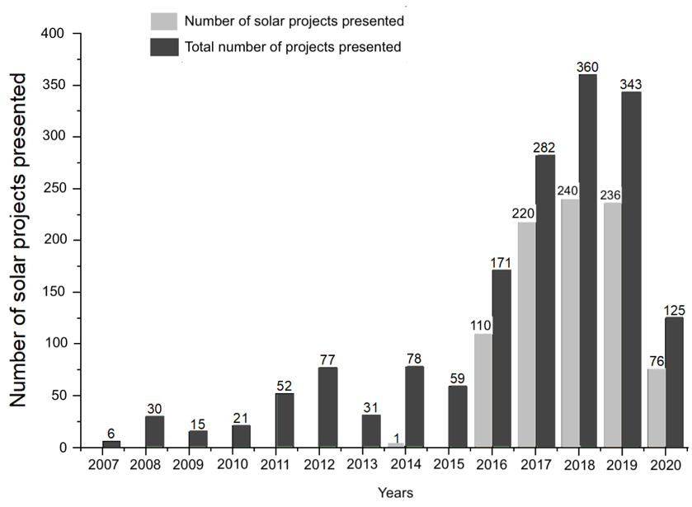
Figure 1. Total renewable energy and solar energy projects from 2007 to 2020

Figure 1 shows the evolution in the implementation and registration of projects before the Mining-Energy Planning Unit (UPME), comparing the total registration of renewable energy projects versus the total of registered solar energy projects. It is evident that since 2016 there has been great progress in the implementation and use of solar energy in the national territory, and in 2017 the highest percentage of participation in solar energy projects was achieved compared to the other sources of renewable energies with 78%.
Figure 2 shows the percentage of participation of solar energy in comparison with the renewable energy projects presented and registered with the UPME. When a single solar energy project was developed in 2014, the percentage of participation concerning the total of projects presented was 1.3%, while in 2018 the largest number of solar energy projects was registered with 240, equivalent to 66.7% of the total. However, it is in 2017 where projects related to solar energy reach the highest percentage of participation compared to other renewable energy sources, reaching a value of 78%.
It should be noted that, in 2020 worldwide, due to the crisis generated by Covid-19, there is evidence of a decrease in the registration of renewable energy projects, however, in Colombia the registration and development of renewable energy projects solar energy performed well, reaching 61% of the total projects presented. This demonstrates the commitment by the Colombian government and private companies to achieve an energy matrix where renewable energies have the highest percentage, thus achieving a less invasive energy generation system to the environment, where the use and penetration are encouraged. in the national network of unconventional energy sources with criteria of environmental, social, and economic sustainability. The objective is to ensure that by 2030 renewable energies are a matter of public utility, social interest, and national convenience due to the importance of the use of these unconventional sources in the protection of the environment and the efficient use of energy [26].

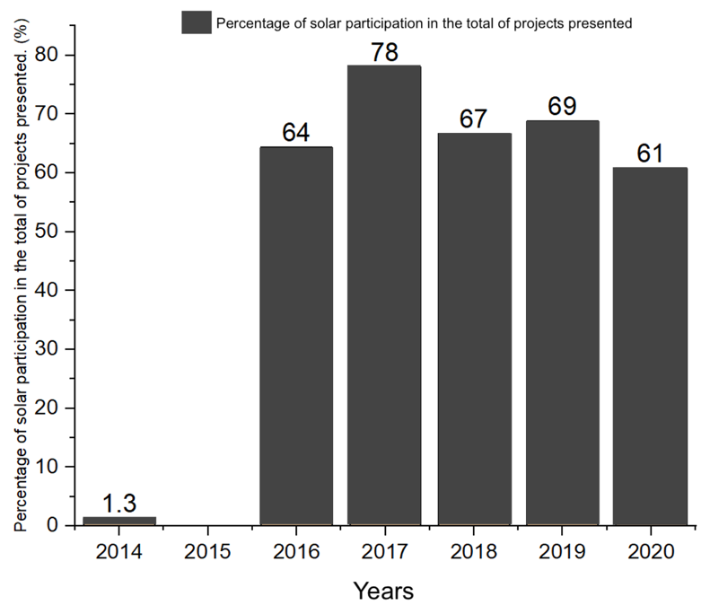
Figure 2. Percentage of participation in projects with solar energy since 2014

Renewable energy projects presented to the UPME must complete 3 phases, the first of which corresponds to the study and analysis of technical and financial viability where strategic markets are identified that offer attractive investment opportunities; The second stage corresponds to the technical design of the project to obtain the necessary permits, licenses, and authorizations to start the project. The last phase corresponds to the development, construction, assembly, and implementation of the system. Once these stages are completed, the necessary procedures must be carried out to certify the plant has been designed according to the project; In the event of any irregularity, the corresponding modifications must be justified and documented. Until the end of September 2020 in Colombia, there were 146 solar energy projects in phase 1, 59 were in phase 2, and 4 projects in phase 3. Figure 3 compares the solar energy projects that are in development since 2018 and the total of projects that involve other sources of renewable energy, concluding that there is a total of 668 current projects of which 209 correspond to the use of solar energy, that is, 31%.
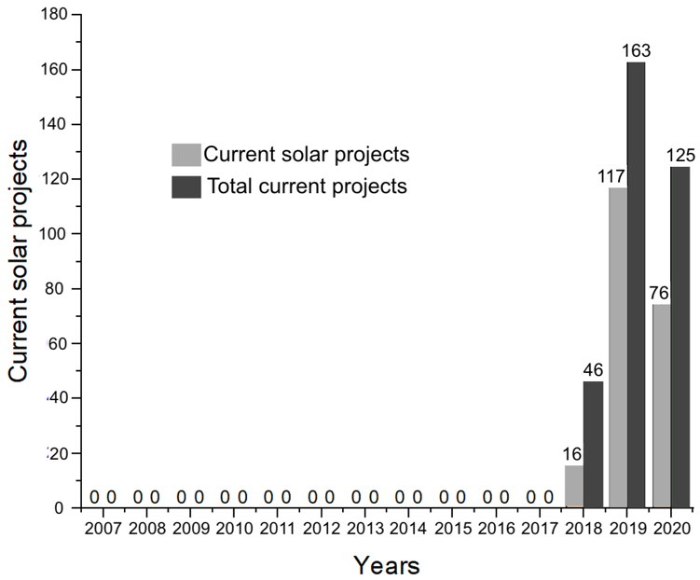
Figure 3. Current solar projects vs total presented since 2018

The 209 current projects for the use of solar energy can be classified according to the design electrical powers, figure 4, noting that 64 projects, corresponding to 30.62% of the total, have a nominal power between 0 to 1 MW. There are 62 projects, corresponding to 29.67% of the total, which have a power value between 2 and 10 MW. These data show that more than 50% of the total solar energy projects registered in Colombia correspond to projects with operating power between 0 and 10 MW and only 17 projects, corresponding to 8.13%, have a design power greater than 100 MW.
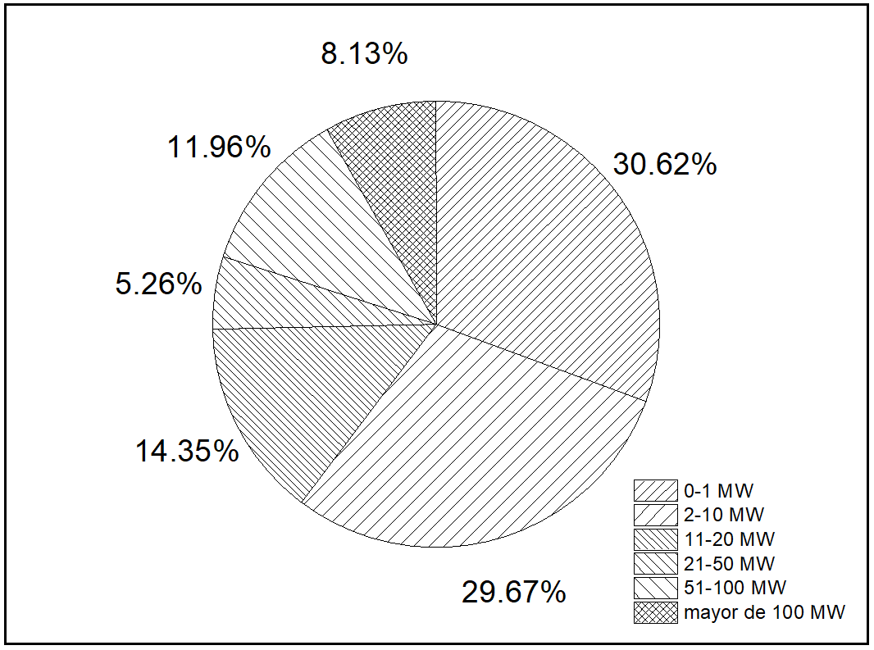
Figure 4. Classification by range of designing electrical powers in current solar projects

In 2018, there was an installed capacity of 2.4 MW from the use of photovoltaic systems between the capital district and the 32 departments that make up the country. Of the total value of installed power, there are 1.9 MW that are distributed in the departments of Cundinamarca, Atlántico, Valle del Cauca, Antioquia, and Norte de Santander [20]. However, at the end of 2020, the total power of the current solar energy projects amounted to 7,036 MW, of which 3,095 MW were in phase 1, 3,961 MW were in phase 2 and only 59 MW were in phase 3. The last value represents 48.34% of all renewable energy projects registered with the UPME. Figure 5 shows the solar energy projects that are in force in 24 of the 32 departments of the country, highlighting the departments of Valle, Atlántico, Boyacá, and Bolívar with 73 projects that represent 35% of the total.

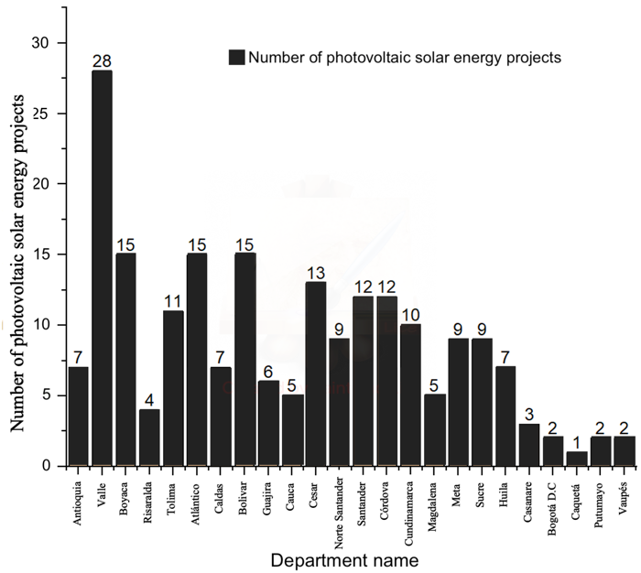
Figure 5. Current solar energy projects by Department

We must also take into account the total installed capacity in each department, figure 6, where it can be seen that Santander, La Guajira, Cesar, and Atlántico are the departments that as a whole have 4157 MW installed, that is, more than 50% of the total. of the installed power in the country.
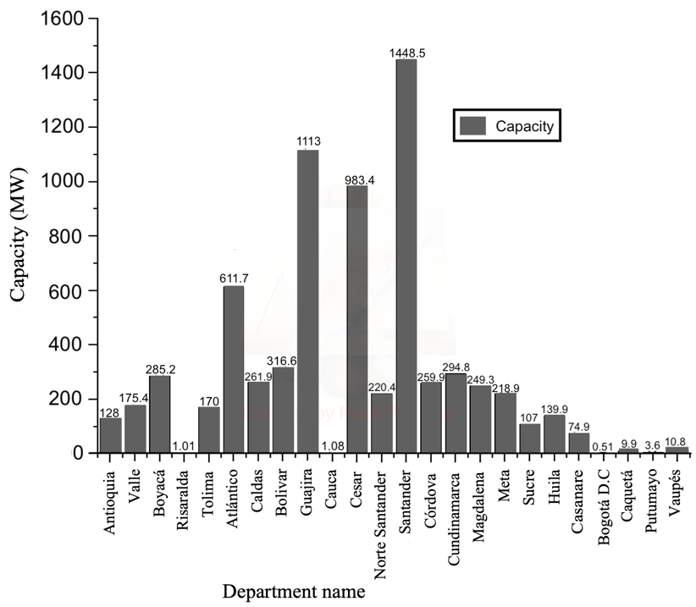
Figure 6. Electric power capacity installed in each Departments

It is also possible to include qualities such as the veracity of the information handled that depends on the design objective; mobility as the agent's ability to move in the environment and move through a network of processing nodes to perform specific tasks [27], [28]. Another quality is intelligence, which provides the agent with the ability to analyze and order knowledge about the environment and use it appropriately. Based on this acquired knowledge, it can self-reconfigure itself to adapt to its environment [29], [30]. Despite all these qualities, and due to the level of complexity existing in the architecture and process of the steelworks, a single agent does not provide an answer to the problem addressed, so it is decided to analyze the communities of agents.
It is interesting to note that the department of Valle has 28 registered projects that are equivalent to 2.48% of the total installed capacity nationwide, while the department of Santander with 12 projects has a value of 20.4%. The department of La Guajira, located in the Colombian Caribbean region, which has good energy potential and an excellent solar radiation index, has only 6 solar energy projects, but equivalent to 15.71% of the total, that is, approximately 1,113 MW. Figure 7 shows the percentage behavior of the installed electrical capacity in each department, highlighting the Atlantic with 15 projects in execution and installed power of 611.7 MW, corresponding to 8.63% of the total installed capacity in the country.
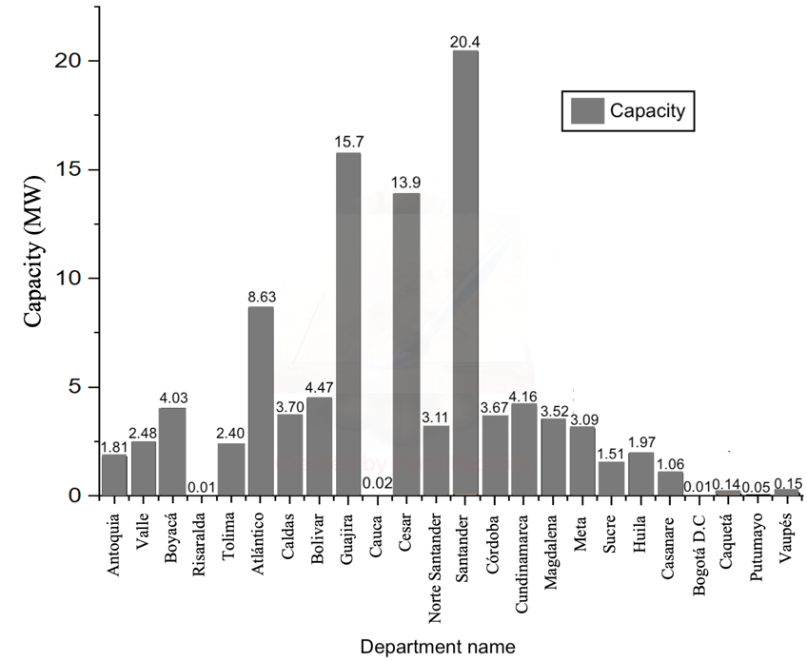
Figure 7. Percentage of installed capacity in each Department

3.1. Regulatory framework and policies
At the global level, the policies and regulatory frameworks of each country have been modified to facilitate and accelerate the introduction of renewable energy sources (FRE for its abbreviation in Spanish). Colombia has not been immune to these changes, so it is intended to carry out a holistic review of the regulatory framework, analyzing the barriers and opportunities for improvements for the development of the FRE.
In Colombia, according to the UPME, the energy demand is increasing, and therefore the environmental problems caused by the generation of electricity from the use of fossil fuels and the depletion of natural resources are increasing. This is one of the compelling reasons for the country to bet on the generalization and use of the FRE through a regulatory framework and the creation of state entities responsible for controlling and managing them. Table 2 shows the main resolutions and laws of the Colombian regulatory framework that govern the policy for the development of FREs.

Table 2. Colombian regulatory framework [23]
Colombian regulatory framework
Organization | Resolution CREG 097/2008  Resolución CREG 179/2014  Resolución CREG 095/2015 | • Regulation of distribution activity.  • Regulated discount rate for the regulation of distribution activity.
 | Resolution CREG 030-038/2018 | • Whereby small-scale self-generation and distributed generation activities are regulated in the National Interconnected System.
 | Law 1715/2014 and Decree 2649/2014 | • The integration of non-conventional renewable energies into the Colombian system.
 | Resolution CREG 011/2015 and 063/2010 | • Demand response programs.
 | Resolution CREG 197/2014, 180/2014, 119/2007 | • By which special conditions are established for the provision of electric power service in areas of difficult access.
 | Resolution CREG 037/2018 | • Regulates the commercialization activity.
 | Resolution CREG 038/2014 | • Code of measurements and smart meters
 | Resolution CREG 019/2019 | • By which CREG Resolution 108 of 1997 is added in relation to the rights of users Small Scale Auto generators.

The regulatory framework has allowed the development and growth of renewable energies, taking as a starting point Colombia's participation in the Kyoto Protocol on climate change in 1997, Law 629 of 2000 that promotes the Rational and Efficient Use of Energy (URE for its abbreviation in Spanish) and Decree 3683 of 2003. In addition, to promote the implementation of unconventional energies in the country, Law 1665 of 2013 is created. Finally, Law 1715 of 2014 is established to regulate the integration of renewable energies in the national energy system (SIN for its abbreviation in Spanish), especially in non-interconnected areas (ZNI), create incentives for projects of this type, for example, exemption from value-added tax (VAT for its abbreviation in Spanish) and reduction of the payment of income tax.

- CONCLUSIONS
This research has made it possible to identify the current situation in Colombia regarding the use of renewable energy sources by analyzing the evolution that the use of solar energy has had during the last 14 years. On the other hand, it is possible to identify the percentage of participation of the main departments in the current projects, observing the active participation of the departments located in the north of the national territory, among which La Guajira, Atlántico, Cesar, and Santander stand out. In addition, these same departments have the highest installed electrical capacity with a value of 4,157 MW, that is, more than 50% of the total registered in all current projects.
The energy matrix that characterizes Colombia depends, to a large extent, on the behavior of the rains to achieve adequate water levels in the different reservoirs. The phenomena known as El Niño or La Niña alter the level of rainfall and therefore affect the generation of electricity in the different hydroelectric plants that the country has, therefore, on many occasions it is necessary that the power plants that they were back-up in an emergency or anomalous situation and that they work with fossil fuels. Faced with these scenarios, the introduction, development, and implementation of renewable energy sources are very useful.
It should be noted that the electricity system has been evolving favorably in recent years, largely due to the adequate willingness of private companies and the Colombian government to promote FRE, for example, the implementation of Law 1715 of 2014 seeks to diversify the electricity matrix aiming at the inclusion of renewable sources through tax incentives for those who develop self-generation projects and sales of surpluses.

REFERENCES
- J. Hernández, E. Sáenz and W. Vallejo, “Study of the Solar Resource in the City of Bogotá for the Design of Residential Interconnected Photovoltaic Systems,” Rev. Colomb. Física, vol. 42, no. 2, pp. 5, 2010.
- E. D. Obando, S. X. Carvajal, and J. Pineda Agudelo, "Solar Radiation Prediction Using Machine Learning Techniques: A Review," in IEEE Latin America Transactions, vol. 17, no. 04, pp. 684-697, April 2019, doi: 10.1109/TLA.2019.8891934.
- E. Mendoza, et al., “An Analysis of Electricity Generation with Renewable Resources in Germany,” International Journal of Energy Economics and Policy, vol. 10, no. 5, pp. 361-367, 2020, doi. 10.32479/ijeep.9369.
- E. F. Cantillo and F. Conde, “Commercial and Technical Diagnosis of Photovoltaic sector at Colombian Caribbean region,” Prospectiva, vol. 9, no. 2, pp. 81–88, 2011.
- A. Ruíz, et al., “Solar PV generation in Colombia - A qualitative and quantitative approach to analyze the potential of solar energy market,” Renewable Energy, vol. 148, pp. 1266-1279, 2020, doi:10.1016/j.renene.2019.10.066.
- L. M. López-Ochoa, et al., “Dataset on solar contributions by thermal solar systems in Chile applying Chilean and Spanish regulations,” Data in Brief, vol. 26, pp. 104505, 2019, doi. 10.1016/j.dib.2019.104505.
- L. Dusonchet and E. Telaretti, “Economic analysis of different supporting policies for the production of electrical energy by solar photovoltaics in western European Union countries,” Energy Policy, vol. 38, no. 7, pp. 3297-3308, 2010, doi. 10.1016/j.enpol.2010.01.053.
- H. Zsiborács, et al., “Grid balancing challenges illustrated by two European examples: Interactions of electric grids, photovoltaic power generation, energy storage and power generation forecasting,” Energy Reports, vol. 7, pp. 3805-3818, 2021, doi. 10.1016/j.egyr.2021.06.007.
- J. Ordóñez, E. Jadraque, J. Alegre, and G. Martínez, “Analysis of the photovoltaic solar energy capacity of residential rooftops in Andalusia (Spain),” Renewable and Sustainable Energy Reviews, vol. 14, no. 7, pp. 2122-2130, 2010.
- S. Shamshirband, T. Rabczuk, and K. Chau, "A Survey of Deep Learning Techniques: Application in Wind and Solar Energy Resources," in IEEE Access, vol. 7, pp. 164650-164666, 2019, doi:10.1109/ACCESS.2019.2951750.
- H. González-Acevedo, et al., “Design and performance evaluation of a solar tracking panel of single axis in Colombia,” International Journal of Electrical and Computer Engineering (IJECE), vol. 11, no.4, pp. 2889-2898, 2021, doi. 10.11591/ijece.v11i4.pp2889-2898
- G. V. Ochoa, J. N. Alvarez, and C. Acevedo, “Research Evolution on Renewable Energies Resources from 2007 to 2017: A Comparative Study on Solar, Geothermal, Wind and Biomass Energy”, International Journal of Energy Economics and Policy, vol. 9, no. 6, pp. 242–253, 2019.
- G. Carvajal-Romo, et al., “Assessment of solar and wind energy potential in La Guajira, Colombia: Current status, and future prospects,” Sustainable Energy Technologies and Assessments, vol. 36, pp. 100531, 2019.
- D. Rodríguez-Urrego, and L. Rodríguez-Urrego, “Photovoltaic energy in Colombia: Current status, inventory, policies and future prospects,” Renewable and Sustainable Energy Reviews, vol. 92, pp. 160-170, 2018, doi. 10.1016/j.rser.2018.04.065.
- A. Vides-Prado, et al. “Techno-economic feasibility analysis of photovoltaic systems in remote areas for indigenous communities in the Colombian Guajira,” Renew Sustain Energy Rev., vol. 82, pp. 4245-4255, 2018, doi. 10.1016/j.rser.2017.05.101.
- J. Quevedo, J. Ruiz and D. González, "Analysis of a photovoltaic solar installation in accordance to performance parameters of IEC61724," 2019 FISE-IEEE/CIGRE Conference - Living the energy Transition (FISE/CIGRE), 2019, pp. 1-6, doi: 10.1109/FISECIGRE48012.2019.8984950.
- UPME and BID, “Integración de las energías renovables no convencionales en Colombia,” Convenio ATN/FM-12825-CO, pp. 188. 2015.
- D. Rodríguez-Urrego and L. Rodríguez-Urrego, “Photovoltaic energy in Colombia: Current status, inventory, policies and future prospects,” Renewable and Sustainable Energy Reviews, vol. 92, pp. 160-170, 2018, doi. 10.1016/j.rser.2018.04.065.
- O. Churio Silvera, M. Vanegas Chamorro, and G. Valencia Ochoa, “Wind and solar resource assessment and prediction using Artificial Neural Network and semi-empirical model: case study of the Colombian Caribbean region,” Heliyon, vol. 7, no. 9, pp. e07959, 2021, doi. 10.1016/j.heliyon.2021.e07959.
- UPME, Mining-Energy Planning Unit. “Electricity generation project records report. Ministerio de Minas y Energías, Colombia, pp. 19. 2020. Date accessed: September 14, 2021 https://app.powerbi.com/view?r=eyJrIjoiODRjNWM2NmEtZDI5MC00OGJhLWFmMTItYmU3NTNiMDE4MTM2IiwidCI6IjUxYzFhOGQwLTMyYmQtNDZlYi05YmRlLTkxZTZlNGU3MDRmZCJ9
- A.M. Aguirre-Mendoza, C. Díaz-Mendoza, J. Pasqualino, “Renewable energy potential analysis in non-interconnected islands. Case study: Isla Grande, Corales del Rosario Archipelago, Colombia,” Ecological Engineering, vol. 130, pp. 252-262, 2019.
- B. Espinar, et al., “Analysis of different comparison parameters applied to solar radiation data from satellite and German radiometric stations,” Solar Energy, vol. 83, no. 1, pp. 118-125, 2009, doi.10.1016/j.solener.2008.07.009.
- I. Pagola, M. Gastón, A. Bernardos, and C. Fernández-Peruchena, “A Combination of Heliosat-1 and Heliosat-2 Methods for Deriving Solar Radiation from Satellite Images,” Energy Procedia, vol. 57, pp. 1037-1043, 2014.
- A. Saavedra, et al., “Feasibility of using photovoltaic solar energy for water treatment plants,” International Journal of Electrical and Computer Engineering (IJECE), vol. 11, no.3, June 2021, pp. 1962-1968, doi. 10.11591/ijece.v11i3.pp1962-1968.
- L. M. Cardenas, C. J. Franco, and I. Dyner, “Assessing emissions mitigation energy policy under integrated supply and demand analysis: the Colombian case,” J. Clean. Prod., vol. 112, pp. 3759e3773, 2016, doi. 10.1016/ j.jclepro.2015.08.089.
- J. Arias-Gaviria, S. X. Carvajal-Quintero, and S. Arango-Aramburo, “Understanding dynamics and policy for renewable energy diffusion in Colombia,” Renewable Energy, vol. 139, pp. 1111-1119, 2019, doi, 10.1016/j.renene.2019.02.138
- D. Rodríguez-Urrego and L. Rodríguez-Urrego, “Photovoltaic energy in Colombia: Current status, inventory, policies and future prospects,” Renewable and Sustainable Energy Reviews, vol. 92, pp. 160–170, 2018, doi. 10.1016/j.rser.2018.04.065.
- J. R. Nuñez, et al., “Design of a Fuzzy Controller for a Hybrid Generation System,” IOP Conf. Ser.: Mater. Sci. Eng., vol. 844, pp. 012017. 2020, doi.10.1088/1757-899X/844/1/012017.
- A. Perez and J. J. Garcia-Rendon, “Integration of non-conventional renewable energy and spot price of electricity: A counterfactual analysis for Colombia,” Renewable Energy, vol. 167, pp. 146-161, 2021, doi.10.1016/j.renene.2020.11.067.
- J. Nuñez, et al., “Tools for the Implementation of a SCADA System in a Desalination Process,” IEEE Latin America Transactions, vol. 17, no. 11, pp. 1858-1864, 2019, doi: 10.1109/TLA.2019.8986424.

BIOGRAPHIES OF AUTHORS
Christian Manuel Moreno Rocha, . Professional in Electrical Engineering, Master in Energy Efficiency and Renewable Energies 2020, graduated from Universidad de la Costa in 2017 and Physicist graduated from Universidad del Atlántico 2016. He also has a degree in Electromechanical technician graduated from the Technological Institute of Soledad Atlántico (ITSA) 2008. During his professional development he has worked as a teacher in primary and secondary schools, as well as a higher education teacher and researcher, and has also held positions in the business sector as head of maintenance. and electromechanical technician. He works in the areas of Energy Efficiency, Renewable Energy, Applied Physics, Decision-Making Methods and Sustainable Development. He can be contacted by email: cmoreno7@cuc.edu.co
Celene Milanés Batista, . Ph.D. in Technical Sciences (2014). Director of the Master and Ph.D. in Sustainable Development. Master’s in integrated Coastal Zone Management (2004). Master in Conservation and Rehabilitation of Built Heritage (2003). Architect (1995). She is expert in Land-Use Planning, vulnerabilities analysis, and urban risk. She focuses her research on governance and public policy issues, coastal pollution, integrated ecosystems management, and urban resilience in small island and coastal cities. She can be contacted by email: celenemilanes@gmail.com
William Fernando Arguello Rodríguez, was born in Barranquilla, Colombia in 2000. Bachelor's degree. He is currently studying the eighth semester of the Electrical Engineering career at the Universidad de la Costa (CUC), Barranquilla, Colombia. He can be contacted by email: warguell@cuc.edu.co
Arley Jesús Fontalvo Ballesteros was born in Barranquilla, Colombia in 2001. Bachelor's degree. He is currently studying the eighth semester of the Electrical Engineering career at the Universidad de la Costa (CUC), Barranquilla, Colombia. He can be contacted by email: afontalv29@cuc.edu.co
José Ricardo Núñez Álvarez received the B.Eng. in Electrical Engineering from the Universidad de Oriente, Santiago de Cuba, Cuba, in 1994 and the M.S. degree in Automatic Engineering at the Universidad de Oriente, Santiago de Cuba, Cuba, in 2014. Currently, he is a full-time professor of the Electrical Engineering Career attached to the Department of Energy at the Universidad de la Costa (CUC), Barranquilla, Colombia. His research interests include renewable energy, power quality, power generation, power grids, power supply quality, power conversion, power transmission reliability, power system stability, power transmission lines, power transmission planning, power transmission protection, load flow control and protection of electrical systems. He can be contacted by email: ricardo10971@gmail.com

