**Local development applied to the energy scheme using the Geographic Information System for decision making**

**María Rodríguez-Gámez1, Antonio Vázque-Pérez2, Mirelys Torres-Pérez3**, **José R. Nuñez-Alvarez4**

1,2Faculty of Mathematical, Physical and Chemical Sciences, Universidad Técnica de Manabí, Ecuador

3Computing Department, Universidad de Las Tunas, Las Tunas, Cuba

4Energy Departament, Universidad de la Costa (CUC), Barranquilla, Colombia

|  |  |  |
| --- | --- | --- |
| **Article Info** |  | **ABSTRACT** |
| ***Article history:***  Received Jun 9, 2018  Revised Nov 20, 2018  Accepted Jan 11, 2019 |  | The availability of endogenous energy resources in the province of Manabí can play an important role in achieving a diverse and sustainable territorial energy matrix. This research work shows the results of the project called Geographic Information System for Sustainable Development through the use of renewable energy sources. For the management of the project database, the geographic information system was used, and the information analysis took into account the works published in the main international databases on the use of renewable sources, planning energy, decision-making, and local development. The work allows revealing the energy potential that the territory of Manabí has ​​in terms of the availability of renewable energy sources using the geographic information system, which can help in the decision-making process that contributes to the achievement of a diverse and sustainable territorial energy matrix. |
| ***Keywords:***  Renewable energy sources  Geographic information systems  Endogenous local development Diverse and sustainable energy  Energy matrix |
| *This is an open access article under the* [*CC BY-SA*](https://creativecommons.org/licenses/by-sa/4.0/) *license.* |
| ***Corresponding Author:***  José Ricardo Nuñez Alvarez,  Department of Energy,  Universidad de la Costa,  Calle 58 No 55-66. Código Postal: 080002, Barranquilla, Atlántico,  Barranquilla, Colombia.  Email: [jnunez22@cuc.edu.co](mailto:jnunez22@cuc.edu.co) | | |

1. **INTRODUCTION**

The organization of the socio-economic sectors is fundamental in local development. The authorities empowered to make decisions must be responsible when it comes to using natural resources to achieve optimal use of the endogenous potential of the localities. In addition, decision-makers must rely on the results of science and technology to carry out viable and sustainable energy planning.

Energy development in Ecuador over the last 50 years has been dizzying. In the 1970s, electrification of the country did not exceed 60 %, and in rural areas, nine out of ten people did not have electricity service. At the beginning of 1990, electric service coverage reached 77% in cities and 45% in rural areas. By 2017, electricity service coverage had been increased to more than 97 % of the population living in the national territory and electrification had been extended to more than 95 % in rural areas [1].

The progress of the electricity sector in Ecuador was given by the great interest of the government and private companies, achieving the construction of several hydroelectric plants that take advantage of the great water potential of the Sierra region and the Amazon slope. In addition, existing power plants were improved, and re-powered and new ones were built [2]. For this, different programs were developed, among which is the Rural and Urban Marginal Electrification Fund (FERUM) [3].

The objective of the FERUM program was to raise the national electricity coverage index, building new power lines in Non-Interconnected Zones [3] but did not take into account the availability of renewable energy sources (RES) in the country.

In the province of Manabí, electric service coverage in cities in 2000 reached 70%, but only 30% in rural areas. By 2017, 99% of the territory had been electrified, although in rural areas 9% of the population continued without access to electricity [1], [2], [4], ]5]. The expansion of the National Interconnected System (SIN) through the FERUM program between 2000 and 2017, influenced the decrease in the efficiency of the electrical system by increasing losses due to sub-transmission, distribution, and supply of energy.

Studies on the available energy potential of renewable energy sources and the possibilities of their use, to achieve diversification and efficiency of the energy matrix, should constitute the starting point of energy planning methodologies for Ecuador and especially for the province of Manabí [1], [2].

Territorial planning and ordering techniques can be used to characterize the territory energetically, and thereby define the energy potential of renewable energy sources, which would allow an efficient and effective choice of the type of source to be used and the types of adequate technical systems that allow their introduction, either as isolated microgrids [6] or systems connected to the grid in the distributed generation model [7].

The relationship and integration of renewable energies to planning and land use planning processes arise from the need to have sustainable development strategies, which achieve a comprehensive perception of the available sources, improve the living conditions of the population. and achieve the development of the territories [4], [8]. The use of tools associated with information and communication technologies can play a key role in this. Geographic Information Systems (GIS) can make the spatial study of the territory feasible, contributing to the location of renewable energy sources and defining the appropriate sites for the installation of technologies that make their use possible [9].

The objective of the work is to disseminate the results of the project entitled Geographic Information System for Sustainable Development (GISDIS), which was developed by professors and students at the Technical University of Manabí, demonstrating the importance of GIS in information management relevant to the potential of renewable energy sources and their possible use to achieve a diverse energy matrix that responds to the principles of sustainable development.

1. **MATERIAL AND METHODS**

The database was managed with the GIS and served as the basis for comprehensively analyzing the territory and the availability of renewable energy sources (RES) at a local scale [8], [10]. For the analysis of the information related to the solar potential, the data generated by [11] were used. For the elaboration of the information on the water potential, the results of the project to study the water potential in the rivers of the province of Manabí [12] were based, and the study of biomass was possible due to the collaboration of specialists in the sector farming of the province, the municipalities, as well as the producers and owners of livestock in the territory.

The research is descriptive since it allowed to evaluate the particular energy characteristics of the province of Manabí, which allows describing the influence of endogenous energy resources to diversify the energy matrix of the territory.

* 1. **Legal justification for the use of renewable energy sources**

In article 413 of the Constitution of the Republic of Ecuador, it is endorsed that: “The State shall promote energy efficiency, the development and use of environmentally clean and healthy practices and technologies, as well as diversified, low-impact renewable energies that do not put at risk food sovereignty, the ecological balance of ecosystems or the water right” [13].

In 2009, the 2009-2020 Electrification Master Plan [14] was approved, which proposed to promote electrification, which led to an extraordinary boost in the electricity sector, which included the extension of electricity networks to rural areas, achieving a positive impact on said communities.

In 2009, the National Planning and Development Secretariat approved the National Development Plan for Good Living [15]. This plan is expected to produce substantial changes in the energy matrix as an engine for generating wealth. It is considered that the production, transfer, and consumption of energy should be radically oriented towards sustainable environments, for which the use of renewable energies and energy efficiency should be promoted.

In 2013 another development plan was approved called the National Plan for Good Living 2013-2017 [16], which constitutes the continuity of the first. The relevance of increasing the representativeness of energy obtained from renewable sources, strengthening the non-renewable energy base, and of establishing adequate management of energy demand, to achieve sustainability over time and minimize risk in the future, is recognized. energy supply [17].

Recently, Ecuador's Electricity Regulation and Control Agency have drawn up a draft regulation to study the regulatory framework for introducing the concepts of distributed generation into the national electricity system [1]. This regulation states that in rural areas, the energy system should be structured based on the concept of improving the quality and efficiency of the service, through the diversification of energy sources, where distributed generation is the center of the restructuring to improve energy quality and increase efficiency. To achieve this, it is necessary to adequately combine the technical options available at the territorial level, taking advantage of endogenous sources to promote the preservation of natural resources and respect for the environment [18].

* 1. **Local development strategy**

Despite the socio-economic progress achieved between 2007 and 2017 in Ecuador, the social development model could not provide answers to all the proposed objectives as it did not demonstrate sufficient effectiveness to face various crises without increasing the poverty rate or maintaining the levels reached. in production and services. For example, the reduction in the price of oil from 2015, the application of neoliberal measures from 2018 that led to a reduction in financing for vital activities such as education and health, the impact of the COVID 19 pandemic to early 2020, among other complex situations [19], [20].

Figure 1 shows the relationship of poverty in urban and rural areas in Ecuador and the province of Manabí from the year 2017 to 2020.

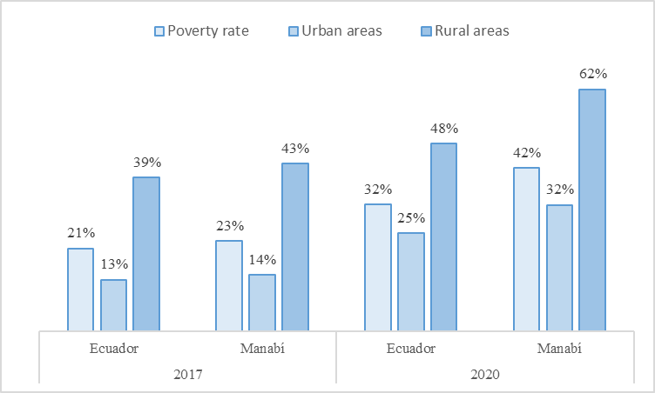

Figure 1. Relationship of poverty in Ecuador and the province of Manabí

To reinforce the strategy for energy diversification and sustainable development, the creation of a Geoportal for Sustainable Development is proposed, which is based on an open-access GIS and with the capacity to offer information on the potential of renewable sources of energy in the territories, as well as other relevant data and information related to the use of these sources.

The province of Manabí is among the territories of Ecuador that have the highest energy consumption per inhabitant. Figure 2 shows the relationship of electricity consumption in the province of Manabí with respect to the rest of the country's provinces.

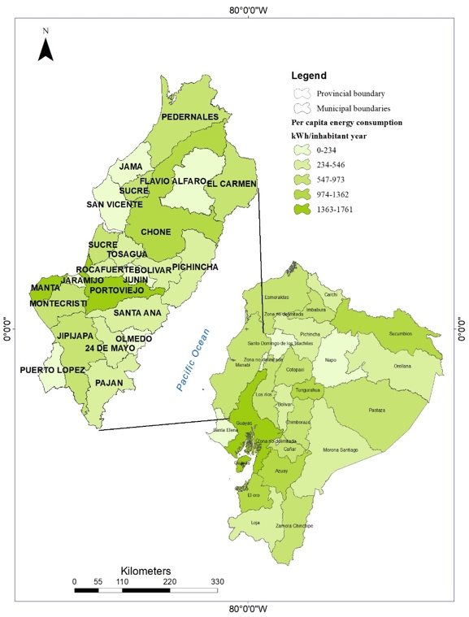

Figure 2. Relationship of electricity consumption in the province of Manabí and the rest of the country [2]

It can be seen that the province of Manabí is among the three provinces with the highest per capita electricity consumption nationwide. In Manabí, the highest consumption is concentrated in the municipalities of Portoviejo, which is the capital of the province, and Manta, which is a port city with an important industrial and administrative component.

Currently, 99.1% of electrical energy production in the province of Manabí is carried out through thermoelectric plants, and only 0.9% of this energy is generated in three photovoltaic plants that were installed at the initiative of the sector private as of 2015. In addition, in the study to achieve the repowering of the generation system of the province, the availability of renewable sources in the territory was not considered [17], [21].

* 1. **Solar Energy**

The geographical location of the province of Manabí is favorable to take advantage of solar energy. The values of the solar radiation index of the province of Manabí can be found in [11].

The province's average annual solar potential is 4601 kWh/m2, which allows generating on average the equivalent of 4009 kWh/kWp per day [22]. It must be taken into account that photovoltaic installations connected to the grid in the distributed generation mode are more efficient, mainly due to a significant reduction in losses and a higher quality in the delivery of electrical energy [23]. Autonomous photovoltaic plants are excellent for guaranteeing electricity service in rural areas that are distant from the electricity grid, as is the case in many areas of the municipality of Chone that still do not have electricity [24].

* 1. **Hydraulic energy**

At present, the potential of hydro energy that exists in the rivers and reservoirs located in the province of Manabí is not used [3], [12], therefore it constitutes an energy reserve that can be used to provide electricity service in rural areas [25], [26]. Table 1 shows the results of the study carried out in 11 rivers in the province where 220 points located near rural communities were analyzed.

Table 1. Flow Measurement in 11 Rivers in the Province of Manabí

|  |  |  |  |  |  |
| --- | --- | --- | --- | --- | --- |
| Rivers | Number of Houses | Electricity demand per dwelling (kW) | Average flow rate (m3/s) | | |
| Ayampe | 475 | 7.8 | 1.98 | | |
| Pajan | 2486 | 8.9 | 1.15 | | |
| Guineal | 890 | 5.2 | | 8.26 |
| Portoviejo | 1670 | 9.8 | | 15.62 |
| Carrizal | 2592 | 8.6 | | 0.22 |
| Chone | 156 | 5.4 | | 5.26 |
| De Oro | 745 | 7.1 | | 0.29 |
| Esperanza | 3003 | 6.2 | | 1.72 |
| Jama | 22 | 5.9 | | 16.01 |
| Convento | 2452 | 5.8 | | 1.80 |
| Coaque | 538 | 8.5 | | 0.46 |

Source: own elaboration based on [12]

The Jama River has the highest flow with 16.01 m3/s, followed by the Portoviejo River with 15.62 m3/s, the Guineal river with 8.26 m3/s, and the Chone river with 5.26 m3/s. In the communities studied there is an average of five people per house, with a demand of 5 kW per family, and the electricity service is evaluated as regular by the residents of the communities themselves.

* 1. **Energy sources derived from biomass use**

Another renewable source that is available in the province of Manabí is the one that comes from the management of biomass. The energy derived from this energy source has many advantages, among which are, it is not a polluting source, generates new jobs, integrates energy vulnerable communities, reduces the emission of greenhouse gases, converts waste into resources, among others [27-30].

The territory is characterized by being rich in different types of residuals from agro-productive and agro-industrial processes [30]. For example, the province of Manabí is the third in the cultivation of rice on a national scale, with a planted area of 14593 ha [28-31].

The energy density and the ease of management for the collection, treatment, and supply to the generating plant of the residuals from the rice harvest make it feasible to be used as an alternative for energy self-consumption of the industrial processing plants of this crop.

One of the energy alternatives that offer development prospects in the province of Manabí is obtaining biofuel. In several cantons, the Jatropha curcas plant is used to limit land and spaces [27]. Good energy quality biodiesel is extracted from the fruit of this plant. Currently, the harvested fruits are sold to the Galapagos Island where biodiesel is extracted to generate electricity [32].

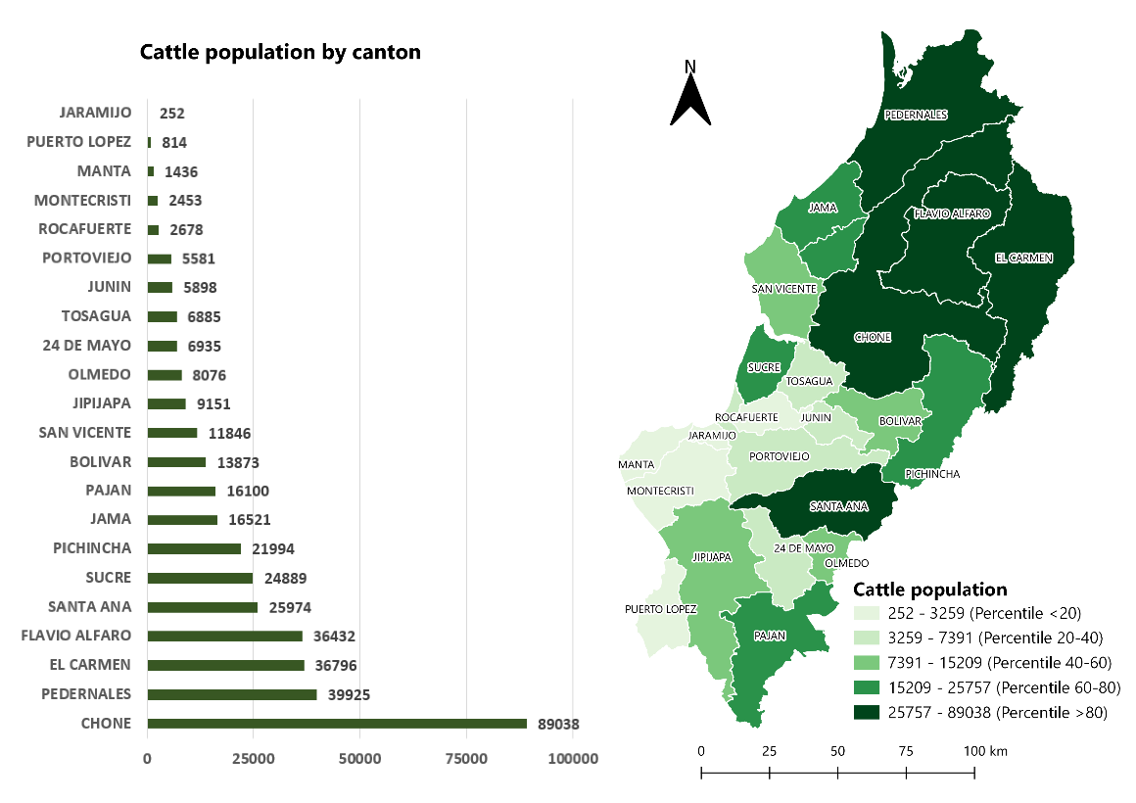Agricultural activity in the province of Manabí is the one that dedicates the largest area of land on a national scale, with 777088 ha for cultivated and natural pastures. Cattle lead the country's livestock sector with 921823 head of cattle, which represents 22.7% of the national total [33]. Figure 3 shows the number of cattle by municipalities, where it can be seen that Chone concentrates the largest agricultural activity in the territory.

Figure 3. Number of cattle per canton [30]

The residuals derived from the raising of cattle can be used in the production of biogas, but at present, this source of energy is not being used in the province [34].

1. **RESULTS AND DISCUSSIONS**

Currently, in the province of Manabí, the diversification of energy sources is limited, although the territory has sufficient endogenous energy resources, which can be used through power generation systems connected to the grid in the way of distributed generation [35-38], as well as isolated systems to achieve the electrification of rural areas.

The province of Manabí ranks among the territories with the highest level of poverty in Ecuador. Four out of ten citizens are in poverty and in rural areas six out of ten are poor. Harnessing RES can serve as a driving force to reduce poverty levels, especially in rural areas. For this, it is necessary to assume a local energy development strategy that is based on the use of the RES, on the decentralization of planning processes, on the allocation of resources, and on energy management. Figure 4 shows the conceptual scheme that is proposed to be assumed as part of the strategy for energy decentralization and sustainable local development.

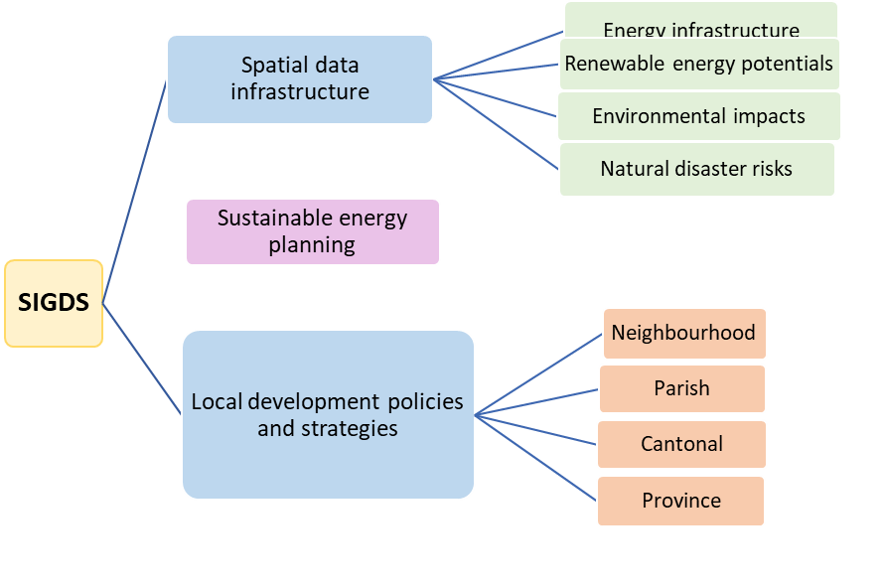

Figure 4. Conceptual outline of the strategy for energy decentralization and local development

The strategy for energy diversification and sustainable local development that is proposed to be applied to ensure the quality of the electricity supply seeks to ensure that local factors actively participate in the energy management of their territory. In addition, it is necessary to move towards the decentralization of energy planning processes to ensure that localities that have technological capabilities can take advantage of their resources.

Currently, the province of Manabí has 7 electricity generation plants, of which 3 correspond to photovoltaic installations connected to the grid, with an effective installed power of 1.52 MWp and 4 plants that operate based on consumption. of fossil fuel, with an effective power of 159.82 MW. In 2018, the province billed 1483.87 GWh of energy consumed, with system losses amounting to 22.81%, a value that is double the national average, which is 11.39%.

The Manavita territory has a territorial extension of 18940 km2. Considering that only 0.1% of this space is used to install photovoltaic solar systems, more than 2 GWh can be generated in a year, a figure higher than what is billed annually in the territory.

In the province of Manabí, there are no significant potential for hydropower, but in the territory, there are several rivers and reservoirs that can be used to provide electricity service to certain rural areas. From the study of the water potential offered by the rivers of the province, it can be determined that 147 communities are close to the Ayampe, Pajan, Guineal, Portoviejo, Chone, La Esperanza, Jama, and Convento rivers, where it is possible to install micro turbines with a power between 5 and 100 kW. In another 73 communities, which are located near the Carrizal, De Oro, and Coaque rivers, turbines with power between 4 and 5 kW can be installed. In general, the territory has equivalent water energy of 0.9 GWh per year, benefiting 75686 residents of rural areas.

The energy reserves of biomass are another source that presents real possibilities of use in the province of Manabí and that is not currently being used. Current paddy rice production can generate about 2980 tonnes of husk. From the study carried out on biomass, it can be determined that the energy potential in the territory amounts to 2.4 GWh.

Another important energy reserve in the province of Manabí is related to agricultural production. The province is home to 23% of the country's cattle. However, there is no reference to the introduction of biogas plants for energy and environmental purposes, which would guarantee the adequate treatment of agricultural waste.

1. **CONCLUSION**

The Ecuadorian legal framework and the political will of the State respond to the need to take advantage of endogenous energy resources to achieve the structuring of a diverse and sustainable energy matrix. Despite this, in the province of Manabí, it has not been achieved for different reasons, among which are the lack of knowledge about the availability and characterization of renewable energy sources in the territory by decision-makers.

Starting in 2016, studies related to the use of GIS and information and communication technologies begin to generate geospatial information on the local availability of RES, which allows promoting their proper use as part of a diverse energy matrix, distributed and sustainable.

The investigation allows revealing the potential and the geographic location of the renewable sources of energy that the province of Manabí possesses. In addition, the study shows that it is necessary to achieve the active participation of decision-makers in the region to achieve the introduction of these technologies in a relatively short time. With this, not only would new jobs be generated, but it would also reduce the cost of energy, increase the environmental role of the territory and contribute to the reduction of environmental impacts associated with energy activity.

The results of the research allow us to verify that in the province of Manabí there is the availability of various FREs such as solar, water, and biomass, with sufficient capacity to reduce dependence on electricity supply from the SIN and thus structure a territorial, diverse and energy matrix sustainable.

**REFERENCES**

1. M. A. Ponce-Jara, M. Castro, M. R. Pelaez-Samaniego, J. L. Espinoza-Abad, and E. Ruiz, “Electricity sector in Ecuador: An overview of the 2007–2017 decade,” *Energy Policy*, vol. 113, pp. 513-522, 2017.
2. A. D. Ramirez, A. Boero, B. Rivela, A. M. Melendres, S. Espinoza, and D. A. Salas, “Life cycle methods to analyze the environmental sustainability of electricity generation in Ecuador: Is decarbonization the right path?,” *Renewable and Sustainable Energy Reviews*, vol. 134, no. 5, pp. 110373, 2020.
3. S. Vaca-Jiménez, P.W. Gerbens-Leenes, and S. Nonhebel, “Water-electricity nexus in Ecuador: The dynamics of the electricity's blue water footprint,” *Science of the Total Environment*, vol. 696, pp. 133959, 2019.
4. P. L. Castro Verdezoto, J. A. Vidoza, W. L. R. Gallo, “Analysis and projection of energy consumption in Ecuador: Energy efficiency policies in the transportation sector,” *Energy Policy*, vol. 134, pp. 110948, 2019.
5. M. R. Peláez-Samaniego, M. Garcia-Perez, L. A. B. Cortez, J. Oscullo, and G. Olmedo, “Energy sector in Ecuador: Current status,” *Energy Policy*, vol. 35, no. 8, pp. 4177-4189, 2007.
6. M. A. Ponce-Jara, E. Ruiz, R. Gil, E. Sancristóbal, C. Pérez-Molina, and M. Castro, “Smart Grid: Assessment of the past and present in developed and developing countries,” *Energy Strategy Reviews*, vol. 18, pp. 38-52, 2017.
7. W. Saltos, M. Rodríguez, A. Vázquez, G. Loor, and L. Cuenca, “The Future of Micro-Grids in Ecuador,” *International Journal of Physical Sciences and Engineering,* vol. 1, no 3, pp. 1-8, 2017.
8. D. Icaza, D. Borge-Diez, and S. Pulla Galind, “Proposal of 100% renewable energy production for the City of Cuenca- Ecuador by 2050,” *Renewable Energy*, vol. 170, pp. 1324-1341, 2021.
9. S. C. Shekar, G. R. Kumar, and S. V. N. L. Lalitha, “A transient current based micro-grid connected power system protection scheme using wavelet approach”, *International Journal of Electrical and Computer Engineering (IJECE)*, vol. 9, no. 1, p. 14, 2019.
10. J. R. Núñez, *et al*., “Methodology of fault diagnosis for grid-connected photovoltaic systems of network connection”, *Revista Iberoamericana de Automática e Informática industrial*, vol. 17, no. 1, pp. 94, 2020.
11. NASA Database. Available in https://power.larc.nasa.gov/docs/services/arcgis/climatology/
12. J. L. Vera Chichanda and F. J. Moreira Miranda, “Study of the water potential of the Portoviejo River and its impact on energy distribution systems,” M. S. thesis, M. S. thesis. Math, Faculty of Mathematical, Physical and Chemical Sciences, Universidad Técnica de Manabí, Portoviejo, Ecuador, 2017.
13. Constitucion de la República del Ecuador 2008, Quito, 2008. Avaible in https://www.oas.org/juridico/pdfs/mesicic4_ecu_const.pdf
14. M*.* P*.* Vela, “Plan Maestro de Electrificación 2010-2020*.* Promesas cargadas de energía y opciones de crecer,” *Revista Gestión,* vol. 24, pp. 30-38, 2016.
15. SENPLADES, “Plan Nacional de Desarrollo Para el Buen Vivir 2017-2021,” Consejo Nacional de Planificación (CNP). Secretaría Nacional de Planificación y Desarrollo, 2017. Available in https://www.gobiernoelectronico.gob.ec/wp-content/uploads/downloads/2017/09/Plan-Nacional-para-el-Buen-Vivir-2017-2021.pdf
16. SENPLADES, “Plan Nacional de Desarrollo Para el Buen Vivir 2013-2017,” Consejo Nacional de Planificación (CNP). Secretaría Nacional de Planificación y Desarrollo, 2013. Available in <http://www.cpccs.gob.ec/wp-content/uploads/2015/12/PNBV-2013-2017.pdf>
17. E. Mendoza Merchán *et al*., “An Analysis of Electricity Generation with Renewable Resources in Germany,” *International Journal of Energy Economics and Policy*, vol. 10, no. 5, pp. 361-367, 2020.
18. J. Cevallos-Sierra and J. Ramos-Martin,“Spatial assessment of the potential of renewable energy: The case of Ecuador,” *Renewable and Sustainable Energy Reviews*,vol. 81, no. 1, pp. 1154-1165, 2018.
19. J. J. Alava and A. Guevara, “A critical narrative of Ecuador’s preparedness and response to the COVID-19 pandemic,” *Public Health in Practice*, vol. 2, pp. 100127, 2021.
20. H. Cevallos-Valdiviezo, *et al.*, “Measuring the impact of the COVID-19 outbreak in Ecuador using preliminary estimates of excess mortality,” *International Journal of Infectious Diseases*, vol. 104, pp. 297-299, 2021.
21. P. Arévalo, A. Cano, and F. Jurado, “Comparative study of two new energy control systems based on PEMFC for a hybrid tramway in Ecuador,” *International Journal of Hydrogen Energy*, vol. 45, no. 46, pp. 25357-25377, 2020.
22. G. Albarracin, “Urban form and ecological footprint: A morphological analysis for harnessing solar energy in the suburbs of Cuenca, Ecuador,” Energy Procedia, vol. 115, pp. 332-343, 2017.
23. F. A. Barrozo Budes, *et al*., “Energy, Economic, and Environmental Evaluation of a Proposed Solar-Wind Power On-grid System Using HOMER Pro®: A Case Study in Colombia”, *Energies*, vol. 13, no. 7, p. 1662, 2020.
24. M. T*.* Palomares *and* A*.* Boni Aristizabal*, “*Off-grid electrification visions in the Ecuadorian Amazon: challenging hegemonic logics,” *Letras Verdes. Revista Latinoamericana de Estudios Socioambientales*, no. 20, pp. 4, 2016.
25. G. Defermos *et al*., “Buen Conocer – FLOK Society. Modelos sostenibles y políticas públicas para una economía social del conocimiento común y abierto en el Ecuador,” Book, Chapter: 2.4. Publisher: IAEN – CIESPAL. 2015.
26. C. Quinaluisa, K. Peralta, A. Solano, A. Gallo, A. Villalva, and F. Zambrano, “Energía hídrica en el Ecuador,” *Revista Ciencia Digital,* vol. 3, no. 26, pp. 219-237, 2019.
27. M. A. Heredia Salgado, *et al*., “Energetic valorization of the residual biomass produced during Jatropha curcas oil extraction,” *Renewable Energy*, vol. 146, pp. 1640-1648, 2020.
28. L. Tipanluisa, A. Barriga, and J. Guasumba, “Valoración energética de la cascarilla de arroz utilizando un sistema térmico con capacidad de 60000 kcal/h,” *1st International Congress. Sustainable Investment and Renewable Energy* *(ISEREE)*, Quito, Ecuador, pp. 1-8, 2013.
29. D. Marin, *et. al*., “Household survey data of adoption of improved varieties and management practices in rice production, Ecuador,” *Data in Brief*, vol. 18, pp. 1252-1256, 2018. <https://doi.org/10.1016/j.dib.2018.04.019>.
30. C. Vega-Quezada, M. Blanco, and H. Romero, “Synergies between agriculture and bioenergy in Latin American countries: A circular economy strategy for bioenergy production in Ecuador,” *New Biotechnology*, vol. 39, Part A, pp. 81-89, 2017
31. Ministry of Public Health, “Projection of the 2007 population by provinces, cantons and parishes according to program groups,” Monography in Spanish, Quito; OPS; UNFPA; UNICEF; pp. 98, 2007.
32. C. Cornejo and A. C. Wilkie, “Greenhouse gas emissions and biogas potential from livestock in Ecuador,” *Energy for Sustainable Development*, vol. 14, no. 4, pp. 256-266, 2010. https://doi.org/10.1016/j.esd.2010.09.008.
33. A. D. J. Montilla Pacheco and H. A. Pacheco Gil, “Comportamiento temporal y espacial del Bosque Ribereño en el curso bajo del Río Portoviejo y la Quebrada Chilán, Provincia de Manabí, Ecuador”, *Revista Internacional de Contaminación Ambiental*, vol. 33, no. 1, pp. 21–35, 2017.
34. I. Vera, J. Martinez, M. Estrada, and A. Ortiz, “Potencial de generación de biogás y energía eléctrica Parte I: excretas de ganado bovino y porcino,” *Ingeniería, Investigación y Tecnología,* vol. 15, no. 3, pp. 429-436, 2014.
35. G. R. Prudhvi Kumar, D. Sattianadan, and K. Vijayakumar, “A survey on power management strategies of hybrid energy systems in microgrid”, *International Journal of Electrical and Computer Engineering (IJECE)*, vol. 10, no. 2, pp. 1667, 2020.
36. C. Milanés-Batista, *et al*., “Application of Business Intelligence in studies management of Hazard, Vulnerability and Risk in Cuba,” *IOP Conf. Ser.: Mater. Sci. Eng*., vol. 844, pp. 012033. 2020.
37. J. R. Nuñez, *et al*., “Design of a Fuzzy Controller for a Hybrid Generation System,” *IOP Conf. Ser.: Mater. Sci. Eng*., vol. 844, pp. 012017. 2020.
38. J. R. Nuñez-Alvarez, *et al*., “Communications in Flexible Supervisor for Laboratory Research in Renewable Energy,” *IOP Conf. Ser.: Mater. Sci. Eng*., vol. 844, pp. 012016. 2020.

**BIOGRAPHIES OF AUTHORS**

|  |  |
| --- | --- |
|  | **María Rodríguez Gámez,** Electrical Engineering career**,** Universidad Técnica de Manabí, Portoviejo, Ecuador**,** born in Baracoa, Cuba, el 27 de may de 1957, Professor and Senior Researcher., Lic. Education, Specialty: Physics and Astronomy, at the Higher Pedagogical Institute “Frank País García", Santiago de Cuba, Cuba, 1981; Master’s in planning and Territorial Development (Strategic Planning Renewable energy sources). Universidad Internacional de Andalucía: La Rábida, Sevilla España, PhD. Strategies and territorial planning in Renewable Energy Sources, Universidad Pablo de Olavide, Sevilla España, 2011, also PhD in Geography, Cuba. |
|  |  |
|  | **Antonio Vázquez Pérez**, Career in the Industrial Engineering Technical University of Manabí, Portoviejo, Ecuador, was born in Santiago de Cuba, Cuba on June 5, 1955, Professor and Researcher. Degree in Law from the Universidad de Oriente, Santiago de Cuba, Cuba, International master’s in environmental training, from the International Institute of Environmental Training, Valladolid, Spain, is currently finishing his doctoral studies at the Universidad de Alicante, España in Philosophy and letters. MSc. Vazquez is a member of the Cubasolar organization, a member of the Legal Group of the World Wind Energy Organization. |
|  |  |
|  | **Mirelys Torres Pérez**, graduated in Computer Science Engineering in 2010 from the University of Computer Sciences (UCI) in Havana, Cuba. In 2018 she defends her master's thesis in Applied Informatics at the University of Las Tunas, in Las Tunas, Cuba). She is currently doing a doctorate in computer science from the University of Informatics Sciences (UCI) of Havana. She is a professor of the computer engineering degree at the University of Las Tunas, Cuba, and holds the teaching category of assistant. |
|  |  |
|  | **José Ricardo Núñez** **Álvarez** was born in Holguín, Cuba, in 1971. From 1994 to 2018, he worked as a professor at the Universidad de Oriente in Santiago de Cuba, Cuba. That same year he began working as a Full-Time Professor at the Department of Energy at the Universidad de la Costa, Barranquilla, Colombia. He obtained the title of Electrical Engineer in 1994. Master of Science in Electrical Engineering in 2003 and Master of Science in Automation in 2014. His areas of interest are Industrial Automation Systems, Electric Power Generation, Transmission and Distribution, Domotic and Real Estate Systems. Prof. Nuñez-Alvarez has been a member of the IEEE since 2018. |