**Best strategy to control of data on robotic of things in heterogeneous networks**

**Wisam Mahmood Lafta1, Ahmed** **A. Alkadhmawee 2, Mohammed A.Altaha3**

1Department of Computer Science, Universitiy of Technology, Iraq

2College of Education for Human Sciences, Universitiy of Basrah, Iraq

3 College of Veterinary, Universitiy of Basrah, Iraq

|  |  |  |
| --- | --- | --- |
| **Article Info** |  | **ABSTRACT** |
| ***Article history:***  Received Sep 9, 2019  Revised May 20, 2020  Accepted Jun 11, 2020 |  | The Control and transmission of huge data constitutes a big challenge in various types of networks (wired and wireless). Current research is giving high attention to the attractive rise of the advanced usage of Internet of Things technology (IoT) by expanding the potential of robotics and the consequences of the problems. Despite the best path to avoid congestion with low traffics and good throughput, they still major problems, the new influencing developments in different application domains, to deal with a complex challenge in a heterogeneous platform in addition to the process of transferring and controlling that data bidirectional from the source to the destination. Discussing the parameters of the ad-hoc On-Demand Distance Vector (AODV) and the Routing Information Protocol (RIP) are protocols applied on wireless networks, which can reduce the bad factors through the use of enhanced and effective best routing protocols.   These protocols are used to solve a specific problems despite to the rest of the factors and the diversity of networks (heterogeneous network) as the infrastructure robotic of things (ROT) and Internet of Things (IOT) is heterogeneous network. To get rid of the issues that appear compelled towards finding a better solution, as a new strategy, by activating RIP protocol on a router or gateway in wire network paralleling with activating the AODV protocol on the wireless network to create the best improvement.of heterogeneous network Hence it provides a better quality of service (QoS) call Routing Information and Distance vector (RIDV) strategy based on OPNET simulation. |
| ***Keywords:***  Internet Of Things  Robotic Of Things  On-Demand Distance Vector  Routing Information Protocol  OPNET |
| *Copyright © 2020 Institute of Advanced Engineering and Science.  All rights reserved.* |
| ***Corresponding Author:***  Wisam Mahmood Lafta,  Department of Computer science,  Universitiy of Technology, Iraq  Email: 10861@uotechnology.edu.iq | | |

**1. INTRODUCTION**

The number of smart devices and robots machine is increasing rapidly[1,2], controlling the the influence of the new developments in various application fields becomes necessary because of the revolution of technology. [2,3], IoT and robotics applications ROTare steadily expected to grow upon networks as a large area of human life has become connected to the Internet based on the urgent need with the technology revolution[3,4], The Definition of the internet is a collection of wired and wireless networks that are Heterogeneous networks [5, 6]. The development of Heterogeneous networks has become a crucial issue nowadays. Most of the studies in this field have been conducted on the the traditional way of studying and developing work on one type of network ignoring its application to different networks. The rapid growth of mixed networks, which have been given a huge attention in the current research because of their widespread in various fields [7,8 ]show in figure 1, leads us towards a real interest in updating and establishing new dealing methods to improve the heterogeneously networks,[9]. Transmission Control Protocol (TCP) standard with wire networks and User Datagram Protocol (UDP) protocol is designed to be utilized with wireless networks [10, 11].   This study applies the new method by selecting a Convenient strategy by using TCP and UDP as standards protocols  compatible with the properties of the data transmitted to make the network organized and harmonic with the packaging type (mp3 .sound .video .ftp) to solve the problems and avoid the congestion that appear with the main parameters. The robotic of things is considered as one of the most important and complex applications as it contains large amounts of data [4]. Therefore, resolving the crisis of big data transfer easies the process of making simple data for other similar applications. However, the concept of the Internet of Robotic Things is Compatible with the same requirements of Heterogeneous networks and protocols of technical in IEEE 802.11 MAC and 802.16 MAC (WiMAX) [p3].

The popular protocols, RIP and AODV, are mostly used separately and review best results if they're applied to wireless networks [12,13], Activating the positive properties of algorithms by reprogramming and tuning generates anew algorithm with a new work mechanisms to select the best performance that makes its process unrestricted by obtaining new strategies that facilitate the process of this communication, which is represented by the RIVD algorithm .

This paper reviews a topic of the identification of heterogeneous network elements as IOT and ROT , Which is one of the most important applications in different fieleds in the current timuse In unconventional methods by applying traditional protocols RIP and AODV in a way that makes communications more effective and highlighting the vital and appropriate aspects to avoid congestion .

 The Section2 explain the features of The Distance Vector Routing Algorithm (DVRA) with demonstrates the dynamic properties of the best protocols RIP and AODV .while the .Section3 focuse on of the stepes of RIVD algorithm and its work mechanisms to choose the only performance makes its work unrestricted by obtaining new strategies that facilitate the work of this Type of communication and how generation the new strategy.Section4 impelemaotion and dicuss the result of new strategy with very important parameters. Section 5 concludes with an explanation the scalable networks through the results obtained.

Figure 1. IOT and ROT

**2. SYSTEM MODEL**

**2.1 The Distance Vector Routing Algorithm (DVRA)**

One of the significant features that enhance the effectiveness of the DVRA is making the network highly reliable according to what is recorded within the priority table by transferring the packet from the main nod to the target accurately and safely [14]. The subsequent hope (router device) should be determined in the table of priorities [15]. The RIP and AODV protocols are the most important interference and control in the DVRA[16]. These two protocols are supported in most campus LAN networks[17]. The RIP protocol is a standard protocol used in routing protocol in small to medium TCP/IP networks to apply a distance-vector algorithm. The metric routing is a variable determined to routers as a mean of ranking them from the most preferred to the least preferred. Different routing protocols have different metrics[18,19]. When there is more than one route between two or more nodes, a router must select a method to calculate the shortest path of a metrics routing protocol which can be classified of the RIP protocol. To choose the best path when there is a real-time logical network layout change.

I.RIP Version1 uses broadcast UDP data packets based on A statistic routing, [20]. Which has no authentication to support.

II. RIP Version 2 is a dynamic routing uses multicast packets to exchange the routing information with supports authentication.

In the current study. We will discuss the RIP Version2. This feature belongs to the dynamic routing protocol to reduce the network traffic that fits with the characteristics of AOVD [20,21].

The software of RIP sends routing information updates every 30 seconds to create a routing table. A device that is running RIP can receive a default network via an update from another device that is running RIP, or the main device using the DVRP protocol. In both ways, the default network is advertised between at least two devices using DVRP protocol.

**2.2 Dynamic routing protocol (DRP)**

The dynamic algorithm is based on the counting of all possible paths that link with the source to the target[ ], the Table routers information for the entire network is updated by supported information from its immediate neighbors[22 ], then the router shares its information with all network nodes and Exchange information between neighbors’ nods at regular intervals[23 ]. The One of the foremost prominent is reactive routing protocol AODV is the clearest application.

On DVRP that deal with wireless communication for mobile ad-hoc networking, the message types defined by AODV with HELLO message to check the active path. If the rout failed, all this procedure is organized by the knowledge table to select the path that is updated periodically to urge obviate congested or failed paths. The first request is Route Requests (RREQs) then wait to answer the second request which is Route Replies (RREPs) show in figure 1, if the link is interrupted or broken the answer will be Route Errors (RERRs), This dynamic protocol interacts with the wireless network environment (mobile nods) to confirm information from interactive commands and by investing during a positive aspect to connect it with another dynamic environment represented by a wired network environment (routers)[24].

To route findings during this protocol, is to select the pathway by a route discovery cycle involving a broadcast or multicast if possible in network to select corroborative a unicast response containing discovered paths[25]. The nodes in AODV keep a routing table and should maintain it by an update during next-hop routing information for destination nodes.

Every routing table is supported with relabeling paths features linked to value, if a route isn't used throughout the life cycle[26].

AODV protocol uses hello messages to increase the reliability of obtainable paths which are period local broadcasts from a node to inform all nearby mobile nodes in wireless network and may even be used to update the local network to avoid connectivity issues of the node [24, 27].

However, to guarantee that the subsequent hop remains active or life the required to use hello messages techniques to avoid losing the linked this operation is very important to check If the retransmission is interrupted or fails to deliver a notification[1,28] .

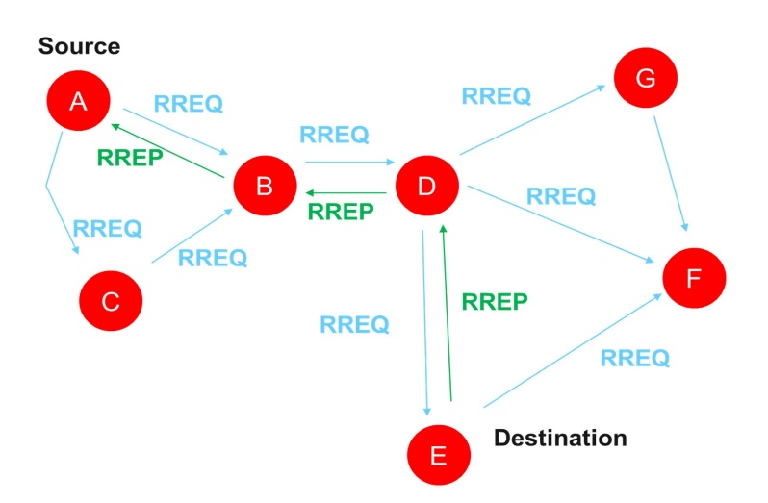

Figure 2. Dynamic performance RREQs and RREPs

**3. PROPOSED MODEL OF RIDV STRATEGY**

The RIDV can also be standing by strategy generation from two algorithms to formulate a novel algorithm, to support the positive side and neglect or disable the negative aspects of the previous algorithms to form an efficient algorithm with a proposed name which is RIDV.

TheNetworks are treated equally (wire and wireless networks), within the primary hop count networks a packet crosses and Route Discovery with Route Maintenance show in figure 4.

The RIDV algorithm can be explained through many steps:

Step1- The first nod (Source node broadcast RREQ AODV request)

Step2- If node is a router (gateway), then perform the procedure of (RIPv2) wired network mode

Step3- else forward the RE-RREQ

Step4- response a wireless network RREQs (Receive a message within the new inform from route table management)

Step5- Update table by refreshing the old table by adding one hop for each advertised. (The information within the routing table is brief inclusive new hop information, inclusive but not limited the every linked to a destination node).

Step6- Choose the only route that supported the updated information from the network.

Step7- The previous steps are often repeated until the target is reached.

Step8- If (destination not within the routing table), advertised information will be added to the table.

Step9- If not: If (next-hop is that the same), replace with the other one.

Step10- If not: If (available hop count < one within the table), then it replaces all nodes within the routing table by maintenance.

Step11- Return the result by sending the unified paths table for two protocols, instead of two different paths tables because of the same path map algorithm implementation (DVR with DRP).

.

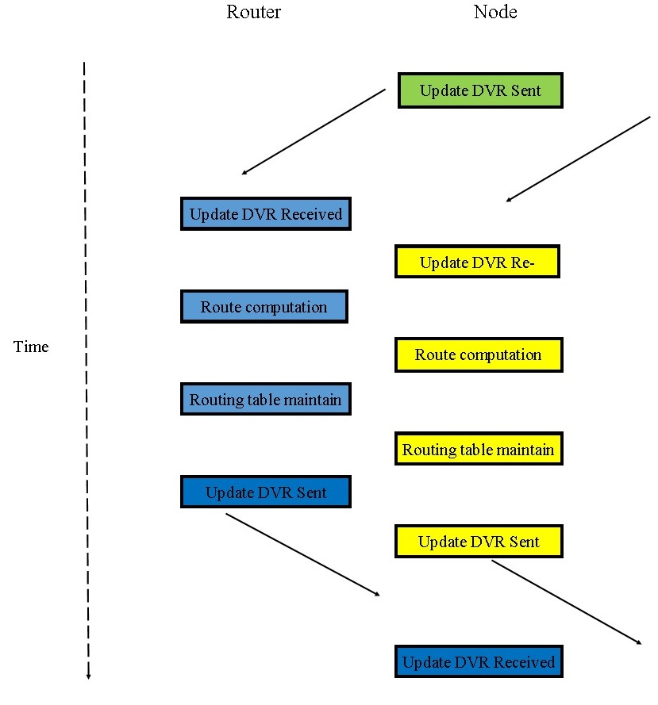

Figure 3. Route Maintenance with Time

**4. IMPLEMENTATION AND RESULT**

Within the aforementioned algorithm, the RIP and AODV protocols’ tables were abbreviated in one table if these protocols were activated together. By doing so, they will end with a diminishing in time and energy, and reduce the congestion and collision that result in the passage of knowledge from the source to the target using the available dynamic property. The results appear within the factors applied within the heterogeneous network as follow.

Table 1. The elements of network .

|  |  |  |
| --- | --- | --- |
| Environment | Details | type |
| Mobile nodes | 16 | source & destination |
| router | 2 | wire |
| Access point | 2 | Wire& wireless |
| Maximum Packet in Queue | 50 packets | size |
| Network interface type | heterogeneous network |  |
| Topographical Area | 2000X 1500 | sq.m |
| Routing protocol | RIP&AODV | RIDV |
| Number of scenario | 3 | With the same conditions |
| Simulation time | 20 | Mints |
| Packet Size | 260 | MB |
| Simulator | OPNET | 14.5 |

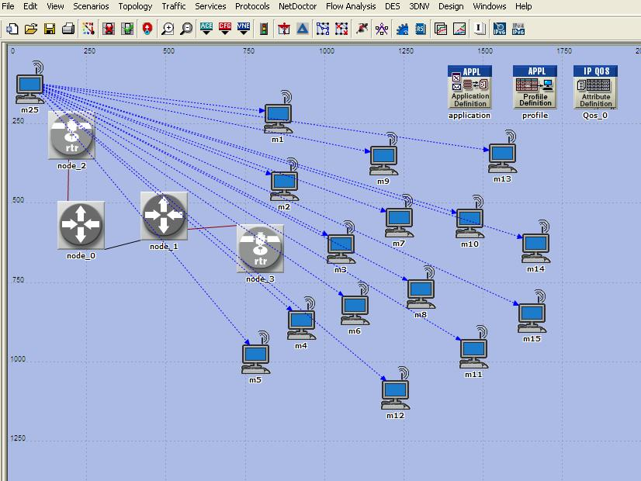Figure 4 explains the heterogeneous network represented by source node m25. It is a controller device (mobile) to send different instruction to other nodes from m1 to m15, these nodes maybe (robot or smart mobiles nodes) connected with access point (node 3 ,node 2) through two routers in OPNET. Simulator is used to perform and analyze different routing protocols such as RIPv2 and RIPv1 with AODV to generate a new RIVD strategy by applying 15 constant nodes, also by having three different scenarios in area of 2000m*1500m

Figure 4. Heterogeneous Network

To comber the results between the first scenario, the RIPv2 protocol is activated only in routers and second scenario without t activating any protocols (RIPv1 default protocol in router) with the proposed new RIVD strategy to measure the different factors.

**4.1 Data drop in LAN**

Notes from figure 5, the RIDV (blue line) equal zero comparing with other scenarios that did not lose any packets through the process by time average. As an innovative result from the new proposed strategy that led to the disposal of the loss data.

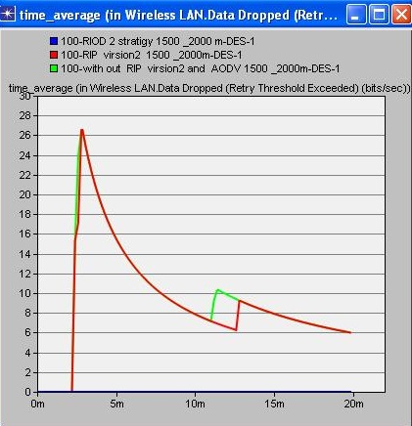

Figure 5. Data drop in LAN

**4.2 The in Traffic Drop IP**

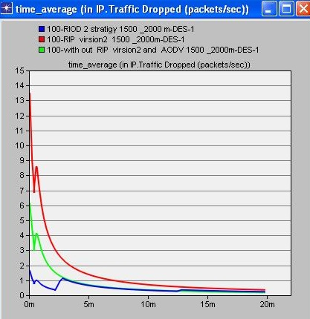 Figure 6 clearly shows that the RIDV strategy curves to its lowest one. The focus on the blue curves with other curves means its best result as the packets’/sec less loss achieved in RIDV strategy in the properties of IP traffic. By achieving this factor, the network becomes far from congestion.

Figure 6. The in Traffic Drop IP

**4.3 Queue Delay**

Queue is very important parameter in measuring the delay in any network and the pointer of congestion. Moreover, to achieve the speed of network depending on the lowest delay and stability of network. Figure 7 shows the blue line is the best one to determine the speed and slowness of communication by measuring the accumulated load on point to point in the queue

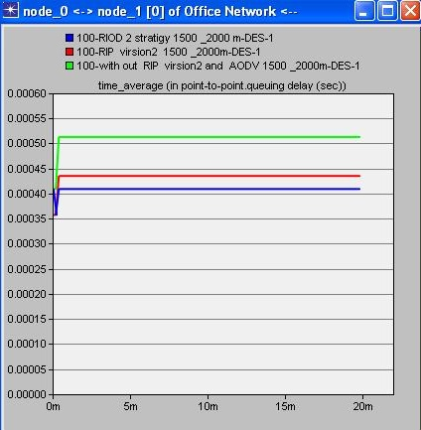

Figure 7. Queue Delay

**4.4 Throughput in Wireless LAN**

The second best pointer in network is the throughput. Figure 8 shows the blue line is the highest one comparing with others. This means that the processes work with excellent output. The Increased network productivity indicates its strength and effectiveness, especially with wireless networks, as it is more vulnerable to noise

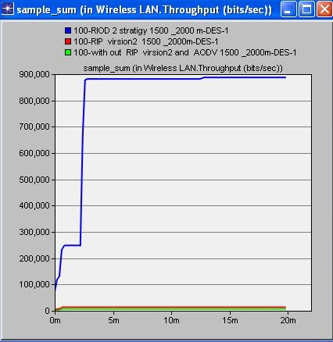

Figure 8Throughput in Wireless LAN

**5. CONCLUSION**

The Scalability router (gateway) with wire network to build an excellent network, there is a need for diligence by network designers and methods or strategies by selecting the only solutions to understand the high performance and meet the requirements of good network as it may be a crucial element in building a discreet network. It is noticeable that the configuration required by RIDV strategy is better than the RIPv2and RIPv1.This is because the AODV protocol has well interaction with the RIPv2 protocol due to the similar properties like dynamics and the updated path table that enable the heterogeneous network to interact with its surroundings by controlling and transmitting information towards its targets such as smart devices or robots in an excellent way. It means that unified paths table for two protocols, instead of two different paths because of the implementation of same path map algorithm.

**REFERENCES**

1. Q. Zhu, T. Xu, H. Zhou, C. Yang, and T. Li, “A mobile ad hoc networks algorithm improved AODV protocol,” Procedia Eng., vol. 23, pp. 229–234, 2011, doi: 10.1016/j.proeng.2011.11.2494.
2. H. H. Qasim, A. E. Hamza, L. Audah, H. H. Ibrahim, H. A. Saeed, and M. I. Hamzah, “Design and implementation home security system and monitoring by using wireless sensor networks WSN / internet of things IoT,” vol. 10, no. 3, pp. 2617–2624, 2020, doi: 10.11591/ijece.v10i3.pp2617-2624.
3. K. Xu, Y. Qu, and K. Yang, “A tutorial on the internet of things: From a heterogeneous network integration perspective,” IEEE Netw., vol. 30, no. 2, pp. 102–108, 2016, doi: 10.1109/MNET.2016.7437031.
4. P. Sethi and S. R. Sarangi, “Internet of Things: Architectures, Protocols, and Applications,” J. Electr. Comput. Eng., vol. 2017, 2017, doi: 10.1155/2017/9324035.
5. W. Mahmood, S. Q. D. Jasim, and G. Ma ,“Performance evaluation of heterogeneous network based on RED and WRED,” Indones. J. Electr. Eng. Comput. Sci., vol. 3, no. 3, pp. 540–545, 2016, doi: 10.11591/ijeecs.v3.i2.pp540-545.
6. B.Sreedevi, Y. Venkataramani, and T. R. Sivaramakrishnan, “Implementation of Zone Routing Protocol for Heterogeneous Hybrid Cluster Routing to Support QoS in Mobile Ad hoc Networks,” Int. J. Comput. Appl., vol. 25, no. 10, pp. 1–6, 2011, doi: 10.5120/3152-4358.
7. S. G. Fernandez et al., “Unmanned and autonomous ground vehicle,” vol. 9, no. 5, pp. 4466–4472, 2019, doi: 10.11591/ijece.v9i5.pp4466-4472.
8. S. Patil and A. M. Bhavikatti, “Heterogeneous network optimization using robust power-and-resource based algorithm,” vol. 9, no. 5, pp. 4226–4237, 2019, doi: 10.11591/ijece.v9i5.pp4226-4237.
9. E. Tragos, M. Serrano, and S. Chessa, Internet of Robotic Things – Converging Sensing/Actuating, Hyperconnectivity, Artificial Intelligence and IoT Platforms, no. June. 2017.
10. K. Pandey and A. Swaroop, “A Comprehensive Performance Analysis of Proactive, Reactive and Hybrid MANETs Routing Protocols,” Int. J. Comput. Sci. Issues, vol. 8, no. 6, pp. 432–441, 2011.
11. W. Mahmood, S. Q. D. Jasim, and G. Ma, “OLWRED: Best Selected Strategy for Data Transmission in Heterogeneous Networks,” Int. J. Comput. Appl., vol. 152, no. 4, pp. 11–15, 2016, doi: 10.5120/ijca2016911781.
12. B. S. Kang, H. S. Kim, and I. Y. Ko, “AODV-RIP: Improved security in mobile ad hoc networks through route investigation procedure,” Concurr. Comput. Pract. Exp., vol. 22, no. 7, pp. 816–830, 2010, doi: 10.1002/cpe.1554.
13. A. Obaid, G. M. T. Abdalla, and P. S. M. Sharif, “Performance of AODV and RIP in Wireless Sensors Networks,” no. June, 2017.
14. J. Govindasamy and S. Punniakody, “A comparative study of reactive, proactive and hybrid routing protocol in wireless sensor network under wormhole attack,” J. Electr. Syst. Inf. Technol., vol. 5, no. 3, pp. 735–744, Dec. 2018, doi: 10.1016/j.jesit.2017.02.002.
15. A. Dhaka, A. Nandal, and R. S. Dhaka, “Gray and Black Hole Attack Identification Using Control Packets in MANETs,” Procedia Comput. Sci., vol. 54, pp. 83–91, 2015, doi: 10.1016/j.procs.2015.06.010.
16. R. van Glabbeek, P. Höfner, M. Portmann, and W. L. Tan, “Modelling and verifying the AODV routing protocol,” Distrib. Comput. vol. 29, no. 4, pp. 279–315, 2016, doi: 10.1007/s00446-015-0262-7.
17. Z. S. Mahmood, A. H. A. Hashem, S. A. Hameed, F. Anwar, and W. H. Hasan, “The Directional Hierarchical AODV (DH-AODV) routing protocol for wireless mesh networks,” Proc. - 2015 Int. Conf. Comput. Control. Networking, Electron. Embed.Syst. Eng. ICCNEEE 2015, pp. 224–229, 2016, doi: 10.1109/ICCNEEE.2015.7381367.
18. A. Syarif, H. Simaremare, S. C. Haryanti, and R. F. Sari, “Adding gateway mode for R-AODV routing protocol in hybrid ad hoc network,” IEEE Reg. 10 Annu. Int. Conf. Proceedings/TENCON, pp. 169–173, 2011, doi: 10.1109/TENCON.2011.6129085.
19. D. Bandral and R. Aggarwal, “Comparative Analysis of Proactive, Reactive and Hybrid Routing Protocols for Improving Quality of Service in Mobile Ad-Hoc Networks,” Int. J. Eng. Trends Technol., vol. 30, no. 4, pp. 192–196, 2015, doi: 10.14445/22315381/ijett-v30p237.
20. S. G. Thorenoor, “Dynamic routing protocol implementation decision between EIGRP, OSPF and RIP based on technical background using OPNET modeler,” 2nd Int. Conf. Comput. Netw. Technol. ICCNT 2010, pp. 191–195, 2010, doi: 10.1109/ICCNT.2010.66.
21. A. A. Susom, “Effectiveness of routing protocols for different networking scenarios,” Adv. Sci. Technol. Eng. Syst., vol. 3, no. 4, pp. 112–121, 2018, doi: 10.25046/aj030412.
22. S. G. Thorenoor, “Dynamic routing protocol implementation decision between EIGRP, OSPF and RIP based on technical background using OPNET modeler,” 2nd Int. Conf. Comput. Netw. Technol. ICCNT 2010, pp. 191–195, 2010, doi: 10.1109/ICCNT.2010.66.
23. A. A. Susom, “Effectiveness of routing protocols for different networking scenarios,” Adv. Sci. Technol. Eng. Syst., vol. 3, no. 4, pp. 112–121, 2018, doi: 10.25046/aj030412.
24. H. Kaur, V. Sahni, and M. Bala, “A Survey of Reactive, Proactive and Hybrid Routing Protocols in MANET: A Review,” Network, vol. 4, no. 3, pp. 498–500, 2013.
25. K. Chawla and K. Vats, “Different QoS Based Simulation Evaluation of TORA and GRP Routing Protocol Based on Frequency Hopping,” vol. 3, no. 11, pp. 523–531, 2014.
26. D. Gupta and R. K. Gujral, “Simulation of Different Routing Protocols in MANET Using NS2,” Int. J. Sci. Res. Publ., vol. 4, no. 8, pp. 1–5, 2014.
27. S. Han, X. Zhu, A. K. Mok, M. Nixon, T. Blevins, and D. Chen, “Control over WirelessHART network,” IECON Proc. (Industrial Electron. Conf., no. September 2014, pp. 2114–2119, 2010, doi: 10.1109/IECON.2010.5675278.
28. R. Fotohi, S. Jamali, and F. Sarkohaki, “Performance Evaluation of AODV, LHC-AODV, OLSR, UL-OLSR, DSDV Routing Protocols,” Int. J. Inf. Technol. Comput. Sci., vol. 5, no. 10, pp. 21–29, 2013, doi: 10.5815/ijitcs.2013.10.03.