# Energy Audit and Analysis of an institutional building under Subtropical climate

Ali M Baniyounes1 and Yazeed Yasin Ghadi2

Applied Science Private University1

Central Queensland University2

## Abstract

Evaluation and estimation of energy consumption are essential in order to classify the amount of energy used and the way it is utilized in building. Hence, the possibility of any energy savings potential and energy savings opportunities can be identified. The intention of this article is to study and evaluate energy usage pattern of the Central Queensland University campus’ buildings, Queensland, Australia. This article presents the field survey results from the audit of an office building and performance-related measurements of the indoor environmental parameters, for instance, indoor air temperature, humidity and energy consumption concerned to the indoor heating and cooling load. Monthly observed energy usage information was employed to investigate influence of the climate conditions on energy usage.

Key Words: Energy audit, Energy savings, usage pattern

# *Introduction*

The institutional buildings energy consumption relies on a building’s envelop, HVAC, lighting systems’ efficiency, and building function and maintenance. From monthly energy usage data and information and supporting building’s specification, different types of electrical energy usage have been recorded. The primary set is the reference energy load that can be described as the climatic condition independent energy consumption such as lighting, and other electrical machineries. The other set is HVAC system energy consumption including AHUs and plants room equipment. In this study, energy savings opportunities are identified as a means to setup baseline against which the results of any retrofit measures can be evaluated.

The purpose behind energy usage control and management systems is to reduce building’s energy consumption while maintaining comfortable and healthy living space and decreasing greenhouse gas emissions. The Australian and New Zealand Standard includes two dominant energy control techniques; the decrease of wasted energy and the decrease in energy demand which are identified as energy conservation strategies and improvement of energy efficiency (AS/NZS 3598, 2000, [1-2]. Based on the *ASHRAE Handbook 1999*, energy audit is classified into walk-through energy evaluation, energy review and evaluation and a comprehensive study of overall concentrated alteration to project energy savings opportunity. The walk-through assessment grants a primary projection of energy savings potential throughout assessing building’s energy cost and system efficiency using the evaluation of energy associated bills and information. According to ASHRAE Standard 105-1984, a yearly building’s energy usage information is essential in building’s energy usage assessment and energy performance analysis [3] .

In this study, the Australian/New Zealand Energy Audit Standard AS/NZS 3598:2000 are pursued in order to assess the reference building’s energy performance (Standard, 2016). Based on Australia and New Zealand Energy Audit Standard, the complexity of energy evaluation requires three different assessment levels: the first level evaluates the total energy usage and boosts primary scales and hence the outcomes of energy degrees can be recognised. The second level classifies the resources and quantity of energy consumption and recommends upgrade techniques and a statement report on energy costs and projected savings. In the third level, energy auditing delivers a specific evaluation of energy consumption, energy savings and its cost [4-5]. Accordingly, this research will consider only the second level of energy audit which is considered as a relatively specified evaluation tool in order to assess rooms of energy savings.

## Campus Building’s Energy Auditing

The second level of energy audit involves complete evaluation of the reference building’s operating systems in order to construct energy consumption portfolio. The previously mentioned fact contains the building’s operation, HVAC and lighting plants and equipment working status, working hours and occupancy density. The procedure of the reference building’s energy audit started with collecting all building’s relevant existing specification and information concerning all energy consuming electromechanical systems and the building’s energy consumption procedure. The building specifications were gathered from the building’s architectural plans and drawings. The energy usage pattern was evaluated in order to categorize energy usage data such as the peak demand, climate conditions and any projected energy savings. Energy usage tariff is presented in Table 4.1 which shows both the peak and off-peak costs [6-8].

|  |  |  |  |  |
| --- | --- | --- | --- | --- |
| Table 4. 1: Energy Tariff Structure | | | | |
|  |  | | Energy Charge (cents/kWh) | |
| Start Period | End Period | Peak Period | Off-Peak Period |
| First Period | 01/11/2015 | 29/10/2016 | 7.8046 | 3.5213 |
| Second Period | 01/11/2015 | 29/10/2016 | 7.0708 | 3.7553 |

The recorded peak demand was at 6:30 am to 11:30 pm Monday to Friday. The energy usage tariff data was gathered from Ergon Energy. Permanent energy supervising and monitoring assists to evaluate energy consumption and energy associated costs.

## Rockhampton Campus Energy Analysis

As expected, building’s energy analysis showed that the main energy consumer is HVAC system. Throughout the CQUniversity expenditure, Electrical spending represents 95% of overall energy spending. Other energy resources such as Natural Gas and Fuel represent 2.5 % and 3.5% of overall energy spending respectively. The Rockhampton campus of CQUniversity is split into three divisions, student residential, Academic Zone and Southern Annexes (Chowdhury, 2007). Between the previously divisions, the Academic zone is the key energy user and accounts for 88% of total electricity consumption. In 2012, energy audit was done which showed that the campus building energy consumption is near to 650 MWh at a cost of $8 million AUD.

### Base energy Load

Rockhampton electrical energy demand experience constant variation throughout the year. Depending on climate conditions, HVAC system normally is the biggest electrical energy consumer. Literature review on commercial building electrical energy consumption showed that there is a significant correlation between building electrical consumption and its surrounding climatic conditions such as air temperature and its humidity (Leard *et al*., 2016, Rahman, 2008, Chowdhury, 2007). Regression evaluation of the gross electrical energy consumption and related mean monthly air temperature is handled at CQUniversity. Rockhampton mean air temperature varies between 16.5oC and 27oC throughout the year.

As shown in Figure 4.1, there is a good correlation between mean air temperature and electrical energy consumption for Rockhampton campus of CQUniversity. The determinant factor (r2) fluctuates between 0.89 and 0.92, showing significant correlation between electric usage and Rockhampton mean air temperature. The reference building load, the least steady quantity of electrical energy used in a building during 12 calendar months, evaluation is essential to clarify the energy conservation strategies. Reference building energy load were projected by supposing a horizontal line that matches with the least electrical energy usage by the mean of linear monthly energy usage information for the last years (2014-2016) versus Rockhampton monthly average air temperature. The reference energy electric energy consumption of Rockhampton campus of the CQUniversity was found out to be approximately 57,000 kWh/month.



Figure 4. 1: Rockhampton campus of CQUniversity   
reference building energy consumption

### Annual Energy Consumption of Rockhampton Campus

Throughout the years 2014, 2015 and 2016, the CQUniversity electrical energy usage has increased by nearly 3% per year, while the Rockhampton campus electric consumption bill has increased approximately by 9% as shown in Figure. 4.2. The variation in building energy usage is due to electrical consumption variation in correlation with climatic conditions (temperature and relative humidity) as shown in Figure. 4.3. In the month of March and December, total electric usage increases despite ambient air temperature decreases in comparison to previously mentioned data. The reason behind this fact is that, in the term of March there are extra classes’ session and thus most of students, management staff and academic members joined the university at the start of the term.

In the month of December students, management staff and academic members are usually on leave due to Christmas and New Year holidays and, consequently, classrooms stay closed. Considering season variations, energy usage was greater during summer season which normally occurs between October and March, as well as it was relatively lower in the following months – so it demonstrated energy usage and climate conditions linear correlation. Figure 4.4 shows that, Peak electric energy demand was alike throughout the past few years where maximum energy usage was recorded in the month of March while the lowest demand usage was recorded in the month of July. Even though, the total energy usage was noticed to be more in the month of December, maximum energy consumption was also correlated with season changes throughout the year. In addition the lowest energy usage cost was noticed to be during the months of June as shown in Figure 4.5. The gross yearly electric energy usage cost is approximately 1,175,149 AUD. The average monthly usage varies from 969,950 kWh to 990,068 kWh.

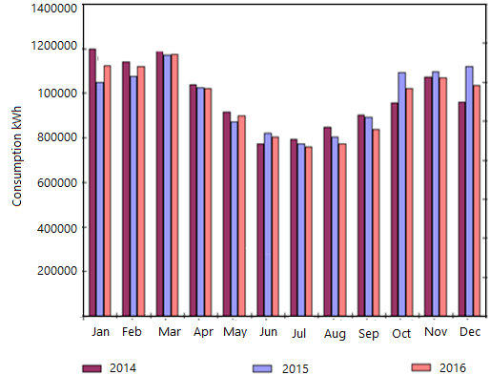

Figure 4. 2: Monthly electric energy usage

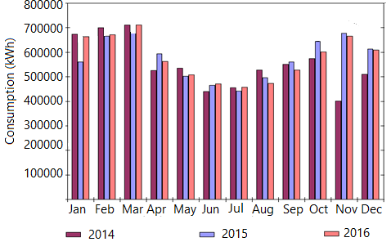

Figure 4. 3: Peak energy usage

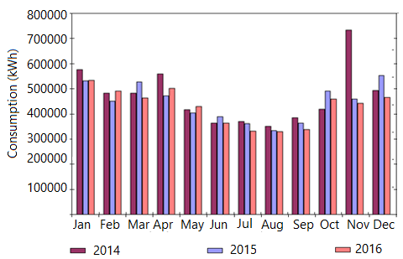

Figure 4. 4: Peak energy usage

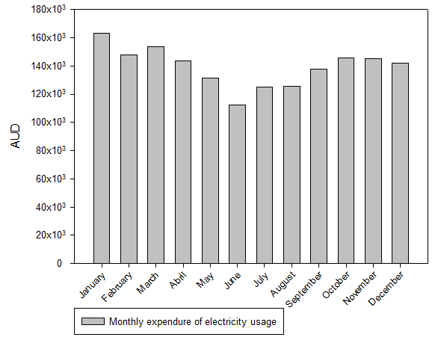

Figure 4. 5: Total Monthly Electricity Cost

## Reference Building Energy analysis

The Information Technology Building (Building 19) of Rockhampton campus of CQUniversity has been evaluated as a case study following Australia/New Zealand Standards energy audit procedures [9-11]. Figure 4.6 shows the photo of reference building. In the reference building the main electric users are HVAC and lighting systems. The data from April 2014 to March 2015 was acquired for evaluating building energy consumption including temperature and humidity profiles. The reference building had four air-conditioned levels.

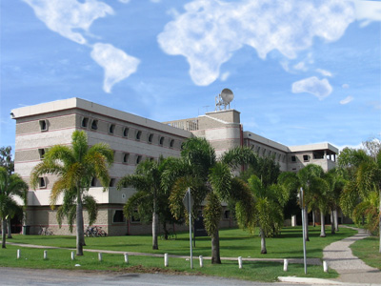

Figure 4. 6: Side View of the Reference Building

The reference building is a typical open-plan office building as illustrated in Figure 4.7. The building functions five days a week, 52 weeks per year, excluding holidays. The building’s indoor electrical load are HVAC equipment, lighting system, plug loads e.g. PCs. The rooms are equipped with manual ON/OFF switches in order to control electric lighting fixtures. Public plug-in fixtures are existed throughout the building such as monitors, printers, fax machines and desktop task lights. The occupancy density level is different from one area to another such as the ground level occupancy density is higher than the second level occupancy density.

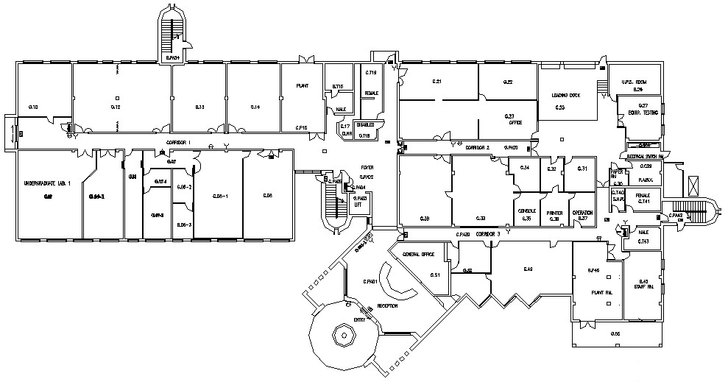

Figure 4. 7: Ground Floor Plan as built of the reference building

### Data Collection

Data were mostly gathered related to the building’s energy status in order to gain an impression about the reference building’s real-time energy performance. The information noticeably covers vital building specifications e.g. building’s layout, geometry design, plug-in loads, envelope, electro-mechanical and function as shown in Table 4.2. The entire information were gathered from building architectural plans, drawings and catalogues which was provided by facility management technician as illustrated in Table 4.3.

|  |  |
| --- | --- |
| Table 4. 2: Building 19 information | |
| Orientation and location: North East | Walls are Double Brick Plaster |
| Building Height is 16 m | Roof Ceiling is Concrete and Plaster Board |
| Numbers of Floors are 4 | Floor is Concrete slab with carpet |
| Occupancy level is 1 person per/10 m2 | Floor Width is 34 m |
| Windows width is 1.5 m | Floor Length is 74 m |
| Inside room temperature 22oC to 23o C | Outside Air Rate is 10l/s/person |
| Window Height 1.5 m | Glaze Type: Single, clear float ¼ inch with blinds |

|  |  |  |  |
| --- | --- | --- | --- |
| Table 4. 3: Reference Building System Details | | | |
| Devices and equipment | Type | Power Density (w/m2) | Schedule |
| Lighting | Fluorescent | 15 | 08:00-midnight (few areas 24 hrs) |
| Office Equipment | Standard | 15 | 08:00-18:00 |
| Cooling | Air-Cooled | 40 | 08:00-18:00 (few area areas 24 hrs) |
| Ventilation | Standard | 5 | 08:00-18:00 |

The building’s Building Management System METASYS installed by Johnson Controls, is considered as a main information source concerning the building’s operational conditions. In order to evaluate the building’s energy performance it was necessary to gathered information concerning the most of the building nature, specification, layout and systems such as construction materials, indoor thermal loads, working hours, HVAC system and etc.

The reference building indoor and outdoor temperature were obtained for one year to define the limit of temperature differences in the reference building throughout the building’s BMS. Temperature and relative humidity measurement tools were already implemented in the building in order to monitor the building energy performance. As shown in Figure 4.8 the building’s average indoor temperature fluctuates from 22.5oC to 25 with small changes over some period. The building’s internal relative humidity status fluctuates from 54% to 78% throughout the measured time as illustrated in Figure 4.9. The building’s internal light concentration for the same duration of time was around 350 lumen/m2 as presented in Figure 4.10.

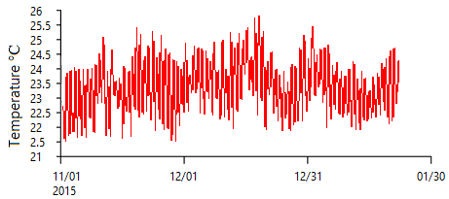

Figure 4. 8: Reference Building Indoor Temperature profile

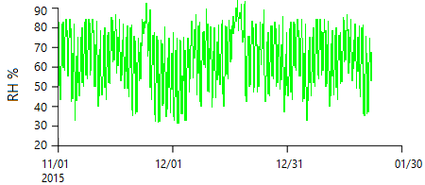

Figure 4. 9: Reference Building Indoor Humidity Level



Figure 4. 10: Reference Building Lighting Intensity Level

### Energy End Use

The major issues in creating the breakdown of different end user energy consumption were lack of energy sub-metering. To overcome these difficulties, all of the end user consumption was divided into two categories. The first category was defined as the non-weather related energy use (lighting, office’s equipment and other appliances, etc.) and the weather dependent energy use (air conditioning). Both load profiles basically exhibit the same patterns. Typical daily profiles of each subsystem were created based on the data that was collected, which verified the schedules that was supplied by the facilities manager and showed that improvements in energy usages could be made. The daily energy demand and consumption profiles as shown in Figures 4.11 and Figure 4.12 indicate that the load begin to rise from 6.00 am due to starting up the air conditioning plant and operation of lights until the peak which persisted from 11.00 am to 5.00 pm then the load decreased gradually to the level of base load. In the reference building, the weekday’s base load is 50kVA per hour. The base load is considered acceptable because the computer equipment and associated air conditioning operates 24 hrs a day. Peak loads occurred between 1.00 pm to 3.00 pm which was dominantly due to air conditioning loads. The graphs indicate the continuous operation of the A/C plant in the computer room even in the night time [12].

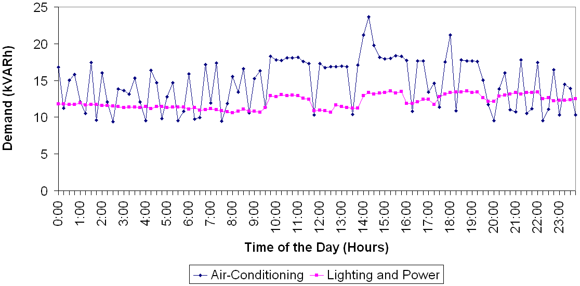

Figure 4. 11: Energy Demand in a Typical Day in the Reference Building

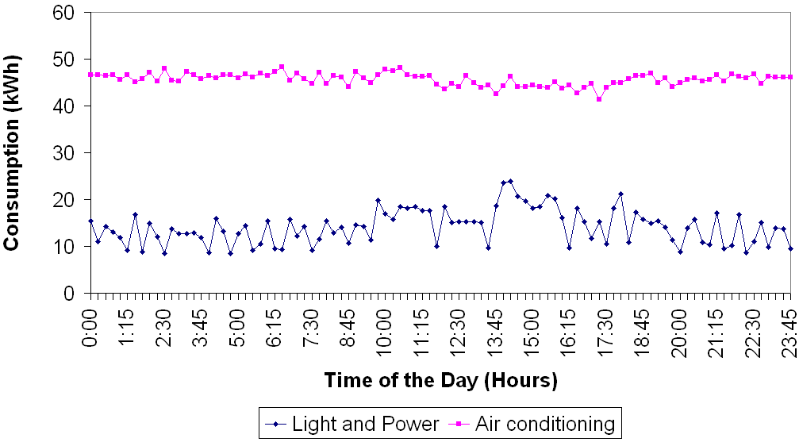

Figure 4. 12: Energy Consumption in a Typical Day in the Reference Building

Data from 12 months (April 2015 to March 2016) were analysed to determine the overall performance of the building, as well as assess the building operation by sub system. Total energy usage data provided important information on the energy usage of the sub-systems within the building. From the Figures 4.13 it is seen that non-weather related energy use (lighting, office equipment and other appliances etc.) are higher compared to the weather dependent energy use (air conditioning). Due to hot-humid climate condition consumption for air conditioning is higher during summer months and relatively less in winter months. Through the energy audit of the representative case study building it was found that one chiller is always in operation along with other air handling units. In addition, the lighting system and office equipment consumption were utilised the rest of the consumption



Figure 4. 13: Reference Building Energy Consumption Profile (15 min. interval)

The hourly gathered data were employed to develop typical daily demand and consumption profiles of the chillers as demonstrated in Figure 4.13. These portfolios are essential for determining energy consumption scenario. The utmost significant reason of determining the process was to improve the building’s HVAC and lighting systems’’ energy usage. Monitored hourly data suggests that there is a rise in energy consumption on day time ranges between the hour of 8.00 am and 8.00 pm. The building energy use profiles show that electricity consumption varies with day and seasons. The reference building’s energy consumption is influenced by outdoor temperature and the building’s working hours.

## Discussion on Energy audit and Analysis

Study shows that picturing of mass energy usage in its own does not confirm to be a handler for operative energy control. It is vital that the specified styles of building energy consumption are evaluated on a facility by facility basis. Here at CQUniversity, the department of facilities management manager is liable for driving the building system. Presently, maintenance profiles, energy consumption and systems efficiency report are used to decide building’s execution and irregularities in working conditions. Nonetheless, various options to improve the buildings’ energy efficiency exist.

### Lighting systems

This building energy audit determine that main energy consuming gear in the Rockhampton CQUniversity campus are HVAC, lighting systems and office and educational amenities. Campus’s lighting system energy consumption is projected to be around 30% of total energy usage of Rockhampton campus of CQUniversity, based on a study performed at Rockhampton campus of CQUniversity in 2012.

The majority of the rooms are equipped with fluorescent lights alongside power factor corrector. External lights are high-pressure sodium and high-pressure, mercury-based lights. As a reason of its design nature which allows using day-light and electric-light system is employed basically to deliver indoor basic lumen intensity.

It is worth mentioning that there are unoccupied rooms’ electric lighting is kept ON all the times. Additional students are permitted to use university facilities and offices post normal working-hours and hence the light stays ON after students leave. In addition, most of outdoor lamps are unclean and have a lot of dust on them which affect the lighting performance and hence waste of energy while unsatisfactory illuminance. Fluid-tilt that installed in car-park worked from 5:00 pm to 5:30 am daily, and thus a reschedule of new working-hours for seasonal variation between summer and winter is needed.

### HVAC Systems

HVAC’s Structures including chillers, AHU, fan coil units (FCU) and etc. within the reference building is considered to be the most energy consumer which its consumption is projected to be around 45-50% of the building’s total energy usage. Building’s HVAC system was functioning under unchanging control strategies strategy. Most of FCUs are noticed to be kept ON in unused spaces. Most of openings such as doors and windows are noted to be stayed open in class rooms, laboratories, offices, etc. similar to lighting’s energy audit, academic and managerial staff and students are allowed to enter all conditioned spaces after normal working hours and, hence, the HVAC system is left operating normally after staff finish their tasks and leave the space. Most importantly all of AHUs which supply spaces with conditioned air are found to be constant air volume supplier (CAV) regardless of indoor temperature.

## Summary

In this article, reference building energy analysis, auditing and pattern is presented. Energy evaluation was done based on the entire Rockhampton campus of CQUniversity energy usage portfolio. The significances of various energy usage scenarios in the reference buildings are examined and highlighted. In addition, influences of strategies planned to endorse energy savings have been clarified. In summary, it was uncovered that the yearly electricity cost in Rockhampton campus of CQUniversity has raised 7-8% while the gross rise in energy consumption was around 2-3% in 2015 compared to the previous year 2014. The article proposes that the rise in energy usage is linked to outdoor air temperatures and outdoor relative humidity. Thus energy consumption can be decreased through upgrading HVAC and Lighting system control techniques.

# References

1. ANSI/ASHRAE Standard, A. 2016. *AS/NZS 3598, 2000* [Online]. Available: http://www.standards.org.au/Pages/default.aspx [Accessed 12/10 2016].
2. CHOWDHURY, A. A. 2007. *Management and Control Strategies of Central Queensland University Building Assets.* Master, CQUniversity.
3. LEARD, B., LINN, J. & MCCONNELL, V. 2016. Fuel prices, new vehicle fuel economy, and implications for attribute-based standards.
4. G. Kabir, A.I. Abubakar, U.A. El-Nafaty, Energy audit and conservation opportunities for pyroprocessing unit of a typical dry process cement plant, In Energy, Volume 35, Issue 3, 2010, Pages 1237-1243, ISSN 0360-5442, https://doi.org/10.1016/j.energy.2009.11.003.
5. Ali Alajmi, Energy audit of an educational building in a hot summer climate, In Energy and Buildings, Volume 47, 2012, Pages 122-130, ISSN 0378-7788, https://doi.org/10.1016/j.enbuild.2011.11.033.
6. M Siddhartha Bhatt, Energy audit case studies I—steam systems, In Applied Thermal Engineering, Volume 20, Issue 3, 2000, Pages 285-296, ISSN 1359-4311, https://doi.org/10.1016/S1359-4311(99)00020-4.
7. Joachim Schleich, Tobias Fleiter, Effectiveness of energy audits in small business organizations, In Resource and Energy Economics, 2017, , ISSN 0928-7655, https://doi.org/10.1016/j.reseneeco.2017.08.002.
8. Aldona Kluczek, Paweł Olszewski, Energy audits in industrial processes, In Journal of Cleaner Production, Volume 142, Part 4, 2017, Pages 3437-3453, ISSN 0959-6526, <https://doi.org/10.1016/j.jclepro.2016.10.123>.
9. Jose Gutierrez del Arroyo, Jason Bindewald, Scott Graham, Mason Rice, Enabling Bluetooth Low Energy auditing through synchronized tracking of multiple connections, In International Journal of Critical Infrastructure Protection, Volume 18, 2017, Pages 58-70, ISSN 1874-5482, <https://doi.org/10.1016/j.ijcip.2017.03.006>.
10. Gianluca Rospi, Nicola Cardinale, Francesca Intini, Elisabetta Negro, Analysis of the energy performance strategies of school buildings site in the Mediterranean climate: A case study the schools of Matera city, In Energy and Buildings, Volume 152, 2017, Pages 52-60, ISSN 0378-7788, https://doi.org/10.1016/j.enbuild.2017.07.018.
11. Yacine Allab, Margot Pellegrino, Xiaofeng Guo, Elyes Nefzaoui, Andrea Kindinis, Energy and comfort assessment in educational building: Case study in a French university campus, In Energy and Buildings, Volume 143, 2017, Pages 202-219, ISSN 0378-7788, <https://doi.org/10.1016/j.enbuild.2016.11.028>.
12. Enrique Cabrera, Elena Gómez, Vicent Espert, Enrique Cabrera, Strategies to Improve the Energy Efficiency of Pressurized Water Systems, In Procedia Engineering, Volume 186, 2017, Pages 294-302, ISSN 1877-7058,