Model for Evaluating CO2 Emissions and the

Projection of the Transport Sector

Daniel Ospina*, Sebastián Zapata**, Mónica Castañeda*, Isaac Dyner*, Andrés Julián Aristizábal*,
Nicolas Escalante***
*Engineering Department, Universidad de Bogotá Jorge Tadeo Lozano
**Department of Computer Science and Decision, Universidad Nacional de Colombia
***Institute of Sanitary Engineering, University of Stuttgart

Article Info |  | ABSTRACT
Article history:  Received Jun 12th, 201x  Revised Aug 20th, 201x  Accepted Aug 26th, 201x |  | This article presents a system dynamics model to analyze the growth of cars and the effect of different policies on carbon emissions from the transport sector. The simulation model used in this work was built using the methodology of systems dynamics (SD) developed by Jay W. Forrester at the Massachusetts Institute of Technology (MIT). The model was applied to the transport sector of the city of Bogota, Colombia for a period of time between 2005 and 2050. The information used to feed the model comes from reliable sources such as DANE (National Administrative Department of Statistics) and EIA (U.S Energy Information Administration). Four scenarios were proposed that relate urban development policy and environmental policy. The main results indicate that the number of cars in Bogota can reach up to 13 million vehicles in 2050 and the projection of CO2 emissions would reach 34 million TonCO2 in the absence of an appropriate environmental policy.
Keyword:
Transport sector model
Transport simulation
CO2 emissions
Software tools
Systems dynamics

Copyright © 201x Institute of Advanced Engineering and Science.
All rights reserved.
Corresponding Author:
Andrés Julián Aristizábal Cardona,
Engineering Department,
Universidad de Bogotá Jorge Tadeo Lozano,
Carrera 4 #22-61, Bogotá, Colombia.
Email: andresj.aristizabalc@utadeo.edu.co

- INTRODUCTION
Transport plays an important role in the social and economic development of a country. But on the other hand, in relation to the environment it is a source of emissions, noise and vibration and causes risks to health and safety [1].
As the sector with the highest oil consumption and the fastest oil demand and carbon emissions growth, transport needs to improve energy efficiency and the development of low carbon technologies [2].
Transport allows great advantages to people in terms of commuting, but also consumes a large amount of energy and emits great amounts of greenhouse gases (GHGs) and pollutants. Because cities are the centers of human transport, urban transport has become the sector with the highest energy consumption and GHG emissions generation [3]. The United Nations reported that a fifth of the world's population lives in 600 cities in the world. It is expected that the population of cities in developing countries will double by 2030 and that their energy consumption will represent 60% to 80% of the total world energy consumption. Thus, GHG emissions will represent 70% of the total human GHG emissions with main emission sources concentrated in fossil fuels for energy supply and the transport sector [4].
Many academics have carried out studies to predict energy demand and carbon emissions. According to the different research objectives, these can be divided into three categories [4]: ​​First, there are predictions of energy consumption and carbon emissions at the global, regional and national levels, as is the case with the annual global energy and carbon emissions of the International Energy Agency (IEA) [5]. Second, there are predictions of energy consumption and carbon emissions in specific sectors of different regions in certain countries [6-8]. In this sense, [9] combines the time-heat-power optimization model and the optimization model of a decentralized energy system to forecast energy consumption in the construction sector in Germany. In [10] the historical trend of the energy demand of road transport in developed economies is analyzed and the trajectory analysis method and the BMA model (Bayesian Model Averaging) were applied to analyze the energy demand of road transport. In [11] Autoregressive–moving-average model (ARMA) was used to forecast the energy demand and environmental emissions of India's iron manufacturing industry. In [12] a linear logarithmic equation was applied to explain the relationship between carbon dioxide emissions and their influence factors, to forecast the CO2 emissions of China's electric power industry during the 2016-2030 period under different scenarios. Third, there are predictions of specific kinds of energy at different scales. For example, in [13] China's demand for natural gas is predicted during the period 2015-2020 using a self-adapting intelligent grey prediction model. In [14] the future evolution of the energy structure of Brazil is analyzed and the demand and supply of power is predicted to 2030.
There are researches that apply different methods and models [15-25] to evaluate the demand and energy consumption of the transport sector of different cities and countries. The methodologies allow predicting future transport emissions as well as energy demand under different possible scenarios. This paper presents a model of systems dynamics using different scenarios to analyze two variables of the transport sector of the city of Bogota: automotive fleet growth and emissions generation.

- MODEL DESCRIPTION
The simulation model used in this work was built using the methodology of systems dynamics (SD), this methodology was developed by Jay W. Forrester at the Massachusetts Institute of Technology (MIT) around the year 1950, SD is a tool that employs a system of differential equations that allows to establish and understand the behavior of complex systems in order to propose future scenarios and make decisions [26].
SD is appropriate for modeling social systems under conditions of uncertainty and imbalance [27]. Cities are social systems that present such conditions, since they face uncertainty associated with urban growth and regulatory interventions at the environmental level [27]. Consequently, the SD is an adequate tool to analyze the effect of this uncertainty on the cycles of growth and planning in the long term. In particular, the simulation model proposed constitutes a laboratory for policy analysis, since it studies how urban growth and the transport sector react to policy changes [26], [28].
The problem of emissions generation of the transport sector can be seen as a diagram of subsystems. The diagrams of subsystems facilitate the definition of the limits and aggregation degree of the model, by allowing to define the structure of the model as a whole composed by modules, where each module represents a physical or conceptual unit relevant for decision making [26].
Next, the modules shown in Figure 1 are described.

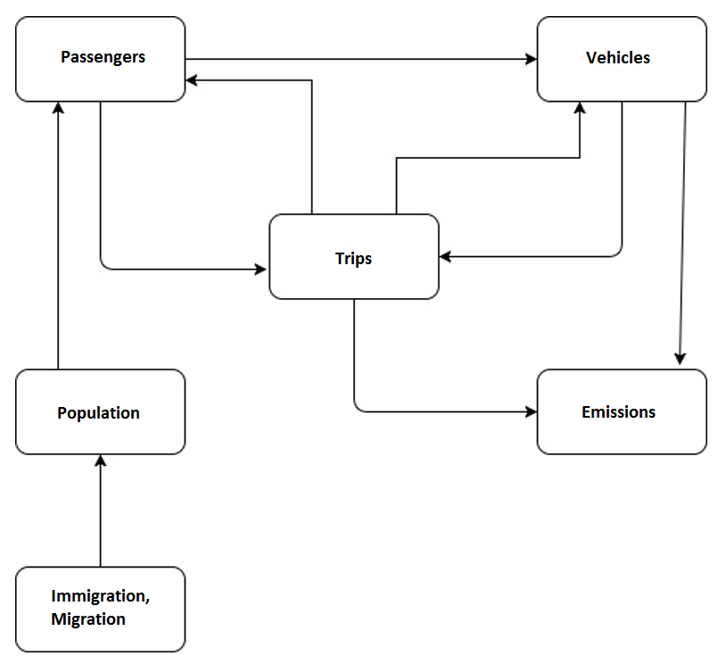
Figure 1. Structure of the simulation model represented in a subsystem diagram.

The population module depends on the entry (immigration, births) and departure (deaths, migration) of the population. The vehicles module depends on the number of passengers and the number of trips they make. The emissions module depends on the total number of trips and the type of vehicle in which these trips are made, since each type of vehicle has a different emission factor. Finally, the passenger’s module depends on the amount of population that is mobilized and the number of trips made during the year.
The stocks and flows diagram of the model is presented in Figure 2, which also shows an overview of the feedback loops. Following, the investment cycles B1, B2, R1 and R2 will be described.

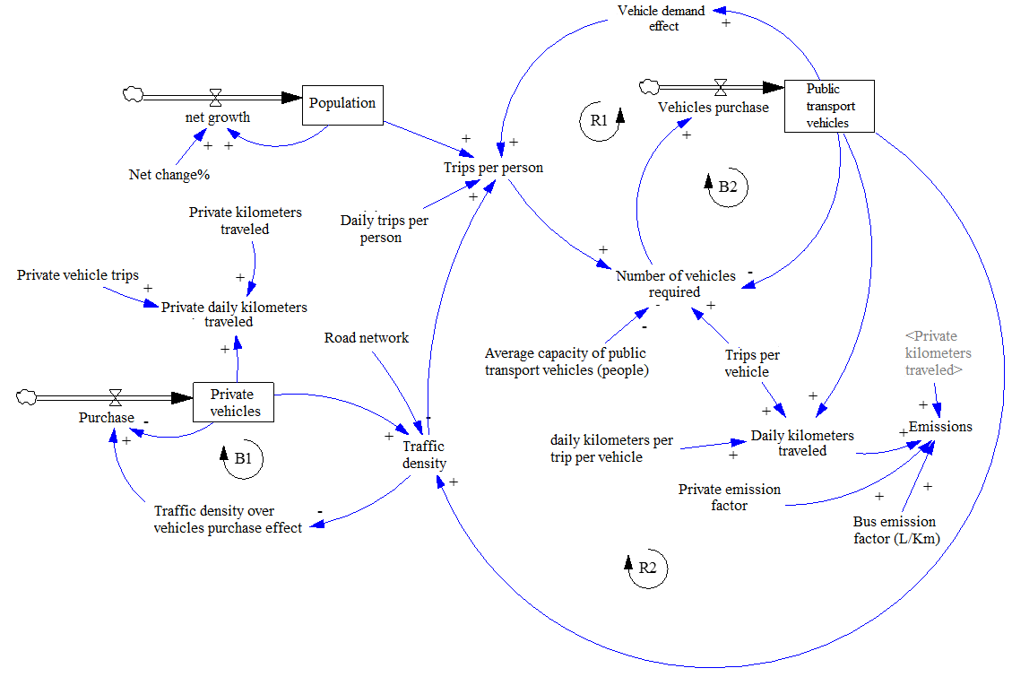
Figure 2. Stocks and flows diagram.

The cycle of private vehicles B1 shows the behavior of the purchase of these vehicles. An increase in the number of private vehicles will produce an increase in traffic density, which in turn makes the purchase of private vehicles less attractive. This last effect will produce a reduction in the purchase of private vehicles.
Cycles R1, R2 and B2 correspond to the purchase of vehicles for public transport. In cycle R1, an increase in the number of public transport vehicles generates a greater sense of comfort among users (this is represented by the variable "demand vehicle effect"), which in turn increases the journeys of people and therefore the number of vehicles required. This last effect increases the purchase of public transport vehicles. In cycle R2, an increase in the number of public transport vehicles generates a higher density of traffic, which increases the trips of people and therefore the number of vehicles required, the latter effect increases the purchase of public transport vehicles. In cycle B2, an increase in the number of public transport vehicles reduces the number of vehicles required, which reduces the purchase of public transport vehicles. The main equations of the model are described in Table 1.

Table 1. Equations of the siulation model.

Equation | Units
$\sum_{i=0}^{N}{{fe}_{i}\left(t\right)*{DT}_{i}(t)}$ (1)  The emissions of the transport sector depend on the distance traveled by type of technology (DT) and the emission factor of each technology (fe). | Million tons CO2
${DT}_{i}\left(t\right)={DTT}_{i}(t)*{NT}_{i}(t)*{NTV}_{i}(t)$ (2)  The total distance traveled (DT) by type of vehicle depends on the number of trips made by each vehicle on a trip (DTT), the total number of trips made and the total number of vehicles. | Km
${NTV}_{i}\left(t\right)=\int{{NVR}_{i}(t)}dt$ (3)  The total number of vehicles (NTV) depends on the purchase of vehicles or number of vehicles required (NVR). | Vehicles
${NVR}_{i}\left(t\right)={MAX(O,NP}_{i}\left(T\right)*UtilMean\left(t\right)-{NVR}_{i}(t-1)$) (4)  The number of vehicles required at time t (NVR) depends on the number of trips (NP), and the capacity of the vehicles according to the type. | Vehicles
$Po\left(t\right)=\int{Change\left(t\right)*Po\left(t-1\right)dt}$ (5)  The population (Po) depends on the percentage of change (Change) and the population in the previous period. | Person

2.1 Assumptions and main parameters of the model
The information used to feed the model comes from reliable sources such as DANE (National Administrative Department of Statistics) and EIA (U.S Energy Information Administration). The simulation period comprises from 2005 to 2050. In the model, private and public vehicles are considered. Private vehicles are divided into: cars, motorcycles and electric bicycles. Public vehicles are divided into: BRT (Bus Rapid Transit, for the study case of Transmilenio), buses, taxis and metro. In the model it is considered that the metro will begin operations in year 2020 and then every 4 years a line will enter according to the scenario (See section III).
In Table 2, the main parameters used and their corresponding values ​​are shown.

Table 2. Values of parameters.

Parameters | Value | Units | Ref.
Initial Population | 6.840.120 | Person | [29]
Initial private vehicles | 698.893 | Vehicles | [30]
Avg gasoline vehicle fuel efficiency | 11/100 | L/Km | [31]
Avg diesel vehicle fuel efficiency | 9,8/100 | L/Km | [31]
Avg natural gas vehicle fuel efficiency | 0.011/100 | m3/km | [31]
Avg diesel BRT fuel efficiency | 35/100 | L/Km | [31]
Avg diesel bus fuel efficiency | 25/100 | L/Km | [31]
Avg gasoline Taxi fuel efficiency | 9/100 | L/Km | [31]
Avg natural gas Taxi fuel efficiency | 0.011/100 | m3/Km | [31]
Energy content of gasoline | 0.0344 | GJ/L | [32]
Energy content of diesel | 0.0371 | GJ/L | [32]
Energy content of Natural gas | 0.0356 | GJ/m³ | [32]
Gasoline emission factor | 69,25/1000 | tonCO2/GJ | [33]
Diesel emission factor | 74,01/1000 | tonCO2/GJ | [33]
Natural gas emission factor | 56,1/1000 | tonCO2/GJ | [33]

The following section presents the results of the simulation model that correspond to the emissions of the transport sector in the city of Bogota under different scenarios.

- RESULTS
Four simulation scenarios have been proposed, which are the result of several workshops conducted in Colombia with mobility experts. The four scenarios presented in Figure 3 combine the two most uncertain variables in the system: urban development policy and environmental policy, which are represented on the x and y axis. The urban development policy encourages construction on the territory. Environmental policy promotes cleaner forms of transport.

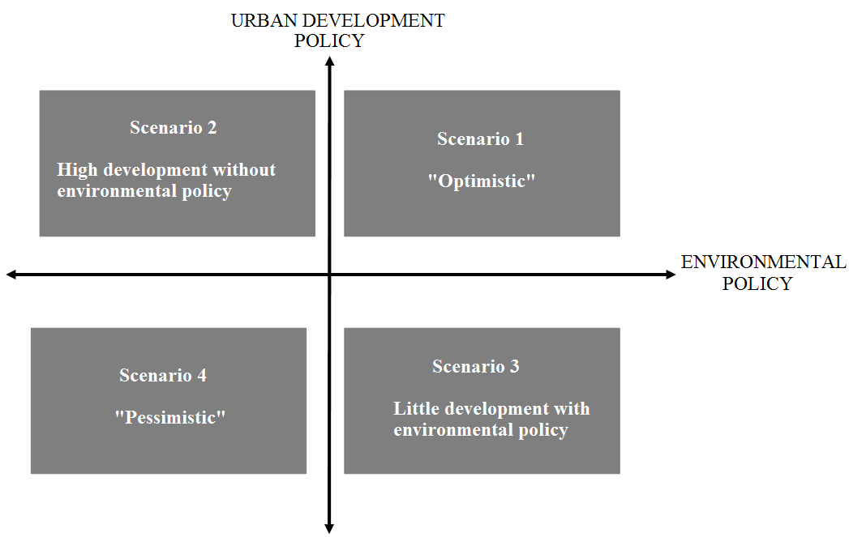
Figure 3. Scenarios to study the emissions of the transport sector under different levels of urban growth.

Scenario 1 is the optimistic scenario, in which an urban and environmental development policy is applied. Under this scenario, 55% of urbanization and 45% of public and green areas are considered, in addition to 5 metro lines.
Scenario 2 gives greater importance to urban development policy and does not consider an environmental policy. In this scenario, 80% of urbanization and 20% of public and green areas are considered; additionally the metro will have 2 lines.
Scenario 3 has an environmental policy. In this scenario only 30% is urbanized and 70% is delimited for public and green areas, in addition to 3 metro lines.
Scenario 4 is the pessimistic scenario. Under this scenario high urbanization of the city is considered corresponding to 90% of the available territory and little availability of green areas, in addition to 1 metro line.
On these scenarios the number of private vehicles, the total emissions of the transport sector and the contribution of this sector on the total emissions of the city have been analyzed.
Figure 4 shows the automotive fleet growth in the city of Bogota. It is possible to observe that in scenarios 2, 3 and 4 there is a great growth in the number of vehicles due to the lack of an environmental policy.

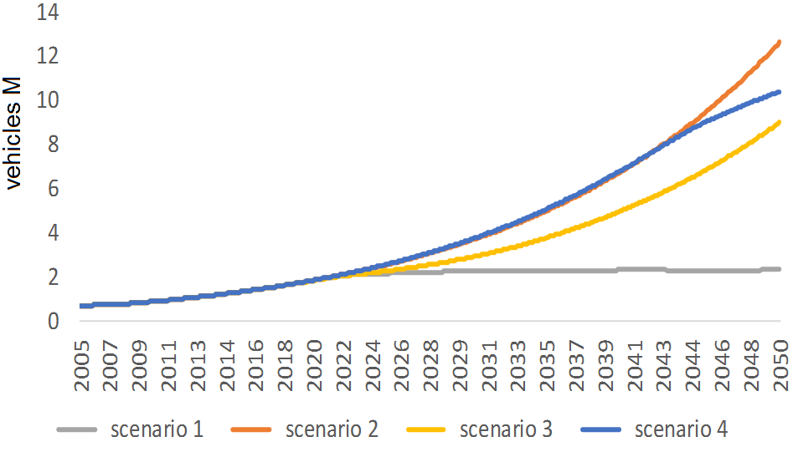
Figure 4. Growth of the automotive fleet in Bogota.

On the other hand, in scenario 1 ("optimistic" scenario) the presence of an environmental policy leads to greater use of public transport and therefore fewer vehicles.
Figure 5 shows the growth of carbon emissions in the transport sector in Bogota. Because scenarios 2 and 4 do not have an environmental policy, there is a faster growth of emissions due to the tise on the vehicle fleet and the lower participation of the metro.

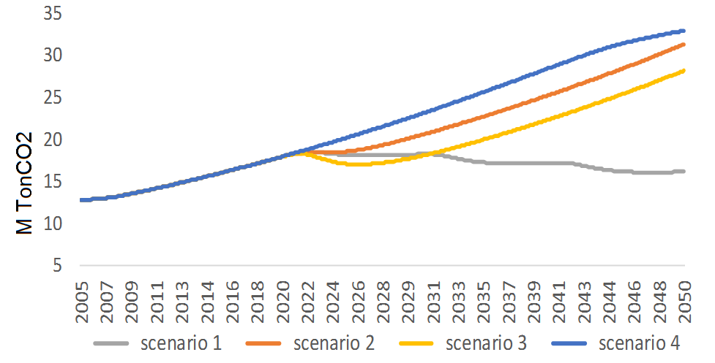
Figure 5. Total emissions from the transport sector in Bogota.
In contrast, scenarios 1 and 3 do consider an environmental policy. Under these scenarios, in scenario 1 emissions grow less than in scenario 3. In addition, scenario 1 shows growth at the beginning of the simulation period and then a decrease in emissions. This decline is due to a greater participation of the metro which is a clean mean of transport.
Figure 6 shows the participation of the transport sector in the total emissions of the city of Bogota.

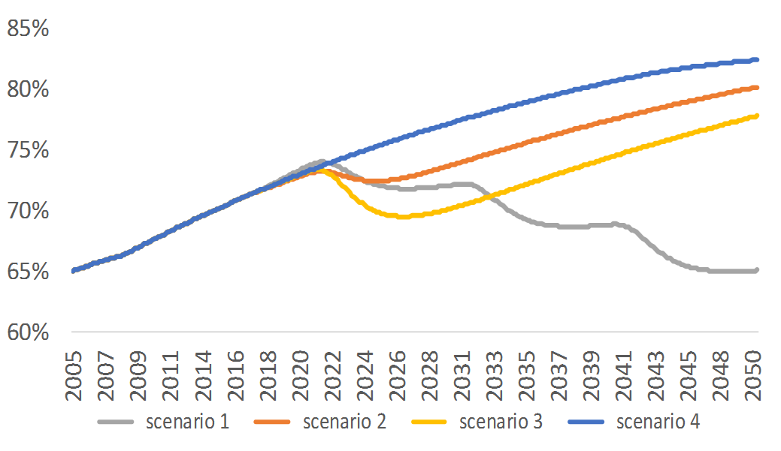
Figure 6. Participation of the transport sector in the total emissions of the city of Bogota.

In scenarios 2 and 4 an environmental policy is not considered, therefore the transport sector is responsible for most of the total emissions of the city of Bogota.
Under scenario 3, emissions from the transport sector show a growing trend.
Finally, in scenario 1 (optimistic scenario), most of the emissions come from the transport sector, although the percentage of participation is lower than in the other scenarios.

- CONCLUSIONS
This article uses an SD model to learn about the design of policies aimed to reduce emissions in the transport sector. Several lessons are derived from this research from the point of view of sustainable planning of cities. In particular, a comprehensive urbanization policy is necessary to effectively reduce emissions from the transport sector. This comprehensive policy implies the coexistence of a policy for urban development and an environmental policy.
The urban development policy facilitates the controlled growth of the city, keeping emissions from the transport sector under acceptable levels. Additionally, this policy is a complement to the environmental policy. The key variable in the design of an environmental policy is the construction of a metro in the city of Bogota, because this would significantly reduce carbon emissions, as indicated by the simulation results.
The SD model built for this research complies with the objective for which it was designed, that is, it allows to analyze the growth of the vehicle fleet and the effect of different policies on the carbon emissions of the transport sector.
The control of carbon emissions from the transport sector is crucial, since this is the sector with the highest share of total emissions. Therefore, it is necessary to study in the future the design of clear policies that help to encourage, other types of mobility, such as electric mobility and the use of bicycles.

ACKNOWLEDGEMENTS
This work was carried out thanks to the financial support of the project “Simulación del Metabolismo de Bogotá para su Desarrollo Sostenible” between Colciencias and Universidad Nacional de Colombia.

REFERENCES
- Petro F., Konecny V. Calculation of emissions from transport services and their use for the internalization of external costs in road transport. Procedia Engineering, 192 (2017), 677-682.
- Fan, F., Lei, Y., 2016. Decomposition analysis of energy-related carbon emissions from the transportation sector in Beijing. Transp. Res. D-Transp. Environ. 42, 135–145.
- Fan J.L., Wang J.X., Li F., Yu H. and Zhang X. Energy demand and greenhouse gas emissions of urban passenger transport in the internet era: A case study of Beijin. Journal of Cleaner Production, 165 (2017), 177-189.
- UN (United Nations), 2016. WORLD CITIES REPORT 2016Urbanization and development: Emerging Futures from: http://wcr.unhabitat.org, (Accessed on 5 December 2016).
- IEA (International Energy Agency), 2016. World Energy Outlook 2016 from: http://www.iea.org/newsroom/news/2016/november/world-energy-outlook-2016. (Accessed on 5 December 2016).
- Meng, M., Jing, K., Mander, S., 2017. Scenario analysis of CO2 emissions from China’s electric power industry. J. Clean. Prod. 142, 3101-3108. http://dx.doi.org/10.1016/j.jclepro.2016.10.157.
- Mi, Z., Wei, Y.-M., Wang, B., Meng, J., Liu, Z., Shan, Y., Liu, J., Guan, D., 2016a. Socioeconomic impact assessment of China’s CO2 emissions peak prior to 2030. J. Clean. Prod. 142, 2227-2236. http://dx.doi.org/10.1016/j.jclepro.2016.11.055.
- Sen, P., Roy, M., Pal, P., 2016. Application of ARIMA for forecasting energy consumption and GHG emission: a case study of an Indian pig iron manufacturing organization. Energy 116, 1031-1038. http://dx.doi.org/10.1016/j.energy.2016.10.068.
- Merkel, E., Mckenna, R., Fehrenbach, D., Fichtner, W., 2016. A model-based assessmentof climate and energy targets for the German residential heat system. J. Clean. Prod. 142, 3151-3173. http://dx.doi.org/10.1016/j.jclepro.2016.10.153.
- Chai, J., Lu, Q.-Y., Wang, S.-Y., Lai, K.K., 2016. Analysis of road transportation energy consumption demand in China. Transp. Res. Part D. Transp. Environ. 48, 112-124. http://dx.doi.org/10.1016/j.trd.2016.08.009.
- Sen, P., Roy, M., Pal, P., 2016. Application of ARIMA for forecasting energy consumption and GHG emission: a case study of an Indian pig iron manufacturing organization. Energy 116, 1031-1038. http://dx.doi.org/10.1016/j.energy.2016.10.068.
- Meng, M., Jing, K., Mander, S., 2017. Scenario analysis of CO2 emissions from China’s electric power industry. J. Clean. Prod. 142, 3101-3108. http://dx.doi.org/10.1016/j.jclepro.2016.10.157.
- Zeng, B., Li, C., 2016. Forecasting the natural gas demand in China using a self adapting intelligent grey model. Energy 112, 810-825. http://dx.doi.org/10.1016/j.energy.2016.06.090.
- De Andrade Guerra, J.B.S.O., Dutra, L., Schwinden, N.B.C., De Andrade, S.F., 2015. Future scenarios and trends in energy generation in Brazil: supply and demand and mitigation forecasts. J. Clean. Prod. 103, 197-210. http://dx.doi.org/10.1016/j.jclepro.2014.09.082.
- Han R., Yu B., Tang B., Liao H. and Wei Y. Carbon emissions quotas in the Chinese road transport sector: A carbon trading perspective. Energy Policy, 106 (2017): 298-309.
- Meersman H., Ehrler V.C., Bruckmann D., Chen M., Francke J., Hill P., Jackson C., Klauenberg J., Kurowski M., Seidel S. and Vierth I. Cahallengers and future research needs towards international freight transport modelling. Case Sudies on Transport Policy, 4 (2016): 3-8.
- Talbi B. CO2 emissions reduction in road transport sector in Tunisia. Renewable and Sustainable Energy Reviews, 69 (2017): 232-238.
- Singh R., Sharmna C. and Agrawal M. Emission inventory of trace gases from road transport in India. Transportation Research Part D, 52 (2017): 64-72.
- Donchenko V., Kunin Y., Ruzski A., Barishev L., Trofimenko Y. and Mekhonoshin V. Estimated atmosfpheric emission from motor transport in Moscow based on transport model of the city. Transport Research Procedia 14 (2016): 2649-2658.
- Song S., Diao M. and Feng C.C. Individual transport emissions and the built environment: A structural equation modelling approach. Transportation Research Part A, 92 (216): 206-219.
- Osório B., McCullen N., Walker I. and Coley D. Integrating the energy costs of urban transport and buildings. Sustainable Cities and Society 32 (2017): 669-681).
- Mommens K., Van Lier T. and Macharis C. Loading unit in freight transport modelling. Procedia Computer Science, 83 (2016): 921-927.
- Ottemoller O. and Friedrich H. opportunities of sectorial freight transport demand modelling. Case Studies on Transport Policy 4 (2016): 9-12.
- Dzikuc M., Adamczyk J. and Piwowar A. Problems associated with the emissions limitations from road transport in the Lubuskie Province (Poland). Atmospheric Environment, 160 (2017): 1-8.
- Santos G. Road transport and CO2 emissions: what are the challenges?. Transport Policy 59 (2017): 71-74.
- J. D. Sterman, Business dynamics: systems thinking and modeling for a complex world. Boston: Irwin/McGraw-Hill., 2000
- H. Rahmandad, & J. Sterman. Heterogeneity and network structure in the dynamics of diffusion: Comparing agent-based and differential equation models. Management Science, vol 54, pag 998-1014., 2008.
- R. Ponzo, I. Dyner, ,S. Arango, & E.R Larsen. Regulation and development of the Argentinean gas market. Energy policy, vol 39.(3), pag 1070-1079 2001.
- DANE, “Departamento administrativo Nacional de estadística,” 2005. [Online]. Available: https://www.dane.gov.co/files/censos/presentaciones/poblacion_adulto_mayor.pdf
- DANE, “Departamento administrativo Nacional de estadística,” 2011. [Online]. Available: https://www.dane.gov.co/files/censo2005/PERFIL_PDF_CG2005/11001T7T000.PDF
- EIA “U.S Energy information administration” 2013 [Online]. Available: https://www.iea.org/media/workshops/2013/egrdmobility/Nylund_Vehicle_energy_efficiencies.pdf
- K. Bozbas Biodiesel as an alternative motor fuel: production and policies in the European Union. Renew Sustainable Energy Rev; vol 12, is 2 pag:542–52, 2008
- EIA “U.S Energy information administration” 2017 [Online]. Available: https://www.eia.gov/tools/faqs/faq.php?id=73&t=11

BIBLIOGRAPHY OF AUTHORS

 | Daniel Ospina received Bachelor of science in Petroleum Engineering from Universidad Nacional de Colombia in 2013. He has extensive experience in planning for public administration and public investment projects. He has financial knowledge and public bidding. His areas of interest are renewable energy, modeling, optimization and sustainable management.
 | Sebastian Zapata received the Engineering degree in System Engineering in 2010 from National University of Colombia, his master degree in System Engineering was obtained in 2013 and he is a PhD student, his current research interests are electricity markets, renewable energy, simulation, and policy analysis.
 | Mónica Castañeda received the Engineering degree in Management Engineering in 2011 from National University of Colombia, her master degree in System Engineering was obtained in 2014 and she is a PhD student, her current research interest are electricity markets, renewable energy, simulation, and policy analysis.
 | Isaac Dyner is a PhD in Decision Sciences from the University of London (LBS); he has a Master's degree in Statistics and Operational Research and Undergraduate Mathematics. He has taught at the National University of Colombia in the areas of Operations Research, System Dynamics, Strategy, Regulation and Energy.
 | Andrés Julián Aristizábal Cardona received the Ph.D degree in science – physics from Universidad Nacional de Colombia, Bogotá, Colombia, in 2008. He is currently the director of the Master's Degree in Engineering - Sustainable Management of Energy, in Universidad Jorge Tadeo Lozano, Bogotá, Colombia. His areas of interest are photovoltaic solar energy, virtual instrumentation, power quality and sustainability.
 | Nicolas Escalante received his M.Sc. in Air Quality Control from Stuttgart University in 2003. He has extensive experience in management and sustainable use of solid, hazardous and contaminated sites, system dynamics and systemic thinking. His areas of interest are Solid Waste Management, Waste Engineering and modeling.

