Accelerated Mobile Pages from JavaScript as Accelerator Tool for Web Service on E-Commerce in the E-Business

Agus Wibowo¹, Guruh Aryotejo², Mufadhol Mufadhol*³
^{1,3}Departement of Computer System, STEKOM Semarang, Indonesia
Jl. Majapahit 605, Semarang, Indonesia, phone +62246723456, +62246710144
²Lecturer for Information System Faculty, STEKOM Semarang, Indonesia
Jl. Brig. Jend. Sudhiarto. 605, Majapahit, Semarang, Indonesia, phone: +62246723456
*Corresponding author, e-mail: agus.wibowo@stekom.ac.id¹, guruh2000@yahoo.com², masyong29@gmail.com³

Article Info |  | ABSTRACT
Article history:  Received Jun 12th, 201x  Revised Aug 20th, 201x  Accepted Aug 26th, 201x |  | E-commerce is a sub-section of E-business which includes all kinds of functions and business activities by using electronic data that has the main purpose to increase corporate profits. One of the strategies used is to automate the existing tasks in E-commerce by utilizing web service facilities, this will significantly save time. The use of smartphones as a means of information and communication to force web service application providers to improve the services and facilities in the form of websites that can be opened quickly and lightly on smartphone devices. This paper will discuss the benefits of accelerated mobile pages as a coding accelerator tool in the JavaScript programming language using XML, HTML and XHTML programming as well as involving the use of SOAP, WSDL and NuSOAP that will run on both HTTP and HTTPS protocols. Using accelerated mobile pages as a means of accelerator tool on E-commerce in E-business can directly improve the performance of web services when accessed via smartphone so that in running the website will feel fast, easy and light.
Keyword:
Javascript
Accelerator
Web service
E-commerce
E-business
Copyright © 201x Institute of Advanced Engineering and Science.
All rights reserved.
Corresponding Author:
Mufadhol Mufadhol,
Departement of Computer System,
STEKOM Semarang, Indonesia,
Jl. Majapahit 605, Semarang, Indonesia, phone +62246723456, +62246710144.
Email: masyong29@gmail.com

- INTRODUCTION
The rise of the use of smartphones as a means of information and communication forces web application service providers to improve their services and facilities [1]. At the beginning of the emergence of smartphones that are used to access website services, where users no longer need computer equipment as the main equipment to access the website, this time the paradigm shift of website design has to change. Website service providers no longer compete to display fantastic features and effects in their website pages, but have to start thinking how the website should be opened quickly and lightly on smartphone devices [2]. Nowadays smartphone has dominate the world and anyone has it. Indonesia is the largest smartphone user in Southeast Asia, the percentage of internet users through smartphone can be seen in figure 1. Indonesia is known as a country with the number four smartphone user in the world with a percentage of 3.44% of the world population and number six in the world for internet use with a ratio of up to 40% of the total population of Indonesia. There is a big market that awaits, just how to make the website services can be accessed by users who have a variety of Internet connections [3], [4].
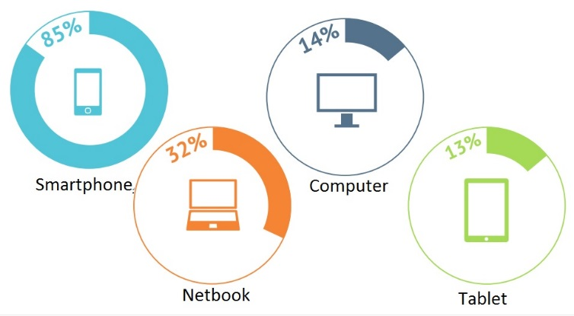
E-business or Electronic Business is a business activity that is done automatically by using information technology system or internet technology that enables a company to connect with internal and external data processing system more efficient and flexible [5]. E-business is often associated with the use of E-commerce in everyday activities. E-commerce is more a sub-section of E-business which includes all kinds of functions and business activities by using electronic data that has the main purpose to increase corporate profits. The more people use the internet to get information or shopping online, the greater the chances of the company getting a big profit [6]. E-commerce cannot work without a strategy. Strategies in E-commerce are needed to support the company's overall strategic business direction. Ease of doing business using E-commerce will be more impressive compared to offline business because the internet knows no boundaries either about time, region or culture and even in the use of its network can be arranged and controlled according to the need [7]. One of the strategies used is to automate the existing tasks in E-commerce by utilizing web service facilities, this will significantly save time [8].
Figure 1. Percentage of Internet User Tools
JavaScript programming that had been forgotten in web programming has quietly developed itself and evolved into a highly calculated technology and is now the backbone of web services with real website technology that is multiplatform [9]. Accelerated mobile pages (AMP) is a programming for website services one of the few programs developed by JavaScript that allows the website to open faster almost without delay especially when using smartphone devices, this is because the rendering process will be in the background so that users do not feel the process of waiting while loading the website. AMP will also optimize the use of preconnect APIs to save resources in the process. In addition, AMP also require modification of script layout in accordance with predetermined standards [10]. Installation of AMP in the web service will speed up access to the service when using a smartphone, so when transacting online using the smartphone feels easier and convenient.

- RESEARCH METHOD
This research was conducted using research and development (RND) method [11]. This study also involves several departments and companies engaged in the IT and online service provider website buying and selling online.
  - Web Service
The widespread use of technology makes organizations, companies and institutions even compete to use technology to achieve the maximum expected goals. The use of the internet in business is changing from as a tool for electronic information exchange into a tool for business strategy applications, such as: marketing, sales, and customer service. The use of information technology, especially in the web, has made it easier to promote, sell and disseminate information globally [12]. One of the conveniences provided by some web applications that are implemented into E-business is the use of web services in E-commerce [13]. Web service is a self-containing software component, a self-describing modular application that can be published, allocated, and implemented on the web. Web services are technologies that change the capabilities of internet technology by adding transactional web capabilities, i.e. the ability of the web to communicate with each other with program-to-program model (P2P). The focus of the web has been dominated by program-to-user (P2U) communication with business-to-consumer (B2C) interaction, while transactional web will be dominated by program-to-program (P2P) with business-to-business interaction (B2B) [14], [15].
  - Basic Development Tools
XML is the basis of the web service used to describe data. At the most detailed level, the overall web service is built on XML. The main functions of XML are inter-application communication, data integration, and external application communications with external partners. Simple Object Access Protocol (SOAP) is a protocol for information exchange with decentralized and distributed. SOAP is a combination of HTTP with XML because SOAP generally uses the HTTP protocol as a means of data transport and the data to be exchanged is written in XML format. SOAP will govern how requests and responses from a web service work. Web Services Description Language (WSDL) is an XML-based language used to define a web service and describes how to access the web service. The main function of the WSDL in web services is to automate business-to-business communication mechanisms in web services via Internet protocols. NuSOAP is a collection of PHP classes that allow users to send and receive SOAP messages via the HTTP protocol. NuSOAP is a component-based web service toolkit. NuSOAP has a base class that provides methods such as variable serialization and SOAP-Envelope packaging. Web service interaction is done with class client called class "soapclient" and class server called with class "soapserver". This class allows users to process the sending and receiving of SOAP messages with the help of several other support classes to complete the process [16].
  - Accelerator Tool
JavaScript is a scripting language based on prototype-based programming concepts. JavaScript name is an implementation of Netscape Communications Corporation for ECMAScript standard. JavaScript is very popular and well known for the use of programming languages ​​implemented on the website (as client-side JavaScript) and is also used to provide script access for embedded system objects in other applications. JavaScript scripts inserted in HTML or XHTML files, running over HTTP or HTTPS protocols, must be written between <script> tags. </ Script> [17]. When searching on Google search engine then get the result and then executed by click one of the website listed there, then the system will redirect from Google search engine to the destination website, then there is a delay or delay that appears at the time of search even though the incident only split second. This is where the role of AMP (Accelerated Mobile Pages) is required, where Javascript as the developer of AMP (Accelerated Mobile Pages) has made the website become more charming. Installing AMP is very easy, simply by installing AMP plugin as a basic foundation or create your own AMP HTML, AMP JS and AMP Cache in JavaScript code. All these components should be installed in order to get a more complete configuration [18].

- RESULTS AND ANALYSIS
  - E-Commerce in The E-Business
In the end, E-Commerce is not just a mechanism of selling goods or services through the Internet media, but rather on a business transformation that changes the ways the company in performing its business activities every day. Fundamental changes and redefinition of the company's core business often need to be done in connection with this phenomenon, as new paradigms have buried the conventional management principles and if they continue to be implemented it would be a disservice [19], [20]. The business strategy formulated in the company's vision, mission, and objectives as well as the results of the evaluation and identification of the application portfolio, focuses on cost reduction and maximum utilization of technology in the field of Information Technology. Application of Information Technology seen from two sides that is from the point of view of the target or management expectations provided by the Information Technology and from the point of view of the application and function in daily operations as an example for the security of data transactions can use the network security is for physical security data storage on space can use room safety sensors [21]. The use of information technology, especially in the web has made it easier in the promotion and dissemination of information globally. One form of convenience provided by some web applications is the use of web services that are implemented into E-business [22].
  - JavaScript Languages Programming
World web development is familiar with JavaScript. This language is also often called the language of the web browser, because we can be sure every internet browser supports javascript. This is the first reason that makes javascript very popular. Javascript is a browser language, therefore the job is to handle user interaction. Since the emergence of node.js released in 2009, Javascript is no longer limited to just the client side but can also be used on the server side or networking. JavaScript can also be used to handle file system access issues. Node.js makes the web service application to become real-time [23].
  - Accelerated Mobile Pages
    - AMP HTML
AMP HTML is HTML with some restrictions for reliable performance. AMP HTML is essentially an expanded HTML with a special AMP property. The code of the AMP HTML file program in the simplest JavaScript can be seen as shown in Figure 2. Although some program code or script besartag in the AMP HTML page is a regular HTML tag, but some HTML tags can be replaced with specific AMP tags. This special element is called the AMP HTML component. The AMP page in the website can be found easily on the internet by search engines via HTML tags <iink rei=" "> [16-18], [23] .
    - Library AMP JS
Library AMP JS ensures rendering of AMP HTML pages on the website can be done quickly. Library AMP JS can implement all the existing facilities in the AMP into the best performance. The AMP JS Library will also manage the loading of content as well as will be tagged specifically and ensure all website page rendering is done quickly. Among the biggest optimizations is that the AMP Library JS can ensure everything coming from external content becomes asynchronous, so there is not a single activity that can hinder the rendering of website pages. The AMP JS Library will optimize the sandbox process of all iframes, including initial calculation of layout of each element on the website page before content is loaded and will disable the slow running CSS selection [18], [23].
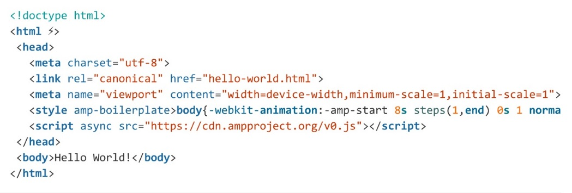

Figure 2. AMP HTML Program Code

    - Google AMP Cache
Google AMP Cache can be used to display AMP HTML pages in cache. Google AMP Cache is a proxy-based website content calling network to display all valid AMP documents. This network takes the AMP HTML page and will place it into the cache. Google AMP Cache can improve website page performance automatically. When using Google AMP Cache, documents and all JS files as well as all images loaded from the same source using HTTP 2.0 will get maximum efficiency. Google AMP Cache working system can be seen in figure 3. This cache is also accompanied by a built-in validation system that ensures that the web page is guaranteed to work and that the web page is not dependent on external content [18].
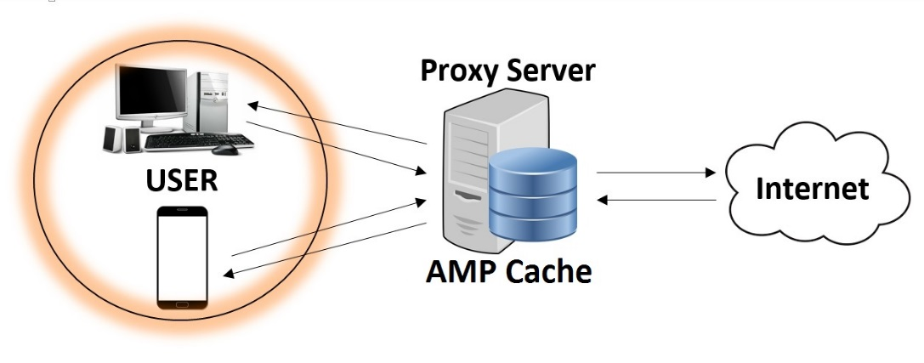
Figure 3. Google AMP Cache
This validation system runs a series of statements that ensure the markup of the website pages matches the AMP HTML specification. Other validator versions are available in one package on every AMP page that can record validation errors directly to the browser console when the web page is rendered [16-18], [23].

- CONCLUSION
It is necessary to improve service and quality in the use of web service as a means of utilizing e-commerce to customers. One that should be improved is the speed and lightness to access e-commerce website services when conducting transactions online. JavaScript programming language ​​has developed AMP to be used as an accelerator tool that allows websites to be opened faster almost without any delay due to the rendering process in the background. Users will not feel waiting when loading when using a smartphone device, so that e-commerce activity is more convenience because it feels light and fast with the accelerator tool on e-commerce website.

ACKNOWLEDGEMENTS
This research is supported by Departement of Computer System of Sekolah Tinggi Elektronika dan Komputer (STEKOM) Semarang under the supervision of Research institutions and community service of STEKOM Semarang, Indonesia.
REFERENCES
- S. Y. Lim and S. F. Wong, “Impact of Applying Aggregate Query Processing in Mobile Commerce,” International Journal of Business Data Communications and Networking, Vol. 8(2), pp. 1-17, 2012.
- J. K. Martinsen, H. Grahn and A. Isberg, “Using Speculation to Enhance JavaScript Performance in Web Applications,” IEEE Internet Computing, Vol. 17(2), pp. 10-19, 2013.
- KEMENKOMINFO, “Internet Users in Indonesia Number Six World Rank,” Ministry of Communications and Informatics, Jakarta, Indonesia, 2014.
- PUSKAKOM, “Internet Users Profile in Indonesia 2015,” Association of Indonesian Internet Service Providers (APJII), Jakarta, Indonesia, 2015.
- D. K. Gangeshwer, “E-Commerce or Internet Marketing: A Business Review from Indian Context,” International Journal of u- and e- Service, Science and Technology, Vol. 6(6), pp. 187-194, 2013.
- R. Lekha, Nair, D. Sujala and S. D. Shetty, “Streaming Big Data Analysis for Real-Time Sentiment based Targeted Advertising,” International Journal of Electrical and Computer Engineering, Vol. 7(1), pp. 402-407, 2017.
- M. Mufadhol, G. Aryotejo and A. Wibowo, “Netscan and Networx for Management Bandwidth and Traffic with Simple Routing,” TELKOMNIKA Telecommunication, Computing, Electronics and Control, Vol. 15(1), pp. 464-470, 2017.
- T. Zhu, Y. Guo, A. Ju, J. Ma and X. Wang, “An Insider Threat Detection Method Based on Business Process Mining,” International Journal of Business Data Communications and Networking, Vol. 13(2), pp. 83-86, 2017.
- J. Andreeva, I. Dzhunov, E. Karavakis, L. Kokoszkiewicz, M. Nowotka, P. Saiz and D. Tuckett, “Designing and developing portable large-scale JavaScript web applications within the Experiment Dashboard framework,” Journal of Physics: Conference Series, 396(052069), pp. 2-11, 2012.
- S. Misra and F. Cafer, “Estimating Quality of JavaScript,” International Arab Journal Of Information Technology, Vol. 9(6), pp. 535-543, 2012.
- M. Mufadhol, S. Siswanto, D. D. Susatyono and U. D. Maya, “The Phenomenon of Research and Development Method in Research of Software Engeneering,” International Journal of Artificial Intelligece Researh, Vol. 1(1), pp. 1-5, 2017.
- H. Yang, J. Li, J. Wang and X. Du, “Shortage of logistics for e-commerce in holiday,” International Journal of Information Technology and Management, Vol. 15(1), pp. 90-98, 2016.
- E. V. Pogorelova, I. V. Yakhneeva, A. N. Agafonova and A. O. Prokubovskaya, “Marketing Mix for E-commerce,” International Journal Of Environmental & Science Education, Vol. 11(14), pp. 6744-6759, 2016.
- K. Anusha, C. Yashaswini and S. Manishankar, “Segmentation of Retail Mobile Market Using HMS Algorithm,” International Journal of Electrical and Computer Engineering, Vol. 6(4), pp. 1818-1827, 2016.
- D. Gurram, B. V. Babu and V. Pellakuri, “Issues and Challenges in Advertising on the Web,” International Journal of Electrical and Computer Engineering, Vol. 4(5), pp. 810-816, 2014.
- S. J. S. Bhanu, A. V. Babu and P. Trimurthy, “Implementing Dynamically Evolvable Communication with Embedded Systems through WEB Services,” International Journal of Electrical and Computer Engineering. Vol. 6(1), pp. 381-398, 2016.
- S. Subramaniam, S. C. Haw and P. K. Hoong, “Bridging XML and Relational Databases: An Effective Mapping Scheme based on Persistent,” International Journal of Electrical and Computer Engineering, Vol. 2(2), pp. 239-246, 2012.
- G. Varma, “Google to roll out Accelerated Mobile Pages (AMP) to Main Search Engine Results Pages (SERPs),” Milestone’s Galexi® CMS Delivers A Rich AMP Experience, Milestone, Santa Clara, C.A, 2016.
- N. M. Hajli, “A study of the impact of social media on consumers,” International Journal of Market Research, Vol. 56(3), pp. 387-405, 2014.
- M. K. Mijinyawa and L. Abdulwahab, “An Extended Framework for Evaluation of Open Source Software Adoption in Small Businesses,” Research Journal of Information Technology, Vol. 6(4), pp. 248-269, 2014.
- M. Mufadhol, G. Aryotejo and D. Y. Kristiyanto, “Rule Based Reasoning Method for Safety Room by Means of Temperature Sensor and Motion Detector,” International Journal of Advanced Science Letters, Vol. 23(3), pp. 2481-2483, 2017.
- N. Newman, “Journalism, Media, And Technology Trends And Predictions 2017,” Digital News Project, Reuters Institute, United Kingdom, 2017.
- J. T. Park, H.G Kim and I. Y. Moon, “Design and Analysis of Content Transfer System Using JavaScript and D2D,” International Journal of Control Theory and Applications, Vol. 9(44), pp. 379-388, 2016.

