Web Application to Build Information System of National Seminar Alerts in Indonesia

Erlin*, Khusaeri Andesa*, Agustin*, Dahliyusmanto**
* Department of Informatics Engineering, STMIK Amik Riau
** Department of Informatics Engineering, Faculty of Engineering, Universitas Riau

Article Info |  | ABSTRACT
Article history:  Received Jun 12th, 201x  Revised Aug 20th, 201x  Accepted Aug 26th, 201x |  | The output of a research in the form of a proceeding published through a national seminar or an international conference has become a routine activity performed by lecturers as a researcher. The increasing atmosphere of disseminating the results of a study is directly proportional with the increasing number of universities, associations, or non-educational institutions organising either a national seminar or an international conference. Each seminar organiser posts their seminar relevant information through an official sites released by each organiser. However, to date, there has never been a storage that is able to compile all the information relevant to all national seminars held in Indonesia. This has resulted in the search done through search engines such as Google, Yahoo Search, Bing and others have not been efficient nor effective. A design of a web-based national seminar alert system is built to address this issue. This information system is able to display all the seminars organised in Indonesia in the current year in a storage and can be broken down based on the choices of topic, location, and time. Other additional facilities are that the application is able to send email messages to the application users as an early warning on the upcoming national seminar. Researchers can track each existing national seminar and always up-to-date on the most current national seminar.
Keyword:
Web application
Information system
Seminar alerts
Copyright © 201x Institute of Advanced Engineering and Science.
All rights reserved.
Corresponding Author:
Erlin,
Department of Informatics Engineering,
STMIK Amik Riau,
Jalan Purwodadi Indah, Km. 10, Panam-Pekanbaru, Riau
Email: erlin@stmik-amik-riau.ac.id

- INTRODUCTION
Research activity is one of the three pillars of higher education done by a lecturer. The Ministry of Research Technology and Higher Education (Kemeristekdikti) has annually and regularly offers grant programs for research and community services to all lecturers under Kemenristekdikti. To improve academician’s scientific publication quality and quantity, a publication is obliged as it is regulated under Permenristekdikti No. 44 of 2015 on the Higher Education National Standard [1]. Scientific publication and presenter on a national seminar or an international conference is the type of output that becomes annual achievement for each research scheme funded by Kemenristekdikti. Then increased atmosphere for the dissemination of research result through national seminar or international conference is directly proportional with the increase of the number of universities, associations, or non-educational institutions organising national seminar or international conference. Each seminar organiser posts their seminar related information through an official sites released by each organiser.
Based on the lecturer’s data on the forlap Kemenristekdikti, 39,392 lecturers are still in the level of Bachelor Degree (14.32%) from the total of 274,988 lecturers in Indonesia. The number of lecturers with a Master’s Degree is 179,087 (65.13%) and lecturers with PhD are 34,471 (12.54%), while the rest are 22,038 (8,01%) with a D4 (Associate Degree), Sp-1, Professionals, and non-degree (forlap, 2017). Based on the percentage, the largest composition of lecturers in Indonesia is both having their Master’s or Bachelor’s Degree (79.45%) whose majority make use of national seminar as the storage to disseminate their research result.
In disseminating their research, researchers/presenters will decide when, where, and how they will communicate their research result. Based on the interview with several research lecturers and an online survey, most of the lecturers input the keywords of national seminar followed by the keywords on the paper’s topic on a search engine when they are looking the information on a national seminar they are interested in. The next step is these researchers will then briefly review and click on a seminar link out of all the seminar options displayed by the search engine. If the accessed seminar is not time and location appropriate, then these researchers/presenters will refresh all the research result until they find the seminar they expected.
A design of a web-based national seminar information system is about to be built to address to this issue. This national seminar alert system will cover all the information on a national seminar organised in Indonesia for the current and the following years and can be made more specific based on location/region of the seminar. Then, this information system is also designed to be able to display national seminars based on the research discipline/topic to make it easier for the presenters to identify the kind of seminar to register to along with the time and location. Other developed facilities are that the information system is able to send Email messages to the users as an early warning on their registered national seminar. In this research, web technology will be implemented on seminar alert information system, which will be built so the information system can be accessed anytime and anywhere using an internet browser. Researchers can track all existing national seminar and always up-to-date with the most current national seminar.

- THEORETICAL BACKGROUND

2.1. National Seminar
National seminar is a forum for all researchers (not always a lecturer/academician) to present and discuss their research. Along with an academic journal or scientific journal, a national seminar provides an important channel for information exchange between researchers. A seminar is usually comprised of numerous presentation. A presentation is usually brief around 10-20 minutes, and then followed by a discussion. The result of a research can be bound in a written form as an academic manuscript and published as a seminar proceeding.
A seminar usually includes keynote speakers usually academicians, although it can also come from non-academician. A keynote speaker delivers a general lecture for 1-1½ hours. A national seminar is usually attended by several keynote speakers who present one after another. Aside from presentation, a seminar also includes a panel discussion or a roundtable related on numerous research issues.
A national seminar is usually arranged on one track or several tracks consisting of several parallel sessions with presenters presenting their paper in different rooms at the same time. A national seminar is sometimes followed by social activities or entertainment such as tourist attractions, which become a part of the seminar’s program. This national seminar is usually organised by a scientific community or a group of researchers for a common interest. A national seminar can sometimes be organised by a professional seminar organiser.
This forum is usually announced through a “call for paper (cpf)” on a poster/pamphlet/brochure sent to potential presenters, which contains an explanation on how to submit the manuscript. CPF mentions the theme of the seminar and the list of topics and the formalities of the forum, such as manuscript format, where to send, and submission due date. The seminar’s poster is usually sent through email, mailing list, or specific online service.

2.2. Web Application
Web application or commonly called as webapps is and application accessed through web browser as the client (Daniel, 2014). Client is a word commonly used in the discussion of client-server application. Client can become an application used to input. Client can be said as an application used to input information, while server is an application used to store information.
Web application consists of the following three main layers:
1. Presentation Layer
The first layer located on the side of user and commonly consisting of a web browser.
2. Application Layer
The second layer consisting of the technology resulting a more dynamic content, like Java servlets (JSP) or Active Server Pages (ASP).
3. Storage Layer
The third layer of data bases used to store displayed information.

The work process of the web application through the three main layers is presented on Figure 1 below.
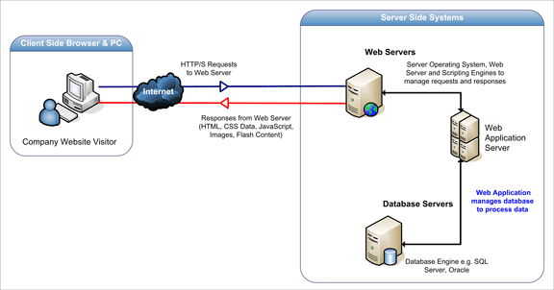

Figure 1. Three main layers of web application (Acunetic, 2016)

- ANALYSIS AND DESIGN

3.1. Requirement Spesification
System requirement is displayed on the use case diagram below, which shows the relationships between actor and system. Based on use case diagram in figure 2, there are three involved actors within the system, which are operator, organiser, and user. Operator is tasked to organise the topic and type of the seminar, manage provincial data, organiser data, and to validate registration. Organiser is tasked to manage seminar’s data. Besides, the organiser and the user can perform a seminar search based on particular characteristics, to see the list of the whole seminar, and to see future seminars. The strengths of the users (academician, practitioner, and general user) is that they are able to register their Email to obtain information on current news on upcoming seminar related to the focus of their research.

Figure 2. Use case diagram

3.2. Database Design
The database used in this application is SQL. The logic of this database is stored in the form of javascript and sql file. SQL database can be accessed using application that has been stored in server. The database design is shown in figure 3 which displays the relationships between one table and another in the form of interconnectedness between the primary key of each table.

Figure 3. Database design

- RESULT AND DISCUSSION

4.1. Main Menu Page

The display for the home page of the seminar alert information system is designed by implementing a user friendly concept, so it can be easily used by the user. There are three actors who have differing access rights. Operator can perform the processes of addition, deletion, editing, validating, monitoring, and controlling the whole system. National seminar organiser can perform seminar data addition, deletion, editing, and national seminar monitoring that have been inputted to the system. The user can see all national seminar data that have been registered by the organiser and can register to obtain news update on the most current seminar relevant to the concentration of each user. Figure 4 below is the home page for all three actors using the system.

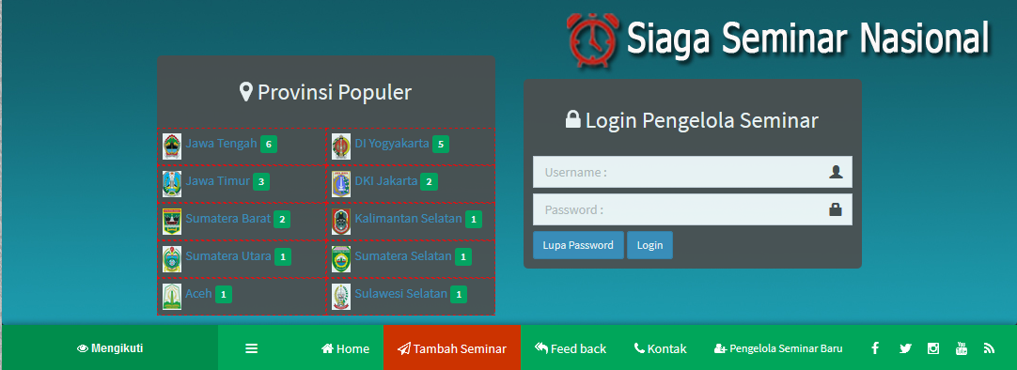

Figure 4. Home page display

The home page also provides seminar organiser’s login facility, the list of new seminar organisers, and add seminars. Besides, user’s menu is also provided for those who are interested to receive regular information on national seminars related to their concentration through the ‘follow’ menu. The home display is also able show the popular province to become the host of national seminar based on the seminar venue for each region/province.

4.2. Seminar National Organiser Menu

Each organiser has to first register from the menu new seminar organiser, which consists of main data on seminar organiser. The main data consists of contact person, organisation name, national seminar url, national seminar admin’s email, province of the venue, city, username and password of the organiser admin.

The next step for the organiser is to input data related to the registered national seminar. The inputted data is the national seminar event’s name, category, sub-category, event type, the opening date of the seminar, closing date of the seminar, due date, and the description of the national seminar. Figure 5 below shows the menu to add seminar for the organisers.

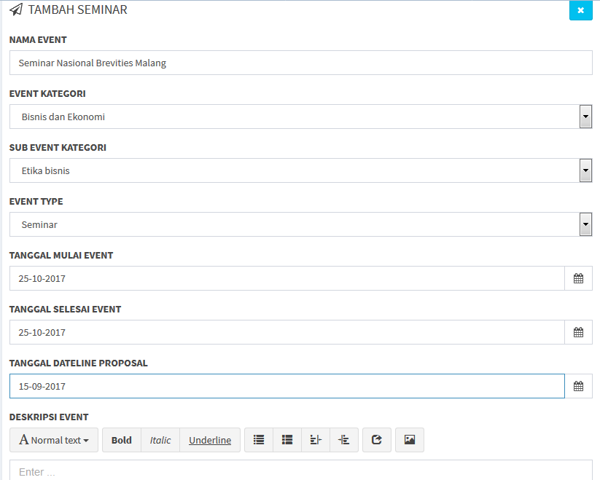

Figure 5. Input menu to add seminar

4.3. Academician, Practitioner, and Public User Menu
The users (academician, practitioner, public) can visit the national seminar alert page to obtain information on the national seminars in Indonesia that can be filtered based on topics, location, or the time of seminar commencement. National seminar alert allows for the user to receive free email notification on seminar that can be participates according to the topics and locations.
Figure 6 below shows the menu that can be used by the user to filter the result of national seminar search based on topics. There are 10 (ten) topics that can become the primary concentrations, such as business and economics, physics and life sciences, law, zoology, social studies and humanities interdisciplinary, health and medicine, mathematics and statistics, education, engineering and technology.

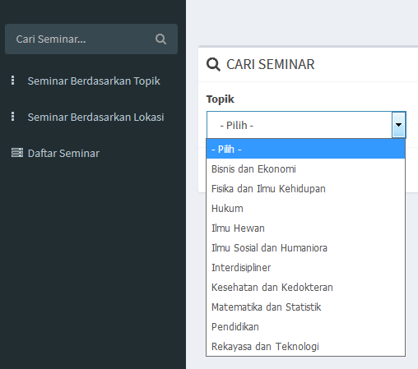

Figure 6. Seminar search based on topics

National seminar search result based on topic is shown in figure 7 below, filtered based on the topic of Physics and Life Science. The search result shows 5 (five) national seminars based on the topics which event’s venue are located in several regions.
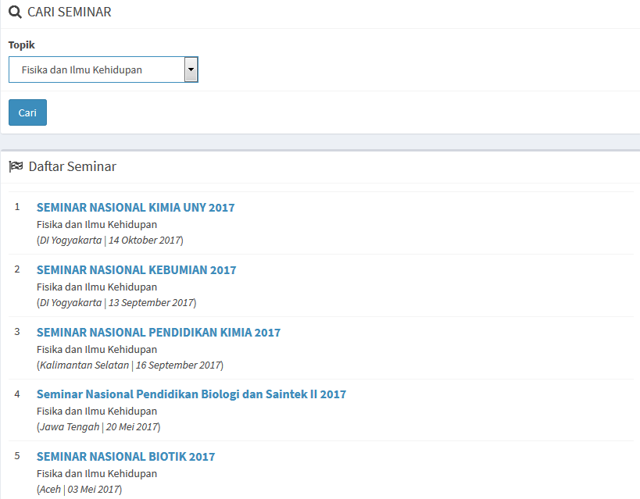

Figure 7. National seminar search result based on topics

National seminar search based on region/location also becomes the strength of this application. User can filter the national seminar based on wanted location by clicking on the search seminar menu based on location (figure 8) or national seminar per province (figure 9).

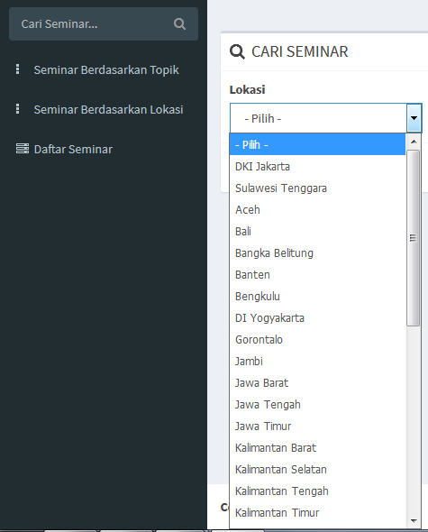

Figure 8. National seminar search based on location

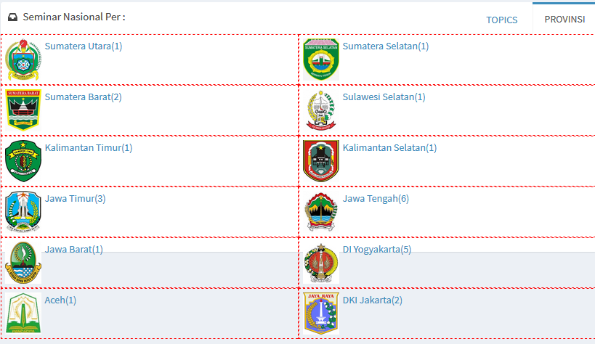

Figure 9. National Seminar per Province
Another specialty for this seminar alert information system is its ability to display a more detailed searches such as filtered based on category/topic, location, keyword, month and year, so it can provide a more specific search result. Figure 10 below shows a more detailed national seminar search menu.

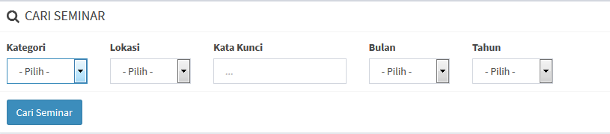

Figure 10. Seminar search based on category, location, keywords, month and year

A validated national seminar will be displayed on the home page on the upcoming seminar list as shown in figure 11 below.

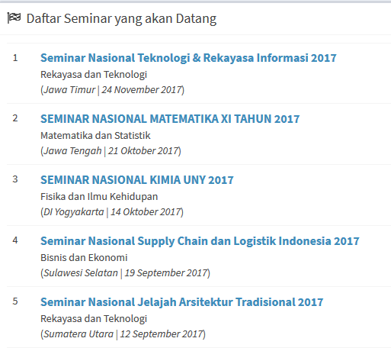

Figure 11. Upcoming seminar

- CONCLUSIONS
A design of web-based Indonesian national seminar alert information system has been built to overcome the issue of user’s (academician, practitioner, and public) difficulty to search for information on a national seminar relevant to the scope/research topic of each user. This seminar alert information system will cover the whole information on the national seminars organised in Indonesia in concurrent and following years and can be made into more specifically detailed based on location/region of the seminar. Although it can also be used by the user as the primary objective of this research, the system can also be used by the national seminar organiser to share clear and complete information for the user. National seminar alert also allows for the user to receive free Email notification seminars that participated according to the topic and location options. Researchers can track each existing national seminar and always be up-to-date with the most current news on national seminar.

ACKNOWLEDGEMENTS
The authors are grateful to the supportive partners, and the academic partners. A special thanks is addressed to Ministry of Research, Technology and Higher Education (Kemenristekdikti) Indonesia, for funding this research through Penelitian Strategis Nasional Scheme.

REFERENCES

- Permenristekdikti No 44 Tahun 2015. (2015). Standar Nasional Pendidikan Tinggi.
- Direktorat Riset dan Pengabdian kepada Masyarakat. (2016). Panduan Pelaksanaan Penelitian dan Pengabdian kepada Masyarakat di Perguruan Tinggi Edisi X.
- Zwass, V. (2016). Information System, Encyclopedia Britannica.
- Nash, J.F. (1989). Accounting information systems , Prentice Hall.
- Mc.Leod, R. & Schell. G.P. (2013). Management Information Systems, Prentice Hall.
- Daniel, N. (2014). Web Applications url: http://webtrends.about.com/od/webapplications/a/web_application.htm
- Acunetix. (2016). Web Applications: What Are They? What of Them? url: http://www.acunetix.com/websitesecurity/web-applications/
- Oracle. (2013). The Java EE 6 Tutorial url: https://docs.oracle.com/javaee/6/tutorial/doc/javaeetutorial6.pdf
- Wodaski, R. (2016). Microsoft Developer Network. ASP Technology Features Overview url: http://msdn.microsoft.com/en-us/library/ms972202.aspx
- Techopedia. (2016). Mobile Application (Mobile App). url: http://www.techopedia.com/definition/2953/mobile-application-mobile-app
- EngineersGarage. (2011). Android. url: http://www.engineersgarage.com/articles/what-is-android-introduction
- Social Compare. (2014). Android version comparison. url: http://socialcompare.com/en/comparison/android-versions-comparison
- Brewer, M. L. (2016). Facilitating The Dissemination Of Interprofessional Education And Practice Using An Innovative Conference Approach To Engage Stakeholders. Journal of Interprofessional Education & Practice. ELSEVIER.
- Hanbige, A. S., Sanderson, N. & Tin, T. (2016). Using Mobile Technology to Enhance Student Digital Information Literacy Skills: A Canadian Case Study. The ISFOR Journal of Education.
- Nunamaker, J.F., Chen, M. & Purdin, T.D.M. (1991). System Development in Information Systems Research. Journal of Management Information Systems, 7 (3), 89-106.
- Forlap. (2017). Data Dosen Indonesia. url: http://forlap.dikti.go.id/dosen/search tanggal akses 3 Mei 2016

