Novel Active Queue Management Scheme for Routers in Wireless Networks

Kennedy Okokpujie*, Chukwu Emmanuel*, Imhade Okokpujie**, Noma-Osaghae Etinosa*
*Department of Electrical and Information Engineering, Covenant University, Ota, Ogun State, Nigeria.
**Department of Mechanical Engineering, Covenant University, Ota, Ogun State, Nigeria

Article Info |  | ABSTRACT
Article history:  Received Jun 12th, 201x  Revised Aug 20th, 201x  Accepted Aug 26th, 201x |  | Stability and the prevention of congestion is the main aim of any decent network traffic management scheme. The protocol that drives congestion control in IP networks called The Transmission Control Protocol (TCP) is plagued by bandwidth underutilization when implemented on wireless networks. The management of network trunk queue size along with its antecedent delay issues with Active Queue Management (AQM) algorithms in such a way that overcomes the bandwidth underutilization issue faced by TCP flows in wireless networks is the goal of this paper. An adaptive TCP model specifically built for wireless networks was created. This made it possible to implement feedback control techniques in the chosen AQM design for queue management. The AQM policies were created with the help of Model Predictive Control (MPC) and Self-Tuning Control (STC). A very thorough comparison was made between the developed AQM scheme and the Early Detection Controllers that was used along with the fixed-parameter Proportional Integral (PI), originally. Under varying wireless network conditions, the results got from simulating the proposed queue management scheme in MATLAB® confirmed that the fixed PI and RED controllers were by comparison inferior in performance.
Keyword:
Model Predictive Control
Active Queue Management
Controllers,
Proportional Integral Random Early Detection
Copyright © 201x Institute of Advanced Engineering and Science.
All rights reserved.
Corresponding Author:
Kennedy Okokpujie,
Department of Electrical and Information Engineering,
Covenant University,
KM 10, Idiroko Road, Ota, Ogun State, Nigeria.
Email: kennedy.okokpujie@covenantuniversity.edu.ng

- INTRODUCTION
Automatic wireless industrial process control, mobile communication and the global information system are a few of the numerous, ubiquitous and unending innovations in wireless technology. Fresh ideas in technology always birth new hurdles that must be scaled. The interconnectivity of epic proportions provided by the internet has most recently added wireless access to its arsenals. Technologies, mostly mobile in nature are accessing internet services and creating a whole new dimension of heavy traffic. Controlling this traffic to avoid congestion and network collapse is a challenge in a class of its own [1][2].The internet has the Transmission Control Protocol (TCP) as its main stay when it comes to ensuring fidelity in the delivery of packets from source to destination nodes and traffic control in IP networks. The TCP is a good protocol for network traffic management but its congestion control technique causes severe bandwidth underutilization and performance degradation in wireless networks [3], [4], [5]. The irony of it all is the unpredictability of wireless connections and the fact that packet losses in wireless networks are caused more by disturbances in the link than by congestion. This reality is one of the reasons why trying to manage congestion in wireless media with the TCP invariably leads to bandwidth underutilization [6]. The trick proposed by the Internet Engineering Task Force was to use Active Queue Management (AQM) techniques on wireless networks with more focus on routers than source nodes for end-to-end congestion control. All these with the aim of boosting the performance of the TCP congestion control mechanism on wireless networks [1][7][8][10].
The ability to predict when congestion will occur in wireless networks and discard packets even before queuing buffers get full is the strength of AQM and its way of improving the way congestion is controlled. The current AQM algorithm being used on many routers is the Random Early Detection (RED). RED as an AQM algorithm is quite impressive but its shortcoming is its rigidity. It is quite challenging to tweak and adapt to diverse traffic scenarios [1]. The advent of the most recent dynamic TCP model has made the implementation of feedback control strategies in active queue management possible. This singular improvement has led to a lot of research interest in TCP congestion control mechanism. Still, majority of the control techniques designed and implemented for AQM have fixed network parameters and wired-network TCP model basis. The core problem of performance degradation and bandwidth underutilization still plague these AQMs especially when there is a change in network parameters.

BACKGROND OF STUDIES

A. Background Studies
The goal of this paper is to design a new AQM algorithm that when implemented on routers, improves wireless bandwidth utilization. Needless to say, complete utilization of wireless bandwidth is crucial since radio resources are scarce [5]. The focus of this paper would be the wireless local area network (WLAN).
The results anticipated are: adept queue utilization, coordinated queuing delay, and adaptability to varying network conditions.
1) Adept queue utilization: in steady state and transient conditions, the middle lane in queue utilization must be maintained. Queuing buffers must neither be empty (to prevent link underutilization) nor allowed to overflow (to prevent loss of packets and unwarranted retransmissions).
2) Coordinated queuing delay: the time it takes for a packet to be serviced after waiting diligently on a queue is termed queuing delay. Mathematically, it is the ratio between the queue length, q, and the link capacity, C. The norm is to make the queue delay as minimal as possible but then, small queue lengths could cause link underutilization. Therefore, a compromise is reached in designing the AQM to get an efficient utilization of the available bandwidth and minimal queue delay.
Sponsor: Covenant University, Ota, Nigeria.

3) Adaptability: there should be no degradation in performance when network parameters such as propagation delay TP, number of TCP sessions N, and link capacity C, change.

B. Wireless networking
Microwaves or radio waves form the channel that makes wireless communication between nodes in a network possible. Wireless networks offer the portability advantage that wired networks do not have. Wireless networks could be base-centered or ad-hoc. Wireless Local Area Networks (WLAN), Mobile Ad hoc Networks (MANETs) and Wireless Wide Area Networks (WWAN) are some of the many examples of wireless networks [6].
All wireless wide area networks are base-station dependent with all hosts communicating with each other through the base station (that is connected to a wired network). One wireless link is needed when communication is initiated between a mobile and a stationary host. In the case of a MANET, there are no base stations or access points but each host in a MANET functions as independent transceivers that are capable of discovering routes and forwarding packets to other hosts in the MANET. Thus hosts in a MANET make use of several links and the MANET is usually called a multi-hop wireless network [6].
Defined by the IEEE 802.11X range of standards [12], WLAN has increased in popularity in recent years due to improvements in wireless technology and upsurge in the use of mobile devices.
Wireless networks are plagues by a plethora of problems among which are frequent handovers, channel fading, interference from other devices, weather conditions and obstructions. High error bit rates and loss of packets in wireless networks can be caused by these problems [4][3][9].

C. Queue management
All routers in a wireless networks have buffers. Data packets transmitted in wireless networks queue in the buffer before being moved to their destinations. When the incoming packets are arriving at a rate higher than the outgoing link capacity, the queue length increases and decreases if the outgoing link capacity is faster than the rate at which packets are arriving at the buffer [13].
The aim of queue management is to ensure optimal network performance through the efficient control of the packet traffic arriving and leaving the buffer. Most queue management schemes employ the use of probability in controlling network traffic due to the unpredictable nature of packet arrival rates [14]. The Drop Tail (DT) queue management scheme currently being implemented on most routers admits packets into the buffer as long as the buffer remains unfilled and discards packets once the buffer becomes full [13]. The packet discarding probability function of the Drop Tail scheme is given as:

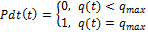 (1)

q(t) stands for (instantaneous queue size) while q stands for (buffer size).
The inefficiency of the Drop Tail queue management scheme is glaring. It does not yield itself easily to global synchronization. Global synchronization makes it possible for a large number of TCP conforming networks that are multiplexed to use a single outgoing link to simultaneously reduce their traffic once congestion is [13]. There is also the nagging problem of lock-out in the Drop Tail scheme. Lock-out is a situation where links are prevented from accessing the buffer because it has been monopolized by other links [15]. Delay variations, unacceptable packet loss rate and unwarranted oscillations are some other shortcomings of the drop tail queue management scheme [13][15].

D. Transmission Control Protocol (TCP)
Timely, orderly and reliable delivery of packets to nodes [16][28] in a network is not guaranteed by the Internet Protocol (IP). Funny enough, it tries to deliver packets at the maximum possible rate without any recourse to the possibility of congestion at such rates. But the Transmission Control Protocol is part of the TCP/IP interconnectivity management scheme of the internet. It makes provision for the timely, reliable and in-order sending and delivery of packets and also provides congestion control [16]. The major drawback of the TCP scheme is the algorithm it uses to carry out congestion control. The algorithm sees a packet loss as a sign of congestion and in response, reduces the window size. But when applied to wireless networks, loss in packets due to other causes but congestion, leads to an unneeded reduction in transmission rate [17][29].

RELATED WORKS

The goal of achieving adept congestion control in wireless networks have been the subject of many research efforts in recent years. Some of the suggestions that have been made or implemented include:

• Creating adaptive TCP algorithms that can work in a wireless network.

• Deploying active queue management techniques specially designed to work with wireless networks.

A. Creating adaptive TCP algorithms that can work in a wireless network.
The following mechanisms were discovered by Xiang Chen et al to be able to improve the performance of TCP implemented in wireless networks:
1. Link-layer solutions
2. End-to-end solutions
3. Proxy-based solutions
4. Split-connection solutions
In mobile communication for instance, the split connection scheme makes it possible to break a TCP connection into two parts at the base station and tune it for adaptability to the wireless connection between the base station and the host device. I-TCP (Indirect TCP) and M-TCP (Mobile TCP) are typical examples of the split-connection scheme as shown in figure 1

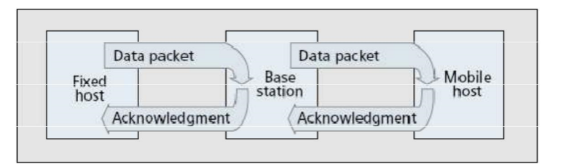

Figure 1: Split Connection of Wireless TCP [4]
Proxy-based solutions make use of an intelligent agent at the base station that detect packet losses and ensures that the TCP responds to such losses correctly. Examples of schemes that make use of an intelligent agent at the base station include Advertised Window Control, Snoop and Ack Regulator.
The link between the host and network is the focus of the Link-Layer scheme. It incorporates a link recovery mechanism that covers up link losses that could trigger unnecessary reduction in transmission rates by the TCP algorithm. The AIRMAIL (Asymmetric Reliable Mobile Access in Link-Layer) and the TULIP (Transport Unaware Link Improvement Protocol) are some examples of Link-Layer solution.
When TCP is improved by quick recovery from several packet losses using selective acknowledgement (SACK) or by predicting when handoffs are about to occur, the end-to-end approach is being used. Freeze-TCP and fast retransmissions are some of the many examples of the end-to-end scheme, as shown in figure 2.

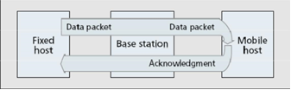

Figure 2: End-to-end wireless TCP connection [4]

There are more modifications that have been done to the conventional TCP for applications in wireless networks and they include [3][4][5]:
1. Soft-state Transport Layer Caching Approaches
2. Hard-state Transport Layer Approaches
3. Pure Link-level Approaches
4. Soft-state Cross Layer Signing Approaches
5. Pure End-to-end Transport Level Approaches

Reference [18] detailed how congestion-sensitive protocols used for transmitting videos in wireless networks make use of end-to-end loss differentiation algorithms (LDA) because it can classify losses as either wireless link losses or congestion losses. In their modification, [19] made the connections of mobile hosts to base stations look like wired connection with the use of an Adaptive TCP (A-TCP). It is a type of Link-aware scheme and could be called the virtual host model. Suggestions by [17], iterated three ways of mitigating the challenge faced by the implementation of TCP in wireless networks and they are:
1. The use of link layer information to distinguish link losses from congestion losses.
2. Adaptively estimating the size of the wireless network bandwidth and using the information garnered to set the network parameters.
3. The use of ECN (Explicit Congestion Notification) to keep the source node aware of all losses in the wireless link.

B. AQM-Based Schemes

Many internet applications were developed using the normal TCP algorithm and developers do not like the idea of designing a different set of application specifically for devices using wireless networks. Thus, the Active Queue Management (AQM) technique was developed to control congestion in wireless networks. AQM schemes are designed to work under worst case scenarios but the major drawback of already existing AQM models is the degradation in performance encountered once changes are made to the network parameters for which they were designed. Some of the AQM techniques in use include:
a. The ANFIS (Adaptive Neuro-Fuzzy Inference Controller) merges neural network and fuzzy logic in developing a very dexterous AQM scheme [23].
b. The SMVSC (Sliding Mode Variable Structure Control) uses a special sliding variable to develop an AQM scheme that is resistant to noise and variations in network parameters [10].
c. A PI Controller that uses phase margins and gain to develop a self-tuning AQM scheme [1][24][25].

d. The use of online parameters to develop a self-tuning controller. The designed controller can adapt to varying network conditions using Minimum Variance [26]
e. Improving the steady state and transient behaviour of TCP with Neural Network Based Models [27]

Despite these fantastic designs, too little work has been done on AQM designs for wireless networks [17].
In the estimated Bit Error Rate (BER) technique proposed by [9] a good throughput in the wireless network is obtained by trying to estimate the effect of bit error rate with a high gain observer and adapting the packet drop probability to the prevalent time-varying link condition and network load. In [17] a dynamic TCP scheme for wireless networks that has the capacity to adapt to the unpredictability of time-delays was developed and called the H-Infinity scheme.

- RESEARCH METHOD

I. SIMULATION STUDIES
This section discusses the various parameters used for the study with the different experiments performed. This section is divided into three subsections which are:
1. Selection of Controller parameters
2. Wireless Simulation
3. Experiments

A. Selection of Controller Parameters
The simulation experiments were carried out using MATLAB®. These were the controller parameters:
1. The router’s buffer size; ${ q}_{max}=800 packets$
2. Queue length (reference); ${ q}_{ref}=200 packets$
3. Initial queue length; $q_{o}=150packets.$
4. The link capacity (bottleneck); $c=3750 packets$
5. The link capacity in Mb/s; $c=15Mb/s$
6. Packet size; 500 bytes.

1) RLS Parameters
These parameters were determined heuristically and they are:

1. Initialized RLS parameter estimate; ǿ0 = 0.
2. Parameter estimation covariance matrix initialized as; P = 1000I. (I) is the identity matrix.
3. Forgetting factors are initialized as; λo =0.92; λ(0) = 0.9.
4. Formula used to update the forgetting factors; λ(k) = λoλ(k-1) + (1- λo)

2) MPC Parameters
The MPC weighting scalar matric are:

1. Q =5, S = 1 (ensures that importance is placed more on minimization of error signal rather than penalizing the control effort made).
2. Prediction horizons: N_{p} = 5; N_{u} = 3.
3. Sampling time: Ts = Ro (to synchronize the MPC to the TCP packet marking dynamics)

3) STC Parameters

1. Closed-loop discrete pole: t₁ = 0.9 (for closed-loop stability).
2. Tim constant: about 9 samples.

PI Parameters
The wired access network PI controller design is tested on the simulated wireless network. The equations used for the implementation of the PI controller are:

$C_{PI}\left(s\right)=K_{PI}\frac{\frac{S}{w_{g}}+1}{S}$ (2)
$w_{g}=\frac{2N^{+}}{{\left(R^{+}\right)}^{2}C} and K_{PI}=\left|\frac{\frac{jw_{g}}{P_{queue}}+1}{\frac{{\left(R^{+}C\right)}^{3}}{{\left({2N}^{-}\right)}^{2}}}\right|$ (3)
To design a PI controller that can stabilize the TCP/AQM system, the following conditions must be met:
For all N ≥ N⁻ and R₀ ≤ R⁺
$w_{g}=\frac{2N^{+}}{{\left(R^{+}\right)}^{2}C} ; K_{PI}=\left|\frac{\frac{jw_{g}}{P_{queue}}+1}{\frac{{\left(R^{+}C\right)}^{3}}{{\left({2N}^{-}\right)}^{2}}}\right|; C_{PI}\left(s\right)=K_{PI}\frac{\frac{S}{w_{g}}+1}{S}$ (4)

Taking the worst case values as N- = 30 and R+ = 0.24 gives wg= 0.278 and KPI = 1.3748e – 6. The phase margin can then be calculated according to equation:
$PM≈90°-\frac{180°}{π}{w^{2}}_{g}$ (5)

$PM≈90°-\frac{180°}{π}w^{2}g=85.6°$ (6)

- Wireless Simulations
The network topology depicted in Figure 3 was used to carry out the simulation experiment. The setup of the network using Simulink is shown in Figure 4 and Figure 5. N represents the TCP connection count.

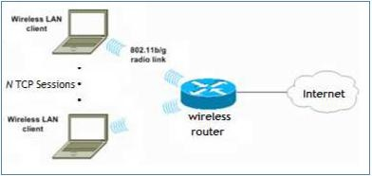
Figure 3: Network Topology simulated
(Source: www.cisco.com)

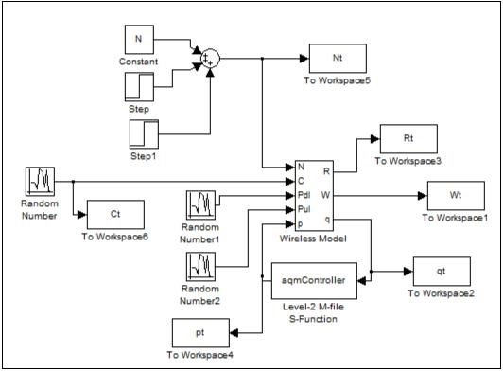
Figure 4: Simulation of wireless topology using Simulink

- Experiments
The various load and delay conditions under which the simulation was carried out are listed below:

1. High network load and long propagation delay
2. Low network load and long propagation delay
3. High network load and small propagation delay
4. High network load and small propagation delay
5. Low network load and small propagation delay

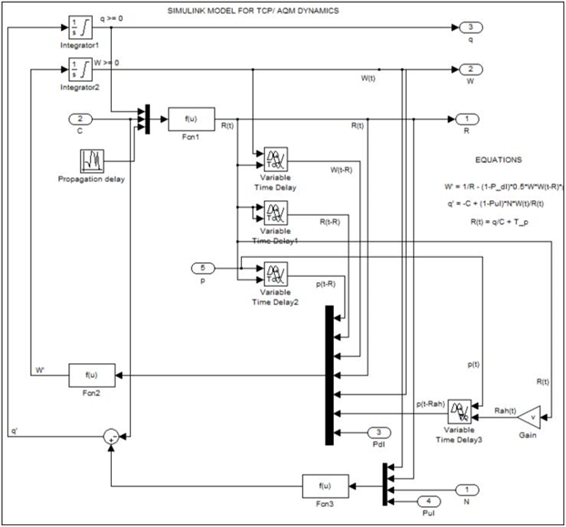

Figure 5: Wireless Subsystem Block Model (modeled with Simulink)

- RESULTS AND ANALYSIS
3.1. Result
- The faltering of the control action of the MPC in experiments one and two was due to the greater priority placed on error minimization over control moves.
- The queue length and window size oscillations experienced by all four controllers in experiment two was due to the closeness of the pole of the TCP window dynamics (${2N}/{{R_{o}}^{2}C}$) and the queue dynamics ($1/{R_{o}})$ to the origin.
- The pole of the TCP queue dynamics ($1/{R_{o}})$ was also close to the origin in experiment three hence the oscillations experienced by the queue length.

3.2. Experiment 1: Low network load and short propagation delay

With:
- N = 30 long-lived FTP flows and 40 short-lived http flows of web traffic.
- Propagation delay: $T_{p}$= 0.06 sec.
- Simulation time: 90 seconds.

Observations for experiment 1:

1. The four controllers had queue delays that were acceptable and maintained a good queue length with stable window size.
2. The control actuator (drop probability) of the MPC faltered with minimal oscillation in window size and queue length.

These observations are illustrated in Figure 6.

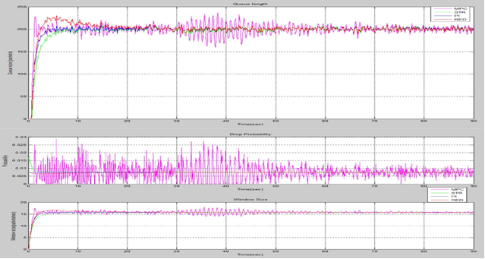

Figure 6: Simulation of Low network load and short propagation delay

3.2. Experiment 2: Low network and long propagation delay

With:
- N = 30 long-lived FTP flows and 40 short-lived http flows of web traffic.
- Propagation delay: $T_{p}$= 0.20 sec.
- Simulation time: 90 seconds.
Observations for experiment 2:
- The four controllers had slower response.
- The RED and the MPC responses were inferior in comparison to the responses of the PI and the STR with respect to queue length (delay) and window size regulation.
- The MPC and the RED had some degree of oscillations in their queue length and window size.
- The oscillations of the RED had bigger amplitude and a settling time that was longer than that of the MPC.
- The degree of oscillations experienced by the STR and the PI were much lower.
These observations are illustrated in Figure 7.

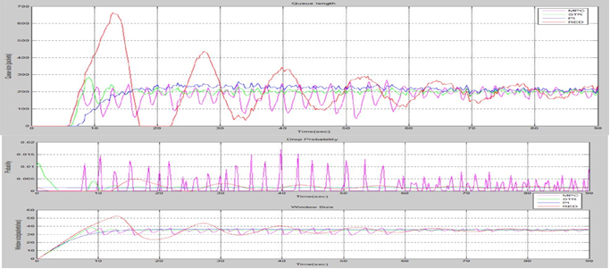
Figure 7: Simulation of Low network load and long propagation delay
3.3. Experiment 3: High network load and long propagation delay

With:

1. N = 300 greedy FTP sessions.
2. Propagation delay: = 0.2 sec.
3. Simulation time: 90 seconds.

3.4. Experiment 4: High network load and short propagation delay
With:
1. N = 300 long-lived FTP flows.
2. Propagation delay: = 0.06 sec.
3. Simulation time: 90 seconds.

Observations for experiments 3 and 4:
1. The four controllers had queue delays that were acceptable and maintained a good queue length with stable window size.
2. Spikes appeared in the MPC response after 30 seconds.

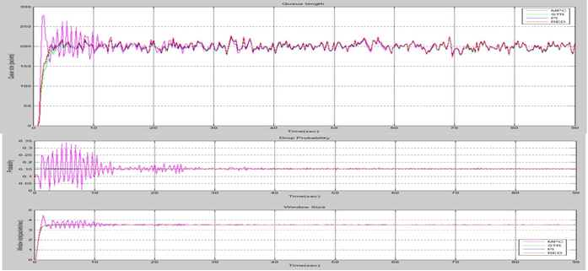

Figure 8: Simulation of High network load and long propagation delay

- CONCLUSION
This paper dealt with two adaptive strategies for active queue management schemes for wireless networks, the Predictive Controller and the Self-Tuning Regulator. After simulations with MATLAB®, it was discovered that the two adaptive strategies for active queue management schemes had better performance ratings over fixed PI and RED controllers when the wireless network parameters were varied. Since wireless network parameters are never static, the use of adaptive strategies for active queue management in wireless network is proposed. But as mobile handheld devices continue to increase in processing speeds, the MPC’s prospect as the AQM scheme of choice is better than that of the STR due to its unique ability to efficiently deal with the time-varying delays and unpredictability of wireless networks.

ACKNOWLEDGEMENTS
We appreciate Covenant University, Ota, Nigeria for the sponsorship of this paper publication.

REFERENCES

- Y. Hong and O. W. W. Yang, “Adaptive AQM Controllers for IP Routers with a Heuristic Monitor on TCP Flows,” Int. J. Communication Systems, vol. 19, pp. 17–38, Jul., 2005. DOI: 10.1002/dac.742.
- S.N. Bhatti and J, Crowcroft, “QoS-Sensitive Flows: Issues in IP Packet Handling,” IEEE Internet Computer, Jul-Aug, pp. 48-57, 2000.
- H. Balakrishnan, V.N. Padmanabhan, S. Seshan and R.H. Katz, “A Comparison of Mechanisms for Improving TCP Performance over Wireless Links,” IEEE/ACM Trans. Netw., vol. 5, no. 6, pp. 756-760, Dec., 1997.
- Y. Tian, K. Xu and N. Ansari, “TCP in Wireless Environments: Problems and Solutions,” IEEE Radio Commun., pp. S27-S32, Mar., 2005.
- M. Patel, N. Tanna, P. Patel and R. Banerjee, “TCP over Wireless Networks: Issues, Challenges and Survey of Solutions,” Comput. Sci. Dept. Univ. Texas, Richardson, TX, 2001.
- X. Chen, H. Zhai, J. Wang and Y. Fang, “A Survey on Improving TCP Performance over Wireless Networks,” Dept. Elect. Comput. Eng., Univ. Florida, Gainesville, FL, 2005.
- C.V. Hollot, V. Misra, D. Towsley and W. Gong, “Analysis and Design of Controllers for AQM Routers Supporting TCP Flows” IEEE Trans. Autom. Control, vol. 47, no. 6, pp. 945-959, Jun., 2002.
- V. Misra, W. Gong and D. Towsley, “Fluid-based Analysis of a Network of AQM Routers Supporting TCP Flows with an Application to RED,” in SIGCOMM’00, Stockholm, 2000. pp. 151-160.
- T. Wen, C. Chen, Z. Ding and T.C. Tang, “A Novel AQM Scheme for Wireless Networks with BER Estimation”, in Proceedings of the 17th World Congress The International Federation of Automatic Control, July 6-11, 2008, pp. 2919-2923.
- R. Fengyuan, L. Chuang, Y. Xunhe, S. Xiuming and W. Fubao, “A Robust Active Queue Management Algorithm Based on Sliding Mode Variable Structure Control,” in IEEE INFOCOM, 2002. pp. 13-20.
- R. Chang, W. Chen and Y. Wen, “Hybrid Wireless Network Protocols,” IEEE Trans. Veh. Techol., vol. 52, no. 4, pp. 1099-1109, Jul., 2003.
- R. Flickenger, C. Aichele, S. Büttrich, L.M. Drewett, et al, “Network Design,” in Wireless Networking in the Developing World, 2nd ed. Hacker Friendly, 2007, ch. 3, pp. 27-94.
- R. Nikaeen, “Combined Queue-Rate Active Queue Management for Internet Congestion Control,” M.S. thesis. Dept. Elect. Comput. Eng., Univ. Toronto, Toronto, 2001.
- Wolfgang Garn, “Theory of Queuing Systems and Network Simulation with OPNET,” Dept. Math. Control, Hybrid Syst. Simulation Techniques, Tech. Univ. Vienna, Vienna, 1999.
- B. Braden, D. Clark, J. Crowroft, B. Davie, et al, "RFC2309: Recommendations on Queue Management and Congestion Avoidance in the Internet," April 1998.
- D.E. Comer, “Reliable Stream Transport Service (TCP),” in Internetworking with TCP-IP, vol. 1, 3rd Ed. New Jersey: Prentice-Hall, 1995, ch. 13, pp. 191-229.
- H. Balakrishnan, V.N. Padmanabhan, S. Seshan and R.H. Katz, “A Comparison of Mechanisms for Improving TCP Performance over Wireless Links,” IEEE/ACM Trans. Netw., vol. 5, no. 6, pp. 756-760, Dec., 1997.
- R. Chang, W. Chen and Y. Wen, “Hybrid Wireless Network Protocols,” IEEE Trans. Veh. Techol., vol. 52, no. 4, pp. 1099-1109, Jul., 2003.
- S. Seok, S. Hong and C. Kang, “An Adaptive Flow Control Scheme for Improving TCP Performance in Wireless Internet,” Dept. Elect. Eng., Korea Univ., Seol, 2002. pp. 458-465.
- D. Agrawal and F. Granelli, “Redesigning an Active Queue Management System,” in IEEE Communications Society Globecom, 2004. pp. 702-706
- D. Melchor-Aguilar and S. Niculescu, “Computing Non-Fragile PI Controllers for Delay Models of TCP/AQM Networks,” Int. J. Control, vol. 82, no. 12, pp. 2249-2259, Dec., 2009. DOI: 10.1080/00207170902984741
- P. Quet and H. Ozbay, “On the Design of AQM Supporting TCP Flows Using Robust Control Theory,” IEEE Trans. Autom. Control, vol. 49, no. 6, pp. 1031-1036, Jun., 2004.
- R. Alasem, M.A. Hossain, I. Awan and H. Mansour, “ANFIS Based AQM Controller for Congestion Control,” in International Conference on Advanced Information Networking and Applications, 2009. DOI: 10.1109/AINA.2009.125.
- Honggang Zhang, C.V. Hollot, D. Towsley and V. Misra, “A Self-Tuning Structure for Adaptation in TCP/AQM networks,” Nat. Sci. Found., Arlington, VA, Tech. Rep. DOD F30602-00-0054,
- Q. Chen, and Oliver W. W. Yang, “On Designing Self-Tuning Controllers

for AQM Routers Supporting TCP Flows Based on Pole Placement,” IEEE J. Sel. Areas Commun., vol. 22, no. 10, pp. 1965-1974, Dec., 2004.
- Heying Zhang, B. Liu, L. Xiao and W. Dou, “A New Self-tuning Active Queue Management Algorithm Based on Adaptive Control,” Nat. Univ. Defence Technol., Changsha, Hunan, China. © IFIP International Federation for Information Processing. 2005, pp. 310-316.
- K. Rahnami, P. Arabshahi and A. Gray, “Neural Network Based Model Reference Controller for Active Queue Management of TCP Flows,” Jet Propul. Lab., California Inst. Technol., CA. © 2005 IEEE, IEEEAC paper #1408.
- Okokpujie Kennedy O., Okoyeigbo Obinna, Okhaifoh J.E., Omoruyi Osemwegie, Nsikan Nkordeh. “Performance Analysis and Modeling of MIMO Systems” International Journal of Applied Engineering Research ISSN 0973-4562 Volume 11, Number 23 (2016) pp. 11537-11541
- Okoyeigbo Obinna, Okokpujie Kennedy, Omoruyi Osemwegie and Nkordeh Nsikan. “Comparative Analysis of Channel Estimation Techniques in SISO, MISO and MIMO Systems.” International Journal of Electronics and Telecommunications. 2017, vol.63. no.3

