Performance Evaluation of Quarter Shift Dual Tree Complex Wavelet Transform Based Multifocus Image Fusion Using Fusion rules

N.Radha¹, T.Ranga Babu²
¹ Department of Electronics and Communication Engineering, Aditya Engineering College, Surampalem, A.P, India
² Department of Electronics and Communication Engineering, RVR & JC College of Engineering, Guntur, A.P, India

Article Info |  | ABSTRACT
Article history:  Received Jun 12th, 201x  Revised Aug 20th, 201x  Accepted Aug 26th, 201x |  | In this paper, multifocus image fusion using quarter shift dual tree complex wavelet transform is proposed. Multifocus image fusion is a technique that combines the partially focused regions of multiple images of the same scene into a fully focused fused image. Directional selectivity and shift invariance properties are essential to produce a high quality fused image. However conventional wavelet based fusion algorithms introduce the ringing artifacts into fused image, due to lack of shift invariance and poor directionality. The quarter shift dual tree complex wavelet transform has proven to be an effective multi-resolution transform for image fusion with its directional and shift invariant properties. Experimentation with this transform led to the conclusion that the proposed method not only produce sharp details (focused regions) in fused image due to its good directionality and also removes artifacts with its shift invariance in order to get high quality fused image. Proposed method performance is compared with traditional fusion methods in terms of objective measures.
Keyword:
Multi Focus Image Fusion
Quarter shift dual tree complex wavelet transform
Multi-resolution transform
Fused image
Objective measures
Copyright © 201x Institute of Advanced Engineering and Science.
All rights reserved.
Corresponding Author:
N.Radha,
Department of Electronics and Communication Engineering,
Aditya Engineering College,Surampalem,
Andhra Pradesh, India.
Email: radha_naina@yahoo.com

- INTRODUCTION
The derivation of an image that comprises all relevant objects in focus became impossible due to the restricted depth of focus of optical lenses in CCD devices [1]. The solution to this problem is multi-focus image fusion, which combines multiple images of the same scene into a composite image which is more feasible for visualization and detection [2].The multi-focus image fusion methods and spatial and transform domain methods[3].Transform domain algorithms, namely, the multi-resolution algorithms, are more robust since the human visual system deals with information in a multi-resolution way, which is in line with the processing principle of transform domain algorithms.
In literature various multi-resolution techniques are developed like the laplacian pyramid [4], gradient pyramid [5], discrete wavelet transform (DWT) [6], stationary wavelet transform (SWT) [7],multi-resolution singular value decomposition (MSVD) [8],discrete cosine harmonic wavelet transform (DCHWT) [9] and double density discrete wavelet transform (DDDWT) [10].The major problem with pyramid based methods is lack of spatial orientation selectivity, which results in blocking effect in the fused image. Use of DWT can prevent this pitfall. But DWT suffers from aliasing, dearth of shift invariance and directionality. Shift invariance and directional selectivity are primary to fused images’ quality. The conventional wavelet based fusion algorithms introduce the ringing artifacts into fused image, which limit the use of DWT for image fusion.
The dual tree complex wavelet transform (DTCWT) [11] is one of the most precise ones eliminating dearth of shift invariance and directional sensitivity caused by DWT.DTCWT, being of near shift invariance and better directional selectivity, can well represent details in fused image. However, in DTCWT, the process of designing filters is a little complicated due to its requirement for satisfying both bi-orthogonal and phase conditions. The quarter shift dual tree complex wavelet transform (q shift DTCWT) is a solution to simplify the construction of filters in DTCWT, producing better fusion results. The q shift DTCWT has verified to be an effective multi-resolution transform for image fusion with its ability to pick up the directional and shift invariant properties.

- QUARTER SHIFT DUAL TREE COMPLEX WAVELET TRANSFORM
The DWT that is intensely sampled suffers from a dearth of shift invariance in 1-D and directional sensitivity in N-D. To conquer these problems, DTCWT, which is approximately shift-invariant, computationally efficient and directionally selective, is developed. The DTCWT is an advanced wavelet transform which produces the real and imaginary parts of transform coefficients by using a dual-tree of real wavelet filters. Implementation of the DTCWT is done with two different two-channel FIR filter banks. For one of the filter banks the output is considered to be the real part (Tree A), while for the other filter bank the output is considered to be the imaginary part (Tree B). Two critically sampled filter banks are used by the DTCWT; for a d-dimensional image the redundancy is 2d. Figure 1reflects three levels of the filter bank structure for 1-D DTCWT.
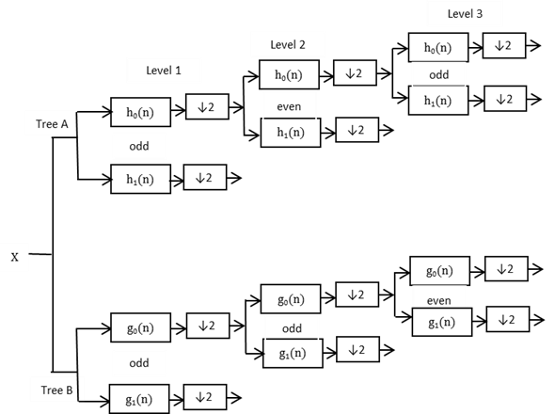

Figure 1. Filter bank structure for DTCWT

Due to its shift invariance, images fused by DTCWT are smooth and continuous while images fused by DWT contain irregular edges. Another major superiority of DTCWT is good directional selectivity since DTCWT produces six sub-bands for both real and imaginary parts in (±15∘, ±45∘, ±75∘) at each scale, whereas DWT merely presents limited directions in (0∘, 45∘, 90∘), which improves the transform precision and keeps more detailed information.
However, there exist a few problems with the odd/even filter approach in DTCWT [11]:
• Good symmetry doesn’t exist in the sub-sampling structure
• Frequency responses are slightly different for the two trees;
• The filter sets need to be bi-orthogonal, rather than being orthogonal, as they are linear phase. This reflects that preservation of energy doesn’t exist between the signals and transform domains.
To minimize and overcome all of the above, a q shift DTCWT is proposed, as in Figure. 2, where one can notice even length in all the filters beyond level 1.
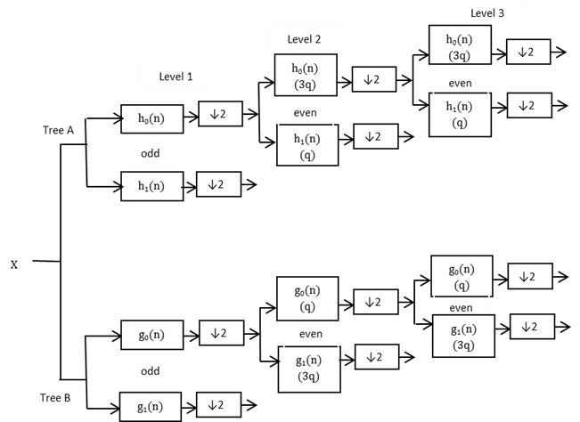

Figure 2. q shift DTCWT Filter structure

Beyond level 1, 1/2 sample delay difference is obtained with filter delays of 1/4 and 3/4 of a sample period (instead of 0 and 1/2 a sample for our original DTCWT). An asymmetric even-length filter and its time reverse can achieve this. Owing to the asymmetry, these can be designed to produce an orthonormal perfect reconstruction wavelet transform. Reverse of Tree-A filters are Tree-B filters, and reverse of analysis filters are reconstruction filters, so all filters are from the same orthonormal set. Same frequency responses are reflected in both the trees. Though the separate responses are asymmetric, the combined complex impulse responses are conjugated symmetric about their mid points. It is for this reason that symmetric extension still works at image edges.

- PROPOSED METHOD
When two input images A and B are considered, the proposed method contains the following steps:
  - Perform l-level q shift DTCWT on source images A and B to get low and high-frequency sub- bands at each level l and direction d denoted as

$A:\left\{L_{l}^{A},H_{l,d}^{A}\right\}, and B:\left\{L_{l}^{B},H_{l,d}^{B}\right\}$ (1)
Where $L_{l}^{A}{,L}_{l}^{B}$ : low frequency coefficients

${ H}_{l,d}^{A},H_{l,d}^{B}$ : high frequency coefficients
- Fusion of low- frequency sub- bands: Shannon entropy based fusion rule is used to fuse low frequency coefficients in low- frequency sub- bands using Eqs. (2)-(6) .
- Shannon entropy of low-frequency coefficients in a region R centered at $\left(x,y\right)$ is calculated as

$E_{A}\left(x,y\right)=\sum_{i,j}{L_{l}^{A}}{\left(i,j\right)}^{2}log{{(L}_{l}^{A}\left(i,j\right)}^{2})$ (2)
$E_{B}\left(x,y\right)=\sum_{i,jϵR}{L_{l}^{B}}{\left(i,j\right)}^{2}log{{(L}_{l}^{B}\left(i,j\right)}^{2})$ (3)

- salient information is extracted from each image low-frequency coefficients at location $\left(x,y\right)$as

$S_{A}(x,y)=\frac{E_{A}\left(x,y\right)}{E_{A}\left(x,y\right)+E_{B}\left(x,y\right)}$ (4)

$S_{B}(x,y)=\frac{E_{B}\left(x,y\right)}{E_{A}\left(x,y\right)+E_{B}\left(x,y\right)}$ (5)

Low-frequency coefficients are fused as

$L_{l}^{F}\left(x,y\right)=S_{A}\left(x,y\right)L_{l}^{A}\left(x,y\right)+S_{B}(x,y)L_{l}^{B}\left(x,y\right)$ (6)

- Fusion of high-frequency sub-bands: high-frequency coefficients in high-frequency sub- bands are fused based on fusion rule using Eq. (7), to select the larger absolute value of the high-frequency coefficients,since these coefficients correspond to edges and object boundaries etc.

$H_{l,d}^{F}(x,y)=\left\{\begin{aligned}H_{l,d}^{A}\left(x,y\right), if\left|H_{l,d}^{A}\left(x,y\right)\right|≥ \left|H_{l,d}^{B}(x,y)\right| \\ H_{l,d}^{B}(x,y), &if\left|H_{l,d}^{A}\left(x,y\right)\right|<\left|H_{l,d}^{B}(x,y)\right|\end{aligned}\right.$ (7)
- Perform l-level inverse q shift DTCWT on the composited low- and high-frequency sub-bands to obtain the fused image.

- EVALUATION
The proposed method performance can be evaluated by reference and non-reference objective measures
4.1 reference measures
- Peak Signal to Noise Ratio (PSNR): The PSNR between the ground truth image R and the fused image F is defined as [12]
(8)
- Structural Similarity Index Measure (SSIM): Representation of SSIM between the ground truth image R and fused image F is given by Zhou et al. [13] as

(9)

4.2 Non-reference measures
- Standard deviation: It is used to evaluate the fused image contrast. Which is defined as [14]:
$σ=\sqrt{\sum_{i=0}^{L}{{\left(i-\overline{i}\right)}^{2}}}h_{I_{f}}\left(i\right),\overline{i}=\sum_{i=0}^{L}{{ih}_{I_{f}}}$ (10)

- Spatial Frequency (SF): To quantity the clarity level of an image spatial frequency can be used. If the SF value is larger it denotes better fusion result:
$RF=\sqrt{\frac{1}{MN}\sum_{x=1}^{M}{\sum_{y=2}^{N}{{\left[I_{F}\left(x,y\right)-I_{F}\left(x,y-1\right)\right]}^{2 }}}}$ (11)
$CF=\sqrt{\frac{1}{MN}\sum_{x=1}^{M}{\sum_{y=2}^{N}{{\left[I_{F}\left(x,y\right)-I_{F}\left(x-1,y\right)\right]}^{2 }}}}$ (12)
$SF=\sqrt{{RF}^{2}+{CF}^{2}}$ (13)

- RESULTS AND ANALYSIS
The proposed method is verified on multi-focus referenced images, non-referenced images and microscopic images. Comparison of performance of the proposed method is done with existing DWT [6], SWT [7], MSVD [8], DCHWT [9] and DDDWT [10] fusion methods.

5.1. Experiment on referenced images
The first experiment is performed on artificially created images with divergent focus levels. In this experiment three images Cameraman, Boat and Lena are used as reference. Two blurred images are produced by filtering the referenced image with a Gaussian filter of 5˟5. Both reference and artificially generated blurred images are shown in Figures 3, 4 and 5.

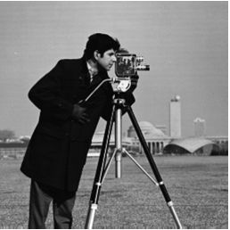 | 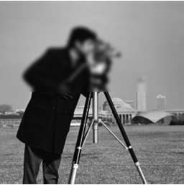 | 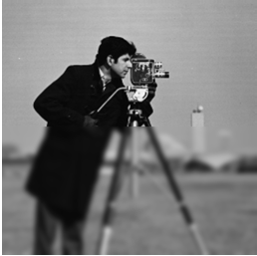
Reference image | top blurred image | bottom blurred image
Figure 3. Reference and blurred images of Cameraman
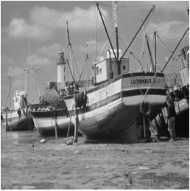 | 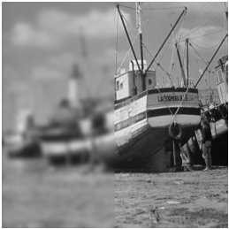 | 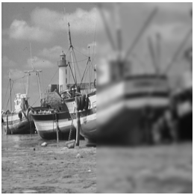
Reference image | Left blurred image | Right blurred image
Figure 4. Reference and blurred images of Boat
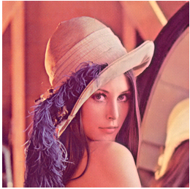 | 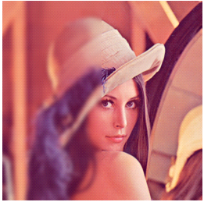 | 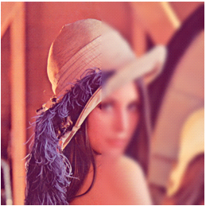
Reference image | Left blurred image | Right blurred image
Figure 5. Reference and blurred images of Lena
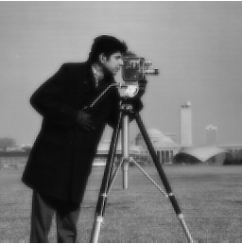 | 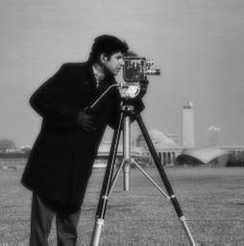 | 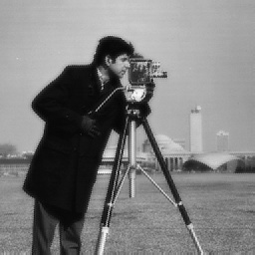
DWT | SWT | MSVD
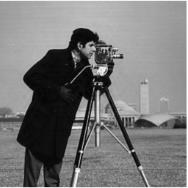 | 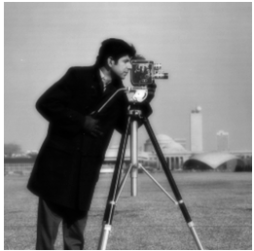 | 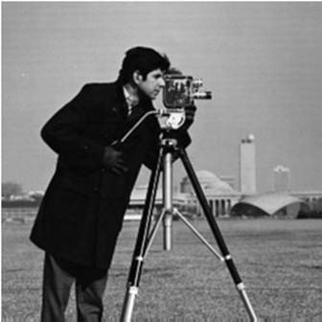
DCHWT | DDDWT | proposed method
Figure 6. Comparisons of fused images of different fusion methods (Cameraman)
 |  | 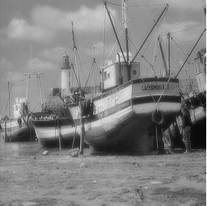
 |  | DWT |  | SWT |  | MSVD
 | 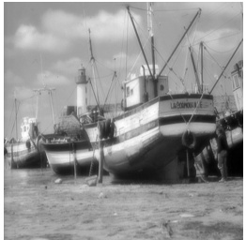 |  | 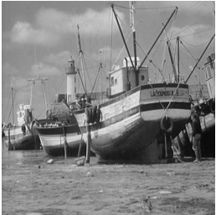 |  |  | 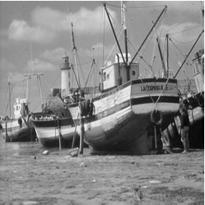
DCHWT |  |  |  | DDDWT | proposed method
Figure 7. comparision of fused images of different fusion methods (Boat)
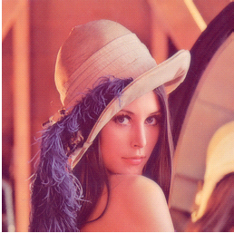 | 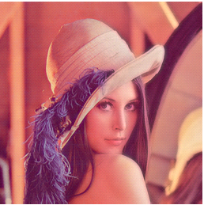 | 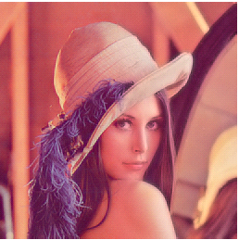
DWT | SWT | MSVD
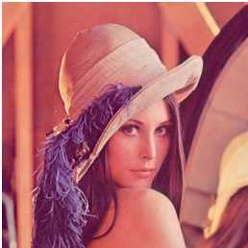 | 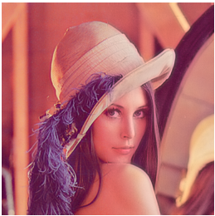 | 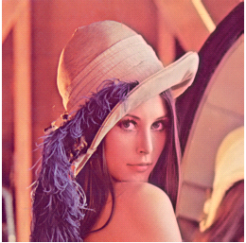
DCHWT | DDDWT | proposed method
Figure 8. Comparison of fused images of different fusion methods (Lena)

The experimental results are reflected in Figures 6, 7 and 8, where one can find that DWT, MSVD and DDDWT methods provide poor edge information compared to DCHWT. Proposed method performs well compared to fusion methods in Table 1.

Table 1. Comparison of reference measures of proposed method with different fusion methods
 | Test image
Fusion method | Cameraman |  | Boat |  | Lena
 | PSNR | SSIM | PSNR | SSIM | PSNR | SSIM
DWT [6] | 27.4231 | 0.8903 | 27.9141 | 0.8758 | 29.9345 | 0.9814
SWT [7] | 30.8535 | 0.9643 | 31.9237 | 0.9631 | 32.1914 | 0.9896
MSVD [8] | 29.2801 | 0.8642 | 30.7809 | 0.9186 | 31.3313 | 0.9868
DCHWT [9] | 40.0761 | 0.9076 | 40.6855 | 0.9690 | 36.3184 | 0.9953
DDDWT [10] | 28.6193 | 0.8159 | 29.1821 | 0.8608 | 32.5541 | 0.9910
Proposed method | 44.3526 | 0.9927 | 44.1491 | 0.9947 | 36.8943 | 0.9957

From Table 1 it can be observed that, PSNR and SSIM values of all test images of proposed method are high which indicates that the proposed method preserves the image details (focus regions) in fused image in a better way.

5.2. Experiment on non-referenced images
The second experiment is run using Pepsi and Clock images with different focus levels as presented in Figures 9 and 10 respectively.

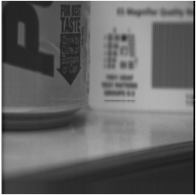 | 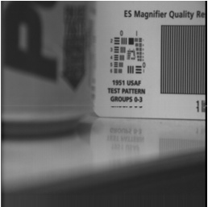
foreground focused | background focused

Figure 9. Non-referenced Pepsi image

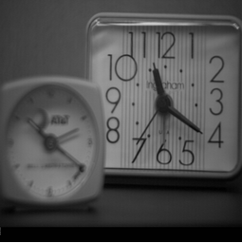 | 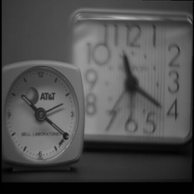
background focused | foreground focused

Figure 10. Non-referenced Clock image

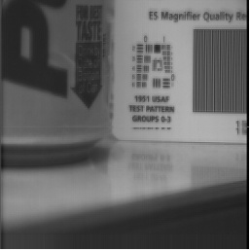 | 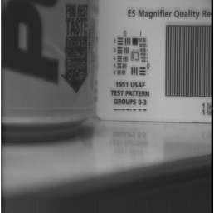 | 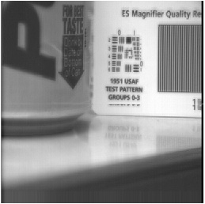
DWT | SWT | MSVD
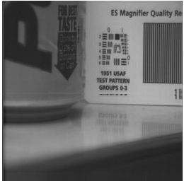 | 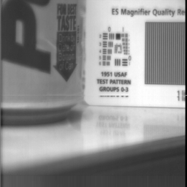 | 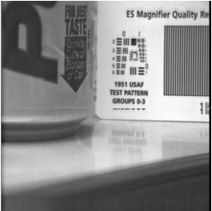
DCHWT | DDDWT | proposed method

Figure 11. Comparison of fused images of different fusion methods (Pepsi)

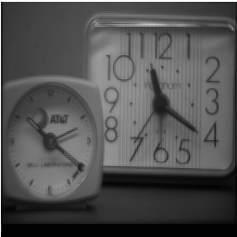 | 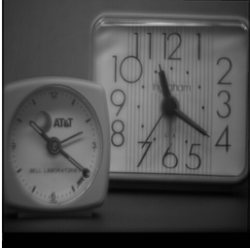 | 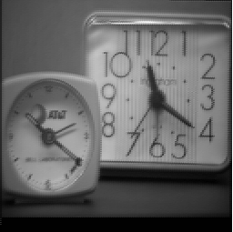
DWT | SWT | MSVD
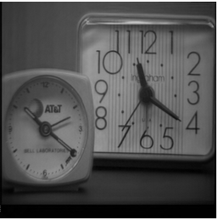 | 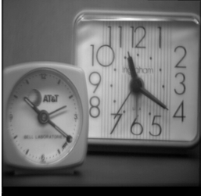 | 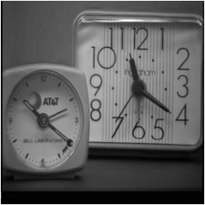
DCHWT | DDDWT | proposed method

Figure 12.Comparison of fused images of different fusion methods (Clock)

The experimental results of Pepsi and Clock image are shown in Figure 11 and 12. One can notice that the fused images produced using the proposed method gives better image quality compared to other methods.

5.3. Experiment on non-referenced microscopic images
The third experiment is to combine multi-focus microscope images as presented in Figure 13.

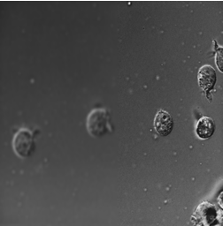 | 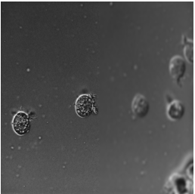
focused on right | focused on left
Figure 13.Non-referenced microscopic image
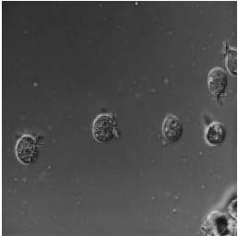 | 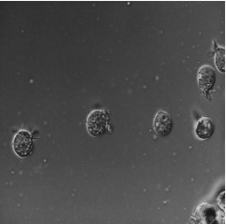 | 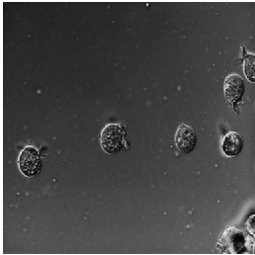
DWT | SWT | MSVD
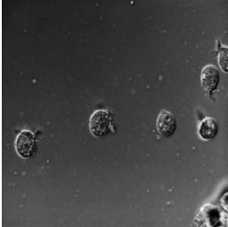 | 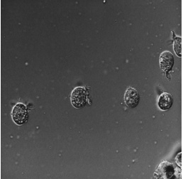 | 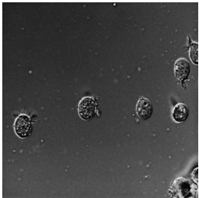
DCHWT | DDDWT | proposed method

Figure 14.Comparison of fused images of different fusion methods microscopic image

The experimental results of microscopic image are shown in Figure 14. The proposed method well transfers focus details into fused image from source images than other methods.

Table2. Comparison of non-reference measures of proposed method with different fusion methods
 | Test image
Fusion method | Pepsi |  | Clock |  | microscope
 | SD | SF | SD | SF | SD | SF
DWT [6] | 43.9368 | 13.7941 | 39.5437 | 9.0516 | 18.0925 | 8.8698
SWT [7] | 43.9723 | 13.3940 | 39.8556 | 10.9479 | 18.6411 | 11.1288
MSVD [8] | 44.0172 | 13.8258 | 39.6455 | 11.2043 | 18.7129 | 11.5933
DCHWT [9] | 44.3854 | 14.8529 | 40.3674 | 12.2549 | 19.2598 | 12.7251
DDDWT [10] | 43.5475 | 9.6315 | 39.3944 | 8.8223 | 18.0099 | 8.0941
Proposed method | 44.9180 | 15.5403 | 41.1259 | 13.7913 | 19.7708 | 13.3553

Table 2 presents the SD and SF performance comparison of various fusion methods. A high SD and SF value shows that high contrast and sharpness are preserved in fused image. It is found that the proposed method has higher SD and SF values when compared to other fusion methods for all test images. Ultimately it is noticed that the proposed fusion method obtains the better objective and subjective quality.

- CONCLUSION
In this paper, multi-focus image fusion using quarter shift dual tree complex wavelet transform is proposed. Good directionality, high degree of shift-invariance, phase information and computational efficiency of q shift DTCWT make the algorithm suitable for image fusion and help to produce a high quality fused image. Experimental results demonstrate that the proposed method preserves the image details in a far better way and extensively improves the image sharpness compared to the other fusion methods with very less information loss. The proposed fusion method is tested on both multi-focus and microscopic images. This indicates that it is well suited for real time applications.

REFERENCES
- P. Shah, et al., “Multifocus and multispectral image fusion based on pixel significance using multiresolution decomposition,” Signal Image and Video Processing, vol.7, pp.95-109, 2013.
- Y. Chai, et al., “Multifocus image fusion scheme using focused region detection and multiresolution,” Optics Communications, vol. 284, pp. 4376-4389, 2011.
- Y. Chai, et al., “Multifocus image fusion scheme based on features of multiscale products and PCNN in lifting stationary wavelet domain,” Optics Communications, vol. 284, pp. 1146–1158, 2011.
- E. H. Adelson, et al., “Pyramid methods in image processing,” RCA Engineer., vol.29, pp.33-41, 1984.
- V. Petrovic and C. Xydeas, “Gradient-based multiresolution image fusion,” IEEE Transactions Image Processing, vol.13, pp. 228–237, 2004.
- Wei-Wei Wang, et al., “Multifocus Image Fusion In Wavelet Domain,” Proc. of the Second International Conference on Machine Learning and Cybernetics, pp. 2887-2890, 2003.
- S. T. Li, et al., “Performance comparison of different multi-resolution transforms for image fusion,” Information Fusion, vol.12, pp.74–84, 2011.
- V.P.S. Naidu, “Image Fusion Technique using Multi-resolution Singular Value Decomposition,” Defence Science Journal, vol. 61, pp. 479-484, 2011.
- B. K. Shreyamsha Kumar, “Multifocus and multispectral image fusion based on pixel significance using discrete cosine harmonic wavelet transform,” Signal, Image and Video Processing, vol.7, pp.1125–1143, 2013.
- JyotiPujar and R.R.Itkarkar, “Image Fusion Using Double Density Discrete Wavelet Transform,” International Journal of Computer Science and Network, vol. 5, pp.6-10, 2016.
- I.W. Selesnick, et al., “The dual-tree complex wavelet transform,” IEEE Signal Processing Magazine, vol.22, pp.123–151, 2005.
- V.P.S. Naidu, “Discrete Cosine Transform-based Image Fusion,” Defence Science Journal, vol.60, pp.48-54, 2010.
- W. Zhou, et al., “Image quality assessment: from error visibility to structural similarity,” IEEE Transactions on Image Processing, vol. 13, pp. 600-612, 2004.
- X. Zhang, et al., “A new image fusion performance measure using Riesz transforms,” International Journal for Light and Electron Optics,vol.125,pp. 1427–1433 ,2014.

