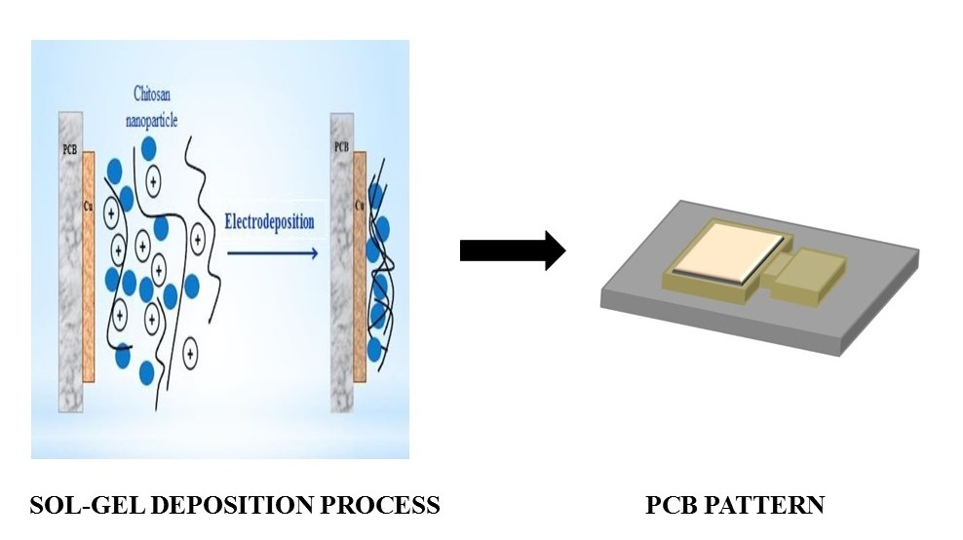

Fig. 1: Electrochemical deposition process.

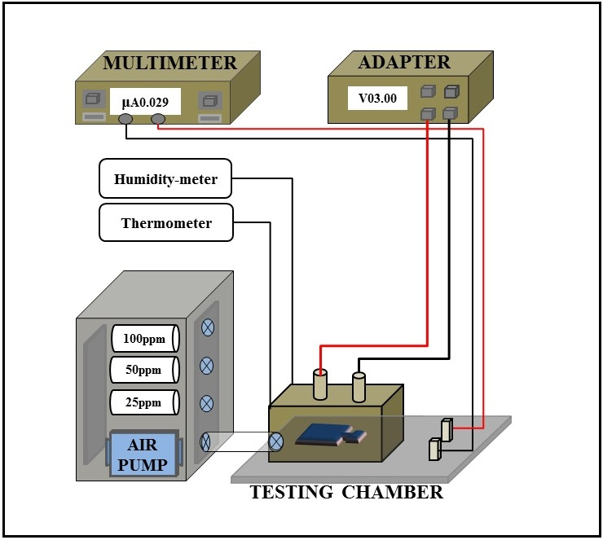
Fig. 2. The breath-analyzer setup.

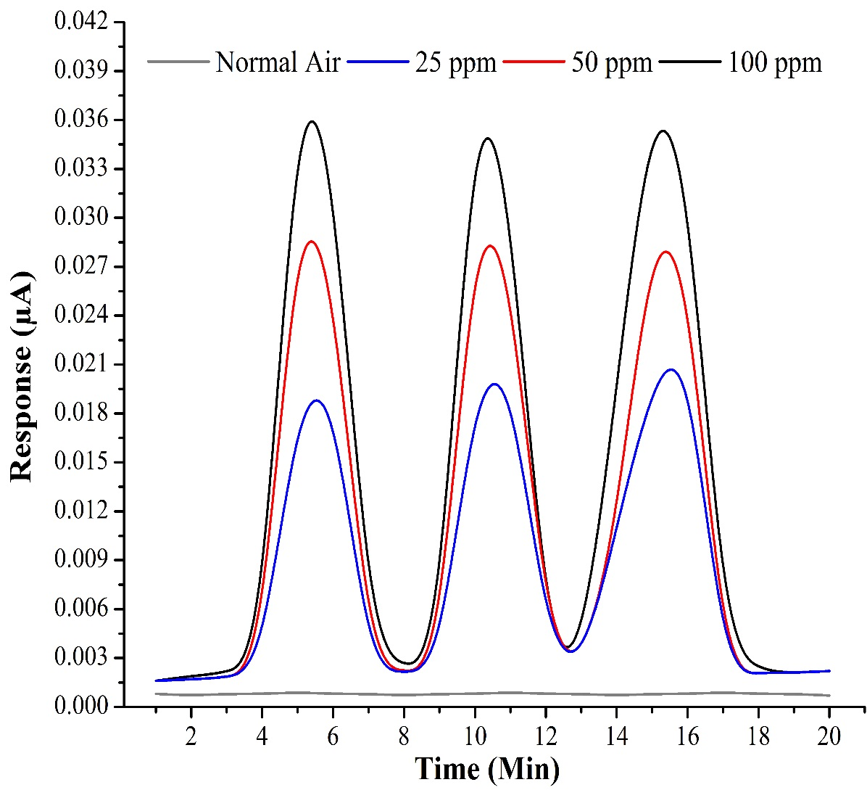

Fig. 3. The response of the breath-analyzer to normal air and different concentrations of ethanol gas.

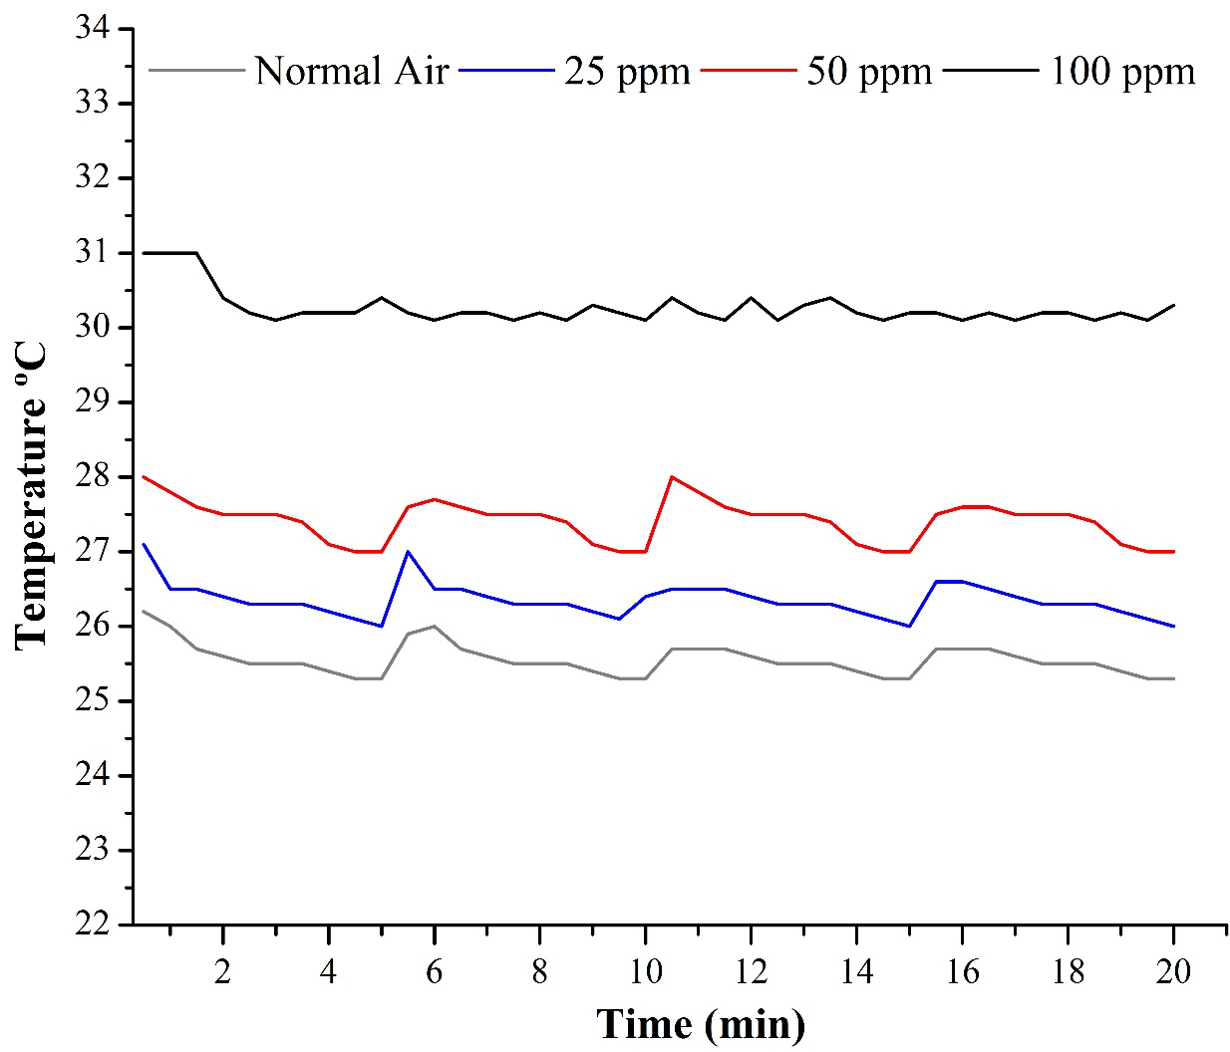
Figure. 4. The change of temperature inside the testing chamber.

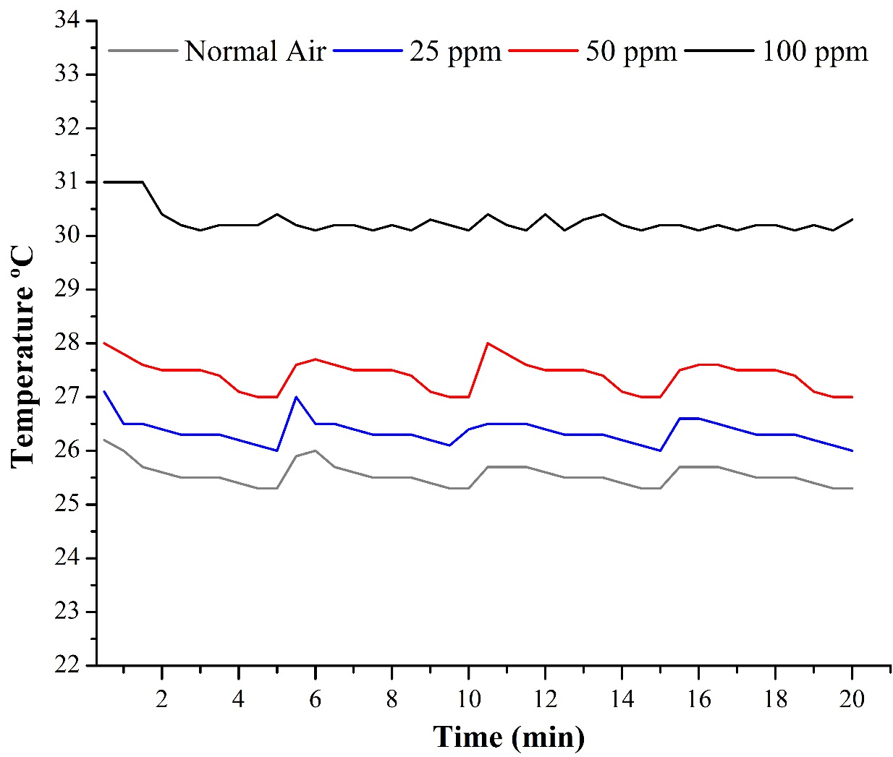
Fig. 5. The change of humidity inside the testing chamber.

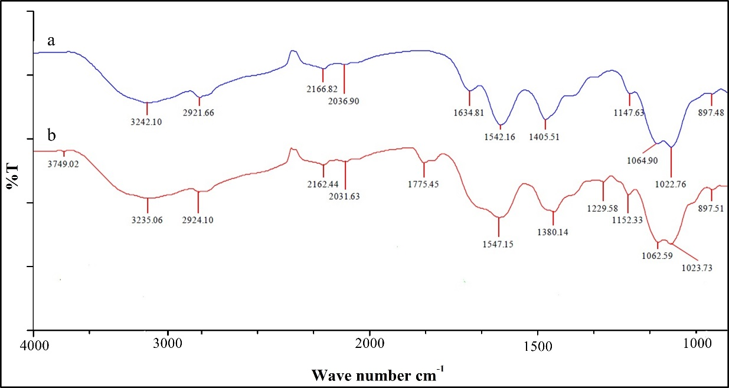
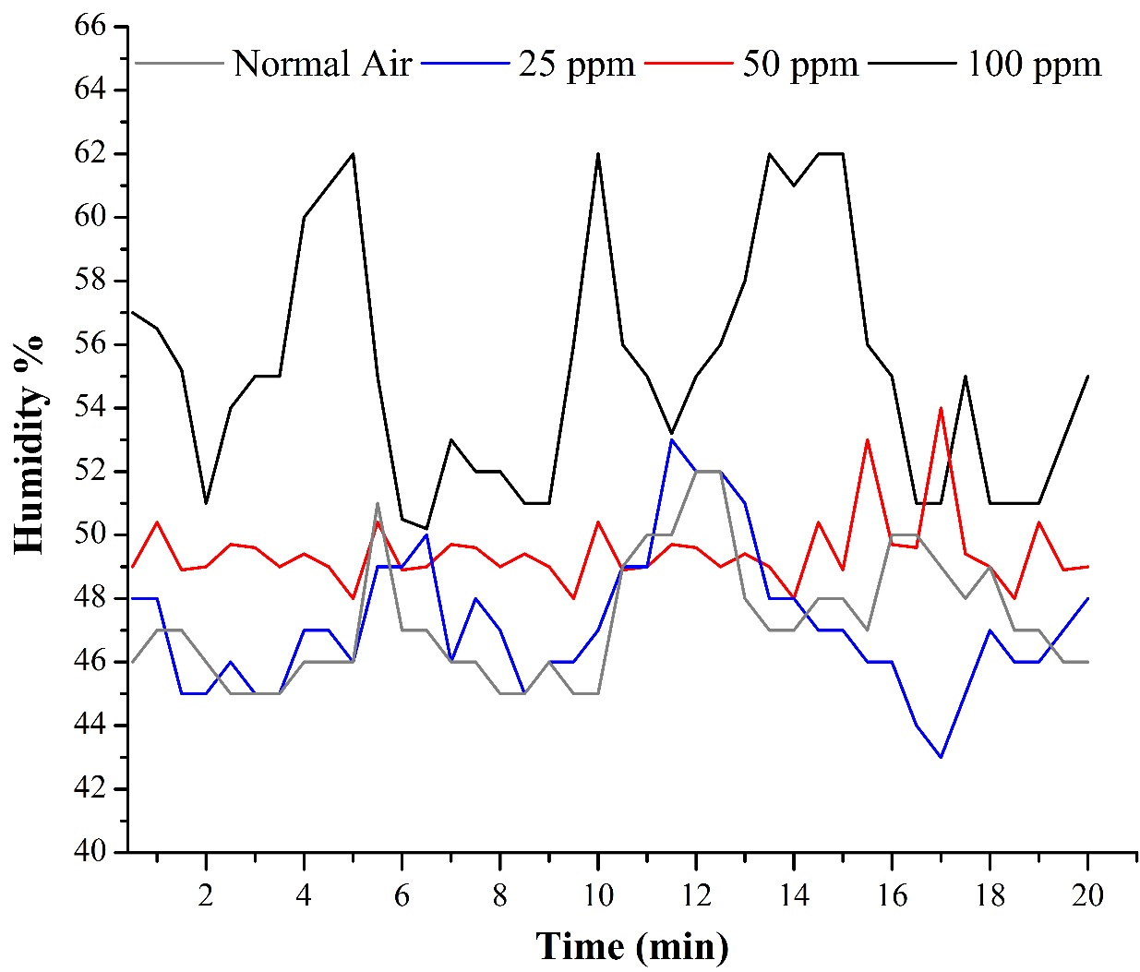
Fig. 6. FTIR spectra over lay Chitosan and chitosan- roselle blend.

