Comparison of Voltage-Vector Control based on Duty Cycle Analysis in Three-Phase Four-Leg System Active Filter

Indriarto Yuniantoro*†, Rudy Setiabudy*and Ridwan Gunawan*
*Department of Electrical Engineering, Faculty of Engineering, Universitas Indonesia, Depok. Indonesia
†Department of Electrical Engineering, Faculty of Industrial Technology, University of Trisakti. Jakarta

Article Info |  | ABSTRACT
Article history:  Received Augst 14th, 2015  Revised:  Accepted: |  | Comparison of voltage vector control in various forms of tetrahedron that result from switching combination on three-phase four-leg system active filter is presented especially asymmetric tetrahedron shape which is a projection pqr-coordinate into αβ0-coordinate. Parameter tetrahedrons such as modulation boundary-line, reference vector, switching duration time and duty cycle are described. Duty cycle analysis conducted on the Shen’s model, the Zhang’s model, the Perales’s model and asymmetric’s model are presented. The characteristics results showed that switching combination of each IGBT conductor especially its reviews on the neutral wire. Asymmetric tetrahedron can be proposed as control technique in three-phase four-leg system active filter.
Keyword:
Voltage vector
Reference vector
Modulation boundary-line
Asymmetric tetrahedron
Duty cycle

Copyright © 2015 Institute of Advanced Engineering and Science.
All rights reserved.
Corresponding Author:
Indriarto Yuniantoro
Department of Electrical Engineering, Faculty of Engineering.
Universitas Indonesia, Kampus UI Depok 16424. Indonesia.
Email: indy_singnet@yahoo.com

- INTRODUCTION
Three-phase system active filter topology has evolved from three-phase three-wire becomes three-phase four-wire and then three-phase four-leg. In three-phase four-wire system active filter, the fourth-wire to form a neutral wire is connected to midplace in couples of split capasitor while in three-phase four-leg system the fourth-wire as a neutral wire is connected to midplace in a pair of IGBT conductor. Steps in compensation current control on three-phase four-wire system resembles as on three-phase three-wire system. Control of the compensation current is done by adjudting voltage-vector either on three-phase four-wire system or three-phase four-leg system active filter. Voltage-vector is three-dimensional space-vector where the vector is result of on-off switching combination signal from pair of IGBT conductor. Although different topology both this active filter have got same technique. Switching combination on three-dimensional space-vector modulation (SVM) produce sixteen pieces of voltage-vector [1],[2]. Modulation parameters such as reference vector, duty cycle, pulse pattern, total harmonics distortion (THD) and distorsion factor (DF) can be determined by sixteenth of voltage-vector in three-dimensional of tetrahedron shape then voltage-vector control on three-phase active filter is regulated by all of them.
In the Shen’s Model [1], results of sixteenth switching combinations in three-phase four-wire active filter can be described by the invariant Clark’s transformation. Three dimensional position of voltage-vector located in αβ0-coordinates consisted two point of zero switching vector (ZSV) position at the original coordinate and fourteen points of non-zero switching vectors (NZSV) at another. The fourteenth points of NZSV can be classified into six-prisms consists the top-bottom of tetrahedrons. That shows fourteen-possible positions voltage-vector as references in the boundary of each tetrahedron. Should be noted, the coordinate transformation is obtained from the invariant Clark’s transformation produce maximum modulation boundary-line on αβ0-coordinate are 0.82 Vdc.
In the Zhang’s model [2], coordinate transformation based on the non-invarian Clark’s transformation is used to produce sixteenth switching combination positions at αβγ-coordinates in three-phase four-leg power converter (active filter). It described in one sector has four of tetrahedron that each voltage-vector occupies three-dimensional space-vector so overall have twentyfour tetrahedrons. Tetrahedrons are reference-vectors that are combination of three pieces of voltage-vector nearest neighbors. It can be seen from the non-invarian Clark’s transformation that maximum modulation boundary-line according to the Zhang’s model are equal 0.67 Vdc.
Without doing Clark’s transformation, in the Perales’s model [3] switching combination of on-off pair of IGBT conductor in three-phase four-wire active filter produce sixteenth voltage-vector as reference-vector like as the Shen’s model and the Zhang’s model. Voltage-vectors in abc-coordinates of the Perales’s model directly mapped in three-dimensional space-vector produce a dodecahedron shape with a side length as maximum modulation boundary-line are 1 Vdc. From sixteenth combinations of voltage-vectors it can be made twentyfour region pointer (tetrahedrons) as reference-vectors description three pieces of voltage-vector nearest neighbors.
This paper aims to create a new model of voltage-vector based on the Kim-Akagi’s mapping matrices model (pqr-power theory) doing for compensation current control space vector modulation (SVM) it can be used to harmonics elimation [4],[5]. Compensation current control in three-phase four-wire system active filter is explained by the pqr-power theory. Re-interpretation of pqr-coordinate of mapping matrices model by the Euler angle rotation method is turned out produce a different way when compared than original theory. In the Kim-Akagi’s mapping matrices model, pqr-coordinate is identical to dqn-coordinate when the n-axes is coincides on the 0-axes, whereas in the Euler angle rotation method pqr-coordinate is generated from twice rotation [6]. Projection of pqr-coordinate into αβ0-coordiate produces twentyfour of asymmetric voltage-vector in three-dimesional space-vector. The maximum modulation boundary-line according to the Euler angle rotation method is equal 0.5 Vdc.

- MODULATION BOUNDARY-LINE IN THREE-PHASE SYSTEM ACTIVE FILTER
Intersection a reference signal from sources derived any signal that has not periodic and has any amplitude there will be produce asymmetric modulation. Square wave pulse width modulation (PWM) signal as a result of this intersection in the interval (0-π / 2), (π / 2-π), (π-3π / 2), and (3π / 2-2π) has random and has different from each other of duty cycle. Any signal can be either total harmonics or disorder signal. Asymmetric model in this modulation can be result from projection of the pqr-coordinate of voltage-vector of the Euler angle rotation method into αβ0-coordinate. Fourier analysis can not be performed because the resulting square signal is not periodic. Keep in separate formulations is to perform a duty cycle analysis. Carrier-based and hysteresis modulation is different from asymmetric modulation.
The following step of duty cycle analysis in space-vector modulation (SVM) has done through measures such follow as [7]:
- Determine the switching combination,
- Indetify the voltage-vector positions,
- Indentify the reference vector,
- Determine the switching time duration, \
- Calculate duty cycle,
- Determine the pulse pattern,
- Measure Total Harmonics Distortion (THD) and Distortion Factor (DF).
Three-phase three-wire system active filter has a capacitor in DC-link voltage that is equal 1 Vdc. The maximum modulation boundary-limit permissible is equal to DC-link voltage. Reference vector and duty cycle is determined by drawing a perpendicular line as the resultant between two pieces of voltage vector in line of the circle. Pythagoras formula can be determined reference vector length is √3 / 2 = 0,87 Vdc. It can be concluded that value of reference vector between 0.87 Vdc -1 Vdc is modulation boundary-line that a forbidden zone within the limits of the Quang’s model [8]. The Perales’s modulation boundary-line description is like as the Quang’s model.

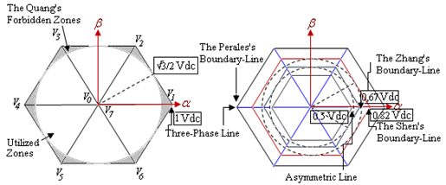

Figure-1: Modulation boundary-line in three-phase systems active filter

Three-phase four-wire system and four-leg system active filter developed by Shen [1] and Zhang [2] obtained voltage vector has a value smaller than allowable modulation boundary-line of three-phase three-wire system that is equal 0.82 Vdc and 0.67 Vdc like shown in figure-1.

  - COORDINATE ROTATION METHOD
Rotation method of Euler angle can be done with a continuous configuration either two or more Cartesian’s coordinate. Rotation R (θ₁, θ₂, θ₃) is a relation that is done to move the stationary reference frame towards the rotating reference frame.
In mathematical notation, the Euler angles rotation method can be determined as follows;
R (θ₁,θ₂,θ₃) = R_{x}(θ₃) R_{y}(θ₂) R_{z}(θ₁)
= $\left[\begin{matrix}\cos{θ_{3}} & \sin{θ_{3}} & 0 \\ -\sin{θ_{3}} & \cos{θ_{3}} & 0 \\ 0 & 0 & 1\end{matrix}\right]\left[\begin{matrix}\cos{θ_{2}} & 0 & \sin{θ_{2}} \\ 0 & 1 & 0 \\ -sin{θ_{2}} & 0 & \cos{θ_{2}}\end{matrix}\right]\left[\begin{matrix}1 & 0 & 0 \\ 0 & \cos{θ_{1}} & \sin{θ_{1}} \\ 0 & -sin{θ_{1}} & \cos{θ_{1}}\end{matrix}\right]$ (1)
where in 0< θ₁, θ₂<2π dan0<θ₃<π.
Principle of the Euler angle rotation method can be used to re-interpretation of the Kim-Akagi’s mapping matrices model in solving problems related to pqr-coordinate in [4],[5]. Multiplication of twice rotation in θ₁, θ₂ angle is same produce formulation as the Kim-Akagi’s mapping matrice model as follows:
$\left[\begin{matrix}X_{p} \\ X_{q} \\ X_{r}\end{matrix}\right]= \left[\begin{matrix}\cos{θ_{2}\cos{θ_{1}}} & \cos{θ_{2}\sin{θ_{1}}} & \sin{θ_{2}} \\ -\sin{θ_{1}} & \cos{θ_{1}} & 0 \\ -\sin{θ_{2}\cos{θ_{1}}} & -\sin{θ_{2}\sin{θ_{1}}} & \cos{θ_{2}}\end{matrix}\right]\left[\begin{matrix}X_{α} \\ X_{β} \\ X_{0}\end{matrix}\right]$
= $\sqrt{\frac{2}{3}}\left[\begin{matrix}\cos{θ_{2}\cos{θ_{1}}} & \cos{θ_{2}\sin{θ_{1}}} & \sin{θ_{2}} \\ -\sin{θ_{1}} & \cos{θ_{1}} & 0 \\ -\sin{θ_{2}\cos{θ_{1}}} & -\sin{θ_{2}\sin{θ_{1}}} & \cos{θ_{2}}\end{matrix}\right]\left[\begin{matrix}1 & -\frac{1}{2} & -\frac{ 1}{2} \\ 0 & \frac{\sqrt{3}}{2} & -\frac{\sqrt{3}}{2} \\ \frac{1}{\sqrt{2}} & \frac{1}{\sqrt{2}} & \frac{1}{\sqrt{2}}\end{matrix}\right]\left[\begin{matrix}X_{a} \\ X_{b} \\ X_{c}\end{matrix}\right]$ (2)
here in X$≡$ i, V (current/voltage).

Equation-2 can be described in steps such as figure-2 and figure-3 for each of the Euler angle rotation.
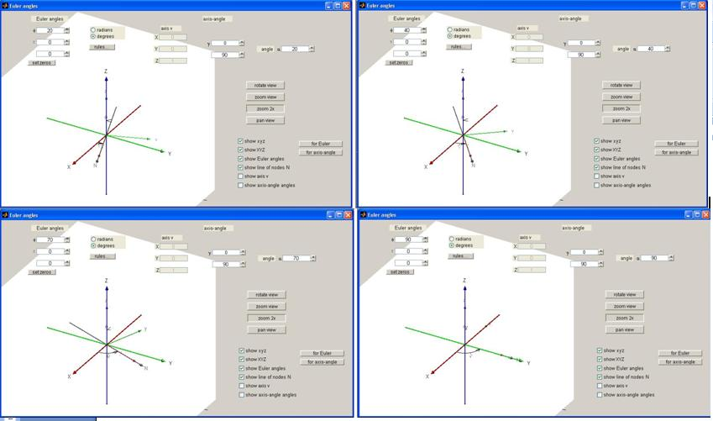
Figure-2: Change a first of angle produce rotation in the horizontal plane

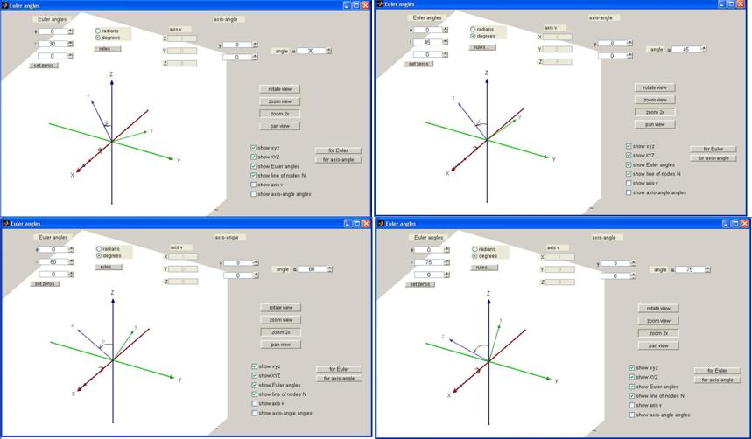
Figure-3: Change the second of angle produce rotation in the vertical plane

- ASYMMETRIC TETRAHEDRON SHAPE
Rotation method of two or three Euler angle becomes like as a spiral shape more than a cylindrical shape. A spiral shape will be easily analyzed when it considered as a skewed vector. Three-dimensional space vector in three-phase four-leg system active filter for this is a cylindrical coordinate (shape) with six prims such as figure-4a, while based on Euler angle rotation method this result is forms a stack of two pieces hexagonal as skewed vector such as figure-4b, 4c. Rotation method of two angle Euler produce pqr-coordinate if done projection in a horizontal plane (sliding side) obtained new coordinates dqr-coordinat such as figure-4b and projection in a vertical plane (sliding oblique) obtained αβr-coordinate such as figure-4c.
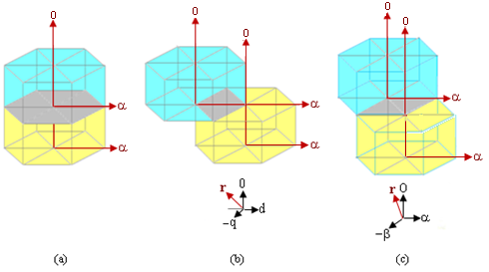
Figure-4: pqr-coordinate projection is produce; (a). a cylindrical coordinate, (b). dqr-coordinate, (c) αβr-coordinate.

Two hexagonal stacked with a shift at a central point where the hexagonal top and bottom are not centralized can be considered as a skewed vector. The center part of the composition of the two hexagonal shape elongated hexagonal with two-piece center point, namely state-(1,1,1,1) and state-(0,0,0,0) which do not coincide with each other. Overall, three-dimensional space vector can be parsed into twelve-pairs of asymmetric tetrahedron. Asymmetric tetrahedron shape between each of tetrahedron is indicates harmonics occurrence on voltage vector in which has got 0.5 Vdc. Hexagonal piles which forms an asymmetric tetrahedron pair when mapped in a two-dimensional horizontal plane (viewed from the top) can be obtained coordinate points which is the position voltage vector in αβ0-coordinates such as figure-5a and from vertical plane (viewed from the side) as shown following in figure-5b.
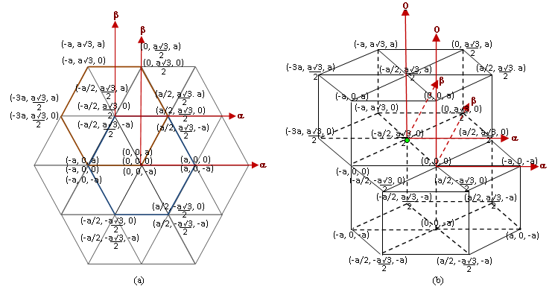
Figure 5: Asymmetric tetrahedron in αβ0-coordinate; (a). View from the top (horizontal) (b). View from the side (vertical)

Each of these coordinate can be mapped in four-pair combinations of IGBT and generates a voltage vector in space of tetrahedron. Sixteenth combinations pair of IGBT conductor can be described in twentyfour coordinates of a pile of regularly hexagonal, that means there have twentyfour or twelve-pairs of asymmetric tetrahedron. The twentyfourth coordinates can be decomposed into each of tetrahedron with separate center point are both in state-(1,1,1,1) and in state-(0,0,0,0). Based on figure-5b, each sided of prism with a length of “a” is equal 0.5 Vdc for upside part of asymmetric tetrahedron and -0.5 Vdc for downside part of asymmetric tetrahedron. Table-1 will be given position of twentyfourth voltage vector as a result of a switching combination pair of IGBT conductor on three-phase system active filter. Twentyfourth voltage vector can be described an asymmetrical tetrahedron pair. A skewed vector actually resembles the Perales’s model when determining voltage vector used to abc-coordinate. In this case, the difference of state-(1,1,1,1) and state-(0,0,0,0) have not coincide with each other at one position. Perales [3] get twentyfour voltage vector without Clarke transformation. In space vector modulation (SVM) Clark’s transformation is used to obtain voltage vector.
Table-1: Voltage vector on the skewed vector model (a=0.5 Vdc)
Voltage  Vector | Vα/a  (Vdc) | Vβ/a  (Vdc) | Vγ/a  (Vdc) | Voltage  Vector | Vα/a  (Vdc) | Vβ/a  (Vdc) | Vγ/a  (Vdc)
V₀ | 0 | 0 | 0 | V₁₂ | 0 | -$\sqrt{3}/4$ | 0
V₁ | 0 | 0 | -1/2 | V₁₃ | ¼ | -$\sqrt{3}/4$ | 0
V₂ | 0 | 0 | ½ | V₁₄ | -1/4 | -$\sqrt{3}/4$ | ½
V₃ | -1/4 | -$\sqrt{3}/4$ | -1/2 | V₁₅ | -1/4 | -$\sqrt{3}/4$ | 0
V₄ | ¼ | -$\sqrt{3}/4$ | ½ | V₁₆ | -1/2 | 0 | ½
V₅ | ½ | 0 | -1/2 | V₁₇ | -3/4 | -$\sqrt{3}/4$ | ½
V₆ | ¼ | $$\sqrt{3}/4$$ | -1/2 | V₁₈ | -1/2 | -$\sqrt{3}/4$ | ½
V₇ | -1/4 | $$\sqrt{3}/4$$ | -1/2 | V₁₉ | 0 | -$\sqrt{3}/4$ | ½
V8 | -1/2 | 0 | -1/2 | V₂₀ | ¼ | -$\sqrt{3}/4$ | ½
V₉ | -1/2 | 0 | 0 | V₂₁ | ½ | 0 | 0
V₁₀ | -3/4 | $$\sqrt{3}/4$$ | 0 | V₂₂ | ¼ | -$\sqrt{3}/4$ | 0
V₁₁ | -1/2 | $$\sqrt{3}/2$$ | 0 | V₂₃ | -1/4 | -$\sqrt{3}/4$ | 0

Reference vector is sum of three pieces of voltage vector nearest neighbor and its represents compare of magnitude (Vdc) from Va, Vb, and Vc. Reference vector can be obtained from each of tetrahedron. After reference vector can be determined then next steps are determine switching time duration and calculate duty cycle. In figure-6, reference vector (Vref) has described in a spherical coordinate and this reduction aims to determine switching time duration and duty cycle.
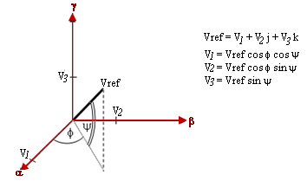
Figure-6: Reference vector (Vref) description in a spherical coordinate

To get the line to neutral voltage (V_{an}, V_{bn}, V_{cn}, V_{nn}), circuit of a,b,c-conductor and neutral conductor on the active filter based on a spherical coordinate can be obtained as follows [9]:

$V_{an}=V_{ref}\frac{\left(cosΦcosψ+sinψ\right)}{2}$ (3a)
$V_{bn}=V_{ref}\frac{\left(-2cosΦcosψ+\sqrt{3}{sin Φ\cos{ψ}}+sinψ\right)}{2}$ (3b)
$V_{cn}=V_{ref}\frac{\left(-2cosΦcosψ-\sqrt{3}{sin Φ\cos{ψ}}+sinψ\right)}{2}$ (3c)
$V_{nn}={-V}_{ref}\frac{\left(cosΦcosψ+sinψ\right)}{2}$ (3d)
So the switching duration time of each a,b,c-conductor and neutral conductor are obtained from the following equations:
$T_{a}/T_{s}$ = $\frac{1}{2}+\frac{V_{an}}{V_{dc}}$ = $\frac{1}{2}+ \frac{M}{2}\left(cosΦcosψ+sinψ\right)$ (4a)
$T_{b}/T_{s}$ = $\frac{1}{2}+\frac{V_{bn}}{V_{dc}}$ = $\frac{1}{2}+ \frac{M}{2}\left(-2cosΦcosψ+\sqrt{3}\sin{Φ}\cos{ψ}+sinψ\right)$ (4b)
$T_{c}/T_{s}$ = $\frac{1}{2}+\frac{V_{cn}}{V_{dc}}$ =$\frac{1}{2}+ \frac{M}{2}\left(–2cosΦcosψ-\sqrt{3}\sin{Φ}\cos{ψ}+sinψ\right)$ (4c)
$T_{n}/T_{s}$ = $\frac{1}{2}-\frac{V_{nn}}{V_{dc}}$ = $\frac{1}{2}- \frac{M}{2}\left(cosΦcosψ+sinψ\right)$ (4d)
Noted that T_{z} = $\frac{T_{s}}{2}=\frac{1}{2f_{s}}$ , modulation index, M =$\frac{V_{ref}}{V_{dc}}$ , and the boundary conditions each sector is 0 $≪ Φ ≪ \frac{π}{3}$, 0 $≪ ψ ≪ \frac{π}{4}$. Furthermore, to determine the duty cycle of each tetrahedron can use the following equation.
$\frac{T_{a}}{T_{s}}=\frac{D_{z}}{2}+ D_{3}+ D_{2}+ D_{1 }$ (5a)
$\frac{T_{b}}{T_{s}}=\frac{D_{z}}{2}+ D_{3}+ D_{2}$ (5b)
$\frac{T_{c}}{T_{s}}=\frac{D_{z}}{2}+ D_{3}$ (5c)
$\frac{T_{n}}{T_{s}}=\frac{D_{z}}{2}$ (5d)
herein Dz = 1- (D₁ +D₂ +D₃).
Value of Vref and ф, ψ-angles if incorporated into twentyfourth asymmetric tetrahedron can be determined time duration and duty cycle, its required for switching combination of both a,b,c-conductor and neutral conductor.

- DUTY CYCLE ANALYSIS ON VARIOUS TETRAHEDRON SHAPE
Geometrical principles are needed to analysis of reference vector on the tetrahedron shape. A cubic has a length side is 2 unit (centimeter) if cut in cross section than resulting a tetrahedron shape like as figure-7. The longitude is connected a central point toward middle point can be used to determine the value of reference vector of tetrahedron (Vref). The resulting angle between the longitude to the edges plane defined Φ-angle while the resulting angle between the longitudes to the upright planes defined ψ-angle such as in equation-3 and equation-4. Weight value of the α-axes, β-axes and γ-axes are represents duty cycle (D₁,D₂.D₃).
Gambar-7: Geometry analysis of tetrahedron from a cubic cutting

- DUTY CYCLE ANALYSIS IN THE SHEN’S MODEL
There are six non-zero vector switching (NZSV) and two zero vector switching (ZSV) in one sector (60º) which can be described as switching combination divided into four initial tetrahedron, wherein each tetrahedron defined by three NZSV and two ZSV. Fourth of tetrahedron in each sector can be produced parameter tetrahedron such as reference vector and duty cycle. In table-2, duty cycle calculation result in the Shen’s model is given.
Table-2: Duty cycle calculation in the Shen’s model
No | Vref | D₁ | D₂ | D₃ | Dz/2 | No | Vref | D₁ | D₂ | D₃ | Dz/2
1 | 1,06014 | 0,80 | 0,22 | 0 | 0 | 7 | 0,8165 | 0,44 | 0,56 | 0 | 0
2 | 0,8165 | 0,35 | 0,62 | 0 | 0 | 8 | 1,06014 | 0,61 | 0,44 | 0 | 0
3 | 0,8165 | 0,44 | 0,56 | 0 | 0 | 9 | 1,06014 | 0,80 | 0,22 | 0 | 0
4 | 1,06014 | 0,61 | 0,44 | 0 | 0 | 10 | 0,8165 | 0,35 | 0,62 | 0 | 0
5 | 1,06014 | 0,80 | 0,22 | 0 | 0 | 11 | 0,8165 | 0,44 | 0,56 | 0 | 0
6 | 0,8165 | 0,35 | 0,62 | 0 | 0 | 12 | 1,06014 | 0,61 | 0,44 | 0 | 0

- DUTY CYCLE ANALYSIS IN THE ZHANG’S MODEL
One state of sector (prism) in the Zhang’s model is produced four pieces of tetrahedron so comprise all of six prism in a cylindrical shape entirely has got twentyfour pieces of tetrahedron. Each of tetrahedron has different so that analysis each of tetrahedron should be performed differently. Using equation-3, equation-4 and equation-5 in previous discussion then the parameters tetrahedron such as value of Vref, switching time of each tetrahderon and duty cycle can be determined. In table-3, duty cycle calculation result in the Zhang’s model is given.
Table-3: Duty cycle calculation in the Zhang’s model
No | Vref | D₁ | D₂ | D₃ | Dz/2 | No | Vref | D₁ | D₂ | D₃ | Dz/2
1 | 0.630185 | 0.37 | 0.48 | 0.03 | 0.1 | 13 | 0.670008 | 0.29 | 0.51 | 0.04 | 0.08
2 | 0.629232 | 0.23 | 0.56 | 0.03 | 0.09 | 14 | 0.737428 | 0.32 | 0.56 | 0.04 | 0.04
3 | 0.770022 | 0.39 | 0.53 | 0.06 | 0.01 | 15 | 0.631682 | 0.06 | 0.59 | 0.02 | 0.15
4 | 0.385343 | 0.01 | 0.39 | 0.04 | 0.25 | 16 | 0.770022 | 0.39 | 0.53 | 0.06 | 0.01
5 | 0.631172 | 0.18 | 0.55 | 0.01 | 0.12 | 17 | 0.631172 | 0.24 | 0.55 | 0.01 | 0.09
6 | 0.631172 | 0.36 | 0.4 | 0.07 | 0.09 | 18 | 0.386695 | 0.19 | 0.24 | 0.05 | 0.23
7 | 0.770685 | 0.33 | 0.57 | 0.05 | 0.02 | 19 | 0.499733 | 0.45 | 0.14 | 0.11 | 0.15
8 | 0.510512 | 0.11 | 0.48 | 0.02 | 0.18 | 20 | 0.770685 | 0.33 | 0.57 | 0.05 | 0.02
9 | 0.598461 | 0.14 | 0.55 | 0.02 | 0.13 | 21 | 0.629232 | 0.18 | 0.69 | 0.01 | 0.11
10 | 0.630185 | 0.2 | 0.56 | 0.02 | 0.1 | 22 | 0.630185 | 0.43 | 0.4 | 0.07 | 0.09
11 | 0.770022 | 0.4 | 0.53 | 0.06 | 0.01 | 23 | 0.770022 | 0.33 | 0.57 | 0.05 | 0.02
12 | 0.770022 | 0.33 | 0.58 | 0.05 | 0.02 | 24 | 0.770022 | 0.4 | 0.53 | 0.06 | 0.01

- DUTY CYCLE ANALYSIS IN THE PERALES’S MODEL
Tetrahedron (region pointer) analysis in abc-coordinate of the Perales’s model uses quite a lot. There are sixtyfour tetrahedrons that can be obtained. However, from this sixtyfourth tetrahedrons then take twentyfour pieces of them is enough to determine value of duty cycle. It is interesting in the Perales’s model when parameter of fourth pieces of initial state of tetrahedron is known then this value will be repeated to another. Using equation-3, equition-4 and equation-5 in previous discussion then the parameters of the fourth initial state tetrahedron in the Perales’s model such as value of Vref, the switching duration time of each phase and duty cycle can be determined. In table-4, duty cycle calculation result in the Perales’s model is given.
Table-4: Duty cycle calculation in the Perales’s model
No | Vref | D₁ | D₂ | D₃ | Dz/2 | No | Vref | D₁ | D₂ | D₃ | Dz/2
1 | 1.060137 | 0.22 | 0.88 | 0 | 0 | 13 | 1.060137 | 0.22 | 0.88 | 0 | 0
2 | 0.8165 | 0.41 | 0.6 | 0 | 0 | 14 | 0.8165 | 0.41 | 0.6 | 0 | 0
3 | 0.694025 | 0.16 | 0.67 | 0.07 | 0.09 | 15 | 0.694025 | 0.16 | 0.67 | 0.07 | 0.09
4 | 0.938975 | 0.58 | 0.54 | 0 | 0 | 16 | 0.938975 | 0.58 | 0.54 | 0 | 0
5 | 1.060137 | 0.22 | 0.88 | 0 | 0 | 17 | 1.060137 | 0.22 | 0.88 | 0 | 0
6 | 0.8165 | 0.41 | 0.6 | 0 | 0 | 18 | 0.8165 | 0.41 | 0.6 | 0 | 0
7 | 0.694025 | 0.16 | 0.67 | 0.07 | 0.09 | 19 | 0.694025 | 0.16 | 0.67 | 0.07 | 0.09
8 | 0.938975 | 0.58 | 0.54 | 0 | 0 | 20 | 0.938975 | 0.58 | 0.54 | 0 | 0
9 | 1.060137 | 0.22 | 0.88 | 0 | 0 | 21 | 1.060137 | 0.22 | 0.88 | 0 | 0
10 | 0.8165 | 0.41 | 0.6 | 0 | 0 | 22 | 0.8165 | 0.41 | 0.6 | 0 | 0
11 | 0.694025 | 0.16 | 0.67 | 0.07 | 0.09 | 23 | 0.694025 | 0.16 | 0.67 | 0.07 | 0.09
12 | 0.938975 | 0.58 | 0.54 | 0 | 0 | 24 | 0.938975 | 0.58 | 0.54 | 0 | 0

- DUTY CYCLE ANALYSIS IN ASYMMETRIC’S MODEL
Based on analysis pair of asymmetric tetrahedron shapes obtained from projection in αβ0-coordinate like as figure-8, it can be described coordinate position on the top and the bottom of tetrahedron pair. Six sectors that are on the top and on the bottom tetrahedrons are produced the same value of duty cycle in one circle. The center point of the top tetrahedron is position in vector V₁₅ and the center point of the bottom of tetrahedron is position in vector V₀. Asymmetrical tetrahedron appears as pieces of prism form pairs that are not balanced between the top and the bottom. Reference vector is determined by drawing a line connecting the center point with a cross-section of the prism. In one circle there have twentyfour pieces of reference vector so that duty cycle can be determined. In figure-8, tetrahedron pair are described with the center point being at the V₁₅ on the top of tetrahedron.
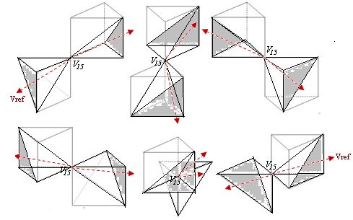
Figure-8: Tetrahedron pair on state-(1,1,1,1) the top of center point (V₁₅).

Using equation-3, equation-4 and equation-5 then the tetrahedron parameters such as value of Vref, switching time of each tetrahderon and duty cycle can be determined. Table-3 are given results of duty cycle calculation in asymmetric’s models.
Table-5: Duty cycle calculation in the asymmetric’s model
No | Vref | D₁ | D₂ | D₃ | Dz/2 | No | Vref | D₁ | D₂ | D₃ | Dz/2
1 | 0.600925 | 0.12 | 0.55 | 0.04 | 0.15 | 13 | 0.471403 | 0.1 | 0.44 | 0.01 | 0.21
2 | 0.166663 | 0.06 | 0.11 | 0.01 | 0.4 | 14 | 0.471399 | 0.1 | 0.44 | 0.01 | 0.21
3 | 0.471399 | 0.26 | 0.32 | 0.04 | 0.19 | 15 | 0.471403 | 0.26 | 0.32 | 0.04 | 0.19
4 | 0.471403 | 0.26 | 0.32 | 0.04 | 0.19 | 16 | 0.471399 | 0.26 | 0.32 | 0.04 | 0.19
5 | 0.220477 | 0.1 | 0.18 | 0.02 | 0.35 | 17 | 0.471393 | 0.1 | 0.44 | 0.01 | 0.21
6 | 0.471403 | 0.16 | 0.4 | 0.01 | 0.21 | 18 | 0.471399 | 0.1 | 0.44 | 0.01 | 0.21
7 | 0.471399 | 0.26 | 0.31 | 0.03 | 0.19 | 19 | 0.471403 | 0.26 | 0.32 | 0.04 | 0.19
8 | 0.471393 | 0.28 | 0.36 | 0.06 | 0.15 | 20 | 0.333326 | 0.36 | 0.11 | 0.23 | 0.15
9 | 0.55277 | 0.12 | 0.43 | 0.01 | 0.21 | 21 | 0.300461 | 0.14 | 0.17 | 0.05 | 0.32
10 | 0.471403 | 0.1 | 0.44 | 0.01 | 0.21 | 22 | 0.471399 | 0.1 | 0.44 | 0.01 | 0.21
11 | 0.471393 | 0.16 | 0.32 | 0.07 | 0.22 | 23 | 0.471393 | 0.24 | 0.3 | 0.06 | 0.19
12 | 0.333331 | 0.12 | 0.43 | 0.01 | 0.21 | 24 | 0.440957 | 0.09 | 0.41 | 0.02 | 0.23

- COMPARISON OF DUTY CYCLE ANALYSIS OF THE SHEN’S-ZHANG’S-PERALES’S-ASYMMETRIC’S MODEL
The following comparison of duty cycle analysis based on each tetrahedron model was developed. In the Shen’s and the Perales’s model, value of duty cycle in the c-conductor (D₃) and the netral conductor (D_{z}) is equal zero even actually calculation produces a negative value this indicates that the Shen’s and Perales’s model to compensation current control is not necessary to regulate switching combinations from the c-conductor and the netral conductor. The Shen’s and Perales’s model even conducted on three-phase four-wire system active filter is results indicate that can be done simplify using on three-phase three-wire system active filter because switching combination is only done in a,b-conductor (two-phase modulation). In the Zhang’s model, it appears that value of duty cycle in netral wire (D_{z}) is smaller than value of duty cycle in asymmetric model. That means, in the Zhang’s model, the period of switching in fourth-leg of IGBT module controller is shorter time than asymmetric’s model.
In figure-9, result comparison of duty cycle between Shen’s-Zhang’s-Perales’s-Asymmetric model is given. The graph the Shen’s and Perales’s lines can not be described because for both of them value of duty cycle (D_{z}) is equal zero.
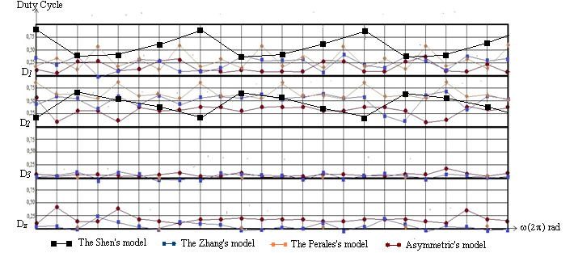

- CONCLUSION
Asymmetric voltage vector model as a result of pqr-coordinate projection into αβ0-coordinate can be used to regulate compensation current control. A skewed vector description of asymmetric voltage vector (tetrahedron) defines the modulation boundary-line is equal 0.5 Vdc where this value is less than the model developed by Shen, Zhang and Perales.
Parameter calculation of tetrahedron and compare existing model based on duty cycle analysis in netral wire (conductor) can be concluded that asymmetric voltage vector model have value is greater than another. This suggests that switching time in the neutral conductor (fourth-leg) of three-phase four-leg system active filter should be longer than the Shen’s, Zhang’s and Perales’s model.
Calculation can also be concluded that in compensation current control, the Shen’s and Perales’s models are actually quite uses a three-phase three-wire system active filter because the modulation is done simplify bythe a,b-conductor (two-phase modulation).

REFERENCES
- D.Shen, P.W. Lehn. “Fixed-frequency space-vector-modulation control for three-phase four-leg active filters”. IEE Proc on Elect. Power. Appl., vol. 149, pp. 268-274, July 2002.
- R. Zhang, V.H. Prasad, D. Boroyevich, F.C. Lee. “Three-Dimensional Space vector Modulation for Four-Leg Voltage-Source Converter”. IEEE Trans on Power Electronics, vol. 17, no. 3, pp. 314-326, May 2002.
- M.A.Perales, M.M. Prats, R. Portilo, J.L. Mora, J.I. Leon, L.G. Franquelo. “Three-Dimensional Space Vector Modulation in abc Coordinate for Four-Leg Voltage Source Converters”. IEEE Power. Electronics Letters, vol. 1, no. 4, pp. 104-109, Dec 2003.
- H. Kim, and H. Akagi. “The instantaneous Power Theory Based on Mapping Matrices in Three-phase Four-wire Systems”. 1997 IEEE International Conf. on PCC, pp. 361-366. Nagaoka 1997.
- H. Kim, and H. Akagi. “The Instantaneous Power Theory on the Rotating p-q-r Reference Frames”. 1999 IEEE International Conf. on PEDS’99, Hongkong 1999.
- I.Yuniantoro, R.Gunawan and R.Setiabudy. “The pqr-coordinate in the Mapping Matrices Model of Kim-Akagi on Power Transformation based on Euler Angle Rotation Method”. 2013 IEEE Xplore Conference on Quality in Research (QiR), pp. 121-126. Jogjakarta 2013.
- A. Mohd, E. Ortjohann, N. Hamsic, W. Sinsukthavorn, M. Lingemann, A. Schmelter, D. Morton. “Control strategy and space vector modulation for three-leg four-wire voltage source inverters under unbalanced load conditions”. IET Power Electronics, 2010, Vol. 3, Iss. 3, pp. 323–333.
- N.P. Quang and J.A. Dittrich. Vector Control of Three-Phase AC Machines: System Development in the Practice. Springer. Berlin. ISBN: 978-3-540-79028-0, eISBN: 978-3-540-79029-7. [online date in 2014s]
- J.H. Kim and S.K. Sul. “A carrier-based PWM method for Three-Phase Fout-Leg Voltage Source Converters”. IEEE Trans on Power Electronics, Vol. 19, No. 1, pp. 66-75. January 2004.

BIOGRAPHIES OF AUTHORS

Indriarto Yuniantoro received Drs and MS degrees in physics from Institut Teknologi Bandung, in 1992 and 1999 respectively. He is currently going toward doctoral degree at Department of Electrical Engineering, Faculty of Engineering Universitas Indonesia. Since 1992, he was lecturer in physics and power electronics at Department of Electrical Engineering, Faculty of Industrial Technology University of Trisakti Jakarta.


Rudy Setiabudy received Engineer (Ir) degree at Universitas Indonesia in 1982, DEA degree at INPG Grenoble, France in 1987, Dr degree at Montpellier II USTL, France in 1991, and Professor in 2008. Since 1991 he has been delivering lecture on Electric Materials Engineering and Electric Measurement Engineering at Department of Electrical Engineering, Universitas Indonesia. During 1993-1998 he was a Head of Electric Measurement Laboratory and from 1997-2004 he was served as a Head of Department of Electrical Engineering, Universitas Indonesia. His research interests are electric materials technology and electrical measurement.

Ridwan Gunawan received Engineer (Ir) and Dr degrees in Electrical Engineering at Department of Electrical Engineering Universitas Indonesia, in 1978 and 2006. His research interests are power system, electrical drive and power electronics. He was senior lecturer and researcher in Department of Electrical Engineering, Faculty of Engineering, Universitas Indonesia.

