Multi-Agent System for Steel Manufacturing Process

Angel Ricardo¹, Israel Benítez², Guillermo González³, José R. Nuñez⁴
¹Automation Department, Integral Automation Company CEDAI, Holguín, Cuba
²Automatic Engineering Department, Universidad de Oriente
³Development and Innovation Group, ACINOX Las Tunas, Cuba
⁴Energy Department, Universidad de la Costa, Barranquilla, Colombia

Article Info |  | ABSTRACT
Article history:  Received Jun 9, 2018  Revised Nov 20, 2018  Accepted Jan 11, 2019 |  | This work was carried out in the company ACINOX Las Tunas, Cuba, to design an integrated automation architecture based on intelligent agents for control, monitoring, and decision-making in the production process that guarantees an improvement in planning and management of the process in the steelwork plant. The great differences of technologies and systems of each steel mill and the multiple restrictions, methods, and techniques, within a wide dynamic strongly concatenated, do not generalize automation systems feasibly. In our research, we use international research results and the experience of the plant technologists to create three levels of distributed intelligent architecture: Business, Production Planning-Control, and Steel Manufacturing. Each level manages to integrate and balance the particular and general interests for efficient decision-making combined between hierarchy and heterarchy in this steelwork plant, which will be reflected in a reduction of at least 99% of the time used for decision-making concerning the current system, which can lead to a decrease in refractory costs, energy consumption, and production cost. The effectiveness of the solution is demonstrated with scenario validation and expert evaluation.
Keywords:
Agents
Decision support systems
Artificial intelligence
Intelligent control
Integrated manufacturing
This is an open access article under the CC BY-SA license.

Corresponding Author:
José Ricardo Nuñez Alvarez,
Energy Department,
Universidad de la Costa (CUC),
Call 58 # 55 - 66, Barranquilla, Atlántico
Colombia.
Email: jnunez22@cuc.edu.co

- INTRODUCTION
The steel industry is characterized by large, complex, and varied processes. To control these processes, a technological platform is required that can handle and interpret large volumes of data automatically to achieve adequate production planning and support decision-making processes when uncertainties arise [1, 2].
With a classic hierarchical pyramidal model of Computer Integrated Manufacturing (CIM) [3], it does not respond to the current needs of the industry [4] due, fundamentally, to delays in the transmission of information and decision making derived from the rigidity and little flexibility of the currently existing structure [3]. For this reason, distributed architectures based on agents are studied with characteristics of reactivity and flexibility inserted in the automation platform in the event of disturbances in the production process. The international experience and that of the plant technologists are integrated to create a distributed artificial intelligence architecture for the automation platform of the steel industry at ACINOX Las Tunas. It must guarantee an improvement in the planning and management of the process, thus increasing productivity and reducing production costs [3, 4].
The document is made up of 3 sections. Section 2 presents the concepts and application background of Multi-Agent Systems (MAS) in the steel industry. The study demonstrates the complexity and diversity of the existing solutions that are not adequately adapted to the process of this steel mill. Section 3 provides a general description of the architecture proposed with the characteristics of its layers, making a critical assessment of its advantages and disadvantages. The use of a variable egalitarian heterarchical architecture at the level of process control stands out, which facilitates speed and effectiveness of decision-making supported by validation of scenarios and expert criteria. Finally, section 4 presents the general conclusions derived from the work carried out.

- MULTI-AGENT SYSTEMS (MAS) APPLICATION BACKGROUND
Distributed Artificial Intelligence (DAI) is a field of Artificial Intelligence (AI) of great importance due to its ability to solve complex problems in the real world. He focuses his study on collective intelligent behaviors, due to the collaboration of various entities called agents. Research in this field is focused on three different directions: parallel AI, Cooperative Distributed Problem Solving (CDPS), and MAS [5].
Studies carried out on existing techniques regarding uncertainties in the steel process show that the solutions presented with MAS have better results than the rest of the applications [6]. Furthermore, MAS is one of the techniques that bring the most benefits to the steelmaking process [7]. This technique provides an efficient solution to solve complex problems [4, 8], with important advantages regarding the construction of autonomous, adaptive systems with coordinated interaction between their elements. For this reason, it has become the most widely used approach to solve the problem of planning and managing the steel process [9]. However, MAS studies and designs in this branch do not cover the entire production process, and the few that do not meet the design requirements for the case study.
The dynamic nature of the steelmaking process and the supply chain, which comprise critical processes, makes them highly susceptible to disturbances and interference [10, 11]. The solution to the high demand for orders and process problems [12] is complicated due to its extensive production flow. Static production plans generally need to be assigned multiple times when unexpected circumstances occur [13] and where production is complex and multi-stage [14]. That is why scientific research related to the search for integrated solutions to this great concatenated dynamic is currently being maintained.
The steel process is a complex chain of transformation processes, from raw materials (iron ore, coal, scrap, etc.) to finished products (coils, plates, rails, tubes, among others). As in many other processing industries, planning, and scheduling play an important role in this sector [6, 15]. To achieve a reconfiguration in the industry, communication between the different levels of automation is required, allowing the timely exchange of information between these levels [16].
This need for flexibility in communication makes agents the entities capable of satisfying this requirement, since each agent evaluates the data locally, without the need to be connected to the Enterprise Resource Planning (ERP) system. In these, all agents are aware of the current condition of the plant and can make local decisions [17] reducing the global impact. In this case of the ACINOX Las Tunas steel mill, a study of the agents was carried out before analyzing their integration into a MAS, to determine the set of entities with special qualities that will allow responding to the problems of this steel mill.

2.1. Agents
There are several versions of the agent concept, but all agree that autonomy is the main characteristic [17], because it offers the opportunity to act without the intervention of the operator, since the system reacts to external stimuli based on its internal states. An agent must be reactive to be able to make quick decisions in dynamic environments, and proactive to take initiatives and plan actions to achieve the objectives of the system [18]. Another quality of the agents is Rationality [19] which, based on the use of shared space, allows reciprocal work and cooperation with other agents if the common objectives do not conflict with the agent's objectives.
It is also possible to include qualities such as the veracity of the information handled that depends on the design objective; mobility as the agent's ability to move in the environment and move through a network of processing nodes to perform specific tasks [20]. Another quality is intelligence, which provides the agent with the ability to analyze and order knowledge about the environment and use it appropriately. Based on this acquired knowledge, it can self-reconfigure itself to adapt to its environment [21]. Despite all these qualities, and due to the level of complexity existing in the architecture and process of the steelworks, a single agent does not provide an answer to the problem addressed, so it is decided to analyze the communities of agents.

2.2. Multi-agent systems
MAS are communities of agents in a social environment, in which these agents cooperate to achieve both their individual and collective goals [22, 23], guaranteeing to solve two fundamental problems of operation: communication and coordination [24]. For this, protocols must be in place to establish the responsibilities or commitments acquired by MAS agents and their interrelationships [25].
A MAS can be seen as a distributed system composed of agents where their combined behavior produces a joint result and where three organizational levels are distinguished: the micro-social, group, and global. Therefore, they can be defined as subclasses of concurrent systems, with three predominant aspects that are very specific to them: autonomy, synchronization techniques, and coordination. These aspects are implemented in the computational platforms that provide support and fulfill the objectives of the MAS [26]. The ways to reach agreements (negotiations) and coordinate dynamically without knowing each other are different from concurrent systems [21].
The coupling between the components of the MAS determines flexibility since a fixed coupling prevents reorganization and adaptation to the environment, and a variable coupling presents fixed structures with variable instantiations allowing flexible relationships between agents, but through well-defined predefined mechanisms [27]. By this, a structure with variable coupling was selected, to guarantee that, if the structural and technological characteristics of the factory evolve, the system is capable of assimilating and evolving with technological improvements.
The subordination relationship of the MAS presents two typical structures, the hierarchical and the heterarchical. The hierarchy is a relationship of subordination that forms a pyramidal structure. However, a variable egalitarian coupling (heterarchical) of the subordination structure generally produces competition between the low-level components, where the high-level components oversee arbitrating the same [28, 29]. The MAS proposed for ACINOX Las Tunas presents a hybrid structure, even with current technological conditions, decision-making is committed to only advising in some areas where the role of the actor is fundamental (hierarchy) and the agents must be able to resolve uncertainties local, without the need for decision-making at higher levels (heterarchy).
The elements previously presented were considered to propose a hybrid structure with the interaction between a fixed hierarchical subordination and an egalitarian subordination. Fixed hierarchical subordination guarantees the central levels of global decision-making and their interaction with human actors prioritized in these decisions. The variable egalitarian subordination at the base guarantees attention to the particularities of each process and its collaborative interaction in equal priorities for the objective of productivity, quality, and successful business of the automated system of the ACINOX Las Tunas steelworks. Dynamic reorganization in the face of uncertainties benefits from the rapidity of collaborative egalitarian decision-making by the components of the steelworks without affecting global decisions that are maintained in the fixed hierarchy at a slower rate.
Based on the selected hybrid structure, it is necessary to study its advantages over other international MAS proposals in steelmaking.

  - Applications of MAS to the steel industry
Among the previous studies of MAS applications in the steel industry is the Multiagent System for Integrated Dynamic (MASID) architecture, which is a multi-agent system for optimization and integrated dynamic programming proposed by [30]. In this study, the author proposes a negotiation protocol for cooperation between agents within a multi-agent system of a steel mill. The study is carried out focused on the continuous emptying installation and does not cover the rest of the process where there are other very important decision-making and a considerable group of uncertainties that are not analyzed.
A Fuzzy Agent Expert System (FAES) architecture composed of a community of cognitive, autonomous, and heterogeneous agents is proposed in [13]. This architecture is made up of six intelligent agents with an Adaptive Neuro-Fuzzy Inference System (ANFIS) knowledge base, where each agent is responsible for locally executing the tasks of the resource in charge and can cooperate and communicate with other agents. These architectures feature a MAS where an agent is assigned to each steelmaking process while coordinating and cooperating and who could work independently. Here the system is based on a general perspective of the processes maintaining a rigid architecture and the business process is not managed by the community of agents.
Effective production scheduling results in an efficient manufacturing process, shorter product delivery times, quality improvements, lower inventory costs, and higher productivity [31]. The dynamic readjustment of this schedule in the face of multiple random events in a steel mill process is what can achieve this required effectiveness. Expert knowledge can be used in a decision support system to improve the management of scheduling disturbances and avoid unnecessary rescheduling [10]. Flexibility, robustness, and rapid reorganization are essential requirements in a responsible system for production planning [11].
Static production plans generally must be assigned repeatedly when unexpected circumstances occur and can be resolved by applying MAS-based techniques [12], [13]. In steel production, adequate methods are required to eliminate the impact of uncertainties in the process, being MAS techniques appropriate in these circumstances [14], [31].
In [32] the architecture Research on Steelmaking-Continuous Casting Production Scheduling System Based on Virtual Real Fusion (SCCVRS) is presented, which proposes a method to establish a virtual system dynamic in the continuous steel casting production environment. The system analyzes the problem focused on changes in requests, delays in the arrival time of the load, and machine failure in the processing time, however, computer simulations are generally performed within virtual systems, and there are many uncertainties in real systems that cannot be accurately predicted in virtual systems.
[33] raise in their work the System of Intelligent Distributed Automation based on Agents (SADIA) in the continuous process of oil extraction using 11 intelligent agents. SADIA allows access to all the information required to know the status of the production process and interpret said information. This is one of the most complete architectures for the control of the process, but it is focused on the oil extraction process, however, the contributions of the automation system are analyzed in a general way, which guarantees that the greatest number of uncertainties are analyzed. with a focus on global objectives to achieve a more effective dynamic reconfiguration. Therefore, it can be considered a good reference for the decision support of this steel mill, where a similar architecture is proposed adapted to the particularities, uncertainties, and objectives of the company.
It should be noted that in the search carried out in the main databases of international prestige, many articles on MAS applications for the main processes in a steel mill were not found, which include: the process assurance system, the Electric Arc Furnace (EAC), Ladle Furnace (LF), Continuous Emptying Facility (CEF) and finished products.

  - Case study
The investigation was carried out to consider an operating time of six years in the operation of ACINOX Las Tunas, a sufficient period to know the effects due to operational errors and bad decisions. In Figure 1, as of 2016, the year in which a new decision-making procedure was carried out, operational errors decreased [4]. Factors such as fluctuations in the workforce and inadequate training of technical personnel had a negative influence on the stable behavior of the production schedule, in addition, the innumerable uncertainties of the process must be added to these factors. These are the reasons why a tool is needed that helps in decision-making and reduces human error since the procedure is currently carried out at the level of the shift manager.
[6] conducts a study on short-term uncertainties in steel mills and classifies them into two main groups, one related to work and the other related to resources Within the first group are situations such as late arrival of personnel, variations in due dates, and changes in the priority of work. In the group related to resources, we can find the failures or breakages of the machines, delay in the arrival or shortage of materials, poor estimation of the processing time, quality problems of the final product, and absence of operators. All these situations of uncertainties have a lot of influence on production schedules.
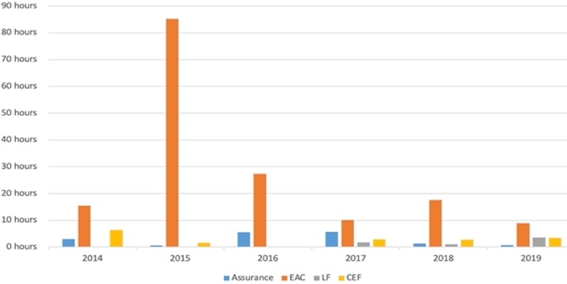
Figure 1. Operating errors for 6 years at ACINOX Las Tunas

Figure 2 shows that the main scenarios of bad decisions have been EAC and Assurance, where there is a high dependence on the actions of technologists and operators. In them, the decision of the human actor has a great influence on the production schedule. The study carried out by [4] in ACINOX Las Tunas in 2015 showed that one of the significant causes that affect the production process is bad decisions made at the operational level, mainly due to the occurrence of breakdowns. These wrong decisions are often based on a lack of preparation for a particular situation. The application of the operating procedure established in [4] has not prevented the effects of these events, an increase can even be observed in recent years [4].
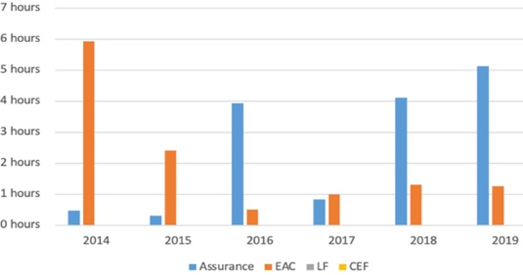
Figure 2. Wrong decisions for 6 years at ACINOX Las Tunas

With the procedure that is currently being carried out, the desired improvement in the electricity consumption index has not yet been achieved. In Figure 3 you can see the study carried out in the EAC, which is where there is the highest energy consumption. Over the years this index has shown instability, it can even be seen that within the same year 2020 the index experienced variations. The uncertainties that affected this index include those related to decision-making and operational errors.
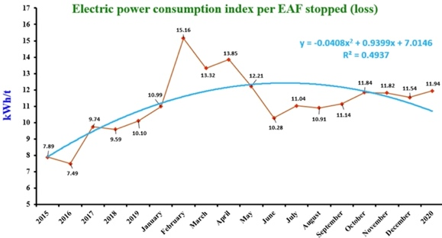
Figure 3. Electric energy consumption index in the EAC

To ensure that steel production is more economically feasible, the sequence or ratio between the castings carried out and the consumption of troughs is analyzed. This is conditioned by the optimal residence time of casting in the LF. In the case study, according to the 2020 prices and the study of [4], the result is that the optimal waiting time at the LF is 90 minutes. This means that after the laundry is ready in the LF, the cost incurred for the wait is greater than the savings for running the sequence with the next laundry.
To determine the maximum waiting time that the casserole can be in the LF and to sequence with the next laundry based on cost, it is necessary to consider that, if the laundry in question is emptied individually in the CEF, an additional cost of refractory, tundish, and special pieces, concerning whether the sequence can be maintained with the next casting.

- SADIA ARCHITECTURE
After studying several architectures, SADIA was selected, an architecture that integrates the levels of the process, from business management and production levels to the control level. It is intended to cover the greatest number of levels in the process management schedules, which translates into more details about uncertainties and the possibility of making more accurate decisions that result in greater use of production time. The first level of abstraction describes the steel production process, which is analyzed as a MAS, where the various production units are modeled as agents. Agents at this level negotiate among themselves to reach agreements and meet production goals established in an egalitarian way, interacting with a higher hierarchy in production, resources, and business. Business objects are represented as agents to grant intelligence and autonomy to each element of the production process. At this level, the management of the process acquires great importance since the raw material is processed and the management time is readjusted depending on the demand of the process and the experience of the technologists stored in the MAS, thus guaranteeing the permanent availability of the raw material without wasting resources.
There are areas, such as the LF, in which it is necessary to know economic data to be able to carry out adequate management of the dynamics of production. The same maintains an exchange with the raw materials management agent, which, in correspondence with the cost of refractories and materials needed in the Trough, could determine if the production is economically feasible. Currently, this statistical calculation is carried out by a human actor, who works with a monthly coefficient due to the cumbersomeness of this task; if there is an AI-based system, considerable time would be saved and there would be more dynamic and precise information for more accurate decision-making [4]. This example demonstrates the need for vertical interaction, from financial management through planning to process control in the LF, in which decision-making can be achieved quickly and effectively if the three levels of MAS are integrated.
Business management, at the first level of abstraction, is shown in Figure 4 and is made up of a community of five agents who were selected with this structure after work sections and surveys carried out with expert personnel in the process and business management.
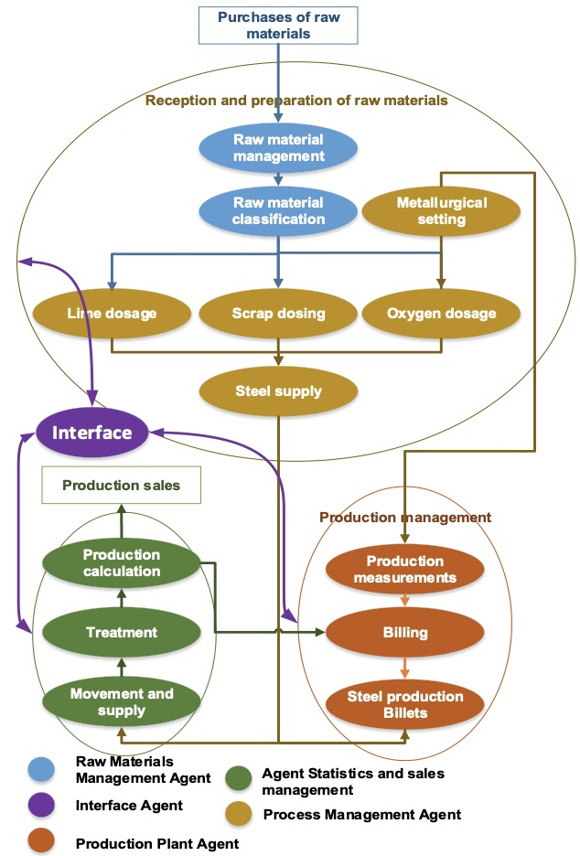
Figure 4. Agents of the first level of the SADIA system (Business management in the steelworks)

The agents of the first level of the SADIA system are the following:
• Raw material management: the market study is carried out for the purchase of raw material. It is carried out by the raw material management agent.
• Classification of the raw material: the classification of the raw material acquired is carried out. Raw material management agent.
• Scrap dosing: scrap dosing is carried out depending on the corrections made in the metallurgical setting. Process management agent.
• Oxygen dosage: the dosage is carried out depending on the corrections made in the metallurgical setting. Process management agent.
• Lime dosage: lime dosage is carried out depending on the corrections made in the metallurgical setting. Process management agent.
• Metallurgical adjustment: analyzes the chemical characteristics of the steel obtained by correcting the error factor. Process management agent.
• Steel supply: once the dosage adjustments have been made, the quantity of steel ready for billets is obtained. Process management agent.
• Steel production: mold steel to its commercial shape. Production plant agent.
• Invoicing: the production is invoiced by the production plant agent.
• Production measurements: the quality of the product obtained is analyzed. Production plant agent.
• Movement and supply: movement and supply to packaging areas are carried out. Statistical agent and sales management.
• Treatment: the product is conditioned for later transfer. Statistical agent and sales management.
• Calculation of production: the statistics of the quantity of manufactured products are kept. Statistical agent and sales management.
In the second level of abstraction, the activities that must be developed to meet the objectives of each agent of the first level are distributed in a group of agents. The number of agents is selected in agreement with the expert production staff where the characteristics of planning, cost control, processing of production orders, input and energy control, product dispatch, control of inventories, among others.
Consequently, we obtain an MAS made up of the second group of agents that respond to the interests of the production plant agent at the upper level, and in turn, perform the tasks of the business level. Figure 5 establishes the relationships between the five types of agents of this intermediate hierarchical level and constitutes the link between the fixed hierarchy and the variable egalitarian heterarchy of the lower level.
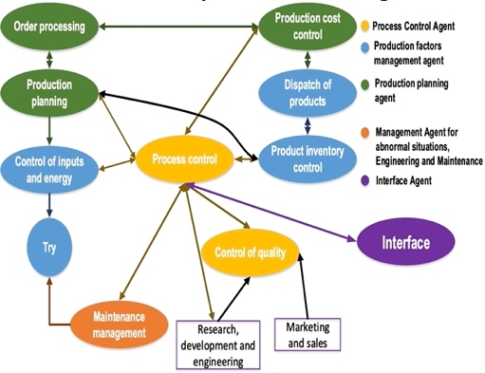
Figure 5. Agents of the second level of the SADIA system (Management of planning and control of production in the steelworks)

Based on the ANSI / ISA 95.00.01 standard [33], the functions of the planning and production control agents are shown:
• Order Processing - Handle customer orders. It is developed by the production planning agent.
• Production planning: preparation and execution of production plans, determination of raw material requirements, and estimation of the availability of final products. Production planning agent.
• Production control or Process control: control of the transformation of raw material into final products, following the production plan. Carried out by the process control agent.
• Control of inputs and energy: inventory management, transfer, and quality of inputs and available energy. Developed by the agent managing the factors of production.
• Procurement: execution of orders for requirements of materials, parts, supplies, and other elements necessary for production. Carried out by the factor of the production management agent.
• Quality control: quality assurance of the final products, following standards and norms. Carried out by the process control agent.
• Product inventory control: inventory management and availability of final products. It is carried out by the factor of the production management agent.
• Production cost control: calculation and execution of the production cost report. Carried out by the production planning agent.
• Product dispatch: organization of dispatch, transport, and delivery of final products to customers. It is carried out by the factor of the production management agent.
• Maintenance management: execution of preventive maintenance plans, monitoring of failures and abnormal situations, calculation of operational reliability. Carried out by maintenance engineering and abnormal situation management agents.
As can be seen in Figure 5, there is a strong interaction between the functions of these five agents to achieve efficient planning and control of production. The activities carried out by the agents of the second level are complex because they respond to the objectives of production planning and control, but also the goals of the higher level and the coordination with the lower-level distributed heterarchical. The base agents that interact directly with the third level are the production control agent and the agent for abnormal situations, engineering, and maintenance, and through them, the interaction with the entire planning, production control, and business process is established.
The third level of abstraction is proposed, which is reconciled with the process experts, where the control systems with the sensors and actuators involved are analyzed and the main components within the control architecture that may influence the operating times are chosen. production. All the agents of each of the levels of abstraction make use of the services provided by the Service Management Medium (SMM) for MAS, for efficient management of shared services.
The third level is adjusted according to the reference model of the SADIA system [33], which is a multi-agent platform specifically designed for industrial automation systems in which a community of agents is proposed to create control loops. By adapting the SADIA system to the ACINOX Las Tunas steelworks, the third level is created interacting directly with the process control agent of the second level, and in which we can find the following agents:
• Measurement agent in the HAE: collects the information necessary to know the status of the process in the EAC.
• EAC controller agent performs control actions based on the state of the system on the HAE.
• Measurement agent in the LF: collects the necessary information to know the status of the process in the LF.
• LF controller agent performs actions based on observing the state of the system in the LF.
• Measurement agent in the CEF: collects the necessary information to know the status of the process in the CEF.
• IVC controlling agent performs actions based on observing the state of the system in the CEF.
• Coordinating agent makes more flexible and/or modifies the decisions of the controlling agents following the higher objectives (business and planning) and establishes new objectives and services at this level. He coordinates the goals of the agents present in his community and guarantees communication with the VERSAT financial system to carry out a production cost analysis and intervene in decision-making.
• EAC action agent executes the decisions made by the controlling agents in the EAC, coordinator, and assurance.
• LF acting agent executes the decisions made by the controlling agents in the LF, coordinator, and financial agent.
• CEF acting agent executes the decisions made by the controlling agents in the CEF, coordinator, and maintenance engineering agent.
• Assurance agent: its function is to verify that there is sufficient raw material to start the smelting in the EAC.
• Interface agent: in charge of communication between the SMM and the staff, it can function as an advisory system proposing solutions.
As can be seen in Figure 6, the SADIA system can be divided into two levels: a level of interaction with the environment, where the measurement and action agents are located, and, on the other hand, a decision level where are the other community agents.
The variable egalitarian heterarchy of this level allows decision-making in the face of uncertainties much more effective and faster than if a hierarchy level is established that needs to decide in these situations. It is only necessary to ask the other three agents of the same level what the situation of the rest of the equipment of the steelworks is so that the decision is adapted to these conditions. The coordinating agent only exchanges the information with the higher level, to ensure that the business objectives and production planning-control are met at the third level. The coordinating agent also guarantees the movement of information in an upward direction, that is, that the higher levels can adjust their business goals and planning-control to the real situation of the steel production process [34, 36].
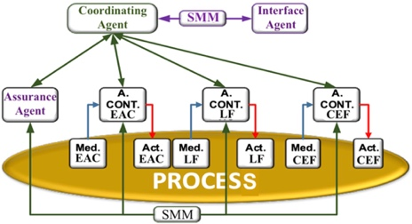
Figure 6. Model of the SCDIA system (Control of the steelmaking process)

The decomposition into levels of abstraction allows us to address the modeling of complex systems generically, by defining a MAS at each level, which allows programming autonomous and flexible agents that perform specific tasks and that can evolve according to their objectives. and those of the MAS in which they are immersed.

  - Technologist simulation and validation scenarios
For the simulation of the system, 4 programmed scenarios were recreated with a basic structure of 11 agents in Schneider Electric M241CE40R automata with SoMachine® software and compared with the real times of the decisions made by the operators and introducing the different uncertainties analyzed in the scenarios, taking advantage of the benefits of the analysis of variance experiment (ANOVA).
Scenario 1 contemplates the breakdown in one of the basket-carrying trolleys in the loading area and the Assurance Agent suggests putting a crane depending on the load and another depending on the unloading to compensate for the production times that are assimilated by two trolleys basket holder.
Scenario 2 analyzes the energy consumption where the EAC agent determines the increase in the oxygen dosage in the scrap cutting to amortize the impact of the arc consumption during the cut.
Scenario 3, the LF Agent negotiates the information with the financial agent to know if the production is economically feasible, and depending on it, another casting sequence begins or ends it and ends the production process; currently, the decision is made by the operators.
Scenario 4 contemplates a breakdown in one of the CEF lines, whose agent suggests the use of the available line, adjusts the emptying time, and negotiates information with the LF agent to adjust the dwell time of the laundry in LF.
These are the scenarios with the fundamental uncertainties that are most frequently generated at the ACINOX Las Tunas steel mill. In the analysis of these, the following conclusions are reached:
Scenario 1: This scenario does not present a good homogeneity of the data since its standard deviation is the second highest; this means that the data is very far from the arithmetic mean. In this scenario, there is an average of 0.05 seconds of dispersion, but the arithmetic mean is low, which means that the system takes less time to reconfigure.
In this case, it is shown that the Assurance agent's decision-making does not require subordination to the other three agents at this level, but only to check if the rest of the production sequence remains unchanged (EAC-LF-CEF working correctly) to decide whether to maintain production by reconfiguring one of the cranes, which strengthens the idea of ​​heterarchical subordination. It is also found that the decision to maintain the supply of raw materials has the same priority as the other three agents at that level because they all contribute to maintaining the efficiency of the steelworks. It is also shown that the decision in the face of this uncertainty is variable, because if the consultation with the other agents is that the EAC, the LF, or the CEF have a different status, then the use of a single car can be maintained, or dedicate both cranes, and a different decision according to the timing of the system.
Scenario 2: In this scenario, homogeneity decreases, since the arithmetic means is the second highest and the data are scattered, showing a standard deviation of 0.09. This shows that subordination of the other agents is not necessary, the EAC agent consumes less time in solving the problem, thus guaranteeing a correct reconfiguration without the need to consult the decisions in a hierarchy chain.
Scenario 3: In this scenario, the arithmetic mean is the highest, so there is the least efficient response to uncertainties, although it has good homogeneity thanks to the standard deviation of 0.038, which means that the data does not differ much from the arithmetic mean. Although a good reconfiguration response is not obtained, in this scenario the best response in the LF was obtained among the simulated systems, which shows that the autonomous performance of the LF agent has a better response if there is no impact on the production sequence.
Scenario 4: In this scenario, the MAS had its best and most favorable performance since the arithmetic means is the lowest, so it takes less time to reconfigure. In addition, it presents a low dispersion of the data since the standard deviation is only 0.0333. This means that with the proposed architecture the performance of the CEF had a considerable increase thanks to the time it takes to reconfigure and resolve the local uncertainty, see Figure 7.
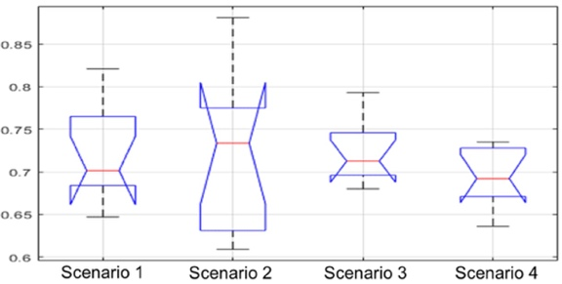
Figure 7. ANOVA experiment

In the statement of the Hypothesis, it is considered that the uncertainties significantly affect the time of dynamic reconfiguration based on intelligent agents for distributed systems.
Null Hypothesis: H0 "The number of uncertainties does NOT significantly affect the dynamic reconfiguration time based on intelligent agents for distributed systems".
Alternate Hypothesis: H1 "The number of SI uncertainties significantly affects the dynamic reconfiguration time based on intelligent agents for distributed systems".
For the analysis of variance, in Table 1, the sum of the squares (SS), the degrees of freedom (df), the average of the squares (Ms), and the variance factor (F) were considered.

Table 1. Analysis of Variance (ANOVA)
Sources | SS | df | Ms | F | p-value
Columns | 0.00439 | 3 | 0.00146 | 0.42 | 0.7411
Error | 0.12608 | 36 | 0.0035
Total | 0.13047 | 39

The data obtained in the ANOVA experiment show that there are no significant differences in the duration of the dynamic reconfiguration times in the face of the different uncertainties, as expressed by the p-value of 0.7411, which is much higher than the p-value of 0.05 widely accepted in statistical analysis. This means that the number of uncertainties does not significantly affect the time spent in executing the reconfiguration, if a variable egalitarian structure is maintained.
The response times with the application of the MAS were notably better than the time records used in the decisions of the shift managers. In Scenario 1 the time was lower by 99.37%, in Scenario 2 the improvement was 99.26%, in Scenario 3 the MAS reconfiguration system makes its best contribution reducing the response time by 99.71% and in Scenario 4 an improvement of 99.27% is achieved.
According to the survey carried out among the steel mill's technologists, it is not only necessary to apply an intelligent system that can manage the production schedule, but also that can reduce production times and the effects created in the taking of Operators' decision since the right decisions are often influenced by preparation, experience, and the work environment. The complex dynamics of the steelworks create possibilities that common and other uncommon effects may arise, where the speed of response to them is essential for the efficiency of the system.
The criteria of the surveyed technologists showed that the proposed system offers an effective response to this problem since it has tools that allow responding to different and multiple effects, thus improving the indices of energy consumption, material costs, and costs of production. The flexibility in the variable egalitarian decision-making of the five fundamental agents in the control of processes of the steelworks allows greater speed and efficiency of response.
The survey was conducted with a group of technologists, shift managers, and experts. Problems that could arise during production were detailed in the survey as uncertainties; 86.6% gave favorable answers, showing that even with good staff training, there is always the possibility of making mistakes. This corroborates the need to store the best experiences by artificial intelligence methods. Other questions in the survey were focused on the importance of the application of an intelligent system, obtaining 100% of the responses in favor of its application. Finally, characteristics of the SADIA adapted to the ACINOX Las Tunas steelworks were shared and the results of its application in other industrial areas were discussed.
As a result of the survey, it was obtained that 80% were in favor of the implementation of this method and 20% claimed not to have criteria since they do not have previous experience of applying for similar work, the studies of the systems of flexible manufacturing carried out in the field of steel are not many and have not been carried out to the scale of implementation. In addition, other aspects were discussed with the specialists, such as the execution schedule and its times, the reconfiguration proposals, the negotiations between agents, and the knowledge bases proposed for the multi-agent system under development. From the debate, 100% agreed on the use of the advisory system. However, 86.6% believed that the proposal should initially be used as an advisory system to aid decision-making, while 13.3% believed that the system should begin by making certain decisions in the subsystems of the steel mill whose technological conditions favor implementation. Due to the, it is proposed that the initial implementation of the system is to use it as an advisor, thus contributing to adequate management of production time to avoid losses, reduce the effects of operating errors and bad decisions.

- CONCLUSIONS
It has been shown that there is a need to implement a system that can manage the steel mill's production schedule more efficiently than the current one, that adapts to the environment, that has the capabilities of reactivity and proactivity. It is also concluded that it must be a hybrid coupling system since it must have a fixed structure (hierarchical) and at the same time egalitarian (Heterarchical) to achieve greater speed and efficiency in the face of multiple uncertainties. Initially, it will be an advisory system to support decision-making and it will be expanded to a system of greater autonomy, as the technology and training of the company's personnel are strengthened.
The current architecture is a rigid structure where there is no autonomy, decision-making is carried out at high hierarchical levels, consuming production time, and, therefore, energy consumption rates, materials, and production costs are compromised. Decision-making is done by staff without an advisory system, leading to operational errors. The proposed solution has a MAS that has a SADIA architecture adapted to the particularities of the ACINOX Las Tunas steelworks and that has twenty-two agents, where the problems are distributed among them, presenting asynchronous management and there is no centralized control system that analyzes both the business process and planning.
An architecture based on MAS is proposed without total control of the process, which performs intelligent consulting and enables a progressive process to assimilate modern technologies, oriented towards the characteristics of an Industry 4.0. The proposal of an advisory system that has a dynamic role with evolutionary capacity could allow its assimilation by the operators and its continuous improvement. In addition, to the extent that the plant infrastructure can be modernized, the system could have a greater role, assimilating more tasks, and even evolving from an advisor to a fully integrated automation system (advisor + supervision + control system + autonomous action).

REFERENCES
- J. Madías, “Sistemas de control de procesos en la acería,” Rev. Acero Latinoamericano, vol. 566, pp. 40-53. 2018.
- A. Suárez León and J. R. Núñez Alvarez, “1D Convolutional Neural Network for Detecting Ventricular Heartbeats,” IEEE Latin America Transactions, vol. 17, no. 12, pp. 1970-1977. 2019.
- J. Cancio, “Design and implementation of a supervision, control and monitoring system for the production of billets and corrugated bars through the use of SCADA software,” M. S. thesis. Universidad de Las Tunas, Cuba. 2017.
- R. Avila Zambrano, “Procedure for making operational decisions programmed in the steel production process in the ACINOX Las Tunas company,” M. S. thesis. Universidad de Las Tunas, Las Tunas, Cuba. 2015.
- Y. González Pérez and I. I. Kholod, “Use of multi-agent systems for machine learning,“ Revista Ciencia e Ingeniería, vol. 41, no. 1, pp. 67-74. 2020.
- M. Iglesias-Escudero, J. Villanueva-Balsera, F. Ortega-Fernandez, and V. Rodriguez-Montequín, “Planning and Scheduling with Uncertainty in the Steel Sector: A Review,” Applied Sciences, vol. 9, no. 13, pp. 2692. 2019.
- J. Backman, V. Kyllönen, and H. Helaakoski, “Methods and Tools of Improving Steel Manufacturing Processes: Current State and Future Methods,” IFAC-PapersOnLine, vol., 52, no. 13, pp. 1174-1179. 2019.
- J. Nuñez, et al., “Tools for the Implementation of a SCADA System in a Desalination Process,” IEEE Latin America Transactions, vol. 17, no. 11, pp. 1858-1864, 2019.
- S. Kiyko, et al., “Multi-agent Model of Energy Consumption at the Metallurgical Enterprise. (eds) Advances in Design, Simulation and Manufacturing III. Lecture Notes in Mechanical Engineering. Springer, Cham. 2020
- R. Roy, B. Adesola, and S. Thornton, “Development of a knowledge model for managing schedule disturbance in steel-making,” International Journal of Production Research, vol. 42, no. 18, pp. 3975-3994. 2004.
- A. M. Riyed, M. S. Irfan, and R. L. Khan, “An adaptive distributed Intrusion detection system architecture using multi agents,” International Journal of Electrical and Computer Engineering (IJECE), vol. 9, no. 6, p. 4951, 2019.
- Y. Ozoe, M. Konishi, “Agent based scheduling of steel making processes,” in International Conference on Networking, Sensing and Control. Okayama, Japan, pp. 278-281. 2009.
- L. Wang, J. Zhao, W. Wang, and L. Cong, “Dynamic scheduling with production process reconfiguration for cold rolling line,” IFAC Proceedings Volumes, vol. 44, no. 1, pp. 12114-12119. 2011.
- M. F. Zarandi and F. K. Azad, “A type 2 fuzzy multi agent based system for scheduling of steel production,” Joint IFSA World Congress and NAFIPS Annual Meeting (IFSA/NAFIPS). Edmonton, Canada, pp. 992-996. 2013.
- N. B. Gusareva, et al., “Energy Enterprise Risks Analysis using Fuzzy Logic Methods,” International Journal of Energy Economics and Policy, vol. 9, no. 3, pp. 366-372. 2019.
- J. R. Nuñez-Alvarez, I.F. Benítez-Pina, and Y. Llosas-Albuerne, “Communications in Flexible Supervisor for Laboratory Research in Renewable Energy,” IOP Conf. Ser.: Mater. Sci. Eng., vol. 844, pp. 012016, 2020.
- J. Du, P. Dong, V. Sugumaran, and D. Castro‐Lacouture, “Dynamic decision support framework for production scheduling using a combined genetic algorithm and multiagent model,” Expert Systems, vol. 38, no. 5, 2020.
- V. Iannino, M. Vannocci, M. Vannucci, V. Colla, and M. Neuer, “A Multi-Agent Approach for the Self-Optimization of Steel Production,” Int. J. Simul. Syst. Sci. Technol, vol. 19, no. 20, pp. 1-20. 2019.
- G. Santos, et al., “Power Systems Simulation Using Ontologies to Enable the Interoperability of Multi-Agent Systems. Power Systems Computation Conference (PSCC), Dublin, Ireland, pp. 1-7. 2018.
- D. Ryzko, “Modern big data architectures: a multi-agent systems perspective,” John Wiley & Sons, Inc. 2020. https://dx.doi.org/10.1002/9781119597926
- G. Jezic, et al., “Agents and multi-agent systems: Technologies and Applications,” 14th KES International Conference, KES-AMSTA. St. Julians, Malta, Proceedings 2020.
- S. Jin, S. Wang, and F. Fang, “Game theoretical analysis on capacity configuration for microgrid based on multi-agent system,” International Journal of Electrical Power & Energy Systems, vol. 125, pp. 106485. 2021.
- K. Patel and A. Mehta, “Discrete-time sliding mode protocols for discrete multi-agent system,” Part of the Studies in Systems, Decision and Control. 1st edition. Book series, vol. 303. 2021.
- A. Winnicka, K. Kęsik, D. Połap, M. Woźniak, and Z. Marszałek, “A Multi-Agent Gamification System for Managing Smart Homes,” Sensors, vol. 19, no. 5, pp. 1249. 2019.
- K. Moummadi, et al., “Secured Remote Control of Greenhouse Based on Wireless Sensor Network and Multi Agent Systems,” AI2SD 2018. Advances in Intelligent Systems and Computing, 912. Springer, Cham. 2018.
- R. Nesterov, A. Mitsyuk, and I. Lomazova, “Simulating behavior of multi-agent systems with acyclic interactions of agents,” Proceedings of the Institute for System Programming of RAS, vol. 30, no. 3, pp. 285-302. 2018.
- E. M. López, C. M. Godoy, L. G. Jimenéz, and E. B. Guerrero, “Multi-Agent Support System for the Analysis of a Collaborative Activity of a Video Game,” Pistas Educativas, vol. 39, no. 127, pp. 270-281. 2018.
- Y. Demazeau, et al., “Advances in practical applications of agents, multi-agent systems, and trustworthiness,” 18th International Conference, PAAMS 2020, l'Aquila, Italy, October 7-9, 2020.
- V. Colla, et al., “Intelligent control station for improved quality management in flat steel production,” IFAC-PapersOnLine, vol. 49, no. 20, pp. 226-231. 2016.
- D. Ouelhadj, et al., “Inter-agent cooperation and communication for agent-based robust dynamic scheduling in steel production,” Advanced Engineering Informatics, vol. 18, no. 3, pp. 61-172. 2004.
- P. I. Cowling, D. Ouelhadj, and S. Petrovic, “Dynamic scheduling of steel casting and milling using multi-agents,” Production Planning & Control, vol. 15, no. 2, pp. 178-188. 2004.
- L. Sun, H. Jin, H. Jia, J. N. Hu, and Y. Li, “Research on steelmaking—Continuous casting production scheduling system based on virtual real fusion,” in 2017 IEEE International Conference on Information and Automation (ICIA). Macao, China, 2017, pp. 1054-1059. 2017.
- G. Angelo Martins and A. Batista de Almeida, “Automatic Power Restoration in Distribution Systems Modeled Through Multiagent Systems,” IEEE Latin America Transactions, vol. 18, no. 10, pp. 1768-1776. 2020.
- J. Andramuño, E. Mendoza, J. Núñez, and E. Liger, “Intelligent distributed module for local control of lighting and electrical outlets in a home,” J. Phys.: Conf. Ser., vol. 1730, pp. 012001, 2021.
- J. R. Nuñez, et al., “Design of a Fuzzy Controller for a Hybrid Generation System,” IOP Conf. Ser.: Mater. Sci. Eng., vol. 844, pp. 012017. 2020.
- E. Mendoza, et al., “Network of multi-hop wireless sensors for low cost and extended area home automation systems”, Revista Iberoamericana de Automática e Informática industrial, vol. 17, no. 4, p. 412, 2020.

BIOGRAPHIES OF AUTHORS
 | Angel Raúl Ricardo Rodríguez. Graduated as an Automation Engineer from the Universidad de Oriente in 2011. He currently works as a specialist in automation in the Department of Industrial Automation Projects of the CEDAI Integral Automation Company, the research areas include integrated automation and applications of the multi-agent systems in the field of automatic control of industrial processes.
 | Israel F. Benítez Pina. He received the title of Engineer in Automatic Control in 1982 and did his doctorate studies at the Universidad de Oriente (UO), obtaining the title of Doctor of Technical Sciences in 1999. Professor of the Department of Automatic Engineering of the UO. His research interests include fault tolerance, modeling of control systems in Petri nets and applications of intelligent automation systems.
 | Guillermo González Yero graduated as an Automatic Engineer from the Automatic Control Department of the Faculty of Electrical Engineering of the Universidad de Oriente in Cuba, in June 1996. Then, in 2018 he obtained the degree of Dr. C.T. from the Universidad de Oriente with the results of a research applied to the continuous steel casting process in the ACINOX Las Tunas metallurgical industry, where he has worked since graduation in 1996. His research interests are: Industrial Automation, Identification, Modeling and Systems Simulation, Process Control, Advanced PID Control, Adaptive Control, Integrated Industrial Automation and Artificial Intelligence.
 | José Ricardo Núñez Álvarez was born in Holguín, Cuba, in 1971. From 1994 to 2018, he worked as a professor at the Universidad de Oriente in Santiago de Cuba, Cuba. That same year he began working as a Full Time Professor at the Department of Energy at the Universidad de la Costa, Barranquilla, Colombia. He obtained the title of Electrical Engineer in 1994. Master of Science in Electrical Engineering in 2003 and Master of Science in Automation in 2014. His areas of interest are: Industrial Automation Systems, Electric Power Generation, Transmission and Distribution, Domotic and Real Estate Systems.

