# International Journal of Electrical and Computer Engineering (IJECE)

Vol. x, No. x, August 202x, pp. xx xx

∼

ISSN: 2088-8708, DOI: 10.11591/ijece.vxix.ppxx-xx ❒ 1

Performance and Statistical Analysis of Ant Colony Route in Mobile Ad-Hoc Networks

# Ibrahim Ahmed Alameri1,2, Jitka Komarkova2

2Institute of System Engineering and Informatics, Faculty of Economics and Administration, University of Pardubice, Pardubice, Czech Republic

1Computer Center, Jabir ibn Hayyan Medical University, Kufa, Iraq

# Article Info

***Article history:***

Received April 05, 2021 Revised

Accepted

**ABSTRACT**

Research on mobile Ad-Hoc networks (MANETs) is increasing in popularity due to its rapid, budget-friendly, and easily altered implementation, and relevance to emerg-encies such as forest firefighting and health care provisioning. The main concerns that Ad-Hoc networks face are dynamic topology, energy usage, packet drop rate, and throughput. Routing protocol selection is a critical point to surmount alterations

in topology and maintain quality in MANET networks. The effectiveness of any net-

***Keywords:***

MANET

Routing Protocols

Nature Inspired Algorithms Metaheuristics

Statistics

work can be vastly enhanced with a well-designed routing protocol. In recent decades, standard MANET protocols have not been able to keep pace with growing demands for MANET applications. The current study investigates and contrasts Ant Colony Optimization (ACO) with various routing protocols. This paper compares AOMDV, DSR, AODV, and AntHocNet protocols regarding the quality of service (QoS) and statistical analysis. The current research aims to study the behavior of the state-of-the-art MANET protocols with the ACO technique. The ACO technique is a hybrid technique, integrating a reactive route-maintaining technique with a proactive methodology. The reason and motivation for including the ACO algorithm in the current study is to improve by using optimization algorithms proved in other domains. The ACO algorithm appears to have substantial use in large-scale MANET simulation.

*This is an open access article under the CC BY-SA license.*



***Corresponding Author:***

Ibrahim A. Alameri,

Institute of System Engineering and Informatics, Faculty of Economics and Administration, University of Pardubice,

Studentska´ 95, 532 10 Pardubice 2, Czech Republic Email: st61833@upce.cz, ib.alameri@jmu.edu.iq

# INTRODUCTION

Nowadays, the wireless communication technologies have changed to meet the modern-day perspec- tive of life [1]. We are surrounded by different types of wireless networks like Wireless Local Area Networks (WLAN), also known as Wireless Fidelity or Wi-Fi, Bluetooth, Infra-Red (IR), mobile networks like 4G/LTE (5G networks is about to explode the market), radio/video broadcast technologies, satellite and other microwave communication systems, etc. One varying possible explanation for wireless options’ availability is the trade-off between overall system cost and solution services. According to the research and Market’ report on the global

***Journal homepage:*** *http://ijece.iaescore.com*

Wi-Fi market 2018-2022 trends, it is anticipated that the Wi-Fi network economy will increase from $5,96 bil- lion in 2017 to $15,60 billion by 2022 [2]. This report also examines the Wi-Fi industry regarding components of products, densities, verticals, and regions.

Wireless systems or networks are usually classified into two categories, infrastructure-based networks and infrastructure-less networks [3], [4]. In infrastructure-based networks, the wireless network is extended by fixed-wired backbone infrastructure. The backbone network performs all communication and routing ac- tions. This tactic is being used in standard mobile devices like the Global System of Mobile communications (GSM) and Wireless Local Area Network (WLAN). There is no such backbone infrastructure that exists in infrastructure-less wireless systems. Since there is no backbone network or infrastructure, nodes in the network communicate directly via point-to-point connections/communication. This style of communication (point-to- point) is feasible only if the nodes are placed next to each other [5].

Nodes at far remote locations cannot communicate or exchange information directly. They depend on other nodes which can forward or relay their message towards intended recipients. These nodes are known as relay points or relay nodes, and the network is known as a multi-hop network. Infrastructure-less wireless networks created in this way are known as Ad-Hoc Wireless Multipoint Networks (AHWMNs) because they can be deployed or created on the fly without any proper prior planning and significant investment [6].

There are three types of AHWMNS: Mobile Ad-Hoc Networks (MANET), Wireless Mesh Networks (WMN), and Wireless Sensor Networks (WSN) [7], [8]. Wireless Ad-Hoc network is also known as a mobile Ad- Hoc network due to the absence of wired infrastructure [9]. MANET is a set of nodes connected without any infrastructure or any centralized administration [10], [11]. The nodes keep moving adaptively to communicate among themselves without depending on the central hub or infrastructure [12].

Nodes in a Wireless Mesh Network are more heterogeneous, mesh client nodes and mesh routing nodes are included. Mesh client nodes are identical to MANET nodes. Mesh routing nodes are typically less mobile and have more resources such as computational and battery power. Routing nodes in WMN support a range of wireless technologies and allow a more organized network topology to be created. Both fixed and mobile wireless sensors make up the Wireless Sensor Network. A sensing node consists of sensors, a remote- control unit, and a radio communications unit. The main challenge in WSN is the scarcity of sensor resources which limits the lifetime of the network [13].

The current paper aims to investigate the influence of different design components at the Ant Colony Optimization (ACO) algorithm performance. The article seeks to address the routing challenges of MANET by studying the pheromone’s usefulness on ant efforts concerning performance and the composite pheromone metric on ant performance. Routing is a task that employs to select the best available connection path that allowing efficient data exchange. Each node constructs a routing table which consists of known network ad- dresses and their next hops to perform routing. Each node constructs a routing table with the help and assistance of routing protocol. The routing protocol is a set of messages which are exchanged by each node to update topology information with each other. MANET routing protocols are classified into two groups, reactive such as Ad hoc On-Demand Distance Vector Routing (AODV), and Ad-hoc On-demand Multi-path Distance Vector (AOMDV), Dynamic source routing protocol (DSR), and Hybrid as AntHocNet (ACO). The presented work uses Perl to analyze various aspects of the studied protocols supported by some statistical analysis

The remaining part of the paper proceeds as follows: Section 2 includes taxonomy routing protocol categories and an overview. Section 3 describes the BIO-Inspired Ant Colony Optimization (ACO) algorithms. Section 4 describes the research methodology, including the simulation setup and the performance evaluation for the network parameters. Results and discussion are in Section 5. Finally, Section 6 provides the conclusion and future work.

# TAXONOMY ROUTING PROTOCOL CATEGORIES IN MANET

Routing is complicated in MANET because the topology is moving all the time. Each vertex node needs to track each node’s validity to determine which nodes are linked at that vertex and available to commu- nicate. Routing protocol selection is an essential action to determining optimal routing paths and transferring the packets through on inter-network [14]. There are three types of MANET routing protocols [15]. They are reactive, proactive, and hybrid, each associated with different approaches to coping with the traffic. The categories of routing protocols are shown in figure 1.

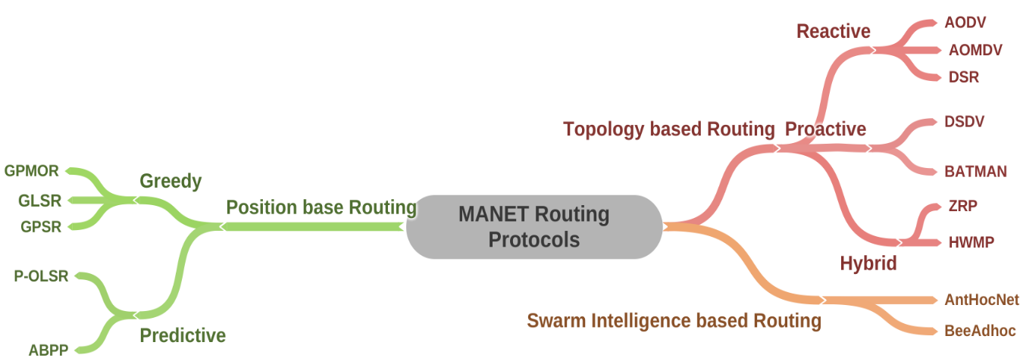

Figure 1. Routing protocols categories.

# Proactive routing protocols

Proactive routing protocols, also known as table-driven routing protocols, builds and maintains routing information or database for the whole network in advance. The Routing Database (RDB) is usually stored in the form of differently structured data tables. These tables are updated regularly or whenever there is a change in the network topology, for instance, in case of link or node failure. It is a crucial task to keep nodes up to date and synchronized all the time [16], [17].

One fundamental issue with these protocols is the amount of network traffic they generate. Proactive routing protocols are very chatty in their operation. They generate a large volume of routing messages over the network to keep nodes updated. Since nodes in MANET have limited resources (CPU, memory, energy, etc.) due to high routing loads, these protocols consume a large amount of energy, CPU cycles, and memory. To address these problems, researchers proposed reactive routing protocols, which are discussed in Section 2.2. Table 1 [18]–[20], presents a summary of different characteristics of proactive routing protocols.

Table 1. Basic Characteristics of Proactive Routing Protocols: Ad hoc On-Demand Distance Vector (AODV), Wireless Routing Protocol (WRP), Global State Routing (GSR), Fisheye State Routing (FSR), Optimized Link State Routing (OLSR), Source-Tree Adaptive Routing (STAR), Distance Routing Effect Algorithm for Mobility (DREAM), F = flat

|  |  |  |  |  |  |
| --- | --- | --- | --- | --- | --- |
| Protocol | Routing Structure | No. of Tables | Frequency of Updates | Hello Message | Critical Nodes |
| AODV | F | 2 | Periodic and as required | Yes | No |
| WRP | F | 4 | Periodic | Yes | No |
| GSR | F | 3 | Periodic | NO | No |
| FSR | F | Same as GSR | Periodic | No | No |
| OLSR | F | 3 | Periodic and as required | Yes | No |
| STAR | H | 1 | Conditional | Yes | No |
| DREAM | F | 1 | Mobility based | NO | No |
| HSR | H | 2 | Periodic | NO | Yes, cluster-head |

# Reactive Routing Protocols

Reactive routing protocols, also known as on-demand routing protocols, are developed to address the weaknesses of proactive routing protocols discussed in Section 2.1. In reactive protocols, nodes discover routes as needed instead of constructing a routing table for the entire network in advance. It means that routes are populated and maintained for only those nodes, which require sending some data to a particular destination. Reactive protocols require nodes to gather only the necessary information [21], [22].

Typically, obtaining routing information encompasses a route discovery or a route repair process. Reactive protocols do not send periodic broadcast messages over the network. Thus, unnecessary network load, congestion, energy, and computational load on the node are reduced. Active discovered routes are stored for a particular time in the routing table and deleted after some inactivity. Routing tables size remains of reasonable length, thus allowing to accommodate a much larger topology. A comparison of different reactive routing protocols is presented in table 2 [23]–[26].

Table 2. Basic characteristics of reactive routing protocols, RS=routing structure; F=flat; RT=route table; RC=route cache; SP=shortest path

|  |  |  |  |  |  |
| --- | --- | --- | --- | --- | --- |
| Protocol | RS | Multiple routes | Beacons | Route metric method | Route maintained in |
| AODV | F | No | yes, hello message | Freshest & SP | RT |
| AOMDV | F | Yes | yes, hello message | Freshest & SP | RT |
| DSR | F | Yes | No | SP, next available in RC | RC |
| ROAM | F | Yes | No | SP | RT |
| LMR | F | Yes | No | SP, next available in RT | RT |
| TORA | F | Yes | No | SP, next available in RT | RT |

# Hybrid Routing Protocols

Hybridization is a technique in which features of two or more algorithms are superimposed together to eliminate or reduce parent algorithms’ weaknesses. It is a fusion of the best properties of proactive and reactive routing protocols.

Scalability is the main problem with reactive and proactive protocols. As discussed in Section 2.1, proactive routing protocols need to build and maintain a to the date routing table for the whole network, and it becomes difficult as the network size grows. In addition, they also consume a lot of network bandwidth, due to which the throughput of the network is decreased. In reactive protocols, as several nodes or network size grows, reactive protocols introduce a delay factor because they discover route on the fly. It becomes unacceptable for soft real-time applications like audio communication or video surveillance etc. Hybrid protocols have the potential to address this problem. These protocols are designed to increase the scalability by allowing nodes to distribute the network in zones (virtually) or backbone areas. Nodes near a node come under the backbone area (zone), and remaining nodes in tertiary zones. For backbone, area routes are discovered by exploiting proactive routing techniques, while the reactive approach is used to discover routes for tertiary zones. Summary of different hybrid routing protocols is presented in Table 3 [27], [28].

Table 3. Basic characteristics of hybrid routing protocols, RS=routing structure; H=hierarchical; F=flat; SP=shortest path; Bc=beacons.

Protocol RS Multiple routes Bc Route metric method Route metric method & Route maintained

in

|  |  |  |  |  |
| --- | --- | --- | --- | --- |
| ZRP | F | No | Yes SP | Intrazone & interzone tables |
| AntHocNet | F | No | Yes SP | Intrazone & interzone tables |

# BIO-INSPIRED ANT COLONY OPTIMIZATION (ACO) ALGORITHM

Nature-inspired algorithms demonstrate promising results in high-performance computing [29]. These algorithms are inspired by the behavior of various animals and insects, plants, etc., [30]–[32]. The simplicity of these algorithms represents their advantage. They are straightforward to analyze, evolve and have shown outstanding scalability and flexibility to adapt to the problem’s changing nature. The article is focused on Ant Colony Optimization (ACO) algorithm. ACO is a metaheuristics optimization algorithm that takes inspiration from natural ants’ behavior in nature [11], [12]. ACO has been applied to various complex optimization problems and often produces optimal results [33].

# Nature of Ants

The prime motivation of ACO and its applications in MANET is the foraging behavior of some ant species [34], [35]. Ants have been noticed to find the shortest path between the feeding place and the hill. Every personal ant has minimal computational and visual abilities (some ant species are completely blind). Discovering the shortest route among several possible routes is undoubtedly a difficult task accomplished through the colony’s members’ participation. Each ant deposits pheromone when it travels to find a food source [36], [37]. Pheromone is an unstable organic and volatile compound naturally produced by ants in attempting to manipulate other ants. Ants follow the path which is rich with pheromones and ignore paths having low pheromone concentration. However, ants can take any random direction also. This is known as local behavior or heuristic. It is essential for exploration purposes. Generally, the ants’ global behavior is the result of colonial coordination, which is achieved with the help of pheromone [38], [39]. This indirect communication mode is known as Stigmergy. Marco Dorigo got inspired by natural ants’ behavior and proposed the ACO metaheuristic algorithm back in 1990 [40]. Initially, the ACO algorithm was applied to the Travelling Salesman Problem (TSP), but after that, it was widely accepted to solve many complex optimization problems.

# Double Bridge Experiment

The ant algorithm experimentation on the double bridge is essential in itself, which served as the impetus for all of the recent studies that tend to interpret the ACO evolutionary algorithms [41]. In addition, its equation is the starting point for all of ACO’s various studies. Figure 2, shows how a double bridge looks like. Consider an ant move from the nest for food search and reaches the branch point. There will be two pathways available for that ant. Since it is the first of its kind, there will be no previous deposits of pheromone. It can randomly select any path and moves forward. While following any direction, it will be depositing pheromone. The following ant comes has two paths again, however, since pheromone is already deposited at one of the paths. The next coming ant will assume this is the shortest path.

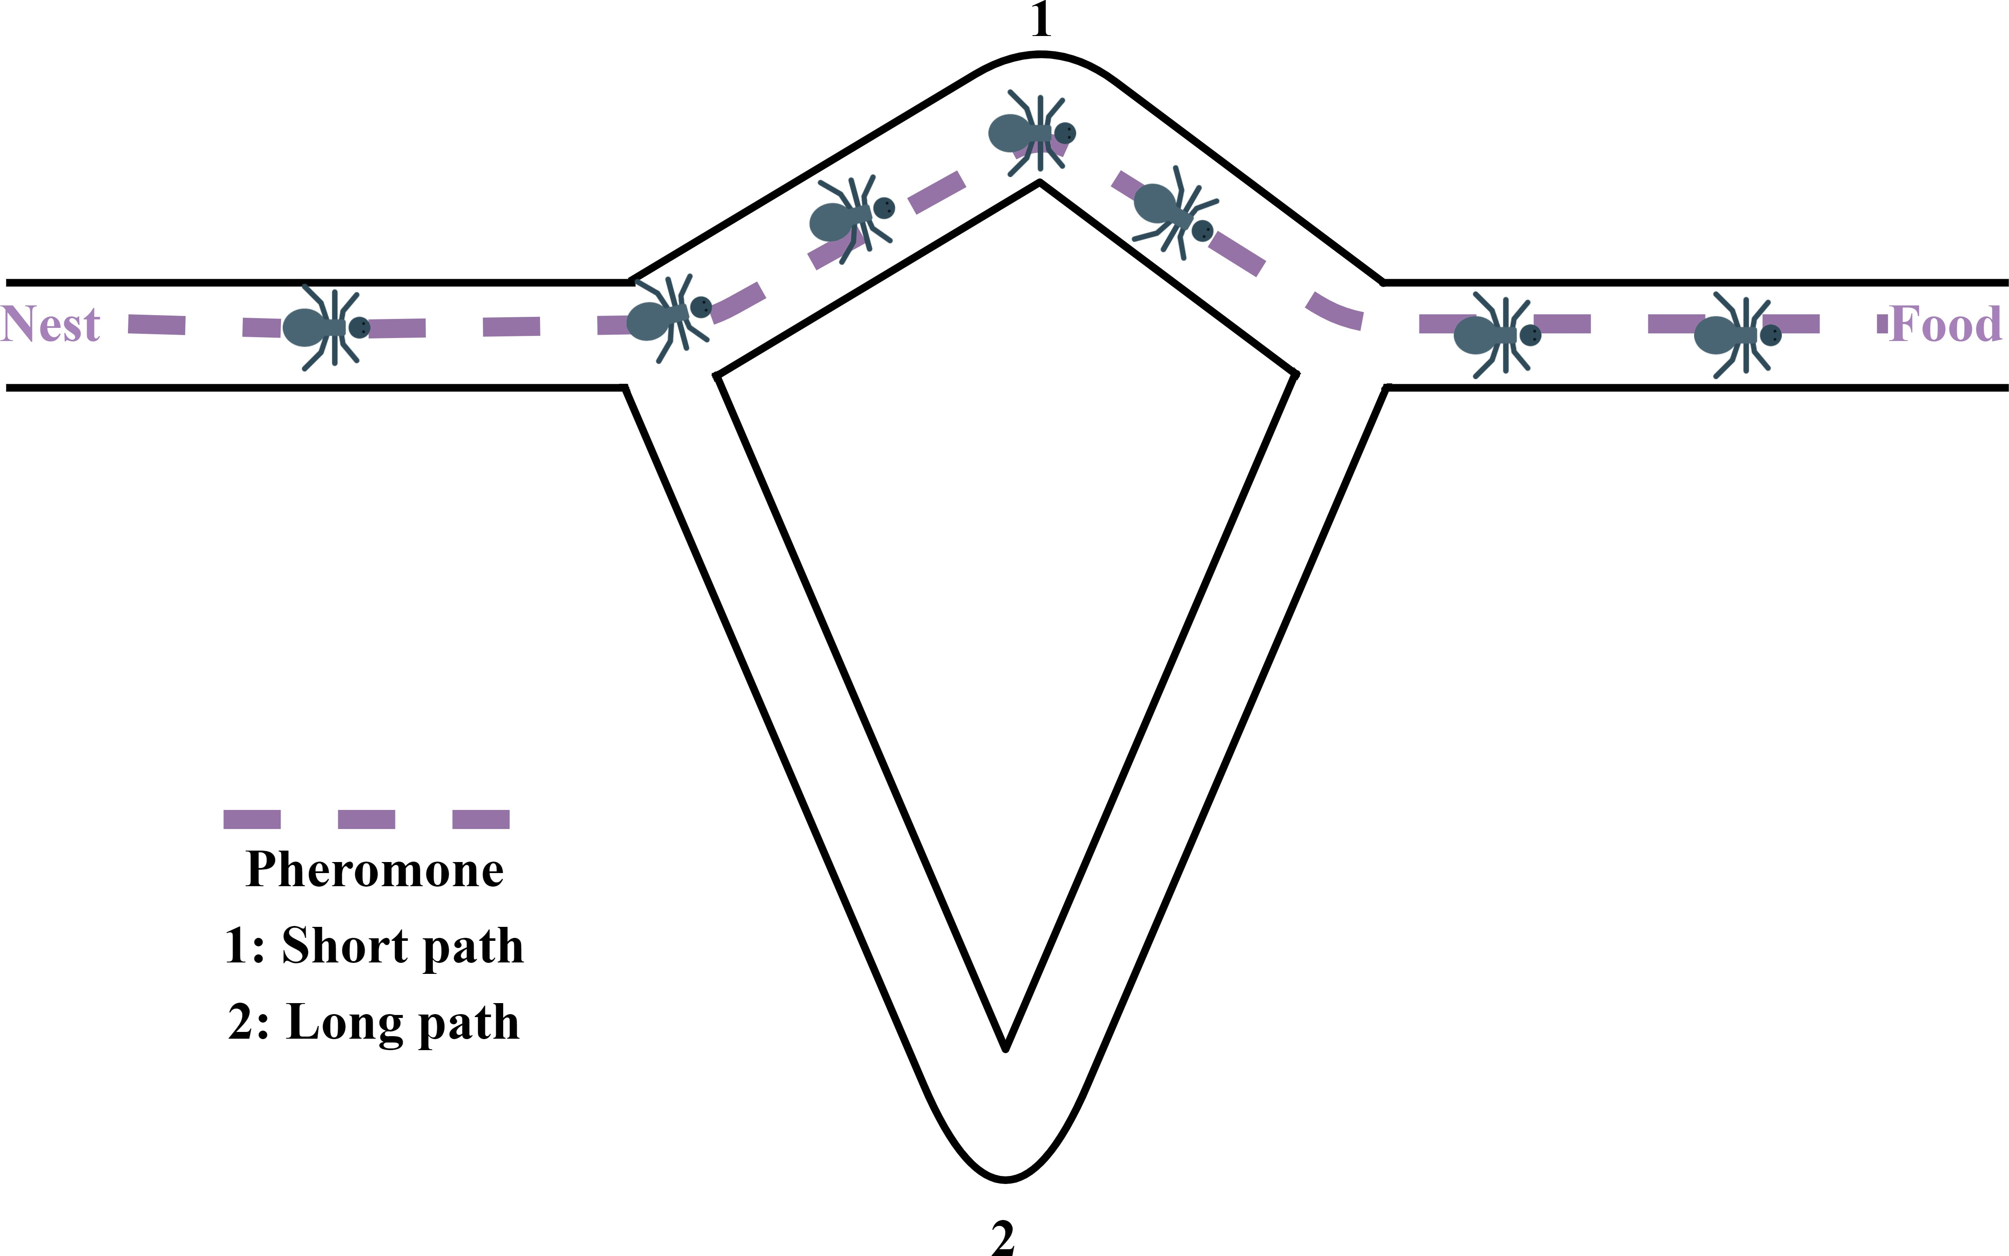

Figure 2. Ant double bridge experiment shows that how ants learn shortest path.

# Algorithm for Classical ACO

This section presents an ACO-based algorithm technique [41], [42]. The ACO metaheuristic consists of the following steps:

* + 1. In the initialization phase, different algorithmic parameters like initial pheromone value, etc., are initial- ized.
    2. Regarding to that, a primary cycle is executed till the ending is achieved.
    3. At the end of each cycle, ants are tasked with creating practical solutions.
    4. Applying a local search optimization could enhance the solution.
    5. At each iteration, the pheromone is updated, pheromone value increases or decreases depends on pheromone evaporation.
    6. At each iteration, the next vertex to visit.

# Pheromone Update Method

The amount of pheromone is updated by all the ants that have created solutions after each iteration cycle. The pheromone amount related with each edge connecting two vertex (I) and (j) are up to date, as shown in equation 1 [43].

*τi,j*(*t* + 1) = (1 − *ρ*) ∗ *τi,j*(*t*) + Σ ∆*τk* (*t*) (1)

*m*

*i,j*

where,

* 1 ≤ *ρ* ≤ 1 is the percentage of evaporation.
* The number of nodes is denoted by *m*.

*k*=1

*k i,j*

* ∆*τ*

the amount of pheromone put at edge i,j is denoted by k.

# RESEARCH METHOD

This paper uses several methodologies and techniques described in this section for selecting the proper routing protocol. Beginning with choosing the network simulator where there are several network simulations tools, such as (NS-2), (NS-3) network simulator, and the network simulation software QualNet (QualNet), all of which are not excluded. NS-2 has been chosen as the protocol simulator for this study because of its abundance and support of several network protocols. In this section will focus on various MANET routing protocols and their simulation. Four different routing protocols have been selected belonging to different families, which are: Dynamic Source Routing (DSR) - reactive routing protocol, Ad hoc On-Demand Distance Vector (AODV)

,Ad-Hoc On-Demand Multiple Path Distance Vector (AOMDV), and AntHocNet (Nature-inspired metaheuristic based) - hybrid. We observed an AntHocNet execution in NS-2.35, but it needs some tweaking to be usable, as it had no way to transmit the required prompt back ants. In addition, we wrote a custom Perl script to calculate metrics such as packet drop rate (PDR), throughput, average end- to-end delay, and energy consumption from the trace files. Finally, after these suggested modifications, the protocols and the four MANET routing scenarios are installed and ready to be tested.

The mobility model refers to the movement pattern of the mobile nodes during the simulation study. It plays a significant role in designing and implementing an excellent wireless infrastructure because a routing protocol has performed well in one mobility model, even though it is not necessary to perform well in other circumstances. Besides, the scripts presented in OTcl, an object-oriented language enhanced version of Tcl modeling and analyzing UDP protocols, routers, and other network items, are used to execute the NS-2 soft- ware. Tcl scripts were used to create network scenario simulation, connection settings, nodes movement, and position are implemented in the same fashion. Other modifications were implemented to adjust the transmitting and receiving power at nodes to produce an effective influence per each packet.

The simulation studies results are produced in a trace-file that included the stimulation details for the network. Graphs are generated by the command-line tool Gnuplot using gathered statistics. In the current study used Random WayPoint (RWP) mobility model in the network simulation parameter, and other parameters have been shown in Table 4.

Table 4. Parameter values of the network simulator

Parameter Value

Routing Protocols AODV AOMDV AntHocNet DSR Area 1500m x 1000m

No. of Nodes 100

Simulation Time 180s

Mobility model Random Way Point (RWP)

Propagation model Shadowing

Initial Energy 1000J

Packet Size 512 bytes Initial Nodes placement Random

# Studied Parameters

The strengths and weaknesses of different routing protocols’ parameters will be analyzed via simula- tion in the study. These parameters are:

* + 1. Packet Drop Rate (PDR): PDR is described as the” quantity of dropped packets per second”. We extracted and calculated the dropped packets from the simulation trace file. Every dropped packet increased the unit time counter. The extracted data will then fed into the Gnuplot graphing software, which is used to plot the line graph for the entire simulation time. The PDR can be calculated by equation 2 [44].

*PDR* =

Number of packets received at destination

Σ Number of packets send by node

Σ

(2)

* + 1. Throughput: A network throughput represents the total number of packets that have been delivered suc- cessfully per period unit of time. The optimal protocol is the protocol that generate a higher throughput rate. In other words, in evaluating the effectiveness and scalability of routing protocols, throughput is essential. Equation 3 [45] is used to calculate it.

Σ

Throughput = Received Packets Count (*pps*) (3)

TotalTime

* + 1. Energy Consumption: Generally, in MANET, nodes are connected with batteries having limited power supply. Energy consumption is an important parameter to measure network lifetime. In our topology, all nodes are mobile; the energy consumed (left) has measured at the end of the simulation. Nodes remaining energy can be calculated by equation 4 [46].

Remaining Energy = Nodes Initial Energy − Consumed Energy (4)

* + 1. Average End to End Delay (E2E): Average E2E delay is the average time required for the packets to be delivered to their ultimate destination. Also, it is defined as the difference between the transit time and the arrival time of the packet at its destination. Equation 5 [47] is used to calculate E2E:

Average Delay = Packet Received Time avg − Packet Origination Timeavg (5)

# Mobility Model

The mobility model refers to the movement pattern of the mobile nodes during the simulation study. It plays a significant role in designing and implementing an excellent wireless infrastructure because a routing protocol, which has performed well in one mobility model, will not necessarily perform well in other arrange- ments—the Random Waypoint (RWP) mobility model used in proposed work. The following parameters are configured for the RWP model: the minimum Speed: 1m/s, maximum Speed: 10 m/s, and Pause Time: 1s.

# RESULTS AND DISCUSSION

The results are extracted with the help of PERL scripts explicitly developed for this study. We extracted the trace file output with the help of custom PERL scripts. The extracted data is then passed to Gnuplot and an excel sheet for further analysis.

Figure 3a presents the packet drop rate per second for AODV, AOMDV, DSR, and AntHocNet routing protocols. The graph clearly shows that the packet drop rate for the AODV routing protocol is far less than the other routing protocols. The experiment results showed extreme fluctuations for the AOMDV and DSR routing protocols. This behavior is not suitable for real-time applications like audio or voice communication. Figure 3b, for the same parameter, also shows that AODV has a low average drop count, and its standard deviation is also less than AntHocNet, AOMDV, and DSR routing protocols.

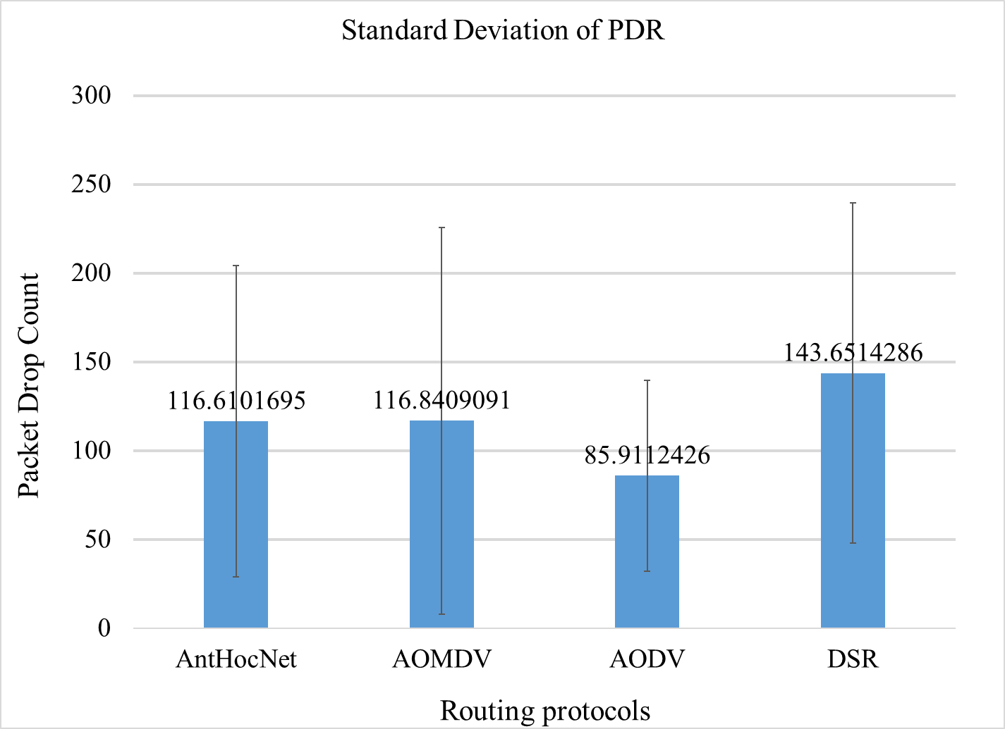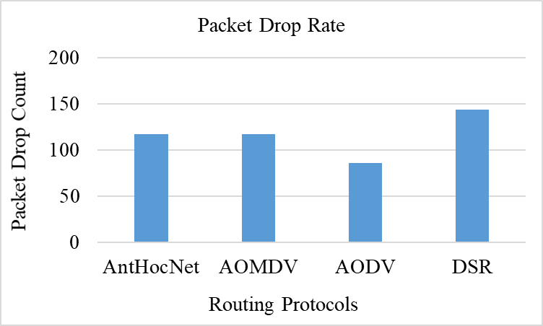

(a) (b)

Figure 3. PDR calculation and discussion , (a)PDR, (b) Standard deviation of PDR

Figure 4a shows overall network throughput. It shows that the AODV routing protocol has an overall high network throughput compared to the other routing protocols. Therefore, it helps bandwidth-hungry applications such as virtual desktops, online gaming, and cloud storage. However, the simulation results indicate fluctuating behaviour. Table 5 presents that there is a massive gap between the average value. Also, Figure 4b presents the standard deviation of AODV. It means that users will not have a steady download speed and will experience high variations.

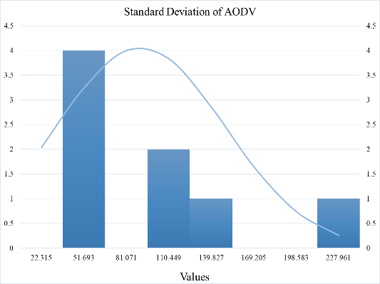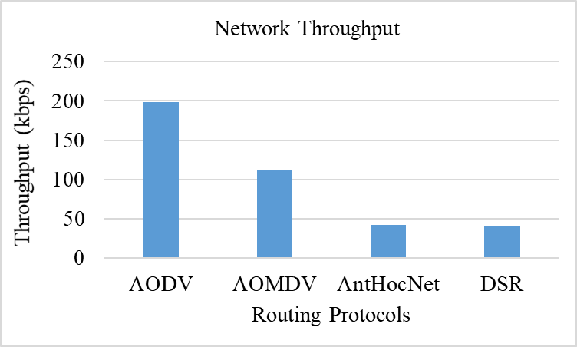

1. (b)

Figure 4. Network throughput calculation and discussion, (a)Network throughput, (b) Standard deviation of AODV

Table 5. Standard deviation of throughput.

|  |  |  |  |  |
| --- | --- | --- | --- | --- |
|  | AODV | AOMDV | AntHocNet | DSR |
| Minimum | 12.46875 | 4.15625 | 4.15625 | 4 |
| Maximum | 344.96875 | 295.09375 | 128.84375 | 96.09375 |
| Average | 198.58936 | 111.88814 | 41.681932 | 41.19436 |
| Standard Deviation | 82.753427 | 82.665883 | 22.319225 | 28.399975 |

Figure 5a shows the average end-to-end delay for all four routing protocols. DSR has a higher delay than reactive routing protocols, which is also proved from this graph. Figure 5a presents that DSR efficiency is better than AOMDV, AntHocNet, and AODV in terms of delay. AOMDV routing protocols are inferior to AntHocNet and AODV. Figure 5b shows how much energy is consumed by each protocol. There is no desired difference among them, with very little superiority being noted on the AntHocNet. AODV consumed

less energy as compared to DSR, AntHocNet, and AOMDV protocols. Less energy consumption makes AODV suitable for regions where replacing batteries is practically not possible. It increases network lifetime also.

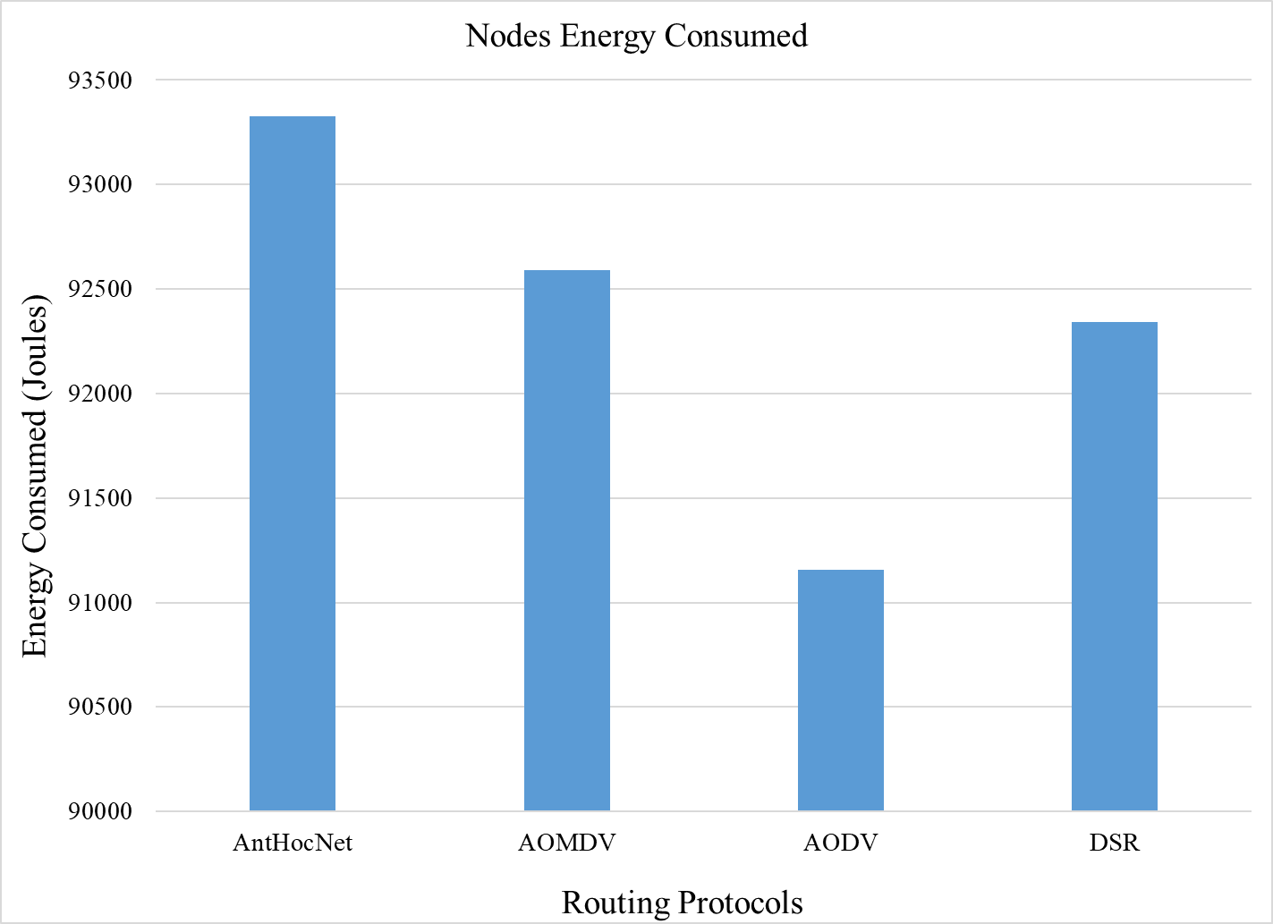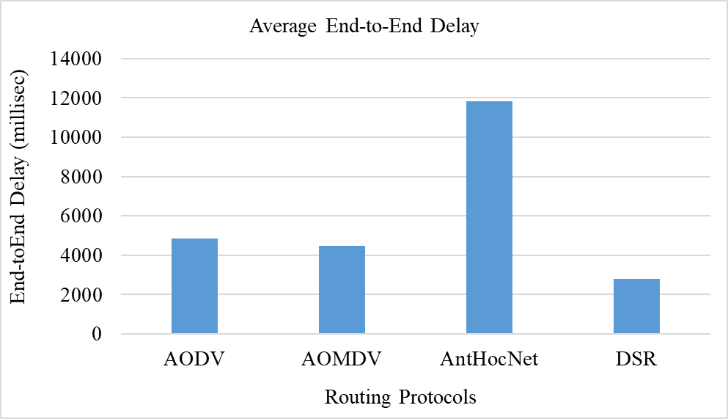

* 1. (b)

Figure 5. Simulation parameters:

(a) Average end-to-end delay, (b) Energy consumptions.

The simulation results conclude that the AODV, on the whole, performs admirably in terms of throughput, energy consumption and PDR compared with the AntHocNet, AOMDV, and DSR. At the same time, the DSR was better in terms of delay. AODVs' feature of operating in connection state and as a routing table causes an increase in throughput and other features. ​However, the simulation shows a higher delay of AntHocNet (proactive and reactive protocol) than AODV, AOMDV, and DSR protocols, with a remarkable advantage in PDR.

This has opened a new research area to explore and reduce its high delay factor. In addition, the experimental result shows that the DODV is better in terms of throughput and energy consumption. On the other hand, the AODV showed a slight delay in terms of delay. This will lead to being an efficient solution for applications that require a long lifetime and higher performance.

# CONCLUSION

In this article, the effectiveness of various routing protocols in MANET is evaluated using the NS-2 simulator. As part of the evaluation, mathematical statistics have been used to study and evaluate the behaviour of the transmitted data and measure the efficiency of the protocol based on the simulation results and the standard deviation of the data.

Despite its throughput, the results show that the ACO algorithm has less potential to be used as a routing protocol due to the network parameters’ results compared to other protocols. Furthermore, the results indicate an incentive to enhance AntHocNet. Its high delay in sending data between source and destination and its energy consumption cause a shorter lifetime of the network. It must shed light on the PDR due to its low packet drop rate compared to other protocols.

In future work, we propose improving the ACO algorithm based on the results and examining it with various scenarios such as simulation time, network load, node speed, and ACO congestion, which can affect packet loss and lower energy and throughput, leading to enhanced network lifetime and giving better performance. Also, this study suggests more investigations of the AODV protocol, which can lead to a modification to the routing mechanism of the protocol to handle the instability of the link quality and enhance the delay.

# ACKNOWLEDGEMENT

This paper was supported by SGS University of Pardubice project No. SGS 2021 011.

# REFERENCES

[1] S. Alani, Z. Zakaria, and H. Lago, “A new energy consumption technique for mobile ad hoc networks,” Int. J. Electr. Comput. Eng., vol. 9, no. 5, p. 4147, 2019.

[2] M. Thiede, D. Fuerstenau, and A. P. B. Barquet, “How is process mining technology used by organizations? A systematic literature review of empirical studies,” Bus. Process Manag. J., 2018.

[3] A. I. A. Salman and K. Jitka, “Comparative Study and Analysis of Wireless Mobile Adhoc Networks Routing Protocols,” 2019.

[4] M. Abbas, H. M. T. Alhilfi, and T. Sutikno, “Performance evaluation of two models in the reactive routing protocol in manets,” Indones. J. Electr. Eng. Comput. Sci., vol. 21, no. 1, pp. 391–397, 2021.

[5] T. K. Priyambodo, D. Wijayanto, and M. S. Gitakarma, “Performance Optimization of MANET Networks through Routing Protocol Analysis,” Computers, vol. 10, no. 1, p. 2, 2021.

[6] M. Zhang, M. Yang, Q. Wu, R. Zheng, and J. Zhu, “Smart perception and autonomic optimization: {A} novel bio-inspired hybrid routing protocol for MANETs,” Futur. Gener. Comput. Syst., vol. 81, pp. 505–513, 2018, doi: 10.1016/j.future.2017.07.030.

[7] L. Aliouat, H. Mabed, and J. Bourgeois, “Efficient routing protocol for concave unstable terahertz nanonetworks,” Comput. Networks, vol. 179, p. 107375, 2020.

[8] I. A. Alameri, “A Multi-Parameter Comparative Study of MANET Routing Protocols.” in 2020 15th Iberian Conference on Information Systems and Technologies (CISTI). IEEE, 2020, pp. 1–6.

[9] S. S. Mohamed, A.-F. I. Abdel-Fatah, and M. A. Mohamed, “Performance evaluation of MANET routing protocols based on QoS and energy parameters.,” Int. J. Electr. \& Comput. Eng., vol. 10, 2020.

[10] I. A. Alameri, A. N. Onaizah, I. A. Koondhar, and others, “Optimized image processing and clustering to mitigate security threats in mobile ad hoc network.,” Telkomnika, vol. 18, no. 1, 2020.

[11] N. Khatoon and others, “Mobility aware energy efficient clustering for MANET: a bio-inspired approach with particle swarm optimization,” Wirel. Commun. Mob. Comput., vol. 2017, 2017.

[12] A. Alamsyah, E. Setijadi, I. K. E. Purnama, and M. H. Purnomo, “Analisis kinerja protokol routing reaktif dan proaktif pada MANET menggunakan NS2,” J. Nas. Tek. Elektro dan Teknol. Inf., vol. 7, no. 2, pp. 138–143, 2018.

[13] I. A. Alameri and J. Komarkova, “Network Routing Issues in Global Geographic Information System,” in SHS Web of Conferences, 2021, vol. 92.

[14] I. U. Khan, I. M. Qureshi, M. A. Aziz, T. A. Cheema, and S. B. H. Shah, “Smart IoT control-based nature inspired energy efficient routing protocol for flying ad hoc network (FANET),” IEEE Access, vol. 8, pp. 56371–56378, 2020.

[15] A. Boukerche, B. Turgut, N. Aydin, M. Z. Ahmad, L. Bölöni, and D. Turgut, “Routing protocols in ad hoc networks: A survey,” Comput. Networks, vol. 55, no. 13, pp. 3032–3080, 2011, doi: 10.1016/j.comnet.2011.05.010.

[16] A. Moussaoui and A. Boukeream, “A survey of routing protocols based on link-stability in mobile ad hoc networks,” J. Netw. Comput. Appl., vol. 47, pp. 1–10, 2015, doi: 10.1016/j.jnca.2014.09.007.

[17] R. B. Al-Bayram and R. M. Abdullah, “Network size variation of geographical aided routing protocols in MANET,” Indones. J. Electr. Eng. Comput. Sci., vol. 21, no. 1, pp. 420–428, 2021.

[18] R. R. Ema, M. Ashrafi Akram, A. Hossain, and S. K. Das, “Performance analysis of DSDV, AODV and AOMDV routing protocols based on fixed and mobility network model in wireless sensor network,” Glob. J. Comput. Sci. Technol., 2014.

[19] C. Brill and T. Nash, “A comparative analysis of MANET routing protocols through simulation,” in 2017 12th International Conference for Internet Technology and Secured Transactions (ICITST), 2017, pp. 244–247.

[20] M. Abolhasan, T. Wysocki, and E. Dutkiewicz, “A review of routing protocols for mobile ad hoc networks,” Ad hoc networks, vol. 2, no. 1, pp. 1–22, 2004.

[21] D. Choudhary and R. Pahuja, “Performance Optimization by MANET AODV-DTN Communication,” in Soft Computing: Theories and Applications, Springer, 2020, pp. 1–9.

[22] W.-C. Wu and H.-T. Liaw, “A study on high secure and efficient MANET routing scheme,” J. Sensors, vol. 2015, 2015.

[23] A. A. Aouiz, S. B. Hacene, P. Lorenz, and M. Gilg, “Network Life Time maximization of the AOMDV Protocol Using Nodes Energy Variation,” Int. J. Netw. Protoc. Algorithms, vol. 10, no. 2, pp. 73–94, 2018.

[24] S. Kumar, S. Khimsara, K. Kambhatla, K. Girivanesh, J. D. Matyjas, and M. Medley, “Robust on-demand multipath routing with dynamic path upgrade for delay-sensitive data over ad hoc networks,” J. Comput. Networks Commun., vol. 2013, 2013.

[25] E. Setijadi, I. K. E. Purnama, M. H. Pumomo, and others, “Performance comparative of AODV, AOMDV and DSDV routing protocols in MANET using NS2,” in 2018 International Seminar on Application for Technology of Information and Communication, 2018, pp. 286–289.

[26] M. Z. Hasan, H. Al-Rizzo, and F. Al-Turjman, “A survey on multipath routing protocols for QoS assurances in real-time wireless multimedia sensor networks,” IEEE Commun. Surv. \& Tutorials, vol. 19, no. 3, pp. 1424–1456, 2017.

[27] M. S. Abuhmida, “ANTMANET: a novel routing protocol for mobile ad-hoc networks based on ant colony optimisation,” University of Wales Trinity Saint David, 2017.

[28] A. K. Sharma and M. C. Trivedi, “Performance comparison of AODV, ZRP and AODVDR routing protocols in MANET,” Proc. - 2016 2nd Int. Conf. Comput. Intell. Commun. Technol. CICT 2016, pp. 231–236, 2016, doi: 10.1109/CICT.2016.53.

[29] A. K. Kar, “Bio inspired computing--a review of algorithms and scope of applications,” Expert Syst. Appl., vol. 59, pp. 20–32, 2016.

[30] I. Fister, X. S. Yang, J. Brest, and D. Fister, “A brief review of nature-inspired algorithms for optimization,” Elektroteh. Vestnik/Electrotechnical Rev., vol. 80, no. 3, pp. 116–122, 2013.

[31] P. Kumar, T. Amgoth, and C. S. R. Annavarapu, “ACO-based mobile sink path determination for wireless sensor networks under non-uniform data constraints,” Appl. Soft Comput., vol. 69, pp. 528–540, 2018.

[32] R. Yarinezhad and S. Azizi, “An energy-efficient routing protocol for the Internet of Things networks based on geographical location and link quality,” Comput. Networks, p. 108116, 2021.

[33] V. V Mandhare, V. R. Thool, and R. R. Manthalkar, “QoS Routing enhancement using metaheuristic approach in mobile ad-hoc network,” Comput. Networks, vol. 110, pp. 180–191, 2016.

[34] J. M. Kandan and A. Sabari, “Fuzzy hierarchical ant colony optimization routing for weighted cluster in MANET,” Cluster Comput., vol. 22, no. 4, pp. 9637–9649, 2019.

[35] J. Wang, J. Cao, B. Li, S. Lee, and R. S. Sherratt, “Bio-inspired ant colony optimization based clustering algorithm with mobile sinks for applications in consumer home automation networks,” IEEE Trans. Consum. Electron., vol. 61, no. 4, pp. 438–444, 2015.

[36] I. Luthra, S. K. Chaturvedi, D. Upadhyay, and R. Gupta, “Comparative study on nature inspired algorithms for optimization problem,” in 2017 International conference of Electronics, Communication and Aerospace Technology (ICECA), 2017, vol. 2, pp. 143–147.

[37] R. Baskaran, P. V. Paul, and P. Dhavachelvan, “Ant colony optimization for data cache technique in MANET,” in Proceedings of International Conference on Advances in Computing, 2013, pp. 873–878.

[38] J. Billen and E. D. Morgan, “Pheromone communication in social insects: sources and secretions,” Pheromone Commun. Soc. insects ants, wasps, bees, Termit., pp. 3–33, 1998.

[39] H. F. Mahdi, M. S. Abood, and M. M. Hamdi, “Performance evaluation for vehicular ad-hoc networks based routing protocols,” Bull. Electr. Eng. Informatics, vol. 10, no. 2, pp. 1080–1091, 2021.

[40] M. Dorigo and T. Stützle, “The ant colony optimization metaheuristic: Algorithms, applications, and advances,” in Handbook of metaheuristics, Springer, 2003, pp. 250–285.

[41] G. Di Caro, F. Ducatelle, and L. M. Gambardella, “AntHocNet: an adaptive nature-inspired algorithm for routing in mobile ad hoc networks,” Eur. Trans. Telecommun., vol. 16, no. 5, pp. 443–455, 2005.

[42] G. Di Caro, F. Ducatelle, and L. M. Gambardell, “AntHocNet: an ant-based hybrid routing algorithm for mobile ad hoc networks,” in International Conference on Parallel Problem Solving from Nature, 2004, pp. 461–470.

[43] W. W. Hager, “Runge-Kutta methods in optimal control and the transformed adjoint system,” Numer. Math., vol. 87, no. 2, pp. 247–282, 2000.

[44] A. Tsirigos and Z. J. Haas, “Analysis of multipath routing-Part I: The effect on the packet delivery ratio,” IEEE Trans. Wirel. Commun., vol. 3, no. 1, pp. 138–146, 2004.

[45] B. A. M. Villela and O. C. M. B. Duarte, “Maximum throughput analysis in ad hoc networks,” in International Conference on Research in Networking, 2004, pp. 223–234.

[46] L. M. Feeney, “An energy consumption model for performance analysis of routing protocols for mobile ad hoc networks,” Mob. Networks Appl., vol. 6, no. 3, pp. 239–249, 2001.

[47] N. Sarma and S. Nandi, “A multipath QoS routing with route stability for mobile ad hoc networks,” IETE Tech. Rev., vol. 27, no. 5, pp. 380–397, 2010.

# Abbreviations and Acronyms

AHWMNs Ad-Hoc Wireless Multipoint Networks AOMDV Ad-Hoc On-Demand Distance Vector Routing ACO Ant Colony Optimization

AODV Ad hoc On-Demand Distance Vector

DSR Dynamic Source Routing

E2E Average End to End Delay

GSM Global System Mobile

TSP Travelling Salesman Problem

IR Infra-Red

MANET Mobile Ad-Hoc Networks

NS-2 Network Simulations version 2

PDR Packet Drop Rate

RWP Random Waypoint

WMN Wireless Mesh Networks

WRP Wireless Routing Protocol

# BIOGRAPHIES OF AUTHORS

**Ibrahim Alameri** is an Iraqi national who was born in the country. He graduated from the University of Al-Qadisiyah with a B.Sc. in computer science and an M.Sc. in computer science from The South Ural State University (SUSU). He is pursuing a Ph.D. in mobile Ad-Hoc networks at the University of Pardubice.

Ad-Hoc routing protocols, wireless communication, and networking technologies are among his re- search interests. He could be contacted by his email: st61833@upce.cz.

**Jitka Komarkova** works as an Associate Professor of Systems Engineering and Informatics at the University of Pardubice, Faculty of Economics and Administration, Institute of System Engineering and Informatics since 2009.

Her researches are in the fields of systems engineering and geoinformation technologies. She is major in the design of web-based GIS with a focus on usability; and spatial data collection, including utilization of UAVs, and data analyses. Recently, wireless networks as another source of spatial data and spatial issues have been tackled. She has been a supervisor of both master and doctoral students at the faculty. She teaches subjects focused on systems engineering and geoinformation technologies. She has served as an invited reviewer of many scientific articles and papers. She could be contacted at email: jitka.komarkova@upce.cz.

Further info can be found on her homepage: https://www.upce.cz/en/user/5057