Early detection of slight bruises in apples
by cost-efficient near-infrared imaging

Chanh-Nghiem Nguyen¹, Van-Linh Lam², Phuc-Hau Le³
Huy-Thanh Ho⁴, Chi-Ngon Nguyen⁵
^{1,2,3,4,5}Department of Automation Technology, Can Tho University, Vietnam
²Department of Electronics and Telecommunication, Kien Giang College, Vietnam

Article Info |  | ABSTRACT
Article history:  Received Jun x, 2021  Revised Nov x, 2021  Accepted Jan x, 2021 |  | Near-Infrared (NIR) spectroscopy has been widely reported for its useful applications in assessing internal fruit qualities. Motivated by apple consumption in the global market, this study aims to evaluate the possibility of applying NIR imaging to detect slight bruises in apple fruits. A simple optical setup was designed, and low-cost system components were used to promote the future development of practical and cost-efficient devices. To evaluate the effectiveness of the proposed approach, slight bruises were created by a mild impact with a comparably low impact energy of only 0.081 Joules. Experimental results showed that 100% of bruises in Jazz and Gala apples were accurately detected immediately after bruising and within 3 hours of storage. Thus, it is promising to develop customer devices to detect slight bruises for not only apple fruits but also other fruits with soft and thin skin at their early damage stages.
Keywords:
Low-cost
NIR
Mild bruises
Fresh
Early detection
This is an open access article under the CC BY-SA license.

Corresponding Author:
Chanh-Nghiem Nguyen,
Department of Automation Technology,
Can Tho University,
Campus II, 3/2 Street, Ninh Kieu district, Can Tho city, Vietnam.
Email: ncnghiem@ctu.edu.vn

- INTRODUCTION
Despite the intermittent decline in apple consumption, apples are still among the most consumed fruits in the global market, partly because they are rich in antioxidants and have high nutraceutrical values. Apple fruit is highly vulnerable to external impact from falling or distortion in various stages and processes related to harvesting and postharvest handling [1]. The resulted brusing will alter the flavor, the color and textural properties of the fruit [2] that affect the consumer’s acceptance of the fresh fruit [3]. However, manual assessment of apple fruits, one of the most common quality assessment methods, is not very accurate and time-consuming [4]. Therefore, it is necessary to develop bruise-detecting tools at postharvest facilities.
In the past two decades, many noninvasive approaches have been proposed for apple bruise detection, such as chlorophyll fluorescence imaging [5], deep learning based on 3D deep features [6], structured-illumination reflectance imaging [7], Raman spectroscopy [8], X-ray computed tomography [9], near-infrared (NIR) imaging in various spectral bands from visible-near to thermal infrared spectral ranges [2], [10]–[16]. Because NIR spectra contain information about the major C–H, O–H, and N–H bonds [17]–[19] besides water absorption wavelengths crucial for bruise detection, NIR spectra might reveal valuable information for fruit quality analysis. Therefore, getting full benefits of hyperspectral information in the VIS-NIR or IR range has attracted much interest and promote classification solutions with higher accuracy. By selecting optimal wavelengths in the spectral range from 401 to 1037 nm, bruise detection for apples could be achieved as high as 97.5% [20]. However, hyperspectral imaging or imaging in the IR spectral range requires sophisticated and high-cost cameras that will not be feasible for developing cost-efficient commercial grading applications or consumer-grade devices. Thus, low-cost multispectral sensors are gaining research focus [17], [21], [22].
Detecting bruises at the early stages is an interesting postharvest problem to reduce the cost incurred in transportation, storage, and shortened shelf-life. Early detection approaches were evaluated with apples immediately after being subjected to a bruising experiment [7], [10], [23]. However, few studies focused on slight bruises with well-defined impact levels, partly due to no standard method currently available for assessing the severity of fruit bruising [24]. A controlled bruise was considered a slight bruise if it was difficult to recognize based on its texture and color [23]. Such definition was subjective and might result in inconsistent classification of impact levels. Thus, it will be advantageous to specify a quantitative limit of bruise detection for reliable implementation of a bruise detection system because the bruise characteristics depend on various mechanical parameters such as drop height, impact force, and impact energy [15].
In a preliminary effort to develop cost-efficient devices for apple bruise detection, the paper presents the detection results of slight bruises in apples in their early stages using a simple imaging setup with cost-efficient IR imaging components. The slight level of apple bruises was quantitatively characterized in a comparative analysis to facilitate future practical applications such as automatic fruit sorting reported in [25].

- RESEARCH METHOD
2.1. Experimental setup
In this study, the apples were initially subjected to a bruising experiment designed to create comparably slight bruises. Then, NIR imaging of the apples was performed after different storage times to evaluate the effectiveness of the proposed approach for the early detection of apple bruises.

2.1.1. Bruising experiment setup
There are two basic brusing techniques which are pendulum-based method and drop test that could be applied for various kinds of fruit [26]. The pendulum-based method involves hitting the apple with a pendulum arm [7], [9], [14], [24], [27], [28]. Therefore, the impact energy (i.e., the kinetic energy) could be adjusted by changing the releasing angle of the pendulum arm. In the drop test, bruises could be generated by dropping the fruit to a contact surface [13], [23], [29]–[32] or by releasing a small steel ball to the fruit from a specific height [26], [33]–[36]. Because the impact energy computed as the potential energy that depends on the weight of the dropped object, a consistent impact level could be achieved for weight-varying apples by dropping a specific steel ball to the apples. In addition, a slight adjustment of the impact energy (i.e., the potential energy) could be easily performed by changing the drop height. Therefore, this method was utilized in this study.
As illustrated in Figure 1, a 55-gram steel ball (23.7 mm in diameter) was dropped at a specific height h above the apple to generate bruises. A 29 mm inner diameter pipe was used to guide the steel ball to impact the equatorial region of the apple. The ink used to mark the impact region was invisible with NIR imaging so that the round mark would not affect the results of bruise detection.

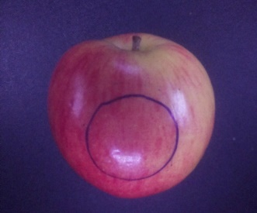
drop height h
23.7 mm diameter steel ball
29 mm inner diameter pipe
impact region

Figure 1. Setup for bruising an apple

With this setup, the impact energy is the potential energy of the steel ball. Thus, the drop heights of 150 and 300 mm correspond to the impact energy of 0.081 and 0.162 J, respectively. Table 1 shows the relationship between the applied impact energy and the qualitative level of visual perception of the induced bruises reported in [37]. A comparison of slight bruise definitions in other studies is tabulated in Table 2. According to these studies, the chosen drop height at 150 mm ensures slight bruises for this study. As shown in Figure 2, the bruises were challenging to be recognized.

Table 1. Impact levels applied on apple fruits [37]
Impact level | Impact energy (J) | Description | Sources of impact
1 | 0.05 | The lowest impact level that is close to the bruise detection limit | Handling and transporting
2 | 0.10 | Visible, easily perceivable damages | Handling and transporting and mechanical harvesting and sorting
3 | 0.19 | Visible, easily perceivable damages | Mechanical harvesting and sorting

Table 2. Summary of impact experiment for slight bruises in various studies
Reference | Impact method | Description of slight impact experiment | Impact energy¹
Gao et al., 2003 [8] | Dropping the apple | Drop height: 50 mm; Apple cultivar: Delicious apple | 0.071 Joules²
Zhu and Li, 2019 [23] | Dropping the apple | Drop height: 400 mm; Apple cultivar: China Fuji apple | 1.023 Joules³
This study | Dropping a steel ball to the apple | Steel ball weight: 55 grams; Drop height: 150 mm | 0.081 Joules
¹ Calculated with the assumption of no penetration nor bouncing at the contact surface.
² Estimate from the mean fruit weight of 145.2 grams [38] due to unreported fruit weight.
³ Estimate from the mean fruit weight of 260.9 grams [39] due to unreported fruit weight.

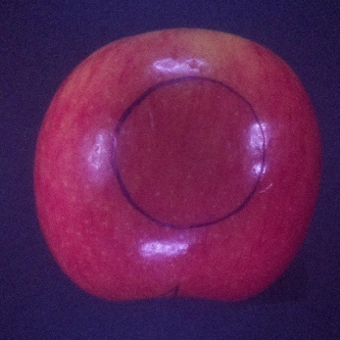  (a) | 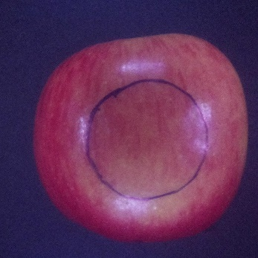  (b)

Figure 2. Jazz apple images immediately captured after the bruising experiment with a drop height of
(a) 150 mm and (b) 300 mm

2.1.2. Imaging setup
Figure 3 shows the experimental setup for imaging an apple inside a dark chamber. Four bars of LEDs were installed to provide normal illumination of the apple. Each LED bar had a row of four NIR LEDs and a row of four white light LEDs (Figure 4). NIR LEDs were turned on only when detecting bruises. In contrast, only white light LEDs were turned on when capturing the color images of the apple. Oil-paper was utilized as a light diffuser for the LED bars (Figure 4).

2.1.3. Characterization of NIR LEDs
The spectrum of low-cost NIR LEDs used in the experiment was measured by a DLP® NIRscan Nano evaluation module, Texas Instrument, with a measuring spectral range from 900 to 1700 nm, and a typical 10 nm resolution [40]. As depicted in Figure 5, the spectrum of the NIR LEDs had a peak at about 954 nm and adequately covered a wide water absorption band centered at about 970 nm [41], [42] Therefore, the LEDs used in the experiment were suitable for this study.


Side view
80 mm
110 mm
300 mm
Raspberry Pi NoIR camera
white light LEDs
Near infrared LEDs
Top view
300 mm

Figure 3. Setup for NIR imaging of the apple in a dark chamber

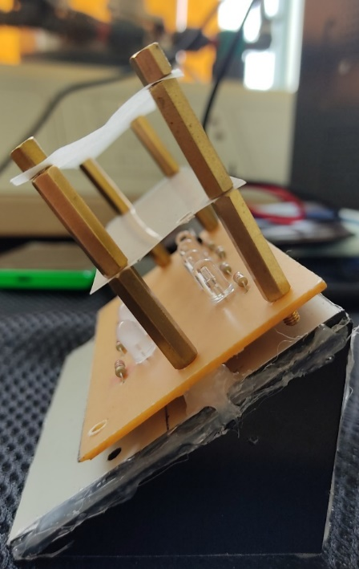
diffuser
white light LED
Near infrared LED

Figure 4. A LED bar for lighting the apple

Figure 5. The spectrum of NIR LEDs used in the system

2.1.4. Design of experiment
The design of the experiment is summarized in Table III. Two types of apples (i.e., French Jazz and New Zealand Ambrosia apples) were used in the experiments to evaluate the robustness of the proposed approach. For each apple type, bruises were created for two apples at a specific drop height (i.e., 150 mm and 300 mm), as illustrated by Figure 1. Because this study aims to detect fresh bruises, apple images were captured immediately after the apple had been subjected to the bruising experiment. Then, the apple was kept at room temperature for the next image capture sessions in 1, 2, and 3 hours.
For each capture session of an apple, three image sets were obtained. Each image set includes an RGB and three NIR images. The first image set was obtained by positioning the apple such that its bruised area was relatively at the center of its image region. Then, it was slightly rotated to the left and the right for capturing the next two image sets. These image sets were necessary to evaluate the robustness of the bruise detection algorithm concerning the bruise position.

Table 3. Summary of design of experiment
Factors | Description
Type of apples | French Jazz, New Zealand Ambrosia
Drop height h | 150 mm, 300 mm
Number of apples per type and drop height | 2
Time after bruising (hour) | 0 (right after intended bruising), 1, 2, 3
Positions of the bruised area in the image | 3

2.2. Algorithm for bruise detection
In this study, the Raspberry Pi NoIR camera was used to capture NIR images for bruise detection and RGB images for bruise notification. The proposed image processing algorithm for bruise detection included three main stages as follows.

2.2.1. Preprocessing for noise reduction
After three NIR images had been captured consecutively, their average image was calculated. This initial step was to reduce noise in NIR images that were prone to noise due to low light conditions. The average image was then scaled down by 30%. A region of interest (ROI) of 1400x1400 pixels in which the apple was centered was cropped from the average image to improve computational cost in the following image processing processes. Then, the median filter was applied to the ROI image for further noise reduction (Figure 6a).

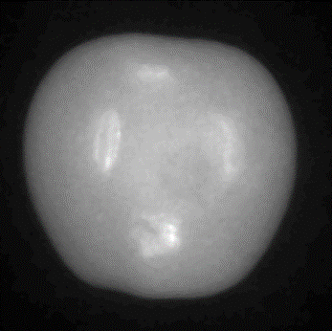  (a) |   (b) | 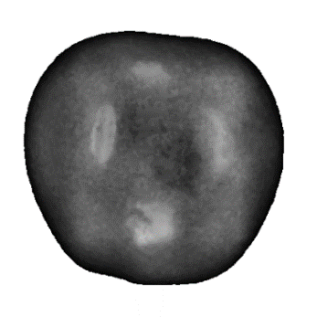  (c)

Figure 6. (a) Region of interest from the average image, (b) the apple mask,
and (c) the contrast-enhanced CLAHE image

2.2.2. Adaptive contrast enhancement
By thresholding the ROI image (as in Figure 6a), the apple mask was created (as in Figure 6b). From the ROI image and the apple mask, the apple-masked ROI image was created. Contrast Limited Adaptive Histogram Equalization (CLAHE), which could enhance the image areas with low contrast [43]–[45] was then applied to the apple-masked ROI image. The resulting image is the so-called CLAHE image in which the contrast of the bruise region was enhanced. As a result, the bruise could be determined to some extent visually and intuitively (Figure 6c).

2.2.3. Area-based bruise detection
The CLAHE image was thresholded (Figure 7a), and contour detection was applied. A bruised area a_{bruise} should satisfy the following condition
,
where a₁ and a₂ are the lower and upper threshold for a bruised area, respectively. In this study, the lower threshold a₁ corresponded to the area of a circle with a 5-mm radius. The upper threshold a₂ was chosen to conform to a circle area with a radius of 27 mm, the possibly largest impact region (Figure 1).
As shown in Figure 7b, the area-based bruise detection was effective for choosing the right contour of the bruised area by removing the large border region of the apple and unexpected noises. Although the bruise was created by a ball impactor, its boundary, as observed in Figure 7b, was noncircular. This finding agreed with the report in [27] in which the shape of the bruised region was irregular despite considerable impact energy of 0.196 J. Therefore, the area-based threshold for bruise recognition was appropriate in this study. The detected bruised area was notified by a green circle in the color image of the apple as shown in Figure 7c.

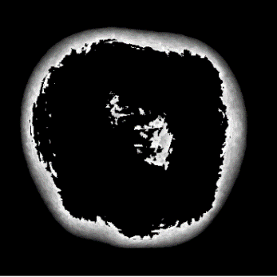  (a) | 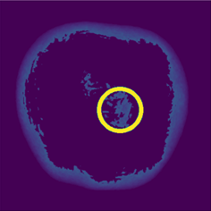  (b) | 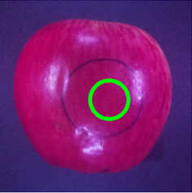  (c)

Figure 7. Area-based bruise detection: (a) thresholded image; (b) detected bruise marked by a yellow circle in the thresholded image; and (c) the detected bruise marked by a green circle in the RGB color image

- RESULTS AND DISCUSSION
3.1. Bruise detection results concerning bruise position
In the experiment, each apple was placed for imaging such that the intended bruising area was relatively at the center, the left and right areas of the apple image. As shown in Figure 8, the apple bruise was accurately detected within the intended bruising area previously marked by a blue circle. There was a small difference in the bruise’s detected areas (green circles in Figure 8), which might be due to light reflection changes when the bruised area was at different positions in the image. This phenomenon agreed with the finding that the apple’s inherent surface morphology might affect a VIS-NIR imaging system [46].

3.2. Bruise detection results concerning storage time after bruising and drop height
Figures 9 and 10 illustrate the detection results of Ambrosia and Jazz apples, respectively with respect to the storage time after intended bruising at different drop heights. All bruises could be detected accurately, although the slighter bruises were not apparent by a brief visual inspection (as shown in Figure 2a).
Bruises could also be accurately detected right after being subjected to bruising experiments. Within a short time of only 3 hours, the bruise areas did not develop sufficiently. As previously discussed, a small difference in the detected bruised area might be due to the surface morphology of the apple [46].

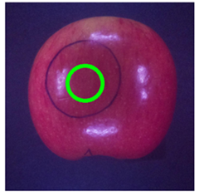  (a) | 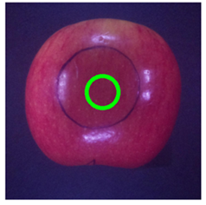  (b) | 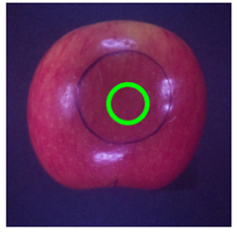  (c)
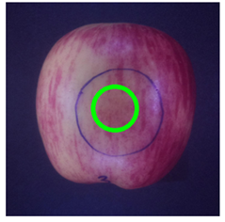  (d) | 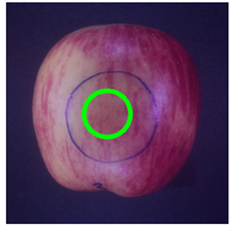  (e) | 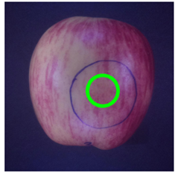  (f)

Figure 8. Bruise detection results of (a)-(c) Jazz apples and (d)-(f) Ambrosia apples with different imaging poses. Green circles show the detected bruise. Intended bruising regions were marked blue
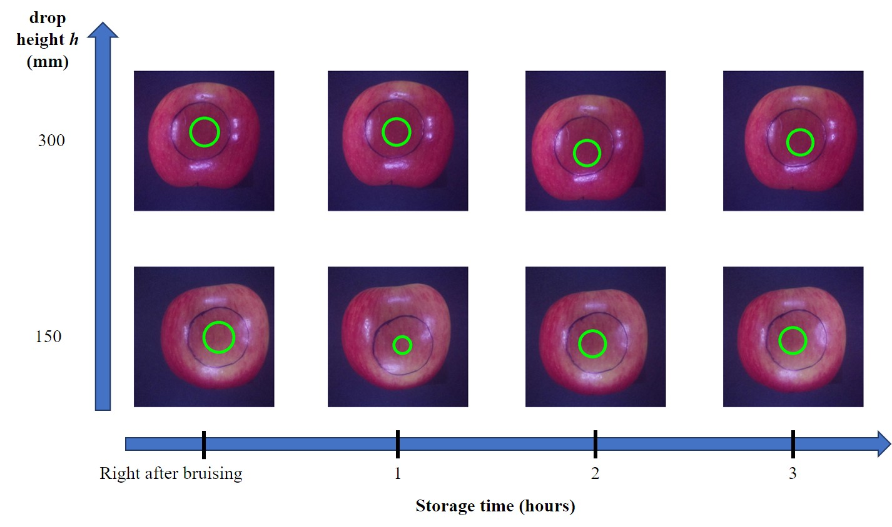

Figure 9. Bruise detection results of Jazz apples concerning storage time after intended bruising and drop height. Green circles show the detected bruise. Intended bruising regions were marked blue

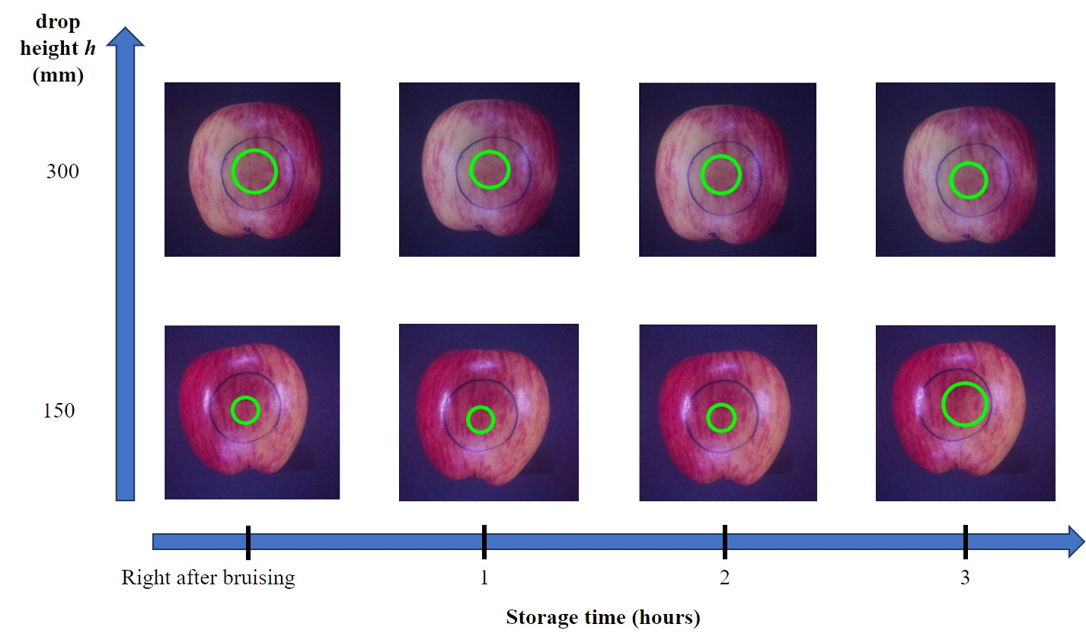

Figure 10. Bruise detection results of Jazz apples concerning storage time after intended bruising and drop height. Green circles show the detected bruise. Intended bruising regions were marked blue

- CONCLUSION
A simple and cost-efficient near-infrared imaging system was successfully developed for detecting slight bruises induced by only 0.081-Joule impact energy at the early damage stages with 100% detection rate. Experimental results showed that similar bruised areas for the same apple were reliably detected in terms of storage time for both Jazz and Gala apples. Because the proposed system was simple in terms of optical setup and detection algorithm, low-cost in terms of imaging components, it is promising to develop cost-effective customer devices to detect fresh bruises in apples and other fruits with soft and thin skin.
ACKNOWLEDGEMENTS
The authors would like to thank Mr. Quoc-Thang Vo for preparing the experimental setup and proofreading the manuscript.

REFERENCES
[1] Z. Hussein, O. A. Fawole, and U. L. Opara, “Harvest and Postharvest Factors Affecting Bruise Damage of Fresh Fruits,” Hortic. Plant J., vol. 6, no. 1, pp. 1–13, Jan. 2020, doi: 10.1016/j.hpj.2019.07.006.
[2] J. Xing and J. De Baerdemaeker, “Fresh bruise detection by predicting softening index of apple tissue using VIS/NIR spectroscopy,” Postharvest Biol. Technol., vol. 45, no. 2, pp. 176–183, 2007, doi: 10.1016/j.postharvbio.2007.03.002.
[3] Z. Hussein, O. A. Fawole, and U. L. Opara, “Determination of physical, biochemical and microstructural changes in impact-bruise damaged pomegranate fruit,” J. Food Meas. Charact., vol. 13, no. 3, pp. 2177–2189, Sep. 2019, doi: 10.1007/s11694-019-00138-z.
[4] Y. Y. Pu, Y. Z. Feng, and D. W. Sun, “Recent progress of hyperspectral imaging on quality and safety inspection of fruits and vegetables: A review,” Compr. Rev. Food Sci. Food Saf., vol. 14, no. 2, pp. 176–188, 2015, doi: 10.1111/1541-4337.12123.
[5] Y. C. Chiu and M. Te Chen, “A study of apple bruise detection by using chlorophyll fluorescence image,” Am. Soc. Agric. Biol. Eng. Annu. Int. Meet. 2011, ASABE 2011, vol. 2, no. 11, pp. 995–1011, 2011, doi: 10.13031/2013.37229.
[6] Z. Hu, J. Tang, P. Zhang, and J. Jiang, “Deep learning for the identification of bruised apples by fusing 3D deep features for apple grading systems,” Mech. Syst. Signal Process., vol. 145, p. 106922, 2020, doi: 10.1016/j.ymssp.2020.106922.
[7] Y. Lu, R. Li, and R. Lu, “Detection of fresh bruises in apples by structured-illumination reflectance imaging,” in Sensing for Agriculture and Food Quality and Safety VIII, 2016, vol. 9864, p. 986406, doi: 10.1117/12.2225148.
[8] X. Gao, P. H. Heinemann, and J. Irudayaraj, “Non-destructive apple bruise on-line test and classification with Raman spectroscopy.” ASAE, St. Joseph, MI, 2003, doi: https://doi.org/10.13031/2013.13842.
[9] E. Diels et al., “Assessment of bruise volumes in apples using X-ray computed tomography,” Postharvest Biol. Technol., vol. 128, pp. 24–32, 2017, doi: 10.1016/j.postharvbio.2017.01.013.
[10] J. Xing, C. Bravo, D. Moshou, H. Ramon, and J. De Baerdemaeker, “Bruise detection on ‘Golden Delicious’ apples by vis/NIR spectroscopy,” Comput. Electron. Agric., vol. 52, no. 1–2, pp. 11–20, 2006, doi: 10.1016/j.compag.2006.01.006.
[11] N. Lopez-Ruiz, F. Granados-Ortega, M. A. Carvajal, and A. Martinez-Olmos, “Portable multispectral imaging system based on Raspberry Pi,” Sens. Rev., vol. 37, no. 3, pp. 322–329, 2017, doi: 10.1108/SR-12-2016-0276.
[12] P. Baranowski, W. Mazurek, J. Wozniak, and U. Majewska, “Detection of early bruises in apples using hyperspectral data and thermal imaging,” J. Food Eng., vol. 110, no. 3, pp. 345–355, 2012, doi: 10.1016/j.jfoodeng.2011.12.038.
[13] J. Varith, G. M. Hyde, A. L. Baritelle, J. K. Fellman, and T. Sattabongkot, “Non-contact bruise detection in apples by thermal imaging,” Innov. Food Sci. Emerg. Technol., vol. 4, no. 2, pp. 211–218, 2003, doi: 10.1016/S1466-8564(03)00021-3.
[14] J. C. Keresztes et al., “Glare based apple sorting and iterative algorithm for bruise region detection using shortwave infrared hyperspectral imaging,” Postharvest Biol. Technol., vol. 130, no. May, pp. 103–115, 2017, doi: 10.1016/j.postharvbio.2017.04.005.
[15] W. Che et al., “Pixel based bruise region extraction of apple using Vis-NIR hyperspectral imaging,” Comput. Electron. Agric., vol. 146, no. January, pp. 12–21, 2018, doi: 10.1016/j.compag.2018.01.013.
[16] Y. Sun, I. Pessane, L. Pan, and X. Wang, “Hyperspectral characteristics of bruised tomatoes as affected by drop height and fruit size,” LWT, vol. 141, p. 110863, Apr. 2021, doi: 10.1016/j.lwt.2021.110863.
[17] C.-N. Nguyen, Q.-T. Phan, N.-T. Tran, M. Fukuzawa, P.-L. Nguyen, and C.-N. Nguyen, “Precise Sweetness Grading of Mangoes (Mangifera indica L.) Based on Random Forest Technique with Low-Cost Multispectral Sensors,” IEEE Access, vol. 8, pp. 212371–212382, 2020, doi: 10.1109/ACCESS.2020.3040062.
[18] K. B. Walsh, J. Blasco, M. Zude-Sasse, and X. Sun, “Visible-NIR ‘point’ spectroscopy in postharvest fruit and vegetable assessment: The science behind three decades of commercial use,” Postharvest Biol. Technol., vol. 168, no. April 2019, p. 111246, 2020, doi: 10.1016/j.postharvbio.2020.111246.
[19] G. Özdoğan, X. Lin, and D. W. Sun, “Rapid and noninvasive sensory analyses of food products by hyperspectral imaging: Recent application developments,” Trends Food Sci. Technol., vol. 111, no. February, pp. 151–165, 2021, doi: 10.1016/j.tifs.2021.02.044.
[20] W. Tan et al., “The feasibility of early detection and grading of apple bruises using hyperspectral imaging,” J. Chemom., vol. 32, no. 10, p. e3067, Oct. 2018, doi: 10.1002/cem.3067.
[21] N.-T. Tran, Q.-T. Phan, C.-N. Nguyen, and M. Fukuzawa, “Machine Learning-Based Classification of Apple Sweetness with Multispectral Sensor,” in 2021 21st ACIS International Winter Conference on Software Engineering, Artificial Intelligence, Networking and Parallel/Distributed Computing (SNPD-Winter), Jan. 2021, pp. 23–27, doi: 10.1109/SNPDWinter52325.2021.00014.
[22] N. T. Tran and M. Fukuzawa, “A portable spectrometric system for quantitative prediction of the soluble solids content of apples with a pre-calibrated multispectral sensor chipset,” Sensors (Switzerland), vol. 20, no. 20, pp. 1–11, Oct. 2020, doi: 10.3390/s20205883.
[23] X. Zhu and G. Li, “Rapid detection and visualization of slight bruise on apples using hyperspectral imaging,” Int. J. Food Prop., vol. 22, no. 1, pp. 1709–1719, Jan. 2019, doi: 10.1080/10942912.2019.1669638.
[24] H. Fu, M. Karkee, L. He, J. Duan, J. Li, and Q. Zhang, “Bruise Patterns of Fresh Market Apples Caused by Fruit-to-Fruit Impact,” Agronomy, vol. 10, no. 1, p. 59, Jan. 2020, doi: 10.3390/agronomy10010059.
[25] T. Dewi, P. Risma, and Y. Oktarina, “Fruit sorting robot based on color and size for an agricultural product packaging system,” Bull. Electr. Eng. Informatics, vol. 9, no. 4, pp. 1438–1445, 2020, doi: 10.11591/eei.v9i4.2353.
[26] P. B. Pathare and M. Al-Dairi, “Bruise Damage and Quality Changes in Impact-Bruised, Stored Tomatoes,” Horticulturae, vol. 7, no. 5, p. 113, May 2021, doi: 10.3390/horticulturae7050113.
[27] X. Pan et al., “Non-destructive classification of apple bruising time based on visible and near-infrared hyperspectral imaging,” J. Sci. Food Agric., vol. 99, no. 4, pp. 1709–1718, 2019, doi: 10.1002/jsfa.9360.
[28] S. Zhang, W. Wang, Y. Wang, H. Fu, and Z. Yang, “Improved prediction of litchi impact characteristics with an energy dissipation model,” Postharvest Biol. Technol., vol. 176, p. 111508, Jun. 2021, doi: 10.1016/j.postharvbio.2021.111508.
[29] M. Xia et al., “Impact of packaging materials on bruise damage in kiwifruit during free drop test,” Acta Physiol. Plant., vol. 42, no. 7, pp. 1–11, Jul. 2020, doi: 10.1007/s11738-020-03081-5.
[30] M. Zhang and G. Li, “Visual detection of apple bruises using AdaBoost algorithm and hyperspectral imaging,” Int. J. Food Prop., vol. 21, no. 1, pp. 1598–1607, 2018, doi: 10.1080/10942912.2018.1503299.
[31] H. K. Celik, H. Ustun, M. Erkan, A. E. W. Rennie, and I. Akinci, “Effects of bruising of ‘Pink Lady’ apple under impact loading in drop test on firmness, colour and gas exchange of fruit during long term storage,” Postharvest Biol. Technol., vol. 179, no. April, p. 111561, 2021, doi: 10.1016/j.postharvbio.2021.111561.
[32] Z. Stropek and K. Gołacki, “Bruise susceptibility and energy dissipation analysis in pears under impact loading conditions,” Postharvest Biol. Technol., vol. 163, no. September 2019, 2020, doi: 10.1016/j.postharvbio.2020.111120.
[33] W. Huang, J. Li, Q. Wang, and L. Chen, “Development of a multispectral imaging system for online detection of bruises on apples,” J. Food Eng., vol. 146, pp. 62–71, 2015, doi: 10.1016/j.jfoodeng.2014.09.002.
[34] Y. Tang et al., “Apple Bruise Grading Using Piecewise Nonlinear Curve Fitting for Hyperspectral Imaging Data,” IEEE Access, vol. 8, pp. 147494–147506, 2020, doi: 10.1109/ACCESS.2020.3015808.
[35] L. Li, Y. Peng, C. Yang, and Y. Li, “Optical sensing system for detection of the internal and external quality attributes of apples,” Postharvest Biol. Technol., vol. 162, no. 17, p. 111101, Apr. 2020, doi: 10.1016/j.postharvbio.2019.111101.
[36] B. C. Poirier, J. P. Mattheis, and D. R. Rudell, “Extending ‘Granny Smith’ apple superficial scald control following long-term ultra-low oxygen controlled atmosphere storage,” Postharvest Biol. Technol., vol. 161, p. 111062, Mar. 2020, doi: 10.1016/j.postharvbio.2019.111062.
[37] S. Zarifneshat et al., “Effect of impact level and fruit properties on golden delicious apple bruising,” Am. J. Agric. Biol. Sci., vol. 5, no. 2, pp. 114–121, 2010, doi: 10.3844/ajabssp.2010.114.121.
[38] S. Solhjoo, A. Gharaghani, and E. Fallahi, “Calcium and Potassium Foliar Sprays Affect Fruit Skin Color, Quality Attributes, and Mineral Nutrient Concentrations of ‘Red Delicious’ Apples,” Int. J. Fruit Sci., vol. 17, no. 4, pp. 358–373, 2017, doi: 10.1080/15538362.2017.1318734.
[39] Q. Zhang, B. bei Zhou, M. ji Li, Q. ping Wei, and Z. hai Han, “Multivariate analysis between meteorological factor and fruit quality of Fuji apple at different locations in China,” J. Integr. Agric., vol. 17, no. 6, pp. 1338–1347, 2018, doi: 10.1016/S2095-3119(17)61826-4.
[40] “DLP ® NIRscanTM Nano EVM User’s Guide User’s Guide,” 2015. Accessed: Feb. 13, 2021. [Online]. Available: https://www.ti.com/lit/pdf/dlpu030.
[41] A. Pissard et al., “Evaluation of a handheld ultra-compact NIR spectrometer for rapid and non-destructive determination of apple fruit quality,” Postharvest Biol. Technol., vol. 172, no. September 2020, 2021, doi: 10.1016/j.postharvbio.2020.111375.
[42] X. Sun, P. Subedi, R. Walker, and K. B. Walsh, “NIRS prediction of dry matter content of single olive fruit with consideration of variable sorting for normalisation pre-treatment,” Postharvest Biol. Technol., vol. 163, no. February, 2020, doi: 10.1016/j.postharvbio.2020.111140.
[43] M. H. Alhabib and O. H. Alhabib, “Detection of partially overlapped masses in mammograms,” vol. 18, no. 1, pp. 235–241, 2020, doi: 10.11591/ijeecs.v18.i1.pp235-241.
[44] S. K. Tao Hwa, A. Bade, M. H. A. Hijazi, and M. Saffree Jeffree, “Tuberculosis detection using deep learning and contrastenhanced canny edge detected X-Ray images,” IAES Int. J. Artif. Intell., vol. 9, no. 4, p. 713, Dec. 2020, doi: 10.11591/ijai.v9.i4.pp713-720.
[45] F. F. Alkhalid, A. M. Hasan, and A. A. Alhamady, “Improving radiographic image contrast using multi layers of histogram equalization technique,” IAES Int. J. Artif. Intell., vol. 10, no. 1, p. 151, Mar. 2021, doi: 10.11591/ijai.v10.i1.pp151-156.
[46] Y. Chen and M. S. Kim, “Visible/NIR imaging spectroscopy for assessing quality and safety of agro- foods,” in Near Infrared Spectroscopy International Conference, 2004, pp. 67–75, [Online]. Available: https://www.ars.usda.gov/research/publications/publication/?seqNo115=149531.

BIOGRAPHIES OF AUTHORS

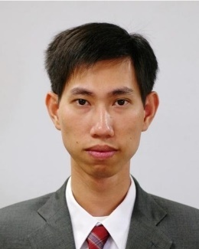 | Chanh-Nghiem Nguyen received the M.S. degree in Mechatronics from Asian Institute of Technology, Pathumthani, Thailand, in 2007 and the Ph.D. degree from Graduate School of Engineering Science, Osaka University, Osaka, Japan, in 2012. Since 2005, he has been a lecturer at the Department of Automation Technology, College of Engineering Technology, Can Tho University. His research interests include machine vision, micro-robotics, embedded control systems, GNSS applications, machine learning, remote sensing, multispectral/hyperspectral imaging and applications.
 | Van-Linh Lam received his Bachelor’s degree in Electronics from Can Tho University in 2005. He received his M.S. degree in Control Engineering and Automation from Can Tho University, Vietnam in 2021. He is currently a lecturer at Department of Electronics and Telecommunication, Kien Giang College, Vietnam. His research interests include machine learning, computer vision, multispectral and hyperspectral applications.
 | Phuc-Hau Le received the Bachelor’s degree in Control Engineering and Automation from Can Tho University, Vietnam in 2021. His research interests include computer vision and multispectral applications.
 | Huy-Thanh Ho received a Bachelor’s degree in Control Engineering and Automation from Can Tho University, Vietnam in 2021. His research interests include computer vision and multispectral applications.
 | Chi-Ngon Nguyen received his B.S. and M.S. degrees in electrical engineering from Can Tho University and Ho Chi Minh City University of Technology in 1996 and 2001, respectively. The degree of Ph.D. was awarded by the University of Rostock, Germany, in 2007. Since 1996, he has worked at Can Tho University. Currently, he is a senior lecturer in the Department of Automation Technology. He is currently Dean of College of Engineering Technology at Can Tho University. His research interests are intelligent control, medical control, pattern recognition, classifications, speech recognition, and computer vision.

