Design and Implement a Smart System to Detect
Intruders and Fire Using IOT

1.HussamJawadKadhim,2. Mohammed Jabbar Blakit
1.M.Tech. communication system
2.M.Tech .communications
Babylon University / College of science for women
Babylon University / College of engineering
hussamjwd@yahoo.com
Mohammedalsalihy@yahoo.com

Article Info |  | ABSTRACT
Article history:  Received Jun 12th, 201x  Revised Aug 20th, 201x  Accepted Aug 26th, 201x |  | Security system is essential for occupants' convenience and protection from intruders and fire. Theft and fire are the most important requirement for the security system. The advancement of wireless sensor network using IOTs increased the features in a security system and play an important role in daily life. In this paper the proposed system is divided into two units. The first one about the security which use to take snapshot by a camera whenever there is fire or intruders in the security zone and mail it to the owner every three seconds by using Arduino configured with MATLAB program. MATLAB program play the main role to coordinate between sensors and to turn on/off the cameras. The second unit is about controllingthe appliances and also the main door by using AVR microcontroller configured by CVAVR software that connected with Bluetooth sensor and controlled by a smart phone by using implementation software built-up in the smartphone. To arrival the control unit, the user should send a code from the software implementation to the framework that use to turn on /off the devices or open/close the door  This proposed system is designed and implemented in details in this paper.
Keyword:
IOT, Security system,
Appliance control system,
AVR atmeg8,
Communication system,
Remote control.
Copyright © 201x Institute of Advanced Engineering and Science.
All rights reserved.

- INTRODUCTION
Nowadays the risk of fire and intruder have been increased. In general the security system is defined as a network of deviceswhitch contain of a trigger and alarm. Thefeatures of the security system has been increased with the advancement in the internet field. The concept ofinternet of things (IOT) is introduced where the appliances can communicate with humans [1-3].
Now a days Internet of Things is a fastly growing technology [4,5]. Explain that IOT is the combination of physical device, software, sensors, network, wired or unwired technology etc. This is essentially due to the instill of sensors on them. These sensors are connected by wired and wireless networks using Internet Protocol that link-up the Internet [6,7]. Internet as aforesaid has become a part of daily habit that most of the people in different contries who have the incomming to it. These people have become contingent on having an Internet connection in their daily lives to be able to really carry on with their life for some cause. Because of increasing risk of burglary and robbery and the busy lifestyle the technology of safety and security system has been increased [8]. In [9] the author designs a smart system to detect intruders using Short Message Service, this system consists ofsensor circuit, controller and receiver. When an intruder pass through the PIR, SMS is sent to the mobilephone numbers.
In [10] Arduino configured with gas module, motion sensor, laser sensor to detect intruders and unwanted occurrences that controlled by Bluetooth when owner indoor and GSM when owner outdoor. [11] Theauthor suggests two methods to apply security system for home. The first one uses webcame. A mail is delivered to the owner whenever there is a motion in front of the camera. The second one sends SMS.
Also, the control of home appliances by a code is very important so in [12,13] the author explain how to control home appliances using AVR microcontroller by the Bluetooth of smartphone.
In this paper if an intruders or fire occurred a snapshot is token by the camera which connect with the server and controlled by Matlab program which use SMTP protocol to send e-mail include a photo of the fire at first time or to the intruders which give an idea to the occupant about the case of the place at that time.
Also, for more safety the door will controlled automatically by sending a code from the smartphone to the Bluetooth sensor which configured by AVR microcontroller and connected to a DC motor to open or close the door and also to turn on/off the appliances.

- RESEARCH METHOD

  - Arduino
Arduino is an open exporter stand that used to building electrnics circuits project. This platformconsists of a physical programmable circuit board and a softwar, or (IDE) that work on your computer and used to write down and transfer a code to the physical board.
This podium has become a popular with world and used widlly in electronics circuits because it does not need a independent piece of hardware (called a programmer), like most previous programmable circuit boards. To programming the Arduino board, you can plainly use usb-asbcable to upload the code.

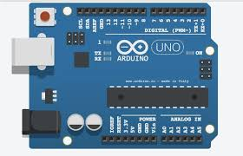

.

Fig 1: Arduino platform
The programming language that used with Arduino software is a simplified version of C++, making it easier learn and to programming [14].

  - AVR MICROCOTROLLER
The AVR microcontroller has a CPU and ROM, RAM, I/O ports, and timer all embedded together on asingle chip. So, the designer cannot annex any external I/O pins, memory, or timer to it. The AVR with this facilities makes it ideal for many applications in which cost and space are critical.
ATmega8 is used in this project which provides 23 general purpose I/O lines, 512 bytes of EEPROM, 8 Kbytes of System Programmable Flash, 1 Kbyte of SRAM, and a serial programmable USART [15].
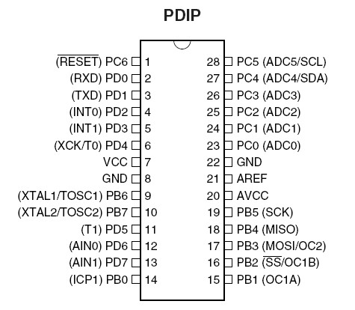

Fig 2: AVR microcontroller (Atmega8)

  - CVAVR
Code Vision AVRis a software that is used to write the code for programming the AVR microcontroller on Windows. To inject the code to the AVR microcontroolerSinaProgprogram is used. The CVAVR is a very good Code Wizard which generate codes automatically [15].

  - MATLAB
MATLAB is a 4thgeneration programming language and it use for numerical analysis. It include matrix calculations, running algorithms, data visualizationand creating user interfaces. MATLAB environment allows developers to interface it with other programs in different languages.
MATLAB is used in many fields by engineers and scientists such as signaland image processing, control systems for industry, communications, robotics, smart grid design [16].

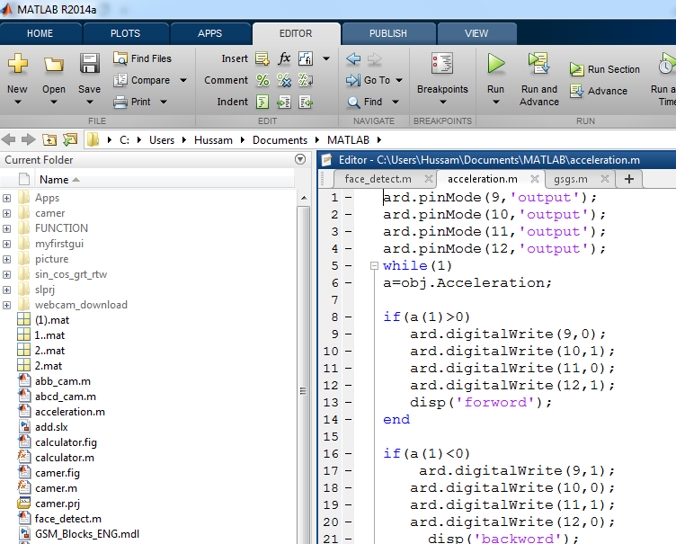

Fig 3: Mat-lab programing

  - Smoke detector
Analogy Smoke Sensor or MQ2 module is sensitive to smoke and it has a protection resistor with an adjustable resistor on board. It could be used for fire or smoke detection, also, it used in gas leakage detection equipments in family and industry. The resistance of the sensor changes as the concentricity of the target smoke changes [17].

  - PIR sensor
PIR is a motion sensor and it used to detect whether a human has moved in the security zone or throuth the sensor range. The PIR sensor is small, simple to use, low-power, cheap, and don't wear out. Because of that why the PIR sensor found in used system in homes or businesses [18].
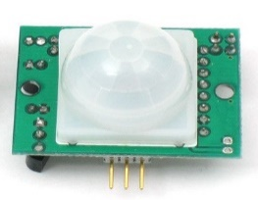

Figure 4:PIR sensor

PIR used for many projects that need to detect intruders or when a person has left the security zone. PIR sensors are low costandlow power, pretty rugged and have a wide lens range [19].

  - Webcam
A webcam is a video camera used to flow its image in real time by means of a personal computer to the internet. When there are intruders or fire throw the security zone the camera take a snapshot and send it throw the network via systems such as the internet, and email as an attachment to the owner. A webcam is generallybuilt into computer hardware or connected by a USB cable [20].

  - E-mail or email
Electronic mail is the exchanging of digital messages by telecommunication between people using digital devices such as mobile phones, computers and tablet. Electronic mail first uses in the 1960s and by the mid-1970s had taken the form now recognized as email [21].
Email systems required both the sender and the recipient online to receive the snapshot at the same time.
  - LCD
Liquid Crystal Display screen is an electronic display module and used in various devices and circuits.A 16x2 LCD means it can display 16 characters per line and there are 2 lines. Each character is displayed in 5x7 pixel matrix. There are two registers in this LCD screen, Command and Data.
The command register stores the command directive given to the LCD. A command is an directive given to LCD to do a predefined task like preface it, clearing its screen, setting the cursor position, controlling display etc. The data register keeps the data to be displayed on the LCD. The data is the ASCII value of the character to be displayed on the LCD [22].

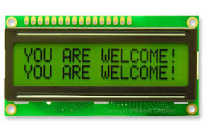
Figure 5: LCD display

  - Relay
A relay is a switch that operate electrically which use an electromagnet to operate mechanically. A relay has DC input to receive a signal and AC output to operate devices, when the relay receive a signal from the AVR microcontroller port it well connect the common port to (NO) port which connected with the AC device. By using the relay it is possible to operate any device when receive a right signal [23].
.

  - Bluetooth module
Bluetooth is a wireless technology that allow to exchange data over short distance. Bluetooth sensor is a sensor that use to detect the data which sent from the smart phone to the microcontroller.
HC-06 Module communicates with the AVR microcontroller via four pins VCC -> VCC is used to power the module GND -> GND is the ground pin. TX -> TXD is used to send data from the module to the AVR microcontroller. RX -> RXD is used to receive data from the AVR microcontroller.
For generality use states the HC-06 is sufficient, as typically I want to have a wireless UART joining to my devices from my smartphone [24,25].

  - BTInterface
BT Interface is a software installed from the play storage of the smartphone that provide interface to connect by Bluetooth with the platform. This software is easy to install in the smart phone by any user and do not need to provide with a remote control to controller the devices jut send a number from this software which received by the Bluetooth sensor to turn on/off the devices.

Figure 6: Bluetooth interface in smart phone

- EXPERIMENTS ON THE SMART SYSTEM
In this section the proposed system performance will evaluate, in the ability to turn on/off appliances, open and close the door, receive a snapshoot of fire or intruder in the email.
Figure (11) shows the the proposed system.
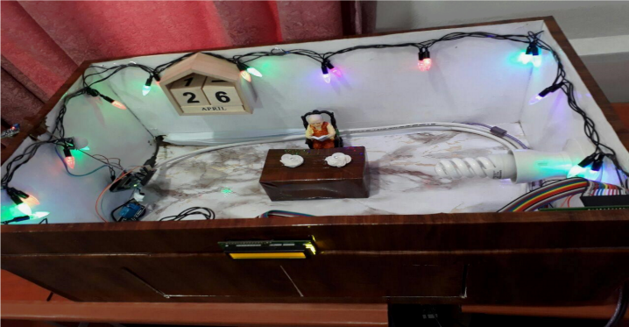

Figure 7: Image of project

3.1 Configure the AVR microcontroller with the outdoor

The security system is desgning for the outdoor by using AVR microcontrollerconfigured with Bluetooth sensor and connected with a DC motor to open and close the door. By sending a code from the smartphone to the sensor the microcontroller will match the code, if the code is correct the outdoor will open and a welcome message will display in the LCD, else the outdoor will not opened.
Open and close the outdoor using a code sending by a smartphone throght the Bluetooth will allow the occupant to easy controlling the door and also it will be asecurt.

Figure 8: Configured the AVR microcontroller.

  - Configure the AVR microcontroller
At the first time configure the AVR (Atmega8) microcontroller using CVAVR software which include the following steps
1- USART to receive the signal from the Bluetooth of the smart phone.
2- Configure the LCD display to display the cases of devices.
3- Configure the Ports for the Output cases which depend on the number received from the smart phone.
When the configuration processes done the microcontroller connecting as the follows
1- Connect HC-06 Bluetooth module Rx to Tx of the microcontroller and Tx of HC-06 Bluetooth module to Rx of the microcontroller than complete VCC to VCC and GND to GND.
2- PortB.4 to Relay
3- Relay to AC device
4- PortB.0 ,.1, .2, .3 to the DC motor drive.
5- Turn on the software application (BTInterface)in the samartphone.
6- Connect to Bluetooth sensor HC-06.
7- Type the password (1234).
8- Press terminal key as shown in fig ( 15 ) and print the number that used in the configuration of the microcontroller, for example No. 1 to open the door and No. 2 close the door also use number 3 to turn on the light and No.4 to turn off the light.

The controlling of DC motor is done by giving a period to drive the DC motor for example 1000 msec to drive the DC motor and open the door, also the same time is given to drive the DC motor in the opposite direction to close the door.
The port B.4 connect to any appliances to controlling it by the Bluetooth of the smartphone.
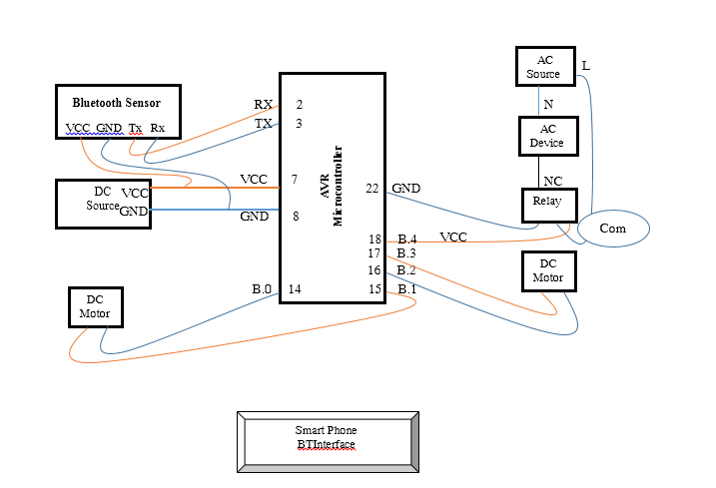

Figure 9: The proposed syetm for the outdoor controlling

3.3 Configure the Arduino with MATLAB
First, start MATLAB andinstall Arduino packages by click the Add-Ons drop down menu and click Get Hardware Support Packages. The package will start download.
To establish a connection between MATLAB and Arduino boards, the following command can be used with MATLABafter the Arduino package installed.

ard=arduino('port no.')
The pinnumber (2 &8) used as an input which received the signal from the PIR and MQ-2 sensorsrespectivily.
The pin no.(13) used to send the a signal to the camera and to turn on the light when the sensors detect intruders or fire
readDigitalPin(ard,2)
readDigitalPin(ard,8)
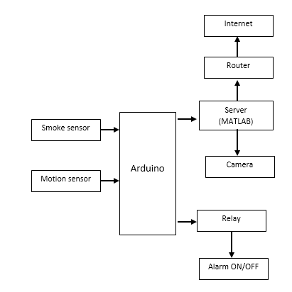
writeDigitalPin(ard,13,1)
writeDigitalPin(ard,13,0)

Figure 11: Design of the smart system

In this project the camera will connected directly with the server and configured with the matlab program, soif there are any intruders to the security zone the sensor send a signal to the Arduino which configured with matlab program to take a snapshot for the introdures and send it by the email to the occupant.
The SMTP protocol code is written in the matlab program to send a snapshot about the fire or introdurs to the occupants email every 10 second. From the received images it is a possible to build a database about all the steps of fire and to know how it happen, by a trigger of an electricity or byintrodurs, and also to take an emergency steps by the owner.

To display the cases in each time, the following code is written as
if(a==1)
writeDigitalPin(ard,13,1);
disp('intro');
else
writeDigitalPin(ard,13,0);
disp('ok');
if(b==1)
writeDigitalPin(ard,13,1);
disp('fair');
else
writeDigitalPin(ard,13,0);
disp('ok');
end

If there are no intruders and fire (OK) will display, else if there are intruders or fires then (Intruders) or (Fires) will displayand an email will send to the occupant.

- CONCLUSION
In this paper the proposed system has been designed using AVR atmega8 microcontroller to control the appliances and to open and close the door also a security system is done by using Matlab with Arduino to detect fire and intruders.
The performance of the proposed system has been tested and it is very comfortable to the occupant for easy control the home or office appliances via the Bluetooth of the smartphone when the user in the remote area and in the same time the smartphone using for calling, internet, games, that’s mean in the future the mobile phone using to control more and more thing also this design is very simple and the cost is low.
In the other side the security system is very important to detect the intruders and send a snapshot through the e mail to the occupant every 3 second to build a database about all the steps of the intruders and also if fire occur in the building it will be very easy to know the reason of the fire and also to take an emergency steps to stop the firing.
In the future scope it is necessary to design a wireless sensor network and connected it with a GPS map to get an idea about the situation of all the places using IOT.

REFERENCES

- S. Swathi, and H. Yogish, “Secure data aggregation in IoT using efficient-CSDA,” International Journal of Electrical and Computer Engineering (IJECE), vol. 9, no. 6, pp. 4889-4897, 2019.
- B. M. Eskofier, S. I. Lee, M. Baron, A. Simon, C. F. Martindale, H. Gaßner, and J. Klucken, “An Overview of Smart Shoes in the Internet of Health Things: Gait and Mobility Assessment in Health Promotion and Disease Monitoring,” Applied Sciences, vol. 7, no. 10, pp. 986, 2017.
- V. Reddy, and P. Gayathri, “Integration of internet of things with wireless sensor network,” International Journal of Electrical and Computer Engineering (IJECE), vol. 9, no. 1, pp. 439-444, 2019.
- K. Bhagchandani, and D. P. Augustine, “IoT based heart monitoring and alerting system with cloud computing and managing the traffic for an ambulance in India,” International Journal of Electrical and Computer Engineering (IJECE), vol. 9, no. 6, pp. 5068-5074, 2019
- D. Giusto, A. Iera, G. Morabito, L. Atzori (Eds.), The Internet of Things, Springer, 2010. ISBN: 978-1-4419- 1673-0.
- Li Da Zu” Internet of Things in Industries: A Survey” IEEE Transactions on Industrial Informatics, vol. 10, no. 4, November 2014
- K. Luechaphonthara, and A. Vijayalakshmi, “IOT based application for monitoring electricity power consumption in home appliances,” International Journal of Electrical and Computer Engineering (IJECE), vol. 9, no. 6, pp. 4988-4992, 2019.
- Audette, W. E., Kynor, D. B., Wilbur, J. C., Gagne, J. R., & Peck, L.“Improved Intruder Detection Using Seismic Sensors and Adaptive Noise Cancellation” 2009.
- Nwalozie G. C1 , Aniedu A. N2 , Nwokoye C. S3 , Abazuonu I.E4 " Enhancing Home Security Using SMS-based Intruder Detection System", International Journal of Computer Science and Mobile Computing, ISSN 2320–088X, Vol.4 Issue.6, June- 2015
- FernazNarinNur, " Smart Security for an Organization based on IoT ", International Journal of Computer Applications, Volume 165 – No.10, May 2017.
- Jayashri Bangali1 and ArvindShaligram, "Design and Implementation of Security Systems for Smart Home based on GSM technology ", International Journal of Smart Home, Vol.7, No.6 (2013).
- Teddy Surya Gunawan, IntanRahmithulHusnaYaldi, Mira Kartiwi, HasmahMansor, "Performance Evaluation of Smart Home System using Internet of Things ", International Journal of Electrical and Computer Engineering (IJECE), Vol. 8, No. 1, February 2018.
- S. Swathi, and H. Yogish, “Secure data aggregation in IoT using efficient-CSDA,” International Journal of Electrical and Computer Engineering (IJECE), vol. 9, no. 6, pp. 4889-4897, 2019.
- A. E. Hamza1 , H. H. Qasim2 , S. A. Alwash3 , M. M. Fadhel4 , L. Audah5 , H. H. Ibrahim6 , O. S. Hamed7 , H. A. Saeed8 , A. I. Hussein9 , M. I. Hamza10, “Design and implement WSN/IOT smart parking management system using microcontroller”, International Journal of Electrical and Computer Engineering (IJECE), Vol. 10, No. 3, June 2020
- Hussam Jawad Kadhim, " Controlling Home and Office Appliances with the Bluetooth of Smartphone ", International Journal of Computer Applications (0975 – 8887), Volume 152 – No.3, October 2016.
- https://www.mathworks.com
- R. Mitra, and R. Ganiga, “A novel approach to sensor implementation for healthcare systems using internet of things,” International Journal of Electrical and Computer Engineering (IJECE), vol. 9, no. 6, pp. 5031-5045, 2019.
- S. Priyadharshini, C. Subramani, and J. P. Roselyn, “An IOT based smart metering development for energy management system,” International Journal of Electrical and Computer Engineering (IJECE), vol. 9, no. 4, pp. 3041-3050, 2019.
- A. J. Samuel, and S. Sebastian, “An algorithm for IoT based vehicle verification system using RFID,” International Journal of Electrical and Computer Engineering (IJECE), vol. 9, no. 5, pp. 3751-3758, 2019.
- D. Javale, A. Pahade, R. Singal, A. Potdar, and M. Patil, “Smart Detection of Parking Rates and Determining the Occupancy,” In book: Proceeding of International Conference on Computational Science and Applications, pp. 381-390, 2020.
- K. Gautam, V. Puri, J. G. Tromp, N. G. Nguyen, and C. Van Le, “Internet of Things (IoT) and Deep Neural Network-Based Intelligent and Conceptual Model for Smart City,” Frontiers in Intelligent Computing: Theory and Applications, Springer, pp. 287-300, 2020
- M. Swatha, and K. Pooja, “Smart Car Parking with Monitoring System,” 2018 IEEE International Conference on System, Computation, Automation and Networking (ICSCA), pp. 1-5, 2018.
- M.I. Younis and T.F. Hussein, "Design and Implementation of a Contactless Smart House Network System," International Journal of Electrical and Computer Engineering (IJECE), vol. 8, no. 6, pp. 4663-4672, 2018.
- A.H. Ali, A.H. Duhis, N.A.L. Alzurfi and M.J. Mnati, "Smart Monitoring System for Pressure Regulator based on IoT," International Journal of Electrical and Computer Engineering (IJECE), vol. 9, no. 5, pp. 3450-3456, 2019.
- K. Luechaphonthara and A.Vijayalakshmi ,"IoT based Application for Monitoring Electricity Power Consumption in Home Appliances," International Journal of Electrical and Computer Engineering (IJECE), vol. 9, no. 6, pp. 4988-4992, 2019

