Energy Efficient Power Control for Device To
Device Communication in 5G Networks

Mohamed Amine CHARAR¹, Zouhair GUENNOUN¹
¹ Equipe de Recherche en Smart Communications (ERSC formerly known as LEC) – Centre de recherche E3S Ecole Mohammadia d’Ingénieurs, Mohammed V University in Rabat

Article Info |  | ABSTRACT
Article history:  ReceivedSep 9, 2019  Revised May 20, 2020  Accepted Jun 11, 2020 |  | Next generation cellular networks require high capacity, enhanced Energy Efficiency and guaranteed Quality of Service (QoS). In order to meet these targets, Device-to device (D2D) communication is being considered for future 5th Generation especially for certain applications that require the proximity gain, the reuse gain, and the hop gain. In this paper, we investigate energy efficient power control for the uplink of an OFDMA (Orthogonal Frequency-Division Multiple Access) single-cell communication system composed of both regular Cellular users and Device to Device (D2D) pairs. Firstly, we analyze and mathematically model the actual requirements forD2D communications and traditional cellular links in terms of minimum rate and maximum power requirement. Secondly, we use fractional programming in order to transform the original problem into an equivalent concave one and we use the non-cooperative Game theory in order to characterize the equilibrium. Then, the solution of the game is given as a water-filling power allocation. Furthermore, we implement a distributed power allocation scheme using three ways: a) Fractional Programming techniques b) Closed form expression (the novelty is the use of Wright Omega function). c) Inverse Water filling. Finally, simulations in both static and dynamic channel setting are presented to illustrate the improved performance in term of EE, SE (Spectral Efficiency) and time of execution of the iterative algorithm (Dinkelbach) than the closed form algorithms.
Keywords:

Energy Efficiency
Power Control
non-cooperative Game Theory
Resource Allocation,
OFDMA
Device-to-Device
5G
Copyright © 2020Institute of Advanced Engineering and Science.
All rights reserved.
Corresponding Author:
Mohamed Amine Charar,
Equipe de Recherche en Smart Communications (ERSC formerly known as LEC) – Centre de recherche E3S Ecole Mohammadia d’Ingénieurs, Mohammed V University in Rabat
Avenue Ibn Sina Rabat Agdal 10 000
Email: Mohamed.charar@gmail.com

- INTRODUCTION & ARTICLE CONTRIBUTIONS
Nowadays, numerous applications of wireless communications has emerged: Mobile broadband, Smart Grid, Intelligent Transportation systems, Smart Home, E-Health… and are using an increasing number of devices: 18 billions are expected by 2022 [1].
The traffic is growing at a 46 percent CAGR (Compound Annual Growth Rate) from 2017 to 2022 [2] forecasted to reach 77 Exabytes (EB) corresponding to a seven-fold increase every 5 years. 5G systems are expected by 2020 and according to a general consensus in the wireless academic and industry the 1000x capacity of 5G must be achieved using the same amount of energy of the previous cellular generation. Therefore, the Energy Efficiency must be increased by a factor 1000 or more [3]. From end user perspective, battery life is a determinant factor of mobile data Quality of Experience [4]. To keep up with mobile data growth, more battery technology improvement is needed. Unfortunately, battery technology is not evolving that fast [5].
Consequently, enhancing the EE (Energy Efficiency) of wireless communication becomes crucial for reducing the gap between the exponential data consumption and the relatively slow battery technology development. Even though a breakthrough happened in battery technology, economical, environmental concerns and social responsibility of end users would continue to be a motivation of higher EE.
Despite limited ICT(Information and Communication Technologies) contribution to the global CO2 emissions around 2%, the ICT related CO2 emissions are increasing 10% on annual base [6]. Energy consumption of mobile networks is growing much faster than ICT on the whole [4]. As a result, more efforts are required in the Energy Efficient Wireless Communication field in order to limit the environmental footprint of Mobile Telecommunication industry.
Increased intelligence and higher processing capabilities of modern User Equipment (UE) paved the way to new distributed paradigms like Cognitive Radio [7] and Device to Device communications(D2D) [8]. Moreover, the massive small cell deployment and the continuous shrinking cell size implies less UEs per Base Station (BS) especially in dense urban area. The power control feasibility study done in [9] is focused on a centralized femtocell network with a multi-channel user.
Consequently, decreasing the processing burden on the BS side is cogent and convenient to increase system scalability and decrease complexity, and distributed decisions should be done at terminals’ level. The power control is of paramount importance in order to mitigate the co-channel interference and the near-far effect. Distributed Energy Efficient power control design allows wireless users to enjoy a better quality of experience by increasing their battery lifetime for the same amount of data transmitted while enhancing the access to shared medium and decreasing the complexity handled by the BS. The peer to peer concept, D2D (Device to Device) is a promising technology that is intended to offer, underlaying a cellular network, direct connection between close devices. By doing so, D2D enhances EE of communication. This article addresses the energy efficient power control in the uplink of a wireless network that offers at same time classical cellular and D2D communications. D2D is a promising technology that was introduced from 3GPP Release 13 [10]. The D2D communication allows spatially close users to exchange data with each other without passing through operator’s base stations which increases EE, throughput and reduces delay and allows new applications like disaster relief [11] and Vehicle to Vehicle communications (V2V) [12]. Comparing to other competitor technologies such as Wifi Direct D2D offers better ranges and better rates [13].
Technology components for interference management, resource allocation, mobility management and other system level techniques enable the efficient D2D operation[14].
In most papers in the literature, D2D communication shares the same spectrum with regular cellular transmissions in order to achieve high spectral efficiency. As D2D communication uses the same resources as the cellular networking, interference handling is a challenge to face when using D2D communications and power control is one of the solutions to deal with interference.
In this article, we derive an uplink Energy Efficient communication scheme for a single cell multi subcarriers system (OFDMA) with minimum QoS requirement sharing its spectral resources with D2D pairs. OFDM technology has several merits: low complexity, compatibility with MIMO. It thus strongly motivates 5G NR(New Radio) still choosing OFDM as the basis of new waveform design [15]. Consequently, we believe that OFDMA technology will remain a foundation to 5G systems.
We used non-cooperative games framework to maximize the EE. We compared three methods to maximize the EE of the network: a) Dinkelbach Method b) Form Expression c) Inverse Water-filling. As far as we know the comparison between these algorithms exists in the literature but was never assessed and implemented. So the novelty of this paper is the assessment and the implementation of the closed form expression algorithm and the use of Wright Omega instead of Lambert-W function. Indeed in [16], closed expression of power was expressed theoretically but was not implemented.
We represent and compare graphically the EE, SE, Power and time execution of Dinkelbach and Closed form algorithms for cellular users and also for D2D users. A baseline algorithm was used: the Inverse waterfilling using exact minimum rate requirements.

- RELATED WORKS
In the seminal work of [17] authors defined the EE metric often encountered in subsequent works, data successfully transmitted (bit) over energy consumed (Joule) and used the non-cooperative Game theory to maximize EE in the case of data transmission. This work was extended by [18] using a pricing that is a linear function of the transmit power. The work of [17] was later extended to multi-carrier CDMA systems by [19].
Power Allocation Games for MIMO Multiple Access Channels with Coordination was proposed by [20]. In [21] authors used the theory of potential games to address non-cooperative resource allocation in multicell uplink orthogonal frequency division multiple access (OFDMA) systems. A Cross-Layer Approach for Distributed Energy-Efficient Power Control in Interference Networks was proposed by [22]. In [5] authors investigate energy efficient power optimization scheme for interference limited environment using non-cooperative games and then derive the trade-off between EE and spectral efficiency Repeated game concept was used in [23] in order to deal with decentralized power control.
The work of [24] proposes a power allocation scheme for maximizing the energy efficiency while respecting minimum QoS of the uplink of an OFDMA based HetNet where a macro cell is aided by a set of small cell. The authors propose a solution concept based on Debreu Equilibrium which is a generalization of Nash Equilibrium, an algorithm based on waterfilling best response. In [25] authors investigate the trade-off between energy efficiency (EE) and spectral efficiency (SE) in device-to device (D2D) communications underlaying cellular networks with uplink channel reuse.
The remainder of this paper is organized as follows. The section 3 the notations used in the paper are defined. In section 4, we describe the system model. The proposed power control game is discussed in section 5 and its Nash equilibrium solution is derived following Fractional Programming formulation in section 6. In section 7 algorithms design is given and practical considerations are described.
Section 8 results obtained from computer simulations are commented. Finally, we give conclusions in section 9.

- NOTATIONS
In this section we define the notations we adopt in this paper:
- $x^{+}$ stands for $max⁡(0,x)$
- Matrices and vectors are written in bold letters
- $W()$ denotes the Lambert W function
- A vector: $(α_{1}, …, α_{K})$ is a denoted in a short form as $(α_{k}, α_{-k})$ with:
$$α_{-k}= (α_{1}, …, α_{k-1},α_{k+1},…,α_{K})$$
- The cardinality of a set $A$: $\left|A\right|$

- SYSTEM MODEL
The system we adopt is composed of one BS (Base Station), K_c cellular UEs and K_d D2D transmitter/receiver pairs.
The set of UEs in the system is denoted as: $K_{c}=\{UE_{1},UE_{2},…,UE_{K_{c}}\}$
The set of D2D pairs in the system is denoted as: $K_{d}=\{D_{1},D_{2},…,D_{K_{d}}\}$
Spectral resource allocation is based on the OFDMA (Orthogonal Frequency Division Multiple Access) technology. One sub-carrier is allocated to each cellular user. Therefore no interference exists in the cellular tier. By contrary, every D2D transmitter has the freedom to transmit on all sub-carriers. We assume no sub-carrier allocation to D2D pairs is performed, but rather D2D transmit randomly their powers over the subcarriers.The Table (1) gives the main notations adopted in the remainder of the paper.
TABLE (1): LIST OF NOTATIONS
Notation | Meaning
$$W$$ | Bandwidth of the system
$$Kc$$ | Number of equally spaced sub-carriers
$$B=\frac{W}{Kc}$$ | Bandwidth per sub-carrier
$$h_{k}$$ | Channel between the cellular k and the BS
$$h_{k,l}$$ | Channel between the cellular k and the D2D receiver l
$$g_{i}^{n}$$ | Channel of the D2D pair i
$$g_{i,c}^{n}$$ | Channel between the D2D transmitter I and The BS over the Sub-Carrier n
$$g_{i,l}^{n}$$ | Channel between the D2D transmitter i  and the D2D receiver l over the sub-carrier n
$$p_{k}^{c}$$ | Power of the cellular k
$$p_{i,n}^{d}$$ | Power of the D2D transmitter i over the sub-carrier n
$$p_{max}^{c}$$ | Cellular maximum power
$$p_{max}^{d}$$ | D2D maximum power
$$p_{cir}^{c}$$ | Cellular circuit power
$$p_{cir}^{d}$$ | D2D circuit power
$$R_{min}^{c}$$ | Cellular minimum rate
$$R_{min}^{d}$$ | D2D minimum rate
Thus, the baseband signal is written for $UE_{k}$ as:
$y_{k}^{c}=h_{k}\sqrt{p_{k}^{c}} x_{k}^{c}+\sum_{i=1}^{K_{d}}{g_{i,c }^{k}\sqrt{p_{i,k}^{d}} x_{i,k}^{d}}+n_{k}$ (1)
With $n_{k}$ is an additive white Gaussian noise (AWGN) with mean 0 and variance $σ^{2}$. Similarly, the baseband signal is written for $D2D_{k}$ in the sub-carrier $n$ as:
$y_{k}^{d}=g_{k}^{n}\sqrt{p_{k,n}^{d}} x_{k,n}^{d}+\sum_{i=1, i≠k}^{K_{d}}{g_{i,c }^{k}\sqrt{p_{i,k}^{d}} x_{i,k}^{d}}+h_{n}\sqrt{p_{n}^{c}}+n_{k,n}$ (2)
With $n_{k,n}$ is an AWGN with mean 0 and variance $σ^{2}$
The channels are assumed complex Gaussian: the real part and imaginary part are both Gaussian.
For each D2D pair $i$, we denote its power vector on all sub-carriers: ${p_{i}^{d} }_{=}\left[p_{i,1}^{d},p_{i,1}^{d},…, p_{i,K_{d}}^{d}\right]$ (3)
And the vector of D2D pairs powers other than D2D pair $i$ is denoted: ${p_{-i}^{d} }_{=}\left[p_{1}^{d},…{,p}_{i-1}^{d}{,p}_{i+1}^{d}{,…,p}_{K_{d}}^{d}\right]$ (4)
The transmitting vector corresponding to all D2D pairs: $p^{d}=[p_{i}^{d}, p_{-i}^{d}]$ (5)
The total power consumption of D2D pair $i$taking into account the circuit power consumption:
$P_{tot}\left(p_{i}^{d}\right)=\sum_{n=1}^{K_{d}}{p_{i,n}^{d}+p_{cir}^{d}}$ (6)
And the vector of powers of UEs other than UE_{k} is denoted: ${p_{-i}^{d} }_{=}\left[p_{1}^{c},…{,p}_{k-1}^{c}{,p}_{k+1}^{c}{,…,p}_{K_{c}}^{c}\right]$ (7)
The global power of cellular users is denoted: $p^{c}=[p_{k}^{c}, p_{-k}^{c}]$ (8)
The total power consumption of UE_{k} taking into account the circuit power: $P_{tot}\left(p_{k}^{c}\right)=p_{k}^{c}+p_{cir}^{c}$ (9)
We denote the SINR (Signal-to-Interference-plus-Noise Ratio) of UE_{k} at the nth sub-carrier:
$γ_{k}^{c}=\frac{{\left|h_{k}\right|}^{2}p_{k}^{c}}{\sum_{i=1}^{K_{d}}{{\left|g_{i,c}^{k}\right|}^{2}p_{i,k}^{d}+σ^{2}}}$ (10)
We denote the SINR of D2D pair $k$ at the ^{nth} sub-carrier:
$γ_{k,n}^{d}=\frac{{\left|g_{k}^{n}\right|}^{2}p_{k,n}^{d}}{\sum_{\begin{aligned}i=1 \\ i≠k\end{aligned}}^{K_{d}}{{\left|g_{i,k}^{n}\right|}^{2}p_{i,n}^{d}+{\left|h_{n}\right|}^{2}p_{n}^{c}+σ^{2}}}$ (11)
Let us define the effective channel gain of the cellular user UE_{k} as following:
$ν_{k}^{c}=\frac{{\left|h_{k}\right|}^{2}}{\sum_{i=1}^{K_{d}}{{\left|g_{i,c}^{k}\right|}^{2}p_{i,k}^{d}+σ^{2}}}$ (12)
Let us define the effective channel gain of D2D pair k as following:
$ν_{k,n}^{d}=\frac{{\left|g_{k}^{n}\right|}^{2}}{\sum_{\begin{aligned}i=1 \\ i≠k\end{aligned}}^{K_{d}}{{\left|g_{i,k}^{n}\right|}^{2}p_{i,n}^{d}+{\left|h_{n}\right|}^{2}p_{n}^{c}+σ^{2}}}$ (13)
The utility function corresponding to the SE (Spectral Efficiency) of the uplink communication of UE_{k} is :
$SE_{k}^{c}\left(p_{k}^{c}, p_{-k}^{c},p^{d}\right)=\log_{2}\left(1+\frac{γ_{k}^{c}}{Γ}\right)$ (14)
With $Γ$ the SINR gap w.r.t BER as defined in [26]: $Γ=-\frac{\ln\left(5BER\right)}{1.5}$
The utility function corresponding to the SE of the uplink communication of the k^{th} D2D pair is :
$SE_{k}^{d}\left(p_{k}^{d}, p_{-k}^{d},p^{c}\right)=\sum_{n=1}^{K_{c}}{\log_{2}\left(1+\frac{γ_{k,n}^{d}}{Γ}\right)}$ (15)
The utility function corresponding to the EE (Energy Efficiency) of the uplink communication of UE_{k} is :
$EE_{k}^{c}\left(p_{k}^{c}, p_{-k}^{c},p^{d}\right)=\frac{SE_{k}^{c}\left(p_{k}^{c}, p_{-k}^{c},p^{d}\right)}{P_{tot}\left(p_{k}^{c}\right)}$(16)
The utility function corresponding to the EE of the k^{th} D2D pair : $EE_{k}^{d}\left(p_{k}^{d}, p_{-k}^{d},p^{c}\right)=\frac{SE_{k}^{d}\left(p_{k}^{d}, p_{-k}^{d},p^{c}\right)}{P_{tot}\left(p_{i}^{d}\right)}$ (17)
The UE_{k} will try to maximize its global energy efficiency while respecting minimum normalized rate constraint. The optimization problem that the UE_{k} will try to solve is the following:
$${\text{Maximize }}_{p_{k}^{c}} EE_{k}^{c}\left(p_{k}^{c}, p_{-k}^{c},p^{d}\right)$$
s.t. (C1A) $p_{k}^{c}∈\left[0,p_{max}^{c}\right]$ (18)
(C2A) $SE_{k}^{c}\left(p_{k}^{c}, p_{-k}^{c},p^{d}\right)≥R_{min}^{c}$

The optimization problem that the k^{th} D2D pair will try to solve is the following:
$${\text{Maximize }}_{p_{k}^{d}} EE_{k}^{d}\left(p_{k}^{d}, p_{-k}^{d},p^{c}\right)$$
s.t. (C1B) $p_{k}^{d}∈{\left[0,p_{max}^{d}\right]}^{K_{c}}$ (19)
(C2B) $SE_{k}^{d}\left(p_{k}^{d}, p_{-k}^{d},p^{c}\right)≥R_{min}^{d}$

Consequently, in our system there are $(K_{c}+K_{d})$ optimization problems that have to be solved jointly. One might wonder why not to apply directly the multivariate Optimization Theory instead of Game Theory. The essential difference between multi-variable optimization and game theory is that in the former a centralized entity has full control on all variables but in the latter each player has partial control on his own variables.
- GAME THEORY FORMULATION
We have then rational agents sharing the same resources controlling only their variables but their outcome depends on all players’ actions. The natural framework to study interactive decision making between rational agents is the non-cooperative game theory. The non-cooperative game is formally defined as the following triplet:
$$G=\left\{K, {\left\{A_{k}\right\}}_{k∈\left\{1,.., K\right\}},{\left\{U_{k}\right\}}_{k∈\left\{1,.., K\right\}}\right\}$$
where:
- Players: $K = \{K_{c},K_{d}\}$
- Actions :
$$A_{k}=\left[0,p_{max}^{c}\right] if k∈K_{c }or {\left[0,p_{max}^{d}\right]}^{K_{c}} if k∈K_{d}$$
- Utilities: The utility function corresponds to normalized EE expressed in (bit/J/Hz).
For each $k∈\left\{1,.., K\right\}$let us denote the action space of the other players: $A_{-k}=\prod_{\begin{aligned}i=1 \\ i≠k\end{aligned}}^{K}{A_{i}}$
Now we have to determine and characterize the equilibrium of the game G. The existence of equilibrium is very important for distributed system design because when agents reach equilibrium they have stable and predictable behavior. It is at the equilibrium that network will effectively operate [27]. The power strategy of each user must be feasible by respecting minimum QoS (Quality of Service) conditions. This leads us to use a different Game theory solution that allows each player to choose its strategy knowing the strategy of other players
while respecting feasibility conditions : the GNE(Generalized Nash Equilibrium). The GNE extends the classical NE(Nash Equilibrium) by assuming that each player’s strategy set can depend on the rival players’ [28]. Unlike the regular non-cooperative games, not only the utility functions, but also the players’ strategy sets are mutually coupled, depending on the other players’ actions [29].
We will denote by $A_{k}^{G}\left(p_{-k}\right)$ the set of actions of the user UEk that respect the minimum normalized rate constraint and the maximum power constraint knowing the other players’ strategy:
$$A_{k}^{G}\left(p_{-k}\right)=\left\{p_{k}∈A_{k}: {(p_{k},p}_{-k}) \text{respects (C1) \& C2)} \right\}$$
Definition. Generalized Nash Equilibrium
A joint power strategy matrix $p^{* }=(p_{k}^{*}, p_{-k}^{*})$ is said to be a Generalized Nash equilibrium if: $p_{-k}^{*}∈A_{k}^{G}\left(p_{-k}\right)$ and:
$∀p_{k}∈A_{k}^{G}\left(p_{-k}^{*}\right):EE_{k}\left(p^{*}\right)≥EE_{k}(p_{k}, p_{k}^{*})$ (20)
In other words, when the other players are playing a GNE no player has interest to deviate unilaterally from this equilibrium to another feasible point (respecting the constraints).
- Fractional Programming Formulation and Game Solution
Given the non-convex, fractional nature of EE objective functions defined in (18) and (19) , the main mathematical tool for the optimization of EE-related metrics is fractional programming – a branch of optimization theory that provides algorithms with polynomial complexity to globally maximize fractional functions with a concave numerator and a convex denominator [29].
First, let us give a formal definition of Fractional programming:
Definition. Fractional programming
Let ${C∈R}^{n}$ convex subset and let $C→ R$ the following functions:
$f:x→f(x)$ g$:x→g(x)$ (21)
A fractional program is the optimization problem:
${Maximize}_{x∈C} \frac{f\left(x\right)}{g\left(x\right)}$ (22)
The fractional programming allows us to solve equivalent form of the problem that is less complex than the original one:
Proposition 1. The vector $x^{*}∈C$ is a solution to the equation (22) if and only if: $\left(f\left(x^{*}\right)-λ^{*}g\left(x^{*}\right)\right)=0$, $λ^{*}$ the zero of the function:
$H\left(λ\right)=Maximize_{x∈C} f\left(x\right)-λg(x)$ (23)
For a given value $λ_{k}^{c}$ the UE_{k} will solve the following transformed fractional programming problem instead of (18):
${\text{Maximize }}_{p_{k}^{c}} SE_{k}^{c}\left(p_{k}^{c}, p_{-k}^{c},p^{d}\right)-λ_{k}^{c}P_{tot}\left(p_{k}^{c}\right)$
s.t. (C1A)& (C2A) (24)

For the optimal value $λ_{k}^{c,*}$we get:

$SE_{k}^{c}\left(p_{k}^{c}, p_{-k}^{c},p^{d}\right)-λ_{k}^{c,*}P_{tot}\left(p_{k}^{c}\right)=0$ (25)
This means that the best response power $p_{k}^{c,*}$ given other transmitters $\left( p_{-k}^{c},p^{d}\right)$verifies the following expression:
$λ_{k}^{c,*}=\frac{SE_{k}^{c}\left(p_{k}^{c}, p_{-k}^{c},p^{d}\right)}{P_{tot}\left(p_{k}^{c}\right)}$ (26)
Similarly, for a given value $λ_{k}^{d}$ the equivalent optimization problem that the k^{th} D2D pair will try to solve instead of (19) is the following:

${\text{Maximize }}_{p_{k}^{d}} SE_{k}^{d}\left(p_{k}^{d}, p_{-k}^{d},p^{c}\right)-λ_{k}^{d}P_{tot}\left(p_{k}^{d}\right)$
s.t. (C1B)& (C2B) (27)
For the optimal value $λ_{k}^{d,*}$ we get:
$SE_{k}^{d}\left(p_{k}^{d}, p_{-k}^{d},p^{c}\right)-λ_{k}^{d,*}P_{tot}\left(p_{k}^{d}\right)=0$ (28)
This means that the best response power $p_{k}^{d}$
given other transmitters $\left(p_{-k}^{d},p^{c}\right)$verifies the following expression:
$λ_{k}^{d,*}=\frac{SE_{k}^{d}\left(p_{k}^{d}, p_{-k}^{d},p^{c}\right)}{P_{tot}\left(p_{k}^{d}\right)}$ (29)
Practically, the players will solve the equation (24) or (27)
by giving their best response to the strategy of the other
players. Hereafter the Best Response function of the k^{th} user which is the best action $p_{k}$ to adopt knowing the action of the other players $p_{-k}∈A_{-k}^{G}(p_{k})$ :

$BR_{k}\left(p_{-k}\right)=argmax_{p_{k}∈A_{k}^{G}\left(p_{-k}\right)} EE(p_{k},p_{-k})$ (30)
In the single carrier case (single-resource block) is analytically more tractable and allows one to obtain necessary conditions for uniqueness of the GNE.

Proposition 2. In the single carrier case, the existence and uniqueness of Generalized Nash Equilibrium are guaranteed as the BR functions of the user k are standard and verify the following properties:
- Concavity : $BR_{k}\left(p_{-k}\right)$ is strictly concave in $p_{-k}$
- Positivity: $BR_{k}\left(p_{-k}\right)>0$
- Monotonicity: if $q_{-k}>p_{-k}$ then $BR_{k}\left(q_{-k}\right)>BR_{k}\left(p_{-k}\right)$
- Scalability: For all $α>1$, $αBR_{k}\left(p_{-k}\right)>BR_{k}\left({αp}_{-k}\right)$

Proof. The proof is given in [30]
In the more general case with multi-carrier case, we can characterize the equilibrium by giving the expression of power per sub-carrier and per user as in the following proposition.
Proposition 3. (Necessary Conditions) When the Game admits a GNE the optimal power of the UE_{k} is given by the following:
$p_{k}^{c,*}=\min\left(p_{max}^{c}, {\left(\frac{1}{λ_{k}^{c,*}}-\frac{1}{ν_{k,n}^{c}}\right)}^{+}\right)$ (31)
The optimal value $λ_{k}^{c,*}:$
$λ_{k}^{c,*}=\min{(}λ_{k}^{c}, λ_{k}^{c,max})$ (32)

$λ_{k}^{c}=\frac{ω\left(\log\left(B_{k}^{c}\exp\left(A_{k}^{c}-1\right)\right)\right)}{B_{k}^{c}}$ (33)
With: $A_{k}^{c}=log⁡(ν_{k}^{c})$ (34)
$B_{k}^{c}=\left(p_{cir}^{c}-\frac{1}{ν_{k,n}^{d}}\right)$ (35)
$p_{max}^{c}$ is obtained when the normalized rate constraints are active:
$λ_{k}^{c,max}=ν_{k,n}^{c}2^{-R_{min}^{c}}$ (36)

Proposition 4. (Necessary Conditions) When the Game admits a NE the optimal power of the D2D_{k} is given by the following formula for each sub-carrier n:
$∀n∈K_{c}:p_{k,n}^{d,*}=\min\left(p_{max}^{d},{\left(\frac{1}{λ_{k}^{d,*}}-\frac{1}{ν_{k,n}^{d}}\right) }^{+}\right)$ (37)

The optimal value $λ_{k}^{d,*}$ : $λ_{k}^{d,*}=min⁡(λ_{k}^{d},λ_{k}^{d,max}$) (38)
$λ_{k}^{d}=\frac{ω\left(\log\left(B_{k}\exp\left(A_{k}^{d}-1\right)\right)\right)}{B_{k}^{d}}$ (39)
Let us denote $N_{k}$, the set of active subcarriers of the user D2D_{k} (i.e. with strictly positive power) when:
$$λ_{k}^{d,*}= λ_{k}^{d}$$
$N_{k}^{*}=\left\{n∈K_{c}|\left(\frac{1}{λ_{k}^{d}}-\frac{1}{ν_{k,n}^{d}}\right)>0\right\}$(40)
With:
$A_{k}^{d}=\frac{\log\left(\prod{n∈N_{k}^{*}}ν_{k,n}^{d}\right)}{\left| N_{k}^{*}\right|}$ (41)
$B_{k}^{d}=\frac{\left(p_{cir}^{d}-\sum_{n∈N_{k}^{*}}{\frac{1}{ν_{k,n}^{d}} }\right)}{\left| N_{k}^{*}\right|}$ (42)

$λ_{k}^{d,max}$ is obtained when the normalized rate constraints are active: $λ_{k}^{d,max}={\left(2^{-\left|N_{k}^{max}\right|R_{min}^{d}} \prod_{n∈N_{k}^{max}}{ν_{k,n}^{d}}\right)}^{\frac{1}{N_{k}^{max}}}$ (43)

With: $N_{k}^{max}=\left\{ n∈K_{c}\right|\left(\frac{1}{λ_{k}^{d,max}}-\frac{1}{ν_{k,n}^{d}}\right)>0\}$(44)
Proof. The proof is given in [34] applied to our model.

- ALGORITHMS DESIGN AND ANALYSIS
7.1. Practical design
Practically, each transmitter will solve the EE maximization problem by giving its best response to the strategy of the other transmitters. As instantaneous feedback is not possible in practice, then we adopt an asynchronous scheme where the transmitter chooses a power vector at step t based on the actions taken by the other users in the previous step $t-1$. Actually, each transmitter receives the SINR all over the used sub-carriers from its corresponding receiver which is the only information available to the transmitter together with his individual CSI (Channel State Information).
In the first step of the algorithm the users choose an initial power vector: each cellular user chooses $p_{init}^{c}$and each D2D transmitter chooses$p_{init}^{d}$.
In each step, the user UE_{k} calculates the estimated effective channel gain using the value of the previous SINR and the value of its previous SINR:
$\hat{ν_{k}^{c}}\left(t\right)=\frac{γ_{k}^{c}\left(t-1\right)}{p_{k}^{c}\left(t-1\right)}$ (45)

The estimated utility function that the user UE_{k} will try to maximize w.r.t to conditions (C1A) and (C2A):
$\hat{EE_{k}^{c}} \left(t\right)= \frac{\hat{SE_{k}^{c}} \left(t\right)}{p_{k,n}^{c}\left(t\right)+p_{cir}^{c}}$(46)
With:
$\hat{SE_{k}^{c}} \left(t\right)=\log_{2}{(1+\hat{ν_{k}^{c}}\left(t\right)p_{k}^{c }\left(t\right))}$ (47)
As in proposition 3:
$p_{k}^{c,* }\left(t+1\right)=\min\left( p_{max}^{c}, {\left(\frac{1}{λ_{k}^{c,*}\left(t+1\right)}-\frac{1}{\hat{ν_{k}^{c}}\left(t+1\right)}\right) }^{+}\right)$(48)
Then in each step the user D2D_{k} calculates the estimated effective channel gain using the value of the previous SINR on sub-carrier n:
$\hat{ν_{k,n}^{d}}\left(t\right)=\frac{γ_{k,n}^{d}\left(t-1\right)}{p_{k,n}^{d}\left(t-1\right)}$ (49)
The estimated utility function that the user D2D_{k} will try to maximize w.r.t to conditions (C1B) and (C2B):
$\hat{EE_{k}^{d}}\left(t\right)=\frac{\hat{SE_{k}^{d}}\left(t\right)}{\sum_{n=1}^{K_{c}}{\begin{aligned}p_{k,n}^{d}\left(t\right)+p_{cir}^{d} \\ \end{aligned}}}$ (50)
With:
$\hat{SE_{k}^{d}}\left(t\right)=\sum_{n=1}^{K_{c}}{\begin{aligned}\log_{2}{(1+\hat{ν_{k,n}^{d}}\left(t\right)p_{k,n}^{d}\left(t\right)} \\ \end{aligned}}$ (51)
As in proposition 4:
$∀n∈K_{c}:p_{k,n}^{d,*} \left(t\right)=min \left(p_{max}^{d}, {\left(\frac{1}{λ_{k}^{d,*}\left(t\right)}-\frac{1}{\hat{ν_{k,n}^{d}}\left(t\right)}\right)}^{+} \right)$(52)
The challenge here is to find $λ_{k}^{c,*}\left(t\right)$ and $λ_{k}^{d,*}\left(t\right)$, for that we use three methods:
- The first method that was used by [24] relies on Dinkelbach algorithm: Algorithm 3.
- The second method is the proposed in this article relies on the closed form expression as in Algorithm 4.
- The third method is the IWF (Inverse Water Filling) is applied using Algorithm 2 which aims to have exactly the minimum normalized SE (R_{min}).
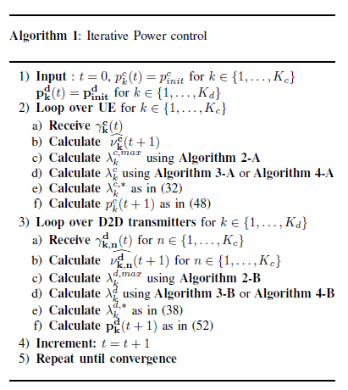
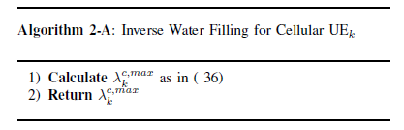
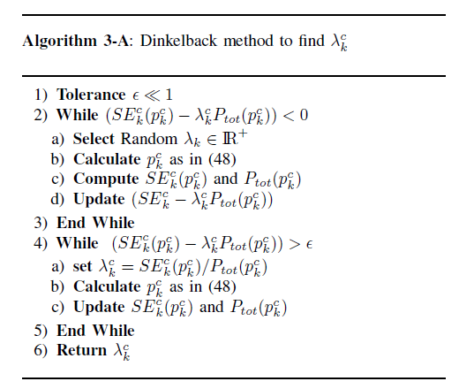
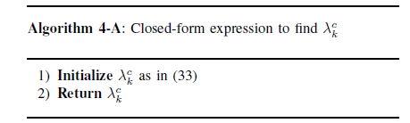

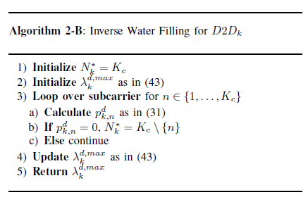

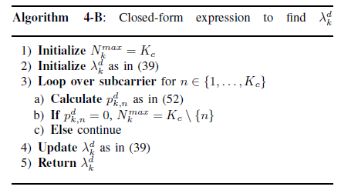

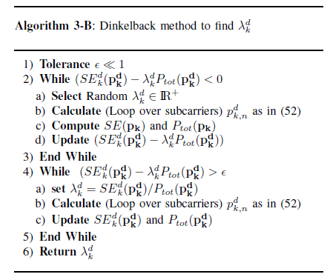

7.2. Complexity analysis
The different algorithms comprise two loops: the inner and the outer loop. The outer loop iteration converges at a superlinear convergence rate; the complexity of the optimal two-loop power control scheme is dominated by the inner loop [31]. The complexity of the Dinkelbach algorithm is calculated as $O({\left(KcKd + Kc\right)}^{3.5})$ The algorithm IWF has superlinear convergence properties both in the inner and in the outer loops. For the Closed-Form algorithm we use the Wright-Omega [32] and the Lambert-W functions embedded [33] in MATLAB Software.
7.3. Convergence analysis
The method that are used to determine the optimal value of λ iteratively, as shown in Algorithm 1, which produces an increasing sequence of λ and converges to an optimal value In each iteration, the optimal power values are obtained with given $λ$ , which is derived based on the previous power values. If the resultant is sufficiently small the iteration is terminated and the optimal power values are obtained. Otherwise, we calculate new value of $λ$ is calculated and we start the next iteration [31].
The algorithms used are asynchronous: using the past strategy of the competitor in order to react to take a present action. The repeated games framework guarantees that the long-term interactions between the players in such a situation will lead to convergence. The players react to past experience by taking into account what happened in all previous stages and make decisions about their future [23].
- SIMULATION AND COMMENTS
We use a single cell system where the BS is located at center of the cell that has 300 meters radius and K_{c} = 3 cellular users have uplink communication towards BS and K_{d} = 5 D2D pairs. The Algorithm 4 was implemented using two different ways using Lambert-W function and Wright-Omega function.
In the figures we adopt the following notations:
- DBK for the algorithm 3 (Dinkelbach)
- CF for the algorithm 4 (Closed form) with Lambert-W function
- CF_{OM} for the algorithm 4 (Closed form) with Wright Omega function
- IWF for the algorithm 2 for Inverse Water-filling algorithm
We choose $p_{init} = 1{\left.​\right|}_{N}\frac{p_{max}}{2}$ as initial power vector for all users. We choose this because it is the mean of the minimum power and the maximum power.
8.1 Static channel: number of iterations
In order to compare Algorithm 3 (Dinkelbach) and Algorithm 4 (Closed-Form), we use a single cell system where the BS is located at center of the cell that has 300 meters radius and K_{c} = 3 cellular users have uplink communication towards BS and K_{d} = 5 D2D pairs. The Table (2) presents main parameters adopted for the simulation. The propagation exponent mentioned in the table $α$ serves to calculate the channel gain as follow: $h=\frac{cte}{d^{α}}$Which accounts the path-loss.
TABLE (2)
LIST OF PARAMETERS

Notation | Meaning | Value
Kc | Number of Cellular users | 3
Kc | Number of D2D pairs | 5
N₀ | Noise spectral density | 3.98 × 10⁻¹⁹W/Hz
B | Bandwidth per subcarrier | 1M Hz
$$p_{cir}^{c}$$ | Power circuit for cellular | 300mW
$$p_{cir}^{d}$$ | Power circuit for D2D | 200mW
$$p_{max}$$ | Maximum power per sub-carrier | 2W
$$α_{c}$$ | Propagation exponent for cellular | 3.6
$$α_{d}$$ | Propagation exponent for cellular | 2
cte | Constant of propagation | 2.57399 x 10⁻2
$$d_{min}^{c}$$ | Min. Distance form BS | 20 meters
$$d_{min}^{d}$$ | Min. between D2D | 5 meters
$$R_{Min}^{c}$$ | Min. Normalized Rate for Cellular | 0.2 bit/s/Hz
$$R_{Min}^{d}$$ | Min. Normalized Rate for D2D | 2 bit/s/Hz
Γ | The BER Gap in the SINR | 1

as initial power vector for all users. We choose this because it is the mean of the minimum power and the maximum power. Users learn the equilibrium by performing iteratively the Algorithm 3 or Algorithm 4 for 10 iterations to be sure of convergence. The results of simulation we obtain are the Energy Efficiency, Spectral Efficiency and Power per subcarrier of the reference user as function of iterations averaged on the number of the users positions for 100 realizations. We deduce from the simulations that equilibrium of the game exists as all algorithms converge before the 10th iteration.
Also the maximum power is not reached so we have a non saturated equilibrium. This is important, because in case of saturated equilibrium the power at equilibrium is $p_{max}$and may be if the condition of maximum power is relaxed the Game will not reach equilibrium.
For all simulations in this subsection we choose a flat fading and static channel. In term of minimum normalized rate respect, we remark that both Algorithm 3 & 4 respect minimum SE.
So both algorithms converge to a solution that respects the minimum normalized rate constraint. By construction the IWF(Inverse Water Filling) algorithm respect the minimum normalized rate constraint as the powers are calculated to achieve exactly the minimum rate.
The outcome of both Algorithm 3 & 4 respects the condition (C1) and (C2) in the maximization problem. When at equilibrium, each user chooses to send at fixed power over all the sub-carriers. This is a direct result of the channel gain flat fading assumption: there is no better subcarrier to transmit for the user. We give below our comments on results obtained:
EE: The Energy efficiency corresponds to the EE utility times the bandwidth.
- Cellular : The simulations in Figure 1 that represent the EE of a reference cellular user shows that the DBK algorithm is 800% better than CF algorithm. CFOM algorithm realizes the same EE as CF algorithm. Unsurprisingly, the IWF algorithm has the least EE.
- D2D: The simulations in Figure 2 that represent the EE of a reference D2D user shows that the DBK algorithm is 20% better than CF algorithm. CF_{OM}
algorithm realizes the same EE as CF algorithm. The IWF algorithm has the least EE.
- Comparison Cellular and D2D: The D2D communication brings proximity gain, the EE of D2D is at least 2.5 times the EE of Cellular.

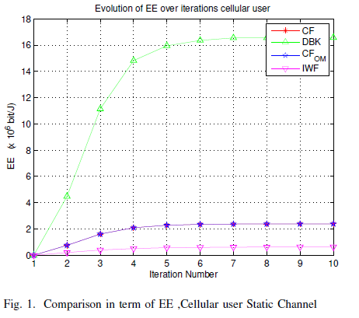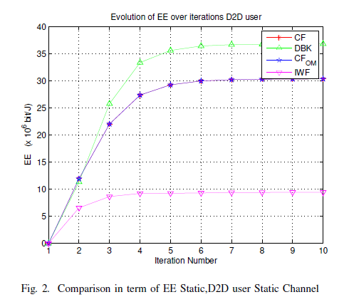

SE: the SE expressed in bit/s/Hz
- Cellular The simulations in Figure 3 that represent the SE of a reference cellular user shows that the DBK algorithm is 10% better than CF algorithm. CF_{OM} algorithm realizes the same EE as CF algorithm. The IWF algorithm has the least EE.
- D2D The simulations in Figure 4 that represent the EE of a reference D2D user shows that the DBK algorithm is slightly better than CF algorithm. CF_{OM} algorithm realizes the same EE as CF algorithm. The IWF algorithm has the least EE.
- Comparison Cellular and D2D: The D2D communication brings proximity gain, the SE of D2D is at least 8.3 times the SE of Cellular .

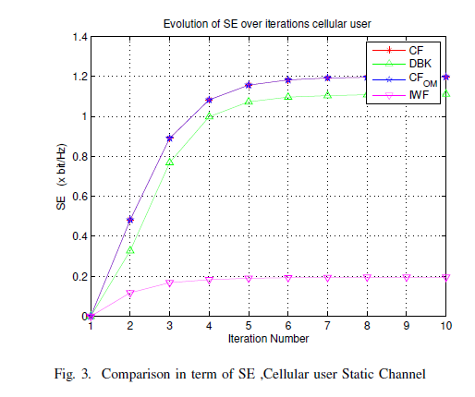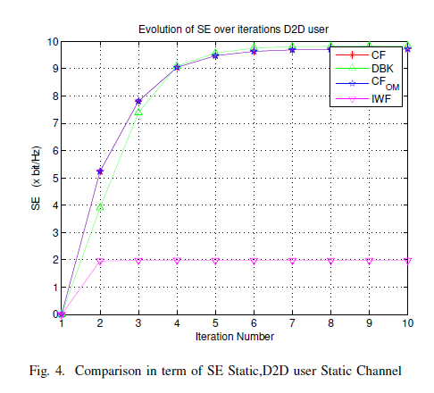
Power: the instant consumed power
- Cellular simulations in Figure 5,that represent the power of a reference Cellular user shows that the CF algorithm consumes 75% more power than DBK algorithm. The IWF algorithm consumes the least power.
- D2D simulations in Figure 6, that represent the power of a reference Cellular user shows that the CF algorithm consumes 25% more power than DBK algorithm. The IWF algorithm consumes the least power.
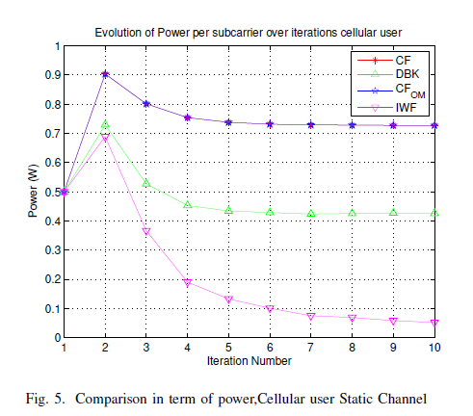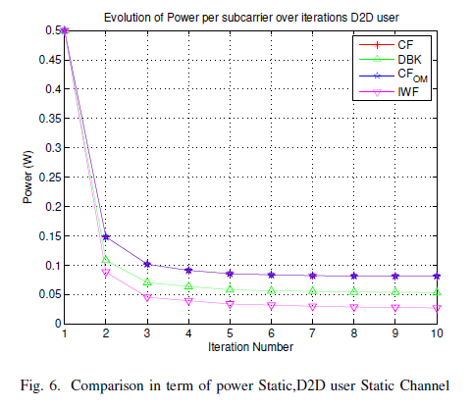
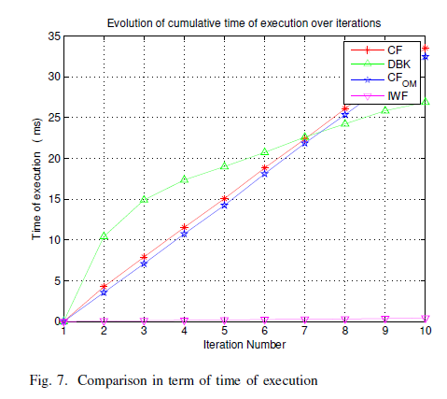
Time of Execution: simulations in Figure 7 shows the cumulative time of execution expressed in millisecond. In the 6 first iterations the DBK algorithm consumes more time than the CF algorithm. The CF_{OM} algorithm based on Wright Omega function has slightly less complexity than Lambert W function Starting from the seventh iteration the DBK algorithm join the closed form. The least time execution belongs to IWF algorithm.

8.2 Rayleigh channel:number of iterations
For all simulations we choose a flat fading channel. In term of minimum normalized rate respect, we remark that both Algorithm 3 & 4 respect minimum SE. So both algorithms converge to a solution that respects the minimum normalized rate constraint. By construction the IWF(Inverse Water Filling) algorithm respect the minimum normalized rate constraint as the powers are calculated to achieve exactly the minimum rate. The outcome of both Algorithm 3 & 4 respects the condition (C1) and (C2) in the maximization problem. When at equilibrium, each user chooses to send at fixed power over all the sub-carriers. This is a direct result of the channel gain flat fading assumption: there is no better sub-carrier to transmit for the user. We give below our comments on results obtained:
EE: The Energy efficiency corresponds to the EE utility times the bandwidth.
- Cellular The simulations in Figure 8 that represent the EE of a reference cellular user shows that the DBK algorithm is 800% better than CF algorithm. CF_{OM} algorithm realizes the same EE as CF algorithm. Unsurprisingly, the IWF algorithm has the least EE.
- D2D The simulations in Figure 9 that represent the EE of a reference D2D user shows that the DBK algorithm is 20% better than CF algorithm. CF_{OM} algorithm realizes the same EE as CF algorithm. The IWF algorithm has the least EE.
- Comparison Cellular and D2D: The D2D communication brings proximity gain, the EE of D2D is at least 2:25 times the EE of Cellular .

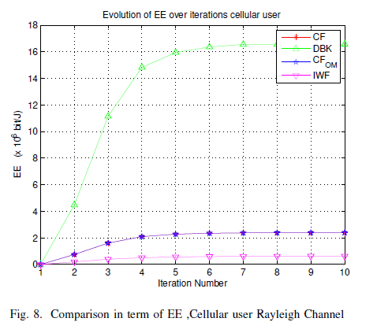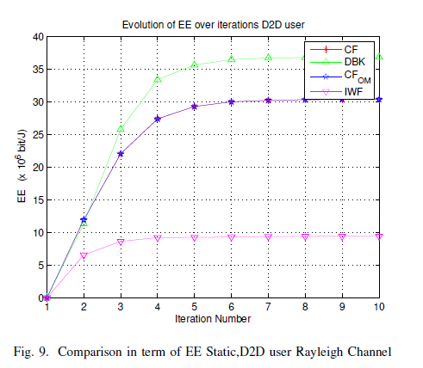
SE: the SE expressed in bit/s/Hz
- Cellular The simulations in Figure10 that represent the SE of a reference cellular user shows that the CF algorithm is 20% better than DBK algorithm. CF_{OM} algorithm realizes the same EE as CF algorithm. The IWF algorithm has the least EE.
- D2D The simulations in Figure 11 that represent the EE of a reference D2D user shows that the DBK algorithm is slightlly better than CF algorithm. CF_{OM} algorithm realizes the same EE as CF algorithm. The IWF algorithm has the least EE.
- Comparison Cellular and D2D: The D2D communication brings proximity gain, the EE of D2D is at least 8.33 times the EE of Cellular .
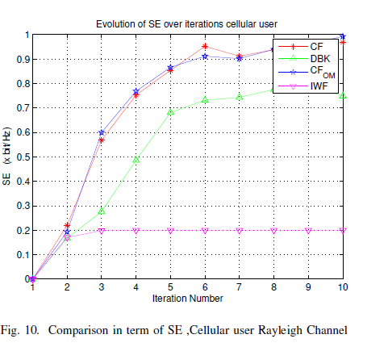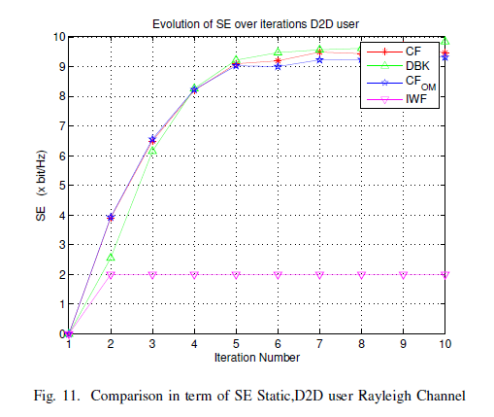
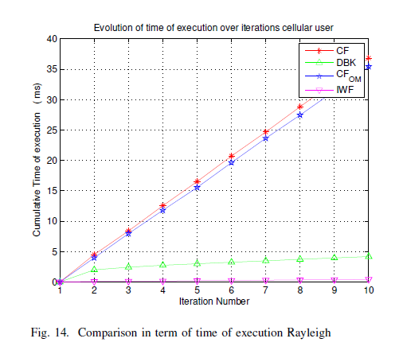
Time of Execution: simulations in Figure 14, shows the cumulative time of execution expressed in millisecond. In this case the DBK algorithm has clearly better complexity than the CF algorithms.
Robustness: Although the algorithms DBK and CF do not converge but they show a good robustness as the power, EE, SE are smooth and stable and slowly varying after few iterations.

8.3 Impact of Minimum Rate
In this subsection we examine the impact of the minimum rate constraint on the SE and EE of the D2D pair. We take a fixed minimum rate constraint for cellular users $R_{ min}^{c}= 0.2 bit/s/Hz$ and we vary the minimum rate for the D2D users from 0 to 30bit/s/Hz As in figure 15 and figure 16:
- EE: The Energy efficiency grows steadily for IWF algorithm until around 7 bit/s/Hz while it is higher for the other algorithm. Then the EE drops beyond 10bit/s/Hz for all algorithms.
- SE: The Spectral Efficiency steadily for IWF algorithm until around 10 bit/s/Hz while it is higher for the other algorithm. Then the SE is stable beyond 15 bit/s/Hz for all algorithms.
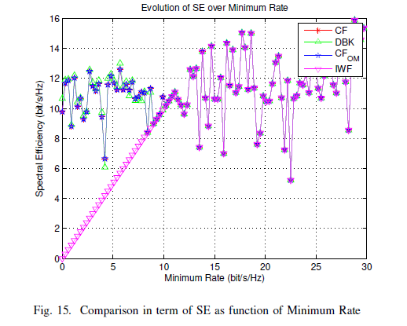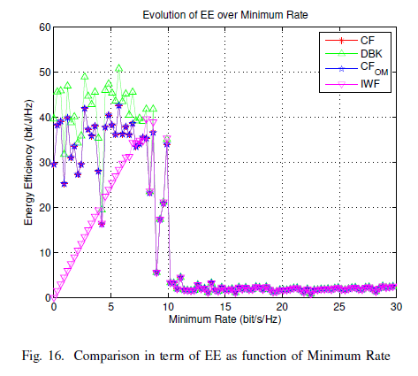
- CONCLUSION & FUTURE WORKS
In this work we compare closed-form expression of the power allocation to Dinkelbach algorithm applied to a D2D communication underlaying a cellular network. Results shows that Dinkelbach Algorithm provides more EE than the Closed form Algorithm. Furthermore, in term of SE Dinkelbach Algorithm is equivalent to Closed form when it comes to D2D communication type. However, Closed form algorithm outperforms the Dinkelbach for cellular type communication which is in line with our previous work [34]. In term of time of execution, we remark that the Dinkelbach Algorithm suffers from a slow start in the first iterations then it becomes faster than closed form algorithms. Due to to its simplicity, the Inverse Waterfilling Algorithm has excellent convergence, low power and complexity properties but its EE is very limited and its SE is just the minimum Rate. This Algorithm (IWF) can be applied to fixed rate application that are not ambitious in term of rate: for instance VoNR (Voice over New Radio). Despite the non-convergence in the dynamic channel conditions, the proposed algorithms show good stability and very similar results to the static case in terms of EE, SE, power. But, the time of execution in the dynamic case of Dinkelbach Algorithm is much lower than closed form. Although the usage of the Wright Omega function compared to Lambert W function brought some reduction of time execution, but it was not enough to get better results than Dinkelbach Algorithm. Whatever the used algorithms, thanks to proximity and hop gain, D2D communication bring significant improvement of Energy Efficiency compared to Cellular communication. Yet, more investigation needs to be done in order to increase Energy Efficiency. Another possible future work is the application to more sophisticated scenarios such as MIMO and Small Cells.
REFERENCES
[1] Internet of Things forecast – Ericsson Mobility Report, Nov.2018. [Online]. Available: https://www.ericsson.com/en/mobility-report/internet-of-things-forecast
[2] “Cisco Visual Networking Index: Forecast and Trends, 2017–2022,”p. 38, 2018.
[3] S. Buzzi, C. I, T. E. Klein, H. V. Poor, C. Yang, and A. Zappone, “A Survey of Energy-Efficient Techniques for 5g Networks and Challenges Ahead,” IEEE Journal on Selected Areas in Communications, vol. 34, no. 4, pp. 697–709, Apr. 2016.
[4] D. Feng, C. Jiang, G. Lim, J. Cimini, L.J., G. Feng, and G. Li, “A survey of energy-efficient wireless communications,” IEEE Communications Surveys Tutorials, vol. 15, no. 1, pp. 167–178, 2013.
[5] G. Miao, N. Himayat, G. Li, and S. Talwar, “Distributed Interference- Aware Energy-Efficient Power Optimization,” IEEE Transactions on Wireless Communications, vol. 10, no. 4, pp. 1323–1333, Apr. 2011.
[6] G. Bacci, E. V. Belmega, and L. Sanguinetti, “Distributed energy efficient power and subcarrier allocation for OFDMA-based small cells,” in Communications Workshops (ICC), 2014 IEEE International Conference on. IEEE, 2014, pp. 647–652. [Online]. Available: http://ieeexplore.ieee.org/xpls/abs_all.jsp?arnumber=6881272
[7] J. Mitola and G. Q. Maguire, “Cognitive radio: making software radios more personal,” IEEE Personal Communications, vol. 6, no. 4, pp. 13–18, Aug. 1999.
[8] S. Mumtaz, K. M. S. Huq, and J. Rodriguez, “Direct mobile-to-mobile communication: Paradigm for 5g,” IEEE Wireless Communications,vol. 21, no. 5, pp. 14–23, Oct. 2014.
[9] A. F. Isnawati, R. Hidayat, S. Sulistyo, et I. W. Mustika, « Feasibility of Power Control for Multi-Channel User in Inter-Femtocell Network », International Journal of Electrical and Computer Engineering (IJECE), vol. 6, nº 4, p. 1685‑1694, août 2016, doi: 10.11591/ijece.v6i4.pp1685-1694.
[10] Evolution of LTE in Release 13, 2014. [Online]. Available: http://www.3gpp.org/news-events/3gpp-news/1628-rel13
[11] J. Liu, N. Kato, J. Ma, and N. Kadowaki, “Device-to-Device Communication in LTE-Advanced Networks: A Survey,” IEEE Communications Surveys Tutorials, vol. PP, no. 99, pp. 1–1, 2014.
[12] W. Sun, E. G. Ström, F. Brännström, Y. Sui, and K. C. Sou, “D2d-based V2v communications with latency and reliability constraints,” in 2014 IEEE Globecom Workshops (GC Wkshps), Dec. 2014, pp. 1414–1419.
[13] D. Feng, L. Lu, Y. Yuan-Wu, G. Li, S. Li, and G. Feng, “Device-to device communications in cellular networks,” IEEE Communications Magazine, vol. 52, no. 4, pp. 49–55, Apr. 2014.
[14] T. B. Iliev, Gr. Y. Mihaylov, E. P. Ivanova, et I. S. Stoyanov, « Power control schemes for device-to-device communications in 5G mobile network », in 2017 40th International Convention on Information and Communication Technology, Electronics and Microelectronics (MIPRO), 2017, p. 416‑419, doi: 10.23919/MIPRO.2017.7973460.
[15] S. Lien, S. Shieh, Y. Huang, B. Su, Y. Hsu, and H. Wei, “5g New Radio: Waveform, Frame Structure, Multiple Access, and Initial Access,” IEEE Communications Magazine, vol. 55, no. 6, pp. 64–71, Jun. 2017.
[16] G. Bacci, E. V. Belmega, and L. Sanguinetti, “Distributed energy efficient power optimization in cellular relay networks with minimum rate constraints,” in 2014 IEEE International Conference on Acoustics, Speech and Signal Processing (ICASSP), May 2014, pp. 7014–7018.
[17] D. Goodman and N. Mandayam, “Power control for wireless data,” IEEE Personal Communications, vol. 7, no. 2, pp. 48–54, Apr. 2000.
[18] C. Saraydar, N. B. Mandayam, and D. Goodman, “Efficient power control via pricing in wireless data networks,” IEEE Transactions on Communications, vol. 50, no. 2, pp. 291–303, Feb. 2002.
[19] F. Meshkati, M. Chiang, S. Schwartz, H. Poor, and N. B. Mandayam, “A non-cooperative power control game for multi-carrier CDMA systems,” in 2005 IEEE Wireless Communications and Networking Conference, vol. 1, Mar. 2005, pp. 606–611 Vol. 1.
[20] E. Belmega and S. Lasaulce, “Energy-Efficient Precoding for Multiple-Antenna Terminals,”IEEE Transactions on Signal Processing, vol. 59, no. 1, pp. 329–340, Jan. 2011.
[21] S. Buzzi, G. Colavolpe, D. Saturnino, and A. Zappone, “Potential Games for Energy-Efficient Power Control and Subcarrier Allocation in Uplink Multicell OFDMA Systems,” IEEE Journal of Selected Topics in Signal Processing, vol. 6, no. 2, pp. 89–103, Apr. 2012.
[22] V. S Varma, s. Lasaulce, y. hayel, and S. Eddine Eleyoubi, “A Cross-Layer Approach for Distributed Energy-Efficient Power Control in Interference Networks,” IEEE Transactions on Vehicular Technology,vol. PP, no. 99, pp. 1–1, 2014.
[23] M. Le Treust and S. Lasaulce, “A Repeated Game Formulation of Energy-Efficient Decentralized Power Control,” IEEE Transactions on Wireless Communications, vol. 9, no. 9, pp. 2860–2869, Sep. 2010.
[24] G. Bacci, E. V. Belmega, P. Mertikopoulos, and L. Sanguinetti, “Energy-Aware Competitive Power Allocation for Heterogeneous Networks Under QoS Constraints,” IEEE Transactions on Wireless Communications, vol. 14, no. 9, pp. 4728–4742, Sep. 2015.
[25] Z. Zhou, M. Dong, K. Ota, J. Wu, and T. Sato, “Energy Efficiency and Spectral Efficiency Tradeoff in Device-to-Device (D2d) Communications,”IEEE Wireless Communications Letters, vol. 3, no. 5, pp.485–488, Oct. 2014.
[26] A. Goldsmith and S.-G. Chua, “Variable-rate variable-power MQAM for fading channels,” IEEE Transactions on Communications, vol. 45, no. 10, pp. 1218–1230, Oct. 1997.
[27] S. Lasaulce, M. Debbah, and E. Altman, “Methodologies for analyzing equilibria in wireless games,” IEEE Signal Processing Magazine, vol. 26, no. 5, pp. 41–52, Sep. 2009.
[28] G. Scutari, D. Palomar, F. Facchinei, and J.-S. Pang, “Convex Optimization, Game Theory, and Variational Inequality Theory,” IEEE Signal Processing Magazine, vol. 27, no. 3, pp. 35–49, May 2010.
[29] A. Zappone and E. Jorswieck, “Energy Efficiency in Wireless Networks via Fractional Programming Theory,” Foundations and Trends in Communications and Information Theory, vol. 11, no. 3-4, pp. 185–396, Jun. 2015. [Online]. Available: https://www.nowpublishers.com/article/Details/CIT-088
[30] M. A. Charar, Z. Guennoun, and G. Aniba, “Achieving energy efficiency for Device to Device communications using power control: A low complexity algorithm,” in 2015 10th International Conference on Intelligent
Systems: Theories and Applications (SITA), Oct. 2015, pp. 1–6.
[31] K. Yang, S. Martin, C. Xing, J. Wu, and R. Fan, “Energy-Efficient Power Control for Device-to-Device Communications,” IEEE Journal on Selected Areas in Communications, vol. 34, no. 12, pp. 3208–3220, Dec. 2016.
[32] R. M. Corless and D. J. Jeffrey, “The Wright Omega Function,” in Proceedings of the Joint International Conferences on Artificial Intelligence, Automated Reasoning, and Symbolic Computation, ser.AISC ’02/Calculemus ’02. London, UK, UK: Springer-Verlag, 2002, pp. 76–89. [Online]. Available: http://dl.acm.org/citation.cfm?id=648168.750650
[33] R. M. Corless, G. H. Gonnet, D. E. G. Hare, D. J. Jeffrey, and D. E. Knuth, “On the LambertW function,” Advances in Computational Mathematics, vol. 5, no. 1, pp. 329–359, Dec. 1996. [Online]. Available:
https://doi.org/10.1007/BF02124750
[34] M. A. Charar, Z. Guennoun, and G. Aniba, “Assessment of a Closed-Form Iterative Water Filling Energy Efficient Power Control Algorithm in Multi-Carrier Context,” in The International Conference on WirelessNetworks and Mobile Communications (WINCOM’17) (WINCOM’17),Rabat, Morocco, Nov. 2017.

BIOGRAPHIES OF AUTHORS
 | Mohamed Amine CHARAR received the Dipl.- Ing. degree from Ecole Nationale Supérieure de Télécommunications Bretagne -France With Major in wireless Communication, in 2008 after a consultant position in BT Services in Paris France, he joined Maroc Telecom as Networks Development Engineer in 2010, from 2015 to present he is the core network engineering Manager at the same company. He is currently pursuing the Ph.D. degree at École Mohammadia d’ Ingénieurs (EMI) where he is member of the ERSC formerly known as LEC , working on Energy Efficiency Power control for Wireless Networks.
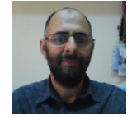 | Zouhair GUENNOUN received the B.Eng. degree in electrical engineering in 1987 from ULG, Liege Belgium, M.Sc. degrees in electrical and computer engineering in 1993 from École Mohammadia d’ Ingénieurs (EMI), Rabat, and the Ph.D. degree in applied science in 1996 from EMI. He is currently a Professor of Computer and electronic Engineering at École Mohammadia d’ Ingénieurs (EMI) where he is member of the ERSC formerly known as LEC, and member of the spatial research center (CRES). His research interests include wireline and wireless networks, advanced communications systems, signal Processing, audio and image compression, audio cryptography. He is a senior member of IEEE.

