Location Tracking using LoRa

Norlezah Hashim¹, Fakrulradzi Idris², Tuan Nur Anisa Tuan Ab Aziz³, Siti Halma Johari⁴, Rozilawati Mohd Nor⁵ Norfariza Ab Wahab⁶
^{1,3, 4}Telecommunication Research & Innovation (CeTRI), Fakulti Teknologi Kejuruteraan Elektrik dan Elektronik (FTKEE), Universiti Teknikal Malaysia Melaka (UTeM), Malaysia
²Telecommunication Research & Innovation (CeTRI), Fakulti Kejuruteraan Elektronik dan Kejuruteraan Komputer (FKEKK), Universiti Teknikal Malaysia Melaka (UTeM), Malaysia
⁵Centre for Robotics & Industrial Automation (CeRIA), Fakulti Teknologi Kejuruteraan Elektrik dan Elektronik (FTKEE), Universiti Teknikal Malaysia Melaka (UTeM), Malaysia
⁶Centre of Smart System and Innovative Design (CoSSID), Fakulti Teknologi Kejuruteraan Elektrik dan Elektronik (FTKEE), Universiti Teknikal Malaysia Melaka (UTeM), Malaysia

Article Info |  | ABSTRACT
Article history:  Received Sep 9, 2019  Revised May 20, 2020  Accepted Jun 11, 2020 |  | Local Area Network (LAN) as Bluetooth, WiFi and ZigBee are well established technology. The biggest problem with many LAN is the battery consumption and short ranges link budgets. LoRa is a new, private, unlicensed and spread spectrum modulation technique which allows sending low rates at extremely long ranges with minimal power consumption. More importantly, there is no access fee associated with this type of wireless technology. The main idea behind this work is to conduct performance and capability analysis of a currently available LoRa transceiver. We develop a location monitoring system using LoRa and Global Positioning System (GPS) module and and we analyze the detectable range of its data, its battery consumption as well as Received Signal Strength Indicator (RSSI). Our deployment experiment demonstrates that the system is able to detect the transmitted data within 290 meters of distances. Using 6 Volts of battery AA, the transmission of data still occurred after 24 hours. This project is emphasized a location monitoring system that provide low power usage but long range.
Keywords:
LoRa
GPS
IoT
Arduino
RSSI
Copyright © 2020 Institute of Advanced Engineering and Science.
All rights reserved.
Corresponding Author:
Norlezah Hashim,
Centre for Telecommunication Research & Innovation (CeTRI),
Fakulti Teknologi Kejuruteraan Elektrik dan Elektronik (FTKEE),
Universiti Teknikal Malaysia Melaka (UTeM),
Hang Tuah Jaya, 76100 Durian Tunggal, Melaka, Malaysia.
Email: norlezah@utem.edu.my

- INTRODUCTION
LoRa is a new, private, unlicensed and spread spectrum modulation technique which allows sending low rates data at extremely long ranges with minimum power consumption. More importantly, there is no access fee associated with this type of wireless technology. Local Area Network (LAN) as Bluetooth, WiFi and ZigBee are well established technology. The biggest problem with many LAN is the battery consumption and short ranges link budgets. Other than that, fundamentally mobile networks like LTE was developed for better data throughput but has disadvantage in term of power consumption. Both LAN and Cellular Network are quite expensive to deploy in a wide area for instance to cover a whole city. All these statements mentioned, a more efficient method is suggested to overcome these issues by using Low Power Wide Area Network (LPWAN), LoRa. LoRa and the Internet of Things (IoT) have become the most important parts of modern telecommunications which need best in class battery life. LoRa needs very minimal cost for deployment at the same time it did not need to be licensed.
LoRa has been used in many health applications where many aimed for the long range communication for real time monitoring. Marco in [1] used LoRa to monitor and control the humidity of different rooms in order to reduce the costs of air conditioning operation. In [2] LoRa has been used to monitor the temperature of blood fridges inside a blood transfusion service. Reference [3] aimed to monitor air quality using different types of gas sensors. Meanwhile the author in [4] have developed a location tracking system without using Global Positioning System (GPS) but using multilateration algorithm on the gateways timestamps from received packages. From the applications mentioned, LoRa has great potential for universal applications especially for long range monitoring purposes. Dragino LoRa is used in many experimental research as mentioned in [5 – 10] but so far there is no analysis related to distances capability of LoRa transceiver while few researchers [11- 17] focusses on improving the Lora protocol.
By comparing to the previous works, this paper presents the development and analysis of location tracking system using LoRa module and GPS shield. The rest of this paper is organized as follows. Section 2 explain the research method used in this work. In Section 3 the author discusses the result and discussions found in this work, and finally the work is concluded in Section 4.

- RESEARCH METHOD
The block diagram of the proposed diagram is shown in figure 1. The system consists of two parts which are LoRa transmitter and receiver. Lora/GPS Shield was stacked onto Arduino at transmitter part before location data being transmitted on the LoRa network. At receiver part, LoRa Shield was stacked onto Yun Shield for data collection and then onto Arduino.

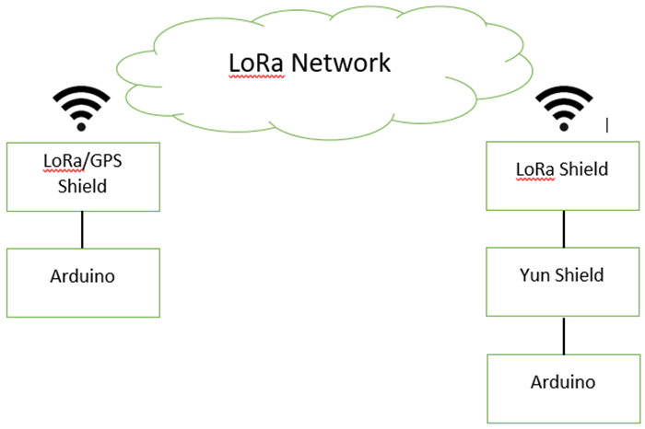

Figure 1. Block diagram of the proposed diagram

2.1. Hardware and Software Component
LoRa or Global Positioning System (GPS) Shield with the part number of SX1276/SX1278 was used in the project. In this project, Arduino Mega was chosen as the microcontroller as it has more pins that can be used as an input or output compared to other version of Arduino. Yun Shield was stacked between LoRa and Arduino, where the purpose of Yun Shield is to solve the storage issue for Arduino Board as this project require more storage to store GPS data. The transmitter and receiver parts were shown as figure 2 and 3. Arduino IDE was used to develop the project.

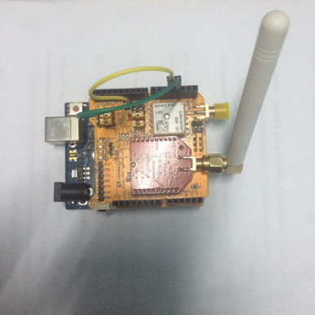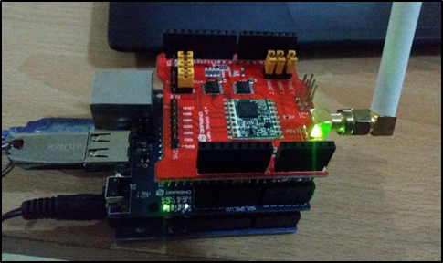
Figure 2. Transmitter Figure 3. Receiver

2.2. Experiment Setup
Figure 4 shows how the experiment has been setup graphically before data was gathered and analyzed. Laptop was connected at each transmitter and receiver respectively while the serial monitor of each laptop will display the longitude and latitude data.

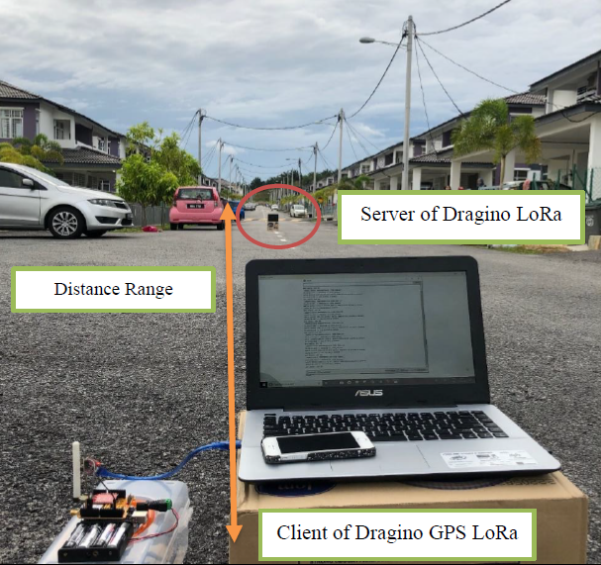
Figure 4. Location of Field Test

- RESULTS AND ANALYSIS
Serial Data in Arduino will generate the reading from LoRa GPS. Figure 5 shows the display in the serial data. The reading shows the LAT, LON, SAT, and PREC which stands for latitude, longitude, satellite, and precision. The precision data shows the relative accuracy of the horizontal position while the satellite indicate the number of available positioning satellite. The reading is displayed in Figure 5.

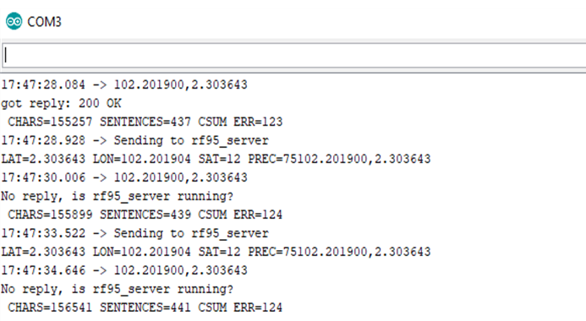
Figure 5. Serial data display the GPS reading at transmitter

Figure 6 shows the received signal observed from serial data. The reading of receiver consists of latitude and longitude data. Apart from that, Received Signal Strength Indicator (RSSI) showing the measurement of the power presented in the received signal was also displayed.

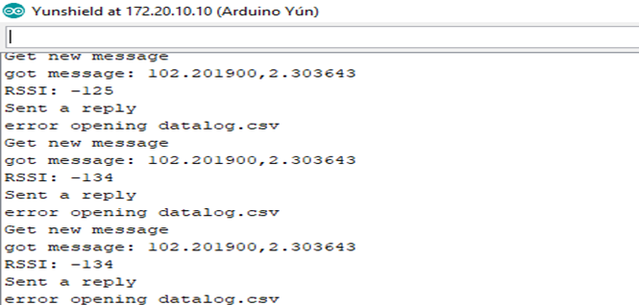
Figure 6. Serial data display the GPS reading at receiver

The measurement for the time taken to receive signal and RSSI were observed for every 50 meters as shown in Figure 7. LoRa signal is able to be received within 290 meters of distances. According to LoRa datasheet, LoRa radio transceiver is able to perform transmission for up to 1500 meters of distances. The transmission could be interrupted by obstacles such as cars and buildings. However, LoRa still proven to be the best performance for long range transmission compared to other wireless technology such as Zigbee, Radio Frequency (RF) and Wireless Sensor Network (WSN) where the transmission is limited within 100 meters of distances [18-22]. The RSSI reading is decreases as distances between transmitter and receiver increases. The performance of RSSI degraded as the distance increases.

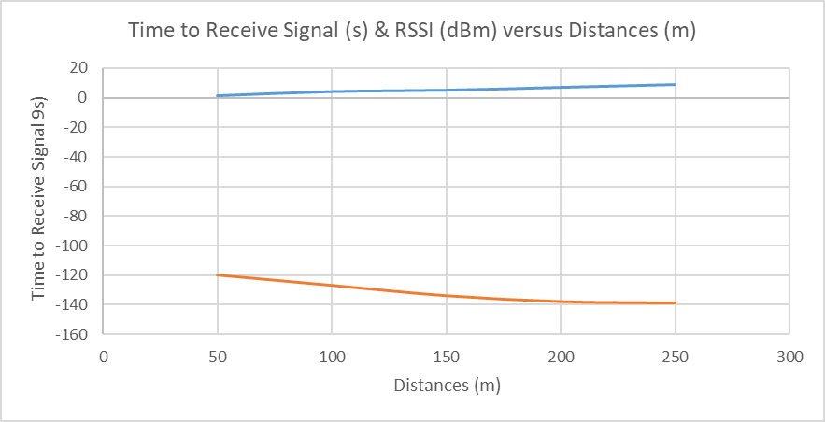
Figure 7. Signal Received and RSSI versus Distances

Figure 8 shows the analysis of LoRa transceiver battery lifetime. Each LoRa hardware was supplied with alkaline battery AA which is equivalent to 6 Volts power supply. It is observed that after 24 hours, the signal transmission still occurred from transmitter to receiver. LoRa proven to be the preferred technology for long hours of operating time.

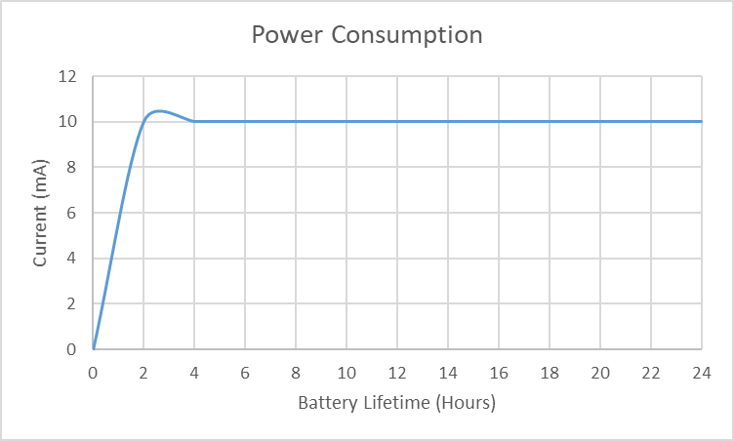
Figure 8. Power Consumption

- CONCLUSION
The results prove Dragino LoRa can give network coverage for 290 meters in suburban area with dense residential dwellings. This project could be extended by developing the gateway such as in research [23-24] where the system can be improved by allowing the devices to communicate with an application over the network server. A pole is suggested to be used as a platform to place LoRa as Line of Sight is needed for better reception [25].

ACKNOWLEDGEMENTS

The authors would like to acknowledge Centre of Research and Innovation (CRIM), Universiti Teknikal Malaysia Melaka (UTeM) for funding this research and those who give energetic and full support in carrying this research.

REFERENCES
- M. Centenaro, L. Vangelista, A. Zanella, and M. Zorzi, “Long range communications in unlicensed bands: the rising stars in the IoT and smart city scenarios,” IEEE Wireless Communications, vol. 23, no. 5, pp. 60–67, oct 2016.
- J. Petajajarvi, K. Mikhaylov, M. Hamalainen, and J. Iinatti, “Evaluation of LoRa LPWAN technology for remote health and wellbeing monitoring,” 10th International Symposium on Medical Information and Communication Technology (ISMICT), pp. 1–5, 2016.
- S. Liu, C. Xia, and Z. Zhao, “A Low-power Real-time Air Quality Monitoring System Using LPWAN based on LoRa,” pp. 3–5, 2016.
- B.C. Fargas & M.N. Petersen, “GPS-free geolocation using LoRa in low-power WANs,” in 2017 Global Internet of Things Summit (GIoTS). IEEE, pp. 1–6, 2017.
- D. Eridani, E. D. Widianto, R. D. O. Augustinus, A. Faizal, “Monitoring system in Lora network architecture using smart gateway in simple Lora protocol,” International Seminar on Research of Information Technology and Intelligent Systems (ISRITI), 2019.
- P. Edward, A. Muhammad, S. Elzeiny, M. Ashour, T. Elshabrawy, J. Robert, “Enhancing the Capture Capabilities of LoRa Receivers,” International Conference on Smart Applications, Communications and Networking (SmartNets), 2019.
- R. Vega Rodriquez, S. Sendra, J. Sendra, J. Lloret, P. Romero-Diaz, J. L. Garcia-Navas, Low Cost LoRa based Network for Forest Fire Detection,” Sixth International Conference on Internet of Things: Systems, Management and Security (IOTSMS), 2019.
- J. Jaffar, A. F. A. Malik ; M. F. A. Zuhairi ; A. A. B. Sajak ; M. T. Ismail, “Development of the LoRaWAN-based Movement Tracking System,” 14th International Conference on Ubiquitous Information Management and Communication (IMCOM), 2020.
- M. A. I. M. Ariff ; Y. L. Then, F. S. Tay, “Establish Connection Between Remote Areas and City to Improve Healthcare Services,” International Conference on Green and Human Information Technology (ICGHIT), 2019.
- S. Sadowski & P. Petros, “RSSI-Based Indoor Localization with the Internet of Things,” IEEE Access, 6, pp. 30149, 2018.
- Y. Hou, Z. Liu and D. Sun, "A novel MAC protocol exploiting concurrent transmissions for massive LoRa connectivity," in Journal of Communications and Networks, vol. 22, no. 2, pp. 108-117, April 2020
- P. Edward, S. Elzeiny, M. Ashour, T. Elshabrawy, “ On the Coexistence of LoRa- and Interleaved Chirp Spreading LoRa-Based Modulations,” International Conference on Wireless and Mobile Computing, Networking and Communications (WiMob), 2019.
- R. Y. Azhari, E. Firmansyah, A. Bejo, “Simple Protocol Design of Multi-Hop Network in Lora,” International Seminar on Research of Information Technology and Intelligent Systems (ISRITI), 2019.
- X. Wang, L. Kong, L. He, G. Chen, “ mLoRa: A Multi-Packet Reception Protocol in LoRa networks,” IEEE 27th International Conference on Network Protocols (ICNP), 2019.
- L. Leonardi, F. Battaglia and L. Lo Bello, "RT-LoRa: A Medium Access Strategy to Support Real-Time Flows Over LoRa-Based Networks for Industrial IoT Applications," in IEEE Internet of Things Journal, vol. 6, no. 6, pp. 10812-10823, Dec. 2019
- M. H. Dwijaksara, W. S. Jeon, D. G. Jeong, “Multihop Gateway-to-Gateway Communication Protocol for LoRa Networks,” IEEE International Conference on Industrial Technology (ICIT), 2019.
- W. Wu, Y. Li, Y. Zhang, B. Wang and W. Wang, "Distributed Queueing-Based Random Access Protocol for LoRa Networks," in IEEE Internet of Things Journal, vol. 7, no. 1, pp. 763-772, Jan. 2020
- N. Hashim, M. A. H. A. Razak, F. Idris, “ Home Security System Using ZigBee”, Jurnal Teknologi (Sciences & Engineering), vol. 74, no. 10, pp. 29-34, 2015.
- N. Hashim, S.H.S. Ariffin, F. Yunus, F. Idris, N. Fisal, “Deployment of Optimized Algorithm for MPEG-4 over Wireless Sensor Netork,” ARPN Journal of Engineering and Applied Sciences, vol. 9, no. 7, pp. 1035-1041, July 2014.
- F. Idris, N. Hashim, A.F. Kadmin, L. B. Yee, “ Intelligent Fire Detection and Alert System using LabVIEW,” International Journal of Electrical and Computer Engineering (IJECE), vol. 9, no. 3, pp 1842-1849, 2019.
- N. Hashim, F. Idris, A. F. Kadmin, S.S.J. Sidek, “Automatic Traffic Light Controller for Emergency Vehicle using Peripheral Interface Controller,” International Journal of Electrical and Computer Engineering (IJECE), vol. 9, no. 3, pp. 1788-1794, June 2019.
- N. Hashim, N. F. A. M. Azmi, F. Idirs, N. Rahim, “Smartphone activated door lock using WiFi,” ARPN Journal of Engineering and Applied Sciences, vol. 11, no. 5, pp. 3309-3312, March 2016.
- F. Idris, M. S. Anuar, M.H.Z. Azman, N. Hashim, “Design and Performance Analysis of IoT Based Sensor System Using LoRa,” in Embracing Industry 4.0. Lecture Notes in Electrical Engineering, Springer, vol 678, pp 51-60, 2020.
- N. Hashim, N. Noordin, F. Idris, S. N. I. M. Yusoff, M. Zahari, “IoT blood pressure monitoring system,” Indonesian Journal of Electrical Engineering and Computer Science (IJEECS), vol. 19, no. 3, pp. 1384-1390, September 2020,
- A. H. Jebril, A. Sali, A. Ismail, M. F. A. Rasid, “Overcoming Limitations of LoRa Physical Layer in Image Transmission,” Sensors, vol. 18, no. 10, pp. 1-22, October 2018.

BIOGRAPHIES OF AUTHORS

Norlezah Hashim obtained her first degree in 2006 from University of Malaya and her master degree from Universiti Teknologi Malaysia in 2014. In the past, she worked in Panasonic as an R&D engineer. Currently she is serving UTeM as a lecturer in Faculty of Electrical & Electronic Engineering Technology. She published several engineering and technical works on wireless communication and wireless sensor network.

Fakrulradzi Idris received the B.Eng. and the M.Eng. Degrees from Universiti Teknologi Malaysia in 2007 and 2008 respectively. He received the PhD degree from The University of Manchester, U.K in 2018. He is a senior lecturer in Faculty of Electronic and Computer Engineering (FKEKK), Universiti Teknikal Malaysia Melaka (UTeM). His research interests include Device-to-Device (D2D) communications, Non-Orthogonal Multiple Access (NOMA) and 5G networks.
Siti Halma Johari received the Bachelor Degree in Electronic Engineering (Industrial Electronics) from Universiti Teknikal Malaysia Melaka (UTeM) in 2005 and Master of Engineering in Control & Automation from University of Malaya (UM), Malaysia. She was a Test Engineer in Venture Electronic Services from 2005 to 2010 under Agilent Technologies Department. From 2010 to 2014, she had been a Teaching Engineer at UTeM and then, in 2015, she was appointed as a Lecturer. She is currently a PhD student in photonic research under Nanotechnology and Sensor Laboratory at Faculty of Engineering, University Malaya.

