A Hybrid Artificial Neural Network - Genetic Algorithm for Load Shedding

Le Trong Nghia¹, Quyen Huy Anh¹, Phung Trieu Tan¹, N Thai An¹
¹Department of Electrical and Electronics Engineering, HCMC University of Technology and Education, Vietnam

Article Info |  | ABSTRACT
Article history:  Received, 2019  Revised, 2019  Accepted, 2019 |  | This paper proposes the method of applying Artificial Neural Network (ANN) with Back Propagation (BP) algorithm in combination or hybrid with Genetic Algorithm (GA) to propose load shedding strategies in the power system. The Genetic Algorithm is used to support the training of Back Propagation Neural Networks (BPNN) to improve regression ability, minimize errors and reduce the training time. Besides, the Relief algorithm is used to reduce the number of input variables of the neural network. The minimum load shedding with consideration of the primary and secondary control is calculated to restore the frequency of the electrical system. The distribution of power load shedding at each load bus of the system based on the phase electrical distance between the outage generator and the load buses. The simulation results have been verified through using MATLAB and PowerWorld software systems. The results show that the Hybrid Gen-Bayesian algorithm (GA-Trainbr) has a remarkable superiority in accuracy as well as training time. The effectiveness of the proposed method is tested on the IEEE 37 bus 9 generators standard system diagram showing the effectiveness of the proposed method.
Keyword:
Hybrid algorithm
Load shedding
Genetic Algorithm
Back Propagation Neural Network
Phase Electrical Distance
Copyright © 2019 Institute of Advanced Engineering and Science.
All rights reserved.
Corresponding Author:
Phung Trieu Tan,
Department of Electrical and Electronics Engineering,
HCMC University of Technology and Education,
01Vo Van Ngan street, Thu Duc district, Hochiminh city, Vietnam.
Email: tanphungtrieu.hcmute@gmail.com

- INTRODUCTION
When a large power imbalance occurs in the power system, the frequency will decline rapidly. This problem appears when a generator suddenly outage or increase in load. Before performing load shedding, the monitoring and control system will immediately implement control solutions to maintain the frequency within the allowable range such as: Primary frequency control and secondary frequency control [1]. In case the frequency of the system continues to decrease, the load shedding is the last and the most effective solution. The under-frequency load shedding relay (UFLS) [2] is the traditional load shedding method used quite commonly in the current power system. The relays are set to operate whenever the frequency drops to a specified level and a fixed amount of load power is shed to restore the frequency [3]. Using under frequency load shedding relay to disconnect the load bus will result in insufficient or excessive load shedding and take a long time to restore the frequency back to stable [4],[5]. This result will make damages for the suppliers and customers using the system's power. Intelligent load shedding is an optimal method of load shedding using artificial intelligence algorithms to help operators perform load shedding quickly and accurately. The combination of Intelligent load shedding methods has also been studied and developed such as Artificial Neural Network (ANN) in load shedding [6], fuzzy logic algorithms [7], Genetic Algorithm (GA) [8] Particle Swarm Optimization (PSO) algorithm [9]. In recent years, Artificial Neural Networks (ANN) have been used in many different problems such as transformer protection [10], load forecasting [11],[12], energy management [13],[14], electricity price forecast [15]. In order to apply an ANN, some issues need to be considered, such as network model, network size, activation function, learning parameters, and number of training samples [16]. In the problems of power systems, artificial neural networks often use network types such as Generalized Regression Neural Network (GRNN), Back Propagation Neural Network (BPNN), Hopfield networks and Kohonen networks which are commonly used. In particular, Back Propagation Neural Network (BPNN) is an algorithm that is used effectively to optimize training of Artificial Neural Networks (ANNs). However, the BPNN algorithm has two main disadvantages: low convergence speed and instability. In order to solve the above limits, the Genetic Algorithms (GA) are one of the suitable techniques to overcome.
This paper presents a load shedding method using artificial neural network (ANN) with Back Propagation Neural Network (BPNN) algorithm combine Genetic Algorithms (GA) to support the proposed load shedding strategies for operators’ power system of power companies quickly and accurately. The Genetic algorithms (GA) are used to support the training of Artificial Neural Networks (ANNs) to improve the regression ability, minimize errors and reduce training time. Control strategies for load shedding take into account the primary control and secondary control of the generators units to minimize the amount of power load shedding. The phase electrical distance between the outage generator and load buses support distribution the amount of load shedding at each load bus. The closer the load bus is to the outage generator position, the greater the amount of power load shedding at that bus. The effectiveness of the proposed load shedding strategy was demonstrated through the test on the IEEE 37 bus – 9 generators system showed the effectiveness of the proposed method.

- LOAD SHEDDING DISTRIBUTION COMBINED WITH PRIMARY AND SECONDARY CONTROL
Primary frequency control is an instantaneous adjustment process performed by a large number of generators with a turbine power control unit according to the frequency variation.
Secondary frequency control is the subsequent adjustment of primary frequency control achieved through the AGC's effect (Automatic Generation Control) on a number of units specifically designed to restore the frequency back to its nominal value or otherwise, the frequency-adjusting effects are independent of the governor's response called the secondary frequency control. The process of the primary and secondary frequency control was shown in Fig. 1 [1].
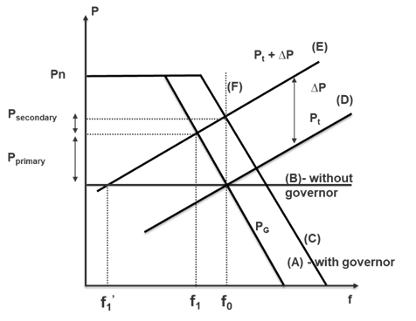
Figure 1. The relationship between frequency deviation and output power deviation
The minimum power load shedding is calculated by the formula below [1]:
(1)
Where ∆f_{p} is the permissible change in frequency (pu); P_{LSmin} is the minimum amount of power required to shed (pu); ∆P_{Secondary control} is the amount of secondary control power addition to the system.
The phase electrical distance between the outage generator and load buses is calculated using the proposed process in [17]
(2)
The general formula calculates the load shedding distribution at nodes according to the phase electrical distance [1]:
(3)
Where: m is the number of generator bus; i is the number of load bus; P_{LSi} is the amount of load shedding power for the i bus (MW); P_{LSmin} is the minimum amount of load shedding power to the restore of frequency back to the allowable value (MW); S_{P,mi} is the phase electrical distance of the load to the m outage generator; S_{P,eq} is the equivalent phase electrical distance of all load buses and generator.

- HYBRID ALGORITHM BETWEEN GENETIC AND BACK PROPAGATION IN ARTIFICIAL NEURAL NETWORK
Back Propagation [18],[19] adjusts the weights in descending the error function and it just needs some basic information. However, back propagation also has drawbacks such as adjusting complex error functions so it often traps in local minima. It is very inefficient in searching for global minimum of the search space makes the training time longer. GA is parallel random optimization algorithms. Compared to BP, GA is more qualified for neural networks when we consider to search for global. On the other hand, the limitation of GA is the long processing time, mainly due to the random initialization of the population and the use of search mechanisms. From the above analysis, it is easy to get the complementarity between BP and GA [20].
This section presents a solution for optimizing BPNN by using GA to find the associated weights in the neural network structure to reduce or avoid local minimum errors then use the back-propagation algorithm to train the neural network with the weights found to ensure convergence and achieve the optimal level. Fig. 2 shows the application of the Hybrid Genetic Algorithm – Back Propagation Neural Networks (GA-BPNN) in online and offline models in the power system.
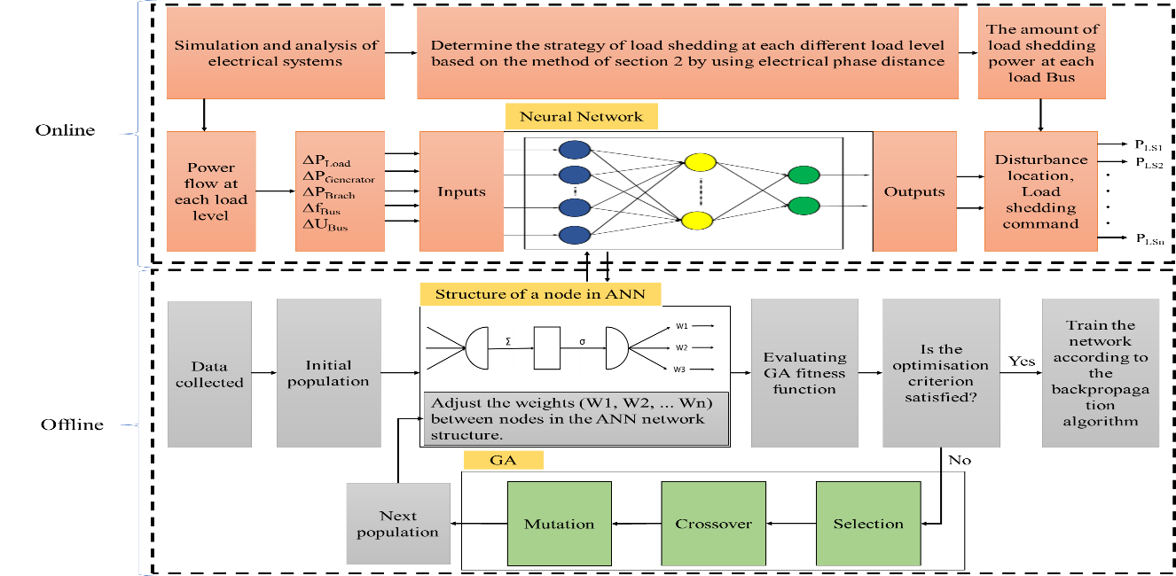
Figure 2. The offline and online processes of the load shedding using the hybrid GA – BPNN
ANN will receive the data which collects from simulation the outage generator with different load levels to create a prediction system. This system incorporates in load shedding strategies which is according to the proposed method to recover frequency to allowable values in a short time. The data set used to train neural networks is collected from the IEEE 37 bus 9 generators model in two cases: shedding and non-shedding with 328 sets with the number of variables decreasing from 165 to 40. The offline process will create ANN by the proposed method to create an identification system which used for the online process.
Offline training process: The simulation process is shown in the flowchart in Fig. 2.
- Step 1: The neural network has a structure of 40 inputs, 2 outputs, with random weights.
- Step 2: Find the weight values in the neural network by genetic algorithm with the minimum fitness function according to the Mean Squared Error (MSE), using the following formula:
(4)
Where, n is the number of samples.
- Step 3: Receive neural networks with optimal weights and train by back propagation algorithm.
Online running process: The neural network after being trained with the optimal weights is applied into the online running process to evaluate the effectiveness of recognition system and propose resolve strategies.
The knowledge base of the load shedding system is preprocessed by using input and output databases carefully selected from system studies and simulations in the offline training process. From there, give a specific load shedding strategy for each disturbance.

- SIMULATION AND REULTS
The IEEE 37 bus standard system diagram is selected as the test system. The single-line diagram of this system is shown in Fig.3, and the system data are available in [21]. The case has nine generators, 25 loads and 57 branches with SLACK345 generator at Bus 31 is slack bus. It is constructed with three different voltage levels (69 kV, 138 kV and 345 kV), and the system is modelled in per unit. The simulated diagram with multiple load levels from 60% -100% creates a data consisting of 328 sets with 123 sets of shedding and 205 sets of non-shedding. This data will be divided into 85% train and 15% test to train ANN to combine genetic algorithms and backpropagation.
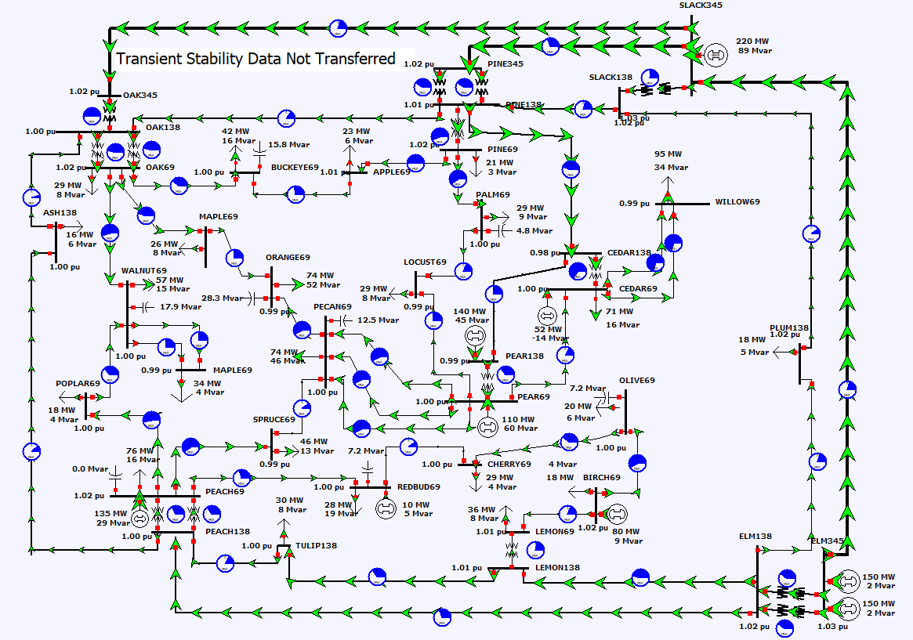
Figure 3. The IEEE 37 bus standard system diagram
4.1. Results of simulation of proposed load shedding method
In the case study, the PEACH69 generator disconnected (Bus 44) from the power system. Primary and secondary control were implemented afterwards with primary control power of 134.6MW and secondary control power of 18.48MW. The frequency of the power system when the outage generator occurs and after performing primary and secondary controls is shown in Fig. 4.
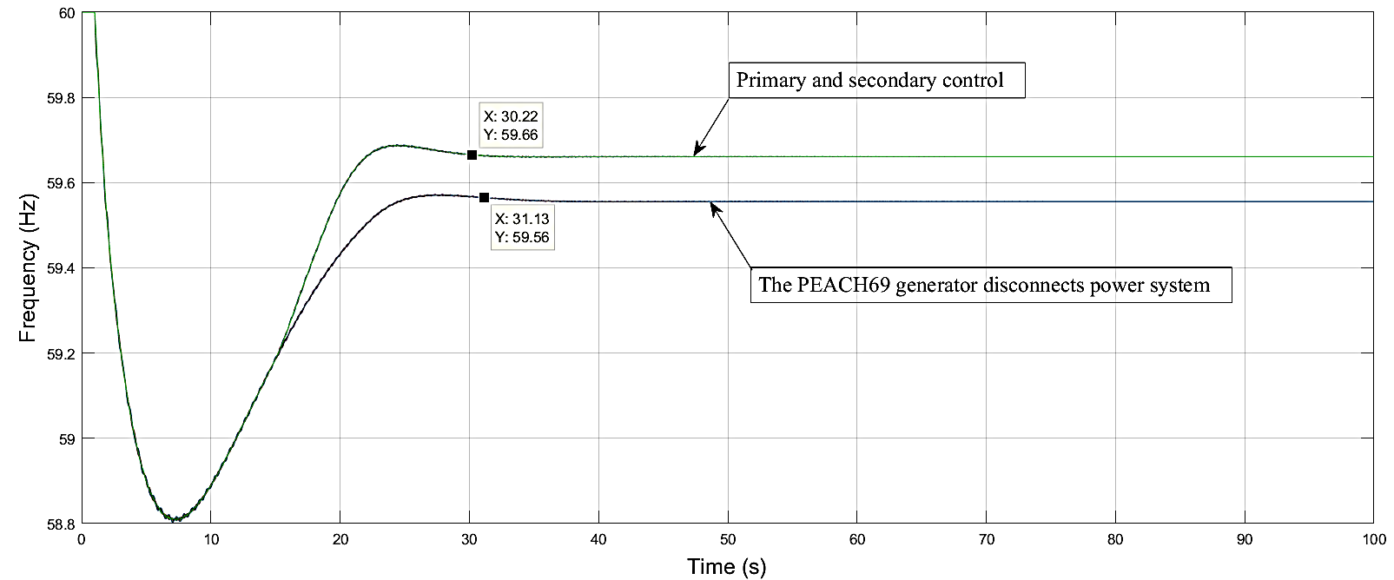
Figure 4. Frequency of the system when the outage generator before and after performing control of the primary - secondary frequency
After performing the primary and secondary controls, the system frequency is restored to 59.66 Hz and has not yet reached the allowed value. Therefore, the final solution is load shedding, based on the formula (1) the minimum load shedding power calculated to restore the frequency to the allowable value of 10.41MW. Apply formula (2) and (3), the minimum load shedding power at each bus is shown below the Table 1.
Table 1. The Load Shedding Distribution at Load Buses
Load Bus | 3 | 5 | 10 | 12 | 13 | 14 | 15 | 16 | 17 | 18 | 19 | 20 | 21
Load shedding (MW) | 0.63 | 0.51 | 0.43 | 0.61 | 0.27 | 0.41 | 0.54 | 0.46 | 0.34 | 0.40 | 0.30 | 0.24 | 0.32
Load Bus | 24 | 27 | 30 | 33 | 34 | 37 | 48 | 50 | 53 | 54 | 55 | 56
Load shedding (MW) | 0.54 | 0.45 | 0.66 | 0.34 | 0.28 | 0.35 | 0.42 | 0.25 | 0.46 | 0.53 | 0.26 | 0.42

Performing the load shedding according to the proposed method, the restored system frequency value is 59.7Hz and within the allowed value. The frequency of recovery after load shedding is shown in Fig. 5.
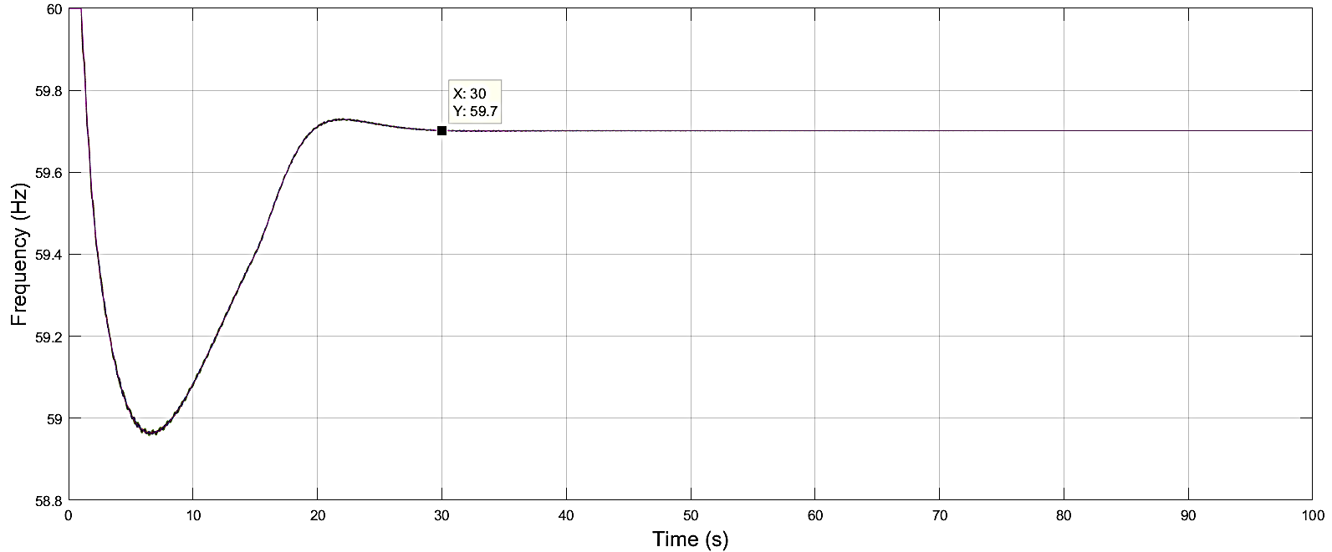
Figure 5. Frequency of the power system after load shedding
4.2. Compare the hybrid GA-BPNN method to traditional methods
In this algorithm, GA is used as an optimal weight generator for BPNN. The weights are coded into chromosomes and evolved by GA. At the end of evolution, the best weights correspond to the best individuals in the selected population as initial weights for BPNN. It is a set of parameters that allows determining the nearest extreme point of the fitness function. With this combination, BPNN will not automatically generate weights but receive weights from GA. The inertial component is removed to increase the speed of the convergence process and to eliminate oscillation during the learning of the Back-Propagation algorithm. Fig. 6 presents a flowchart of the process of developing ANN training data and combining ANN with GA.
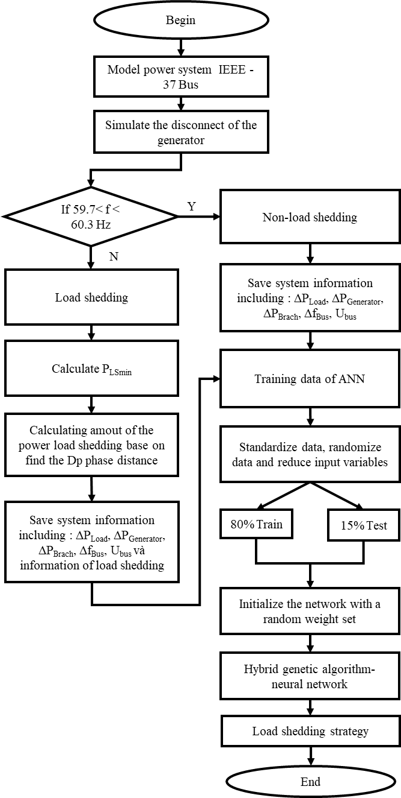
Figure 6. Flowchart hybrid GA-BPNN
The ANN test simulation process is performed with MATLAB software with four training algorithms commonly used in BPNN identification problems: Levenberg – Marquardt (Trainlm), Bayesian regularization (Trainbr), Scaled Conjugate Gradient (Trainscg), Resilient Back propagation (Trainrp). Calculation results and simulations results are presented in Table 2.
Table 2. Results of the Training Process of the Proposed Method with the Traditional Method
The number of hidden neural | Levenberg – Marquardt |  |  |  | Bayesian regularization
The number of hidden neural | Time CPU |  | Accuracy (%) |  | Time CPU |  | Accuracy (%)
The number of hidden neural | BPNN | GA-BPNN | BPNN | GA-BPNN | BPNN | GA-BPNN | BPNN | GA-BPNN
2 | 2.875 | 1.275 | 86.794 | 98.832 | 13.773 | 2.096 | 97.832 | 98.782
4 | 1.500 | 0.399 | 92.057 | 98.772 | 27.321 | 1.303 | 98.752 | 99.795
6 | 4.123 | 0.874 | 93.330 | 99.542 | 65.978 | 22.831 | 93.056 | 99.976
8 | 17.695 | 2.928 | 92.134 | 99.776 | 357.384 | 68.138 | 99.610 | 99.718
10 | 19.062 | 2.567 | 92.185 | 99.431 | 647.969 | 111.709 | 99.671 | 99.745
12 | 12.855 | 6.902 | 90.519 | 99.567 | 1121.148 | 25.566 | 98.994 | 99.643
14 | 47.318 | 14.296 | 93.586 | 99.738 | 1154.992 | 126.165 | 99.202 | 99.976
16 | 30.295 | 13.010 | 92.856 | 99.742 | 2048.421 | 167.674 | 95.523 | 99.879
18 | 25.508 | 10.771 | 89.925 | 99.658 | 722.287 | 123.624 | 99.286 | 99.665
20 | 94.816 | 14.170 | 94.267 | 99.913 | 3276.834 | 65.523 | 99.617 | 99.894
The number of hidden neural | Scaled Conjugate gradient |  |  |  | Resilient Back propagation
The number of hidden neural | Time CPU |  | Accuracy (%) |  | Time CPU |  | Accuracy (%)
The number of hidden neural | BPNN | GA-BPNN | BPNN | GA-BPNN | BPNN | GA-BPNN | BPNN | GA-BPNN
2 | 0.160 | 0.153 | 86.750 | 99.799 | 1.458 | 0.114 | 85.311 | 99.540
4 | 0.079 | 0.118 | 88.749 | 99.750 | 0.256 | 0.072 | 92.601 | 99.774
6 | 0.100 | 0.178 | 92.109 | 99.545 | 0.247 | 0.071 | 79.462 | 99.680
8 | 0.160 | 0.102 | 92.820 | 99.407 | 0.110 | 0.093 | 82.987 | 99.195
10 | 0.108 | 0.114 | 91.552 | 99.600 | 0.185 | 0.089 | 92.996 | 99.247
12 | 0.146 | 0.197 | 92.006 | 99.653 | 0.135 | 0.089 | 94.473 | 98.849
14 | 0.106 | 0.124 | 81.299 | 98.760 | 0.122 | 0.163 | 92.092 | 99.300
16 | 0.121 | 0.103 | 90.975 | 97.836 | 0.086 | 0.120 | 88.835 | 99.287
18 | 0.133 | 0.111 | 91.959 | 99.421 | 0.085 | 0.080 | 89.469 | 98.108
20 | 0.112 | 0.177 | 88.819 | 98.387 | 0.123 | 0.091 | 92.161 | 97.586
Table 2 shows the results of ANN training according to the proposed method compared with the traditional method through 4 training algorithms of BPNN. The comparison results showed that the Gen-Bayesian regularization (GA-Trainbr) has a remarkable superiority in accuracy as well as training time. As with 20 hidden neurons, the improved Bayesian regularization training algorithm reduces CPU training time from 3276,834s to 65.523s and accuracy from 99.617% to 99.894% or Levenberg - Marquardt training algorithm with 2 improved hidden neuron increased accuracy from 86.794% to 98.832%. In the tests, the proposed method uses Bayesian regularization training algorithms combining genetic algorithms (hybrid GA-Trainbr) for the highest efficiency in all hidden neurons.
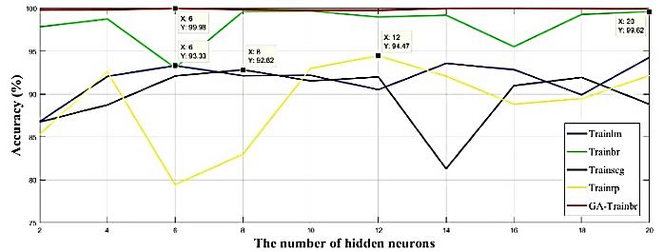
Figure 7. Comparison the hybrid Genetic – Bayesian regularization algorithm (GA-Trainbr) method to traditional methods

- CONCLUSION
A hybrid artificial neural network - Genetic algorithm overcomes the disadvantages of BPNN. Genetic algorithms are used to optimize the weights of neural network structures to reduce disadvantages such as slow convergence rates and local minimum errors. The Relief algorithm is used to reduce the number of input variables in order to narrow the data space horizontally. The combination of two Gen – Bayesian regularization algorithms (GA - Trainbr) with the idea of taking advantage of this algorithm overcomes the remaining algorithm disadvantages. The result is a network structure capable of learning faster and capable of predicting with better accuracy.
The optimal in terms of power, position and load shedding time has taken the primary and the secondary frequency control. The hybrid Genetic – Bayesian regularization algorithm (GA - Trainbr) create knowledge base or rules base which is based on the electrical phase distance to apply to the IEEE 37 bus 9 generators power system standard model, it has achieved training time efficiency as well as high accuracy.

ACKNOWLEDGEMENTS
This research was supported by the HCMC University of Technology and Education.

REFERENCES
- Nghia. T. Le, Anh. Huy. Quyen, Binh. T. T. Phan, An. T. Nguyen, and Hau. H. Pham, “Minimizing Load Shedding in Electricity Networks using the Primary, Secondary Control and the Phase Electrical Distance between Generator and Loads,” International Journal of Advanced Computer Science and Applications (IJACSA), Vol. 10, No. 2, pp.293-300, 2019.
- GazmendKabashi; SkenderKabashi, “Review of under Frequency Load Shedding Program of Kosovo Power System based on ENTSO-E Requirements,” International Journal of Electrical and Computer Engineering (IJECE), Vol. 8, No. 2, pp. 741-748, April 2018.
- Mousa Marzband, MaziarMirhosseini Moghaddam, MudathirFunshoAkorede, and Ghazal Khomeyrani, “Adaptive load shedding scheme for frequency stability enhancement in microgrids,” Electric Power Systems Research, Vol. 140, pp. 78-86, June 2016.
- Raghu C. N, A. Manjunatha, “Assessing Effectiveness of Research for Load Shedding in Power System,” International Journal of Electrical and Computer Engineering (IJECE), Vol. 7, No. 6, pp. 3235-3245, December 2017.
- Y. Halevi, and D. Kottick, “Optimization of load shedding systems,” IEEE Transactions on Energy Conversion, Vol. 8, Issue: 2, pp. 207–213, June 1993.
- C. T. Hsu, M. S. Kang and C. S. Chen, “Design of Adaptive Load Shedding by Artificial Neural Networks,” IEE Generation, Transmission, Distribution, Vol. 152, Issue: 3, pp. 415-421, May 2005.
- A. A. Sallam, and A. M. Khafaga, “Fuzzy Expert System Using Load Shedding for Voltage Instability Control,” IEEE Large Engineering Con. on Power Engineering, June 2002.
- W. P. Luan, M. R. Irving, and J. S. Daniel, “Genetic Algorithm for Supply Restoration and Optimal Load Shedding in Power System Distribution Networks”, IEE Proceedings - Generation, Transmission and Distribution, Vol. 149, Issue: 2, pp. 145-51, March 2002.
- T. Amraee, B. Mozafari, A. M. Ranjbar, “An Improved Model for Optimal Under Voltage Load Shedding: Particle Swarm Approach,” 2006 IEEE Power India Conference, April 2006.
- B.S.Shah, and S.B.Parmar, “Tranformer protection using artificial neural network,” 2017 IJNRD, Vol. 2, Issue: 5, May 2017.
- Ramesh Kumar V,PradipkumarDixit, “Daily peak load forecast using artificial neural network,”International Journal of Electrical and Computer Engineering (IJECE), Vol.9, No.4, pp. 2256-2263, August2019.
- Ricardo Alonso, and Alcides Chávez, “Short term load forecast method using artificial neural network with artificial immune systems,” 2017 IEEE URUCON, October 2017.
- S.L. Arun, and M.P. Selvan, “Intelligent Residential Energy Management System for Dynamic Demand Response in Smart Buildings,” IEEE Systems Journal, Vol. 12, Issue: 2, pp. 1329-1340, June 2018.
- BoniSena, Sheikh Ahmad Zaki, Fitri Yakub, Nelidya Md Yusoff and Mohammad Kholid Ridwan “Conceptual Framework of Modelling for Malaysian Household ElectricalEnergy Consumption using Artificial Neural Network based on Techno-Socio Economic Approach,”International Journal of Electrical and Computer Engineering (IJECE), Vol.8, No.3, pp. 1844-1853, June 2018.
- DimitrijeKotur, and MiletaŽarković, “Neural network models for electricity prices and loads short and long-term prediction”, 2016 4th International Symposium on Environmental Friendly Energies and Applications (EFEA), September 2016.
- NazriMohd. Nawi, Abdullah Khan, and Mohammad Zubair Rehman, “A New Back-Propagation Neural Network Optimized with Cuckoo Search Algorithm,” International Conference on Computational Science and Its Applications, Part I, Vol. 7971, pp. 413–426, 2013.
- L. Patrick, “The different electrical distance,” in Proceedings of the Tenth Power Systems Computation Conference, Graz, 1990.
- Saduf, and MohdArifWani, “Comparative Study of Back Propagation Learning Algorithms for Neural Networks”, International Journal of Advanced Research in Computer Science and Software Engineering, Vol. 3, Issue: 12, pp. 1151-1156, December 2013.
- Yann LeCun, BengioYoshua, and Geoffrey Hinton, “Deep learning,” Nature, Vol. 521, pp. 436–444, May 2015.
- IttiHooda, R.S. Chhillar, “Test Case Optimization and Redundancy Reduction Using GA and Neural Networks,” International Journal of Electrical and Computer Engineering (IJECE), Vol. 8, No. 6, pp. 5449-5456, December 2018.
- J. D. Glover, M. S. Sarma, and T. J. Overbye, “Power System Analysis and Design,” Sixth Edition, Cengage Learning, pp.718, 2017.

BIOGRAPHIES OF AUTHORS

 | Trong Nghia Le received his M.Sc. degree in electrical engineering from Ho Chi Minh CityUniversity of Technology and Education (HCMUTE), Vietnam, in 2012. Currently, he is a lecturer in the Faculty Electrical and Electronics Engineering, HCMUTE. His main areas of research interests are load shedding in power systems, power systems stability, load forecasting and distribution network.
 | Quyen Huy Anh received PhD degree in power system from MPIE, Russia in 1993. Currently, he is a professor, lecturer in the Faculty Electrical and Electronics Engineering, HCMUTE. His research interests are modeling power systems, pattern recognition in dynamic stability of power systems, and artificial intelligence.
 | Phung Trieu Tan received his Eng. degree in electrical engineering from Ho Chi Minh City University of Technology and Education (HCMUTE), Vietnam, in 2018. Currently, he is learning electrical master's degree in HCMUTE. His main areas of research interests areartificial neural network, load shedding in power systems, power systems stability, load forecasting and distribution network.
 | Nguyen Thai An received his Eng. degree in electrical engineering from Ho Chi Minh City University of Technology and Education (HCMUTE), Vietnam, in 2018. Currently, he is learning electrical master's degree in HCMUTE. His main areas of research interests are load shedding in power systems, power systems stability, load forecasting and distribution network.

