Performance Evaluation of the IEEE 802.11n Random Topology WLAN with QoS Application

Ziyad Khalaf Farej, PhD¹, Mustafa Mohammad Jasim²
¹Department of Computer Engineering, Northern Technical University, Iraq
²Department of Computer Engineering, Northern Technical University, Iraq

Article Info |  | ABSTRACT
Article history:  Received xx x, xxxx  Revised xx xx, xxxx  Accepted xx xx, xxxx |  | The IEEE 802.11n supports high data rate transmissions due its physical layer Multiple Input ‎Multiple Output (MIMO) advanced antenna system and MAC layer enhancement features (frame ‎aggregation and block acknowledgement). As a result this standard is very suitable for multimedia ‎services through its Enhanced Distributed Channel Access (EDCA). This paper focuses on ‎evaluating the Quality of Service (QoS) application on the performance of the IEEE 802.11n ‎random topology WLAN. Three different number of nodes (3, 9 and 18) random topology with one ‎access point are modeled and simulated by using the Riverbed OPNET 17.5 Modular to ‎investigated the Wireless Local Area Network (WLAN) performance for different spatial streams. ‎The result clarified the impact of QoS application and showed that its effect is best at the 18 node ‎number topology. For a 4x4 MIMO, when QoS is applied and with respect to the no QoS ‎application case, simulation results show a maximum improvement of 86.4%, 33.9%, 52.2% and ‎‎68.9% for throughput, delay, data drop and retransmission attempts, respectively. ‎
Keyword:
IEEE 802.11n
MIMO
QoS
WLAN
EDCA
Multimedia Services
Riverbed Modeler 17.5
Copyright © 2019 Institute of Advanced Engineering and Science.
All rights reserved.
Corresponding Author:
Ziyad Khalaf Farej, PhD
Department of Computer Engineering,
Northern Technical University,
Mosul, Iraq.
Email: drziyadk.farej@gmail.com

- INTRODUCTION
Researches on wireless networks aim for feasible and cheap broadband internet access, as well as ‎investigation on Quality of Service (QoS) for critical time services systems (such as healthcare and ‎telemedicine, emergency and disaster networking systems) have recently attracted considerable ‎attention. Wireless multi-hop networks, such as wireless mesh networks (WMNs) random topology, ‎are considered an ideal networks field for such services [1] thus; multi-hop wireless networks ‎become necessary for users. However due to the limitation of the transmission range of wireless ‎network interfaces, multiple hops are needed to extend range and exchange data between stations in ‎the network [2] and the IEEE 802.11 standard is widely applied in multi-hop wireless networks. ‎The fundamental channel accessing protocol for this (IEEE 802.11) standard is the distributed ‎coordination function (DCF) and it is based on carrier sense multiple access with carrier avoidance ‎protocol [1, 3]. In comparison with its previous counterpart the IEEE 802.11n has better ‎performance, compatible with previous WLAN standards and supports QoS protocol of the IEEE ‎‎802.11e which grants differentiated services for voice, video and data [4, 5]. The improvement of ‎the physical layer Multiple Input Multiple Output (MIMO) smart antenna communications design ‎and the necessary MAC layer enhancement such as the two level (MAC Service Data Unit (MSDU) ‎and MAC Protocol Data Unit (MPDU)) frame aggregation mechanism cause the data rate and ‎spectral efficiency to be increased by sending more data frames in a single transmission. Also block ‎acknowledgement (BA) improves the MAC efficiency to resolves the drawback of large ‎aggregation without the need to acknowledge every received unicast frame, so it is obviously ‎suitable for unicast and sensitive to delay or real time applications where retransmission is critical, ‎as a result throughput can be significantly increased [6, 7]. The changes at the physical and MAC ‎layers of the IEEE 802.11n standard enhance the previous IEEE 802.11 standards and the peak ‎data rate of this standard may reach around 300 or 600 Mbps when working on the 2.4 or 5 GHz band with ‎‎20 or 40 MHz channel bandwidth respectively [5, 6, 7, 8]‎‏.‏

- RELATED WORK
The performance of the WLAN based on the IEEE 802.11n standard is better when using ‎two level frame aggregations at the MAC layer and MIMO-OFDM at physical layer compared to the ‎no frame aggregation case, reference [9] shows perform improvement values of 37.4% and 13.7% ‎in terms of throughput and end to end delay respectively. The authors in [10] proposed a routing ‎protocol for wireless body area network to transmit data with low energy consumption value and ‎high network life time, moreover they presented a multi-hop random topology and performance ‎evaluation using simulations approach. In [1], the authors proposed a scheme which is based on ‎IEEE 802.11 standard for multi-hop wireless networks with Transmission Opportunity (TXOP) to ‎support QoS for wireless networks. Their scheme assigns the variable length of TXOPs to different ‎traffics based on precise channel condition prediction. They concluded that their scheme improved ‎the network reliability (by allowing more failure recovery times), reduced delay and increased ‎throughput. The authors in [3] presented an approximated analytical model for the throughput and ‎delay performance for multi-hop ad hoc networks, they show an obvious improvement on the 8 ‎nodes random topology performance of the IEEE 802.11a standard with enhanced DCF, their ‎improvement values with QoS applications are 7.14% and 40% for throughput and delay ‎respectively. The authors in [12] concentrated on the IEEE 802. 11 Mac layer parameters and used ‎the OPNET network simulation tool to show that the WLAN performance can be improved by fine ‎tuning parameters such as ‎fragmentation threshold, Request to Send (RTS) thresholds and buffer ‎size. The authors in [13] summarized the Modified Binary Particle Swarm Optimization (MBPSO) ‎algorithm to improve the performance of the wireless network random topology. With the used ‎optimization function and the distance between nodes taken into consideration, their result show ‎that the maximum improvement is 8.33%, 5.79% and 17.83% for end to end delay, throughput and ‎packet delivery ratio respectively. Many other attempts have been made by references [14, 15] to ‎provide more simple analytical models to compute throughput and delay. Their analysis without ‎hidden node problem show that interference among nodes can be reduced to maximize throughput ‎by using the smallest transmission range and the achievable per node throughput is 11% of the ‎channel capacity.‎

- IEEE 802.11n AMENDMENTS AND QoS APPLICATION
IEEE 802.11n has higher throughput improvements and better spectral efficiency due to the ‎improvement of the physical layer (MIMO) antenna communication system and the necessary ‎MAC layer enhancement such as the two level (A-MSDU with maximum size is 7935 bytes and A-‎MPDU with maximum size is 65535 bytes) frame aggregation mechanism and block ‎acknowledgement that resolves the drawback of large aggregation by retransmitting only erroneous ‎frames as shown below in Figure1 [6, 7, 16].
‎
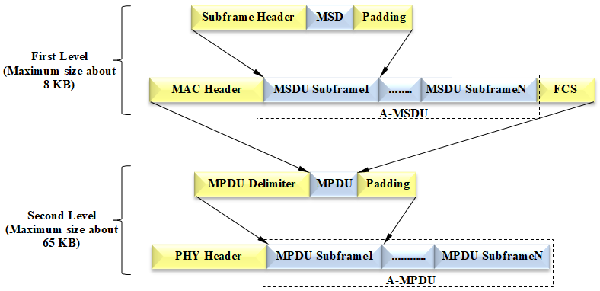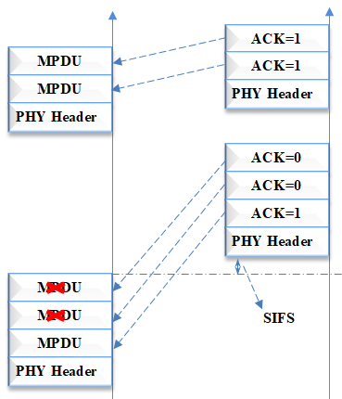
(a) (b)
Figure 1. (a) Two level frame aggregation and (b) Block acknowledgement in IEEE 802.11n standard

QoS technology is applied to manage and investigate the performance of the high ‎data ‎traffic load for high number of nodes network model and also in order to perfectly evaluate the ‎performance (throughputs, packet ‎loss and reduce latency) of the network [17]. Through the process ‎of the data flows ‎management and ability to give priorities for the different types of services, ‎a ‎certain level of data flow is ensured according to the needs and performance is ‎improved. The ‎QoS is implemented through the application of the MAC layer ‎Hybrid Coordination Function (HCF) ‎with Enhanced Distributed Channel ‎Access (EDCA) mechanism as shown in Figure 2a. ‎According to this accessary function, the parameters ‎on which the QoS is prioritized are the ‎minimum size Contention Window (CWmin) and maximum size contention window (CWmax) ‎techniques which ‎count on providing the required Arbitrary Inter Frame Space (AIFS) and ‎Transmission Opportunity (TXOP). It shows that the back-off of the highest priority access ‎category (AC) is assigned the lowest value of AIFS; the TXOP is a bounded time interval during ‎which a node can send as many frames as possible. In these scenarios when QoS ‎is applied, the ‎QoS parameters are listed in Table 1 and the RTS threshold was used and determined by a frame ‎length of 512 ‎bytes. In our performance analysis the scheduled service queues are considered as ‎Voice, Video and Best effort (FTP) as shown in Figure 2b.‎

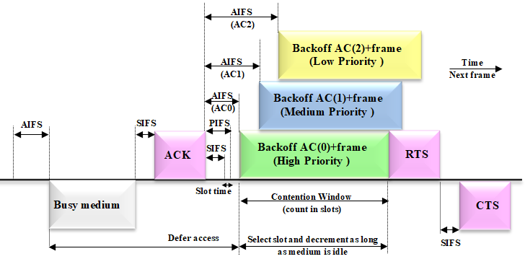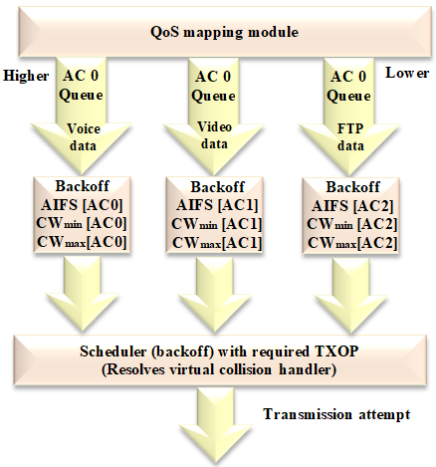
(a) (b)
Figure 2. (a) Timing diagram representation of EDCA and (b) QoS mapping module

Table 1. EDCA (QoS) prioritized parameters
Parameters | Values
Parameters | Voice | Video | Best effort
Max TXOP (ms)‎ | ‎6.016‎ | ‎6.016‎ | ‎3.264‎
AIFSN(back-off) ‎ (slot) | ‎2‎ | ‎2‎ | ‎3‎
CWmin (slot) | ‎3‎ | ‎7‎ | ‎15‎
CWmax (slot) | ‎7‎ | ‎15‎ | ‎1023‎

- THEORETICAL PERFORMANCE OF MULTI-HOP WIRELESS NETWORKS
This type of Networks offers communications capability to multiple users with a fixed ‎infrastructure. Each node in a wireless multi-hop network functions as both a host and a router, and ‎the nodes in this network forward data to the destination according to the Ad-hoc routing protocol. ‎The network packets can traverse multiple intermediate nodes from the source to the destination and ‎each forwarding step is called a hop. A simple uniform multi-hop wireless network, which forms the ‎basis of the WMN random topology, is shown in Figure 3. [18-19]. ‎

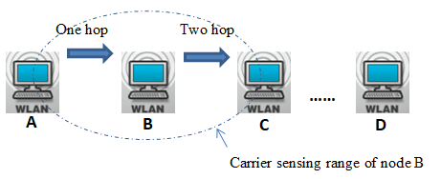
Figure 3. Multi-hop wireless ad-hoc networks

A simple mathematical model that provides the upper bond throughput and delay is given by [20]‎:

$$Max Data Rate \left(bits/sec.\right)= \frac{\text{DS * SS * Bits Per Symbol * CR}}{\text{Symbol Duration} } …(1)$$

$${Delay}_{sec}=\frac{L_{max} }{\text{Max Data Rate }} …(2)$$

Where:
DS = Data Subcarriers (equal to 52 for 20 MHz),
SS = Spatial Stream is variable from one up to four,
Bits per Symbol are 6 for 64-QAM,
CR = Code Rate is 5/6,
Symbol Duration equal 3.6µs include guard interval of 400 ns,
$L_{max}$ is the A-MPDU length which is 65535 bytes and Table 2 shows the maximum theoretical throughput and delay for different spatial stream.

Table 1. Shows theoretical throughput and overall delay values of the 802.11n standard
Spatial stream | 1x1 | 2x2 | 3x3 | 4x4
Throughput (Mbps) | 72.2 | 144.4 | 216.6 | 288.8
Delay (Sec.) | 0.00726 | 0.00363 | 0.00241 | 0.00181

- RANDOM TOPOLOGY WIRLESS NETWORKS MODOLING AND ASSUMPTIONS
Three randomly distributed node topologies with different (3, 9 and 18) number of nodes are ‎considered as shown in Figure 4. These topologies are modeled and simulated using the OPNET ‎‎(Riverbed) modeler version 17.5. The nodes in these topologies transmit multimedia services ‎‎(for ‎monitoring and diagnostic) such as audio, video, and urgent images to the ‎monitoring center ‎‎(destination). Based on the QoS parameters which are introduced in Table 1 and under the ‎assumption that no hidden terminal problem exist, these topologies are considered (with an ADOV ‎routing protocol) to investigate the performance of the IEEE 802.11n based WLAN under the ‎following simulation set up parameters as shown in Table 3.‎‎

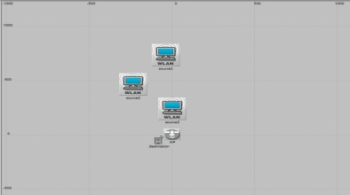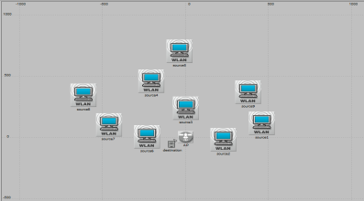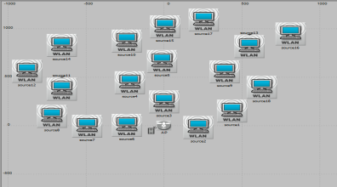

Figure 4. 3, 9 and 18 nodes random topology‎

Table 3. WLAN based 802.11n simulation parameters
Parameters | Values
Randomly distributed area | ‎1000 x 1000 m‎
Buffer size (bits)‎ | ‎1024000‎
Data rate (Mbps)‎ | ‎288‎
packet size (bytes)‎ | ‎2048‎
Standard slot time (µsec)‎ | ‎9‎
Voice type | G.711 (encoder scheme)‎
Video type | ‎30 frame/sec- 352x240 pixel‎
Files information (bytes)‎ | ‎ high load
Transmit power (Watt)‎ | ‎0.1‎
Packets reception power threshold (dbm)‎ | ‎-95‎
RTS Threshold (bytes)‎ | ‎(512/None ) and CTS to-self Option is Enabled
Frame aggregation A-MSDU (bytes)‎ | ‎7935‎
Frame aggregation A-MPDU (bytes)‎ | ‎65535‎
physical characteristics | ‎802.11n , 2.4 GHz‎ with channel BW 20 MHz
Block Acknowledgement capability | Supported
Simulation time (min)‎ | ‎1‎

- IEEE 802.11n WLAN WITH RANDOM TOPOLOGY RESULT ANALYSIS
The performance of the networks with random ‎topology have been investigated in terms of ‎‎(Throughput, Delay, Packets ‎Drops and Retransmissions attempts). The simulation processes are ‎carried out under the network assumptions and simulation set up parameters that have been ‎introduced in Table ‎‎3 and Table (1) previously. Different numbers (1, 2, 3 and 4) of spatial ‎streams ‎are considered in the process of investigating the performance of the IEEE 802.11n ‎WLAN ‎efficiency and as follows: ‎

6.1. Throughput
As a matter of fact and for the different spatial streams 1x1, 2x2, 3x3 and ‎‎4x4 configuration, the ‎average throughput gradually increases as the ‎network is loaded with data. From the Figures (5: a, b, c and d), it ‎can be noted that the maximum throughput value decreases as the ‎numbers of nodes ‎increased from 3 nodes to 18 nodes due to more ‎collision and packets drop when high number of ‎packets are injected to ‎the coordinator. But when QoS is implemented, the throughput is ‎improved ‎and that is obvious specially at high number of nodes and for ‎different antennas configuration; the ‎reason for that is QoS provides ‎priorities to the scheduled services and organizes data flowing. ‎Without and with QoS and for a 1x1 antenna system, the results show ‎that the maximum ‎throughput values that can be acquired are (57.3, 40.8, ‎‎30.5 Mbps) and (61.4, 54.6, 53.7 Mbps) for ‎‎3, 9 and 18 nodes scenarios ‎respectively. So when QoS is applied the improvement values are ‎‎6.9%, ‎‎33.8% and 76% for 3, 9 and 18 nodes scenarios respectively. Although ‎the maximum ‎throughput value is at the lowest (3) node number ‎topology, however the highest improvement is ‎obtained at the highest ‎‎(18) node number topology; the reason for that is the effect of QoS ‎becomes ‎more obvious when congestion with number of hops are ‎increased. So QoS application is required ‎to improve network ‎performance‎.

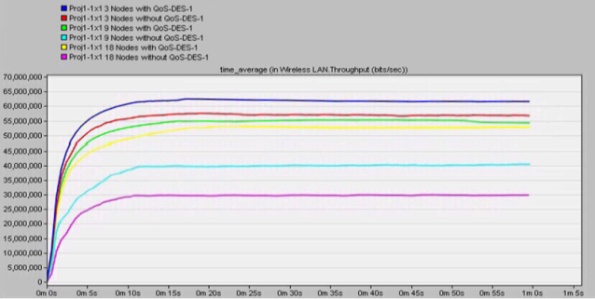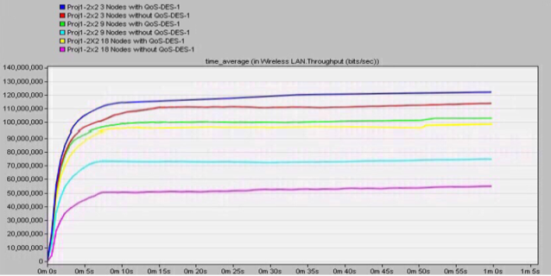
(a) (b)
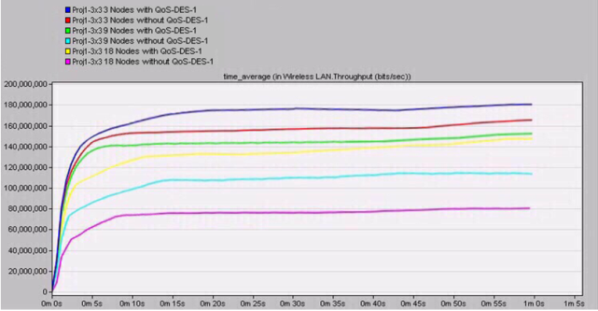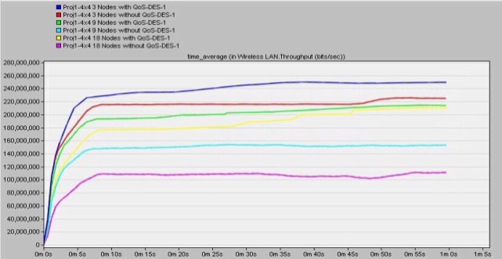
(c) (d)
Figure 5. Shows throughput performance with and without qos application for (a: 1x1, b: 2x2, ‎c: 3x3 and d: 4x4) antenna systems

6.2. Delay
Figures (6: a, b, c and d) show delays for different number of spatial ‎streams also with and ‎without QoS application. Through the increase of ‎the data load (number of nodes) of the network, ‎the delay is increased as ‎well and that leads to more collision and retransmission attempts. This ‎lateness ensures handing of the data when the WLAN is ‎crowded. ‎Without QoS and for 1x1 ‎antenna system the average delay has ‎maximum steady state values of 0.0763, 0.1459 and 0.278 ‎second for 3, ‎‎9 and 18 nodes number scenarios respectively. However when QoS is ‎applied and ‎data is scheduled, the latency improvement (reduction ‎percentage in delay) for high number of ‎nodes module is the best and it ‎has the values of 8.5%, 12.9% and 27.6% for nodes number of 3, 9 ‎and ‎‎18 values respectively, where the maximum delay values are 0.0698, ‎‎0.0127 and 0.201 second ‎respectively as well‎.‎

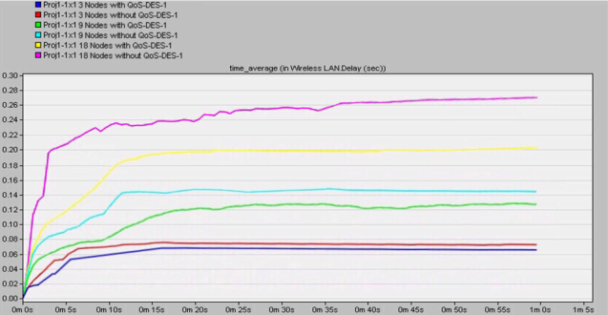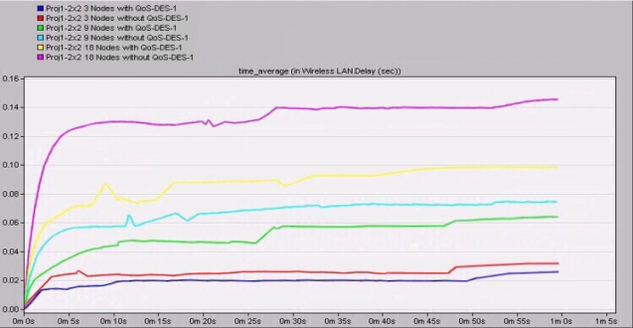
(a) (b)
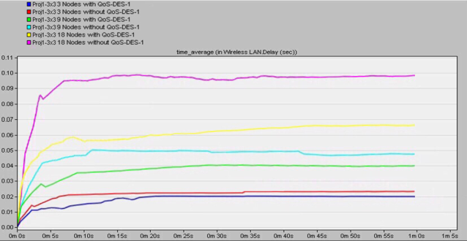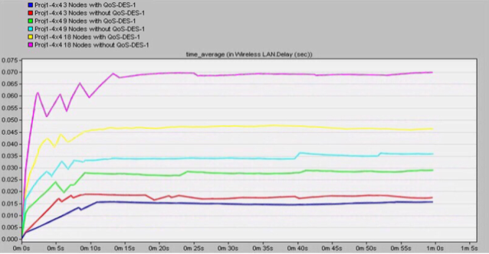
(c) (d)
Figure 6. Shows delay performance with and without qos application for (a: 1x1, b: 2x2, ‎c: 3x3 and d: 4x4) antenna systems

6.3. Data drop
Figures (7: a, b, c and d) ‎illustrate the data packets drop for different number of nodes (3, 9 and ‎‎18) ‎with spatial streams (1, 2, 3 and 4). In general, data packets drop is growing up over time as the ‎network is loaded with data. Figure (7:a) show that the data drop ‎increases as the number of nodes ‎increases and (for 1x1 spatial stream) the ‎maximum average packet drop is (61, 69.8, 78.6) and ‎‎(76.9, 99.7, ‎‎137.4) with and without QoS respectively. The increase in the dropped data packets is ‎due to the collisions which are as well increases as the number nodes are increased, however for ‎the mesh (or random) topology, the ‎collision domain is distributed over all the nodes along the ‎routing paths ‎and the collisions are not concentrated at the coordinator as in uniform (single ‎hope) ‎topology where the network suffering high dropping packets when it is ‎highly loaded.

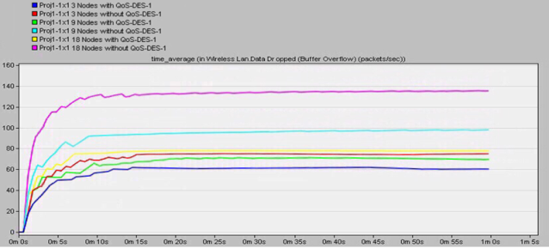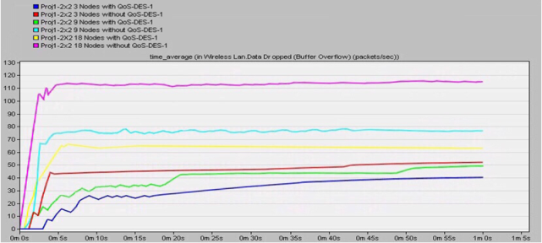
(a) (b)
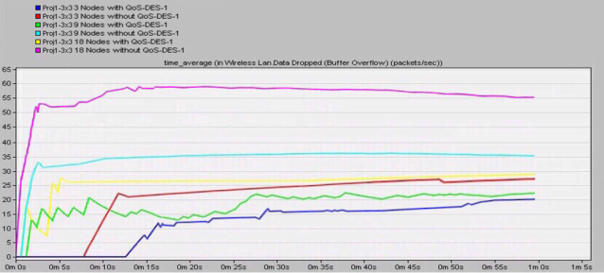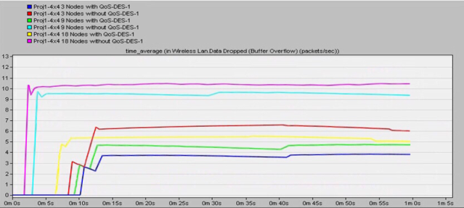
(c) (d)
Figure 7. Shows data drop performance with and without qos application for (a: 1x1, b: 2x2, ‎c: 3x3 and d: 4x4) antenna systems

6.4. Retransmission attempt
Figures (8: a, b, c and d) show the results of the retransmission ‎attempts which are for 18 nodes ‎are fairly more than that for 9 and 3 node ‎topologies due to the load increase of the WLAN, ‎congestion and data packet dropping. Retransmission ‎attempts decreases and data packets drop ‎decreases as the number of spatial streams increases due to‏ ‏channel capacity enhancement. ‎However in comparison with no ‎QoS case, when QoS is considered, the retransmission attempts ‎are ‎increased by the QoS data scheduler to reduce the packets drop chances. For a 4x4 ‎spatial ‎stream with and without QoS application, Figure (8:d) shows that the ‎maximum average ‎retransmission attempt values are (0.495, 2, 3.92) and ‎‎(0.371, 1.47, 2.32) for 3, 9 and 18 number ‎of nodes respectively, where ‎it is clear that the best improvement (highest retransmission attempt ‎i.e. ‎least packet drop) of 68.9% is acquired at 18 node number scenario.‎

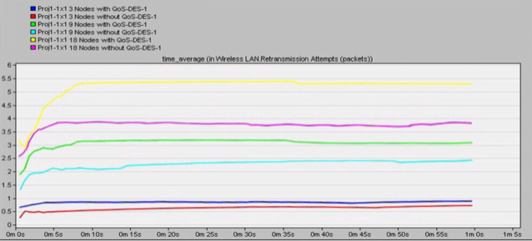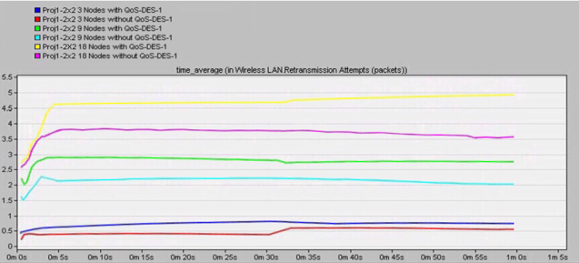
(a) (b)
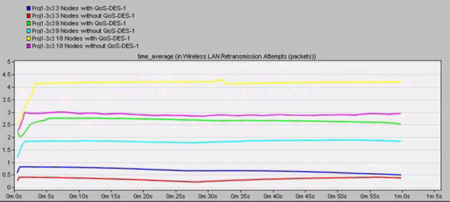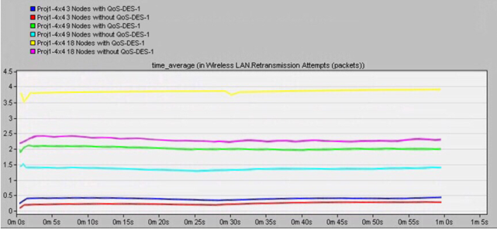
(c) (d)
Figure 8. Shows retransmission attempt performance with and without qos application for (a: 1x1, b: 2x2,‎ c: 3x3 and d: 4x4) antenna systems

The‏ ‏performances of the throughput, delay, packets drops and ‎retransmission attempts with their ‎improvements, when QoS is applied, ‎are summarized in Tables 4, 5, 6 and 7 respectively.‎

Table 4. Summarizing throughput performance ‎
Spatial ‎  Streams | 3 Nodes |  |  | 9 Nodes |  |  | 18 Nodes
Spatial ‎  Streams | Without QoS | With QoS | % Improve | Without QoS | With QoS | % Improve | Without QoS | With QoS | % Improve
1x1 | ‎57.383‎ | ‎61.4‎ | ‎6.9‎ | ‎40.8‎ | ‎54.6‎ | ‎33.8‎ | ‎30.5‎ | ‎53.7‎ | ‎76‎
2x2 | ‎113.4‎ | ‎112‎ | ‎7.5‎ | ‎76.402‎ | ‎102.5‎ | ‎34.1‎ | ‎54.9‎ | ‎99.8‎ | ‎81.7‎
3x3 | ‎166.2‎ | ‎180.9‎ | ‎8.8‎ | ‎113.9‎ | ‎154.7‎ | ‎35.8‎ | ‎80.7‎ | ‎148.1‎ | ‎83.5‎
4x4 | ‎224.9‎ | ‎248‎ | ‎10.2‎ | ‎156‎ | ‎215‎ | ‎37.8‎ | ‎111.04‎ | ‎210.01‎ | ‎86.4‎

Table 5. Summarizing delay performance ‎
Spatial ‎  Streams | 3 Nodes |  |  | 9 Nodes |  |  | 18 Nodes
Spatial ‎  Streams | Without QoS | With QoS | % Improve | Without QoS | With QoS | % Improve | Without QoS | With QoS | % Improve
1x1 | ‎0.07631‎ | ‎0.0698‎ | ‎8.5‎ | ‎0.1459‎ | ‎0.127‎ | ‎12.9‎ | ‎0.2780‎ | ‎0.201‎ | ‎27.6‎
2x2 | ‎0.0320‎ | ‎0.0287‎ | ‎10.5‎ | ‎0.0751‎ | ‎0.064‎ | ‎14.7‎ | ‎0.1434‎ | ‎0.0997‎ | ‎30.4‎
3x3 | ‎0.0231‎ | ‎0.0205‎ | ‎11.2‎ | ‎0.0489‎ | ‎0.0401‎ | ‎17.9‎ | ‎0.981‎ | ‎0.067‎ | ‎31.7‎
4x4 | ‎0.0174‎ | ‎0.0151‎ | ‎13.2‎ | ‎0.0366‎ | ‎0.0298‎ | ‎18.3‎ | ‎0.0709‎ | ‎0.0468‎ | ‎33.9‎

Table 6. Summarizing data drop performance ‎
Spatial ‎  Streams | 3 Nodes |  |  | 9 Nodes |  |  | 18 Nodes
Spatial ‎  Streams | Without QoS | With QoS | % Improve | Without QoS | With QoS | % Improve | Without QoS | With QoS | % Improve
1x1 | 76.985 | 61.093 | 20.6 | 99.78 | 69.8 | 30 | 137.4 | 78.6 | 42.5
2x2 | 51.8 | 40.7 | 21.4 | 77.3 | 49.1 | 36.4 | 116.8 | 63.5 | 45.6
3x3 | 27.895 | 20.4 | 26.8 | 35.817 | 22.401 | 37. | 55.670 | 28.7 | 48.3
4x4 | 6.009 | 3.978 | 33.7 | 9.279 | 4.8 | 48.2 | 10.522 | 5.019 | 52.2

Table 7. Summarizing retransmission attempt performance ‎
Spatial ‎  Streams | 3 Nodes |  |  | 9 Nodes |  |  | 18 Nodes
Spatial ‎  Streams | Without QoS | With QoS | % Improve | Without QoS | With QoS | % Improve | Without QoS | With QoS | % Improve
1x1 | 0.711 | 0.905 | 27.2 | 2.401 | 3.116 | 29.7 | 3.896 | 5.310 | 36.2
2x2 | 0.560 | 0.729 | 30.1 | 2.04 | 2.787 | 33.3 | 3.6 | 4.990 | 38.6
3x3 | 0.406 | 0.534 | 31.5 | 1.821 | 2.534 | 39.1 | 2.99 | 4.252 | 45.5
4x4 | 0.371 | 0.495 | 33.4 | 1.47 | 2 | 42.8 | 2.32 | 3.92 | 68.9

- CONCLUSION
This paper presents an investigation and performance evaluation of the IEEE 802.11n random ‎topology WLAN for multimedia services. The optimal configuration of the standard MAC layer ‎features with the suitable physical layer spatial stream clarified the impact of the standard on the ‎network performance. Although throughput value decreases, the effect of QoS on improving the ‎WLAN network efficiency increases and becomes more obvious as the number of nodes increases. ‎Without and with QoS and for a 4x4 MIMO, simulation results show that the maximum average ‎throughput can be acquired at the lowest node number topology and its values are (224.9, 156, ‎‎111.04 Mbps) and (248, 215, 210.01 Mbps) for 3, 9 and 18 node number topology respectively. ‎The simulation result, which are within the upper bond theoretical results also reflects the ‎efficiency and feasibility of the standard for high load networks specially when services are ‎scheduled through the QoS process according to its EDCA mechanism.‎

REFERENCES
- S. Alabady, et al., “Throughput and Delay Analysis of IEEE ‎‎802.11 DCF in the Presence of Hidden Nodes for Multi-Hop Wireless Networks,” Wireless ‎Personal Communications, Vol. 79, pp. 907-927, 2014.‎
- P. Mahasukhon, et al., “‎‏ ‏Performance ‎Analysis of Multi-hop IEEE 802.11 DCF Backhaul Networks” International Confernce on ‎Wireless and Mobile Computing on Networking and Communications (WiMOB), pp.69-74, ‎‎2008.‎
- A. Maher and Z. Khalaf, “Design and Performance Analysis of Biomedical Wireless Senser ‎Network,” M.Sc. ‎Thesis, Northern Technical University, 2017.‎
- E. Perahia, “IEEE 802.11n Development: History, Process, and Technology,” ‎Communications Magazine, IEEE, Vol. 46, pp. 48-55, 2008.‎
- I. A. Alimi, et al., “ A Hybrid Coding ‎Technique for Efficient Bandwidth Usage in Conformity with IEEE 802.11 WLAN ‎Standard,” International Journal of Electrical and Computer Engineering (IJECE), Vol. 3, ‎pp. 593-602, No. 5, Oct 2013.‎
- Y. Lin and V. W. S. Wong, “WSN01-1: Frame Aggregation and Optimal Frame Size ‎Adaptation for IEEE 802.11n WLANs,” San ‎Francisco, CA, USA, IEEE, 2006.‎
- D. Skordoulis, et al., “IEEE 802.11n ‎MAC frame aggregation mechanisms for ‎next-generation high-throughput WLANs,” IEEE ‎Wireless Communications, Vol. 15, Feb 2008.‎
- A. Z. Younis, “Performance Analysis of IEEE 802.11ac Based WLAN in Wireless ‎Communication Systems,” International Journal of Electrical and Computer Engineering ‎‎(IJECE), Vol. 9, pp. 1131-1136, No. 2, Apr 2019.‎
- Mir M. and Sauman B., “Performance Improvement of IEEE 802.11n WLANs via Frame ‎Aggregation in NS-3,” International Conference on Electrical, and Communication ‎Engineering (ECCE), INSPEC NO. 16851147, Bangladesh, 2017.‎
- B. Abidi, et al., “Wireless Senser Networks in Biomedical: Wireless ‎Body Area Networks,” Europe and MENA Cooperation Advances in Information and ‎Communication Technologies, Vol. 520, pp. 321-329, No. 33, 2017.‎
- D. Lee, et al., “Dynamic Traffic Prioritization and TXOP Allocation in ‎‎802.11e Based Multihop Wireless Networks,” International Journal of Computer Science ‎and Network Security (IJCSNS), Vol. 12, No. 2, Feb 2012.‎
- R. vohra, et al., “WLAN Performance Improvisation by Fine Tuning IEEE 802.11 ‎Parameters,” International Journal of Computer Applications (IJCA), Vol. 43, No. 6, April ‎‎2012.‎
- S. Q. Ameen and F. L. Khaleel, “Wireless Mesh Networks Based on MBPSO Algorithm to ‎Improvement Throughput,” International Journal of Electrical and Computer Engineering ‎‎(IJECE), Vol. 8, pp. 4374-4381, No. 6, Dec 2018.‎
- P. Siripongwutikom, “Throughput Analysis of An IEEE 802.11b Multihop Ad hoc ‎Network,” In TENCON 2006. IEEE Region 10 Conference IEEE, pp.1-4, 2006.‎
- V. A. Siris, et al., “A simple End-to-end Throughput Model for ‎‎802.11Multi-ratio Multi-rate Wireless Mesh Networks,” IEEE Communications Letters, Vol. ‎‎15, pp. 635-637, 2011.‎
- Y. Xiao, “IEEE 802.11n: Enhancements for higher throughput in wireless LANS,” IEEE ‎Wireless Communications, Vol. 12, ‎Dec.2005.‎
- M. I. Youssef, et al., “Performance Enhancement of MIMO-‎OFDM using Redundant Residue Number System, ” International Journal of Electrical and ‎Computer Engineering (IJECE), Vol. 8, pp. 3902-3912, No. 5, Oct 2018.‎
- S. Xu, et al., “Layer-2 Multi-hop IEEE 802.11 Architecture: ‎Design and Performance Analysis,” IEEE Proc.-Communication, Vol. 151, No. 5, Oct ‎‎2004.‎
- L. T. Nguyen, et al., “Performance Analysis of IEEE 802.11 in Multi-‎hop Wireless Networks,” Proc. of the 3rd International Conference on Mobile Ad-hoc and ‎Sensor Networks (MSN), Springer-Verlag Berlin, 2007.‎
- J. A. Mohamed, “Wireless Local Area Network WLAN 802.11,” DIT, Digital Networks, ‎ETU 08102, May 2016.‎

BIOGRAPHIES OF AUTHORS

 | Dr. Ziyad Khalaf Farej is a lecturer and has BSc. in Electronic System Eng. from Cranfield University/UK with honor degree in 1989.MSc. in Spread Spectrum System/FH from Mosul University in 2003. Ph.D. in Computer and Communication Networks (Mesh Network based WIMAX IEEE 802.16 Standard technology) from Mosul University in 2012 with excellent grade.He has been to Salford Greater Manchester University/UK in Research Scholarship for 6 months during his Ph.D. studying period.
 | Mustafa Mohammad Jasim BSc. in Computer Engineering in 2013 from Technical Engineering Collage/ Mosul, now he is a post-graduate student for the master degree in Computer Engineering (Wireless Networks Based on IEEE 802.11n Standard) in Technical College/Mosul.

