Projectile velocity control on coilgun using genetic algorithms

Basuki Winarno¹, Rakhmad Gusta Putra², Indarto Yuwono³, Bambang Sumantri⁴, Agus Indra Gunawan⁵
^{1,2,3} Electrical Engineering- Engineering Department, State Polytechnic of Madiun, Indonesia
^{4,5} Department of Electrical Engineering, Electronics Engineering Polytechnic Institute of Surabaya, Indonesia

Article Info |  | ABSTRACT (10 PT)
Article history:  Received Feb 16, 2019  Revised xxx xx, 201x  Accepted xxx xx, 201x |  | Multistage Coilgun is an electromagnetic coil composed of more than one coil so that can throw a projectile. The velocity of the projectile coming out of the barrel must be controlled. The mechanism can be done by a multistage coilgun design that has a varying number of turns. Each coil that coincides with one another is wrapped separately. To increase the velocity of displacement within the barrel which can be controlled by adjusting the current that works with different variations and the amount in the amount of each coil based on energy requirements. The coils current settings are needed to push and pull the projectile using the Genetic Algorithm method. We built a prototype and tested the multistage coilgun system with the proposed coil variation. The test is carried out 7 times with an average final velocity of the projectile of 29,89 m/s. While the results of the numerical simulation are 32,63 m/s. Testing error compared to simulation is 9,15%.
Keyword:
Projectile
Velocity control
Multistage
Coilgun
Genetic algorithm
Copyright © 2019 Institute of Advanced Engineering and Science.
All rights reserved.
Corresponding Author:
Basuki Winarno,
Electrical Engineering- Engineering Department,
State Polytechnic of Madiun,
84 Serayu Road, Madiun, 63133, Indonesia.
Email: basuki@pnm.ac.id

- INTRODUCTION
Coilgun is an electromagnetic launching system. It can be divided into single-stage and multi-stage based on its coils arrangement. Multistage coil consists of several coils and is superior to a single stage type. Electromagnetic launcher coil gun system with existing multi-stage electromagnetic coils, current injection of each coil is carried out alternately and does not control the motion of projectiles [1][2][3][4]. The projectile transfer rate can be controlled by variation of the coil [5]. Control of the projectile motion inside the barrel, is done by changing the number of turns or number of layers on each coil. The motion of the projectile is affected by the difference magnetic size field in each coil [6][7][8].
The main contribution in this paper is to regulate the rate of displacement of projectiles inside the barrel which can be controlled by adjusting the injection of current that works simultaneously and the variation in the number of turns or number of layers on each coil. Flow injection settings and coil variations based on energy requirements to move projectiles according to predetermined references that form a projectile velocity profile are shown in Figure 1 . Setting injection currents on each stage coil is difficult because the coil works together to push or slow down motion projectile so that it requires a certain method.
The genetic algorithm method is offered to regulate the injection current of each coil simultaneously in order to control the motion of projectiles [9][10][11][12]. The injection current arrangement can use PWM with changes in the duty cycle[13][14]. This is done so that the projectile gets the magnetic force as needed to reach the expected velocity profile[15][16][17]. The results of controlling the motion of these projectiles can be used as a reference for designing a weapon in a combat vehicle because the coilgun projectile is easily made using iron so it does not depend on the factory.

- RESEARCH METHOD

To design a multistage coilgun that can control a projectile, the velocity profile reference must be determined first. While the other parameters specified are the number of stage coils and projectile dimensions. In this study the stage coil arrangement was determined as many as 6 coils with coil forming wires using the AWG # 10 standard with a diameter of 2,58 mm and arranged coincidentally. The projectile is determined by 39 mm length and 5,45 mm diameter. The motion of the projectile along the barrel has a v/s velocity shown in Figure 1. The order of 6 polynomial interpolation method is used to obtain the equation of the velocity profile which is used as an objective function and shown by equation (1)

$$v\left(t\right)=1,5.{10}^{-7}.t^{6}-9.{10}^{-6}.t^{5}+3.{10}^{-4}.t^{4}-2,9.{10}^{-3}.t^{3}+3,04.{10}^{-2}.t^{2}-9,7.{10}^{-2}.t+1$$ | (1)

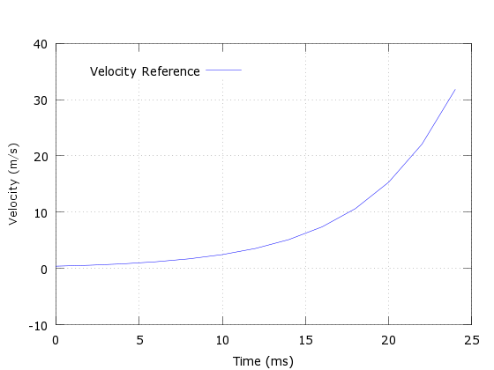
Figure 1. Velocity Profile

- Genetic Algorithms
The objective function used is a velocity profile that follows a geometric sequence. A projectile to move along the velocity profile, all coils must be simultaneously injected. To find the sequence of duty cycles that produce the best velocity close to the reference, the Linear Rank Selection (LRS) method is used. To get better results, the selection with the best duty cycle are encoded into binner numbers which are then carried out uniformly in the crossover process so that the variation of the new duty cycle is obtained. The mutation process is then carried out to obtain the next generation and form a new population duty cycle. This process continues until a minimum error.

- Procedure of GA
Genetic Algorithms applied by limiting a number of generations of 200 in a period. The Process of Genetic Algorithms takes place from the 1st to the 12th period which each generation produces a duty cycle value. Setting injection currents by changing the duty cyle encoded in a binary number 6x8 bits, so that each coil is encoded 8 bits. Changes in duty cyle are carried out by trial and error 50 times and collected in a population. Each change in duty cycle is used as input for calculating projectile velocity. The results of velocity calculations are compared with the velocity profile used as a reference and produce a certain error value. This process continues until a minimum error is reached with a maximum limit of 200 generations The flow chart of the Genetic Algorithms method can be seen in Figure 2

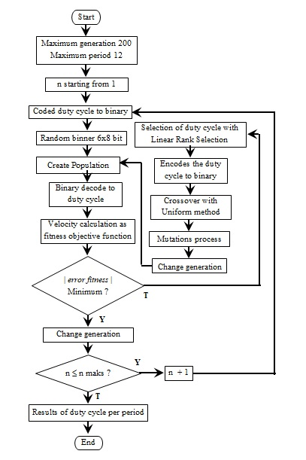
Figure 2. Folwchart Genetic Algorithm

- Current Settings
The current used for injection into the coil has a time range between 0 to maximum current (I_{max}), while the maximum current is limited by conductivity conductor. The current injection time range is divided into 10 time steps. Each time step is divided into 10 time interstep. Current injection is every period of 2 ms and requires a total injection time of 24 ms. Calculation of current injecting uses equation (2)

$$I=I_{max}.(1-e^{-t/τ})$$ | (2)

While the calculation of current injecting is stopped using equation (3)

$$I=I_{max}.e^{-t/τ}$$ | (3)

- RESULTS AND ANALYSIS

The distance profile is obtained by integrating equation (4) as a function of time.

$$x\left(t\right)=\int{v\left(t\right).dt}$$ | (4)
The farthest distance traveled for 24 ms is x (24) = 160.17 mm. Projectile mileage is used as the basis for determining the sixth coil length. As each coil is determined to have the same length so calculation the length and number of turns of each coil.

$$Length coil=\frac{160,17}{6}=26,695 mm$$

$$Turn per layer=\frac{26,695}{2,588}=10,315≈11$$

As the number of turns per coil are 11 turns, while the distance between coils coincides (zero), so the length of the coil

$$Length coil=11 x 2,588=28,468 mm$$

The motion of the projectile as far as x requires the force at each point that forms a force profile by inferring the velocity profile and calculating the projectile mass according to equation (5)

$$F\left(t\right)=m.a(t)$$  $$F\left(t\right)=m.\frac{dv}{dt}$$ | (5)

The acceleration experienced by projectiles at 24 ms is m/s². The projectiles used are cylindrical made of ferromagnetic material with a density of 7800 kg/m3. Calculation of projectile volume and mass :

$$V_{p}=l.π.{r_{p}}^{2}$$
$$=9,039. {10}^{-7}m^{3}$$
$$m=ρ.V_{p}$$
$$=0,07093 kg$$

Force profiles that affect projectile motion are force profiles based on velocity profiles and friction, while friction occurs due to the gravitational force in each position. Friction calculation using equation (6)

$$F_{friction}=m.g.\sin{ϑ}+m.g.\cos{ϑ}. coefficient of friction$$ | (6)

The force profile required to move the coil is the sum of the reference force profile and friction. The sum of the style profiles is used as input for the calculation of magnetic flux that must be generated by the six coils. To simplify the calculation, the distance is divided into 6 areas :
- Area 1 is the stationary position to the center of the coil 1
- Area 2 is the middle of coil 1 to center coil 2
- Area 3 is the middle of coil 2 to the middle of coil 3
- Area 4 is the center of coil 3 to the center of coil 4
- Area 5 is the center of coil 4 to the center of coil 5
- Area 6 is the center of coil 5 to center of coil 6
Each area is used for calculating the maximum energy required. Maximum energy calculation in each area based on style as shown in Figure 3 a function of distance using equation (7)

$$E=\int{F\left(x\right).dx}$$ | (7)

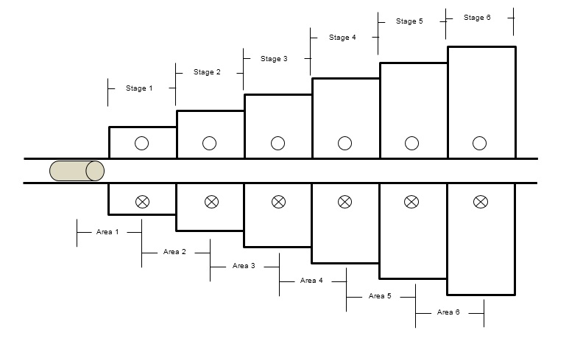

Figure 3. Coil Area

The coil design specifications are shown in Table 1.

Table 1. Specification Coils.
Specification | Coil 1 | Coil 2 | Coil 3 | Coil 4 | Coil 5 | Coil 6
Turn per Layer | 13 | 26 | 37 | 39 | 51 | 56
Layer | 28.47 | 28.47 | 28.47 | 28.47 | 28.47 | 28.47
Wire Length (mm) | 16.41 | 63.04 | 126.10 | 132.90 | 237.63 | 285.96
Energy Max (J) | 0.075 | 0.27 | 0.58 | 1.07 | 1.73 | 2.72
Current Max (A) | 330 | 385 | 990 | 1100 | 1100 | 1100
Voltage Max (V) | 11 | 44 | 247 | 504 | 802 | 1244

The energy calculation is used to determine the number of layers that will be used in the six coils. Calculation of the number of layers in each coil is done by iteration given the interrelationship between the coil parameters, while the current used in the iteration may not exceed the allowable conductor rating current. Iterating process using octave software using Equation (8)

$$I_{max}=\sqrt{\frac{2.E.{D_{k}}^{2}}{μ_{0}.A.n^{2}}}$$ | (8)

While the wire length is calculated using equation (9)

$$P_{kn}=π.T_{PL}.(n.D_{L1}+\left(n^{2}-n\right).D_{k})$$ | (9)

P_{kn} is the length of the wire, T_{PL} is the number of turns per layer, n is the number of layers, D_{L1} is the winding diameter in layer 1, A is the cross-sectional area of the wire and D_{k} is the diameter of the wire used to form the coil. The Genetic Algorithm method is used to regulate 6 current injection duty cycles according to the velocity profile requirements. The iteration of duty cycle results is shown in Table 2.

Table 2. Iteration of Duty Cycle
Period | Coil 1 | Coil 2 | Coil 3 | Coil 4 | Coil 5 | Coil 6
1 | 31.37 | 43.92 | 66.27 | 81.57 | 81.96 | 75.68
2 | 18.43 | 28.23 | 16.08 | 48.63 | 19.21 | 66.62
3 | 26.25 | 84.18 | 9.41 | 17.60 | 57.64 | 81.97
4 | 71.76 | 3.53 | 82.74 | 89.08 | 85.58 | 37.17
5 | 17.25 | 53.55 | 95.56 | 78.33 | 93.72 | 96.08
6 | 89.29 | 61.51 | 99.12 | 97.54 | 90.58 | 84.34
7 | 23.52 | 34.98 | 87.84 | 85.88 | 99.78 | 84.70
8 | 30.68 | 12.15 | 95.47 | 99.28 | 82.16 | 90.98
9 | 63.92 | 98.12 | 96.71 | 70.21 | 83.52 | 92.50
10 | 62.84 | 94.18 | 92.78 | 67.41 | 84.41 | 92.94
11 | 73.33 | 90.57 | 90.66 | 90.95 | 88.25 | 94.56
12 | 27.34 | 19.21 | 1.96 | 11.20 | 10.46 | 64.47

The results of the duty cycle settings for the voltage and current for coil 1 in period 1 to 12 are shown in Figure 4-9.

Figure 4. Voltage and Current coil 1

Figure 5. Voltage and Current coil 2
Figure 6. Voltage and Current coil 3

Figure 7. Voltage and Current coil 4
Figure 8. Voltage and Current coil 5

Figure 9. Voltage and Current coil 6

Deviation occurs in each injection period, this is due to a non-continuous injection system, ie PWM injection. Whereas the velocity profile produced from the simulation is shown in Figure 10.
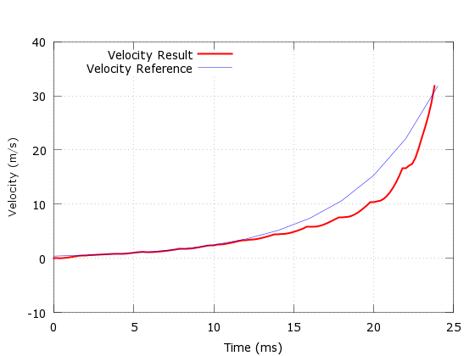
Figure 10. Velocity Result

The coil and barrel coil used for testing is shown in Figure 11. The test is carried out by assembling all the coils and connecting with the voltage generator.

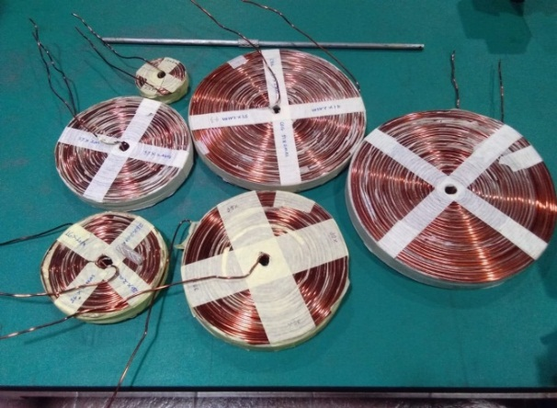
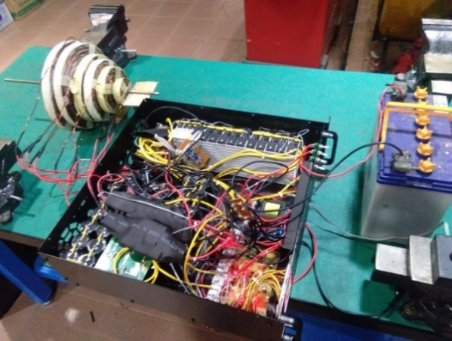

Figure 11. Coilgun Test

Velocity measurement is done by placing 2 infrared sensors at the end of the barrel. Sensor placement by giving 2 holes on the barrel as far as 100mm. Hole 1 is marked with T1 and hole 2 is marked with T2 to measure the time it takes for the projectile to move from T1 to T2. Projectile velocity is calculated based on the difference in time shown on the two sensors. The results of velocity measurements are shown in Table 3.

Table 3. Velocity Measurements
Period | T₁ – T₂ (mm) | Measurements Result
 |  | Distance (mm) | Velodity (m/s)
1 | 3.29 | 100 | 30.40
2 | 3.46 | 100 | 28.90
3 | 3.06 | 100 | 32.68
4 | 3.76 | 100 | 26.60
5 | 3.31 | 100 | 30.21
6 | 3.47 | 100 | 28.20
7 | 3.16 | 100 | 31.65

- CONCLUSION
We propose the Genetic Algorithm method to control the motion of projectiles on multi-stage gun coil systems a velocity that can be adjusted as desired. To improve the efficiency of the coil system optimally designed with coil variation construction according to energy requirements. Because the coil works together, the injection flow must be adjusted as needed. Flow injection settings are carried out using PWM by adjusting variations in the duty cycle. The simulation that has been done shows that there is a match between the reference velocity profile and the design velocity profile. We built a prototype and tested a multistage coilgun system with the proposed coil variation. The test is carried out 7 times with an average final velocity of the projectile of 29.89 m / s. While the results of the numerical simulation are 32.63 m / s. The test error compared to the simulation is 9.15%. This high level of error occurs because of the coil density in each coil which affects changes in the magnetic field and thermal energy of the coil. We hope to conduct additional studies to improve energy efficiency and reduce errors.

ACKNOWLEDGEMENTS
The author would like to thank the State Polytechnic of Madiun and Electronics Engineering Polytechnic Institute of Surabaya for facilitating infrastructure and the Ministry Of Research, Technology And Higher Education, Ristekdikti for financial support to this research.

REFERENCES
[1] S. J. Lee, J. H. Kim, B. S. Song, and J. H. Kim, “Coil gun electromagnetic launcher (EML) system with multi-stage electromagnetic coils,” Journal of Magnetics, vol. 18, no. 4, pp. 481–486, 2013.
[2] T. Zhang, W. Guo, W. Fan, H. hai Zhang, Y. Liu, and Z. zhou Su, “An efficiency-improved method of multi-stage induction coilgun based on magnetic field arrangement,” Defence Technology, pp. 6–13, 2018.
[3] S. Lee, J. H. Kim, and S. Kim, “Design and experiments of multi-stage coil gun system,” JOURNAL OF VIBROENGINEERING, vol. 18, no. 4, pp. 2053–2060, 2016.
[4] T. Sandhya, K. S. Chandan, and P. M. Rao, “Modelling and Critical Analysis of a Two Stage Tubular Coil Launcher,” vol. 1, no. 2, pp. 17–24, 2015.
[5] J. Y. J. ; Y. J. H. ; S. L. ; Y. S. Choi, “Optimal Design and Multicoils Quench Analysis of the EMPS Superconducting Magnet Employing Hybrid Genetic Algorithm,” IEEE Transactions on Applied Superconductivity, vol. 28, no. 3, 2018.
[6] J. Nett and L. Gernandt, “Inductive Acceleration of Moving Projectiles and Synchronization between the Driving Field and the Projectile Motion,” IEEE Transactions on Magnetics, 1995.
[7] M. S. Nathi Ram Chauhan, Deeksha Singh, Aditi Monga, Shivangi Sharma, Shreya Devgun, “Mathematical Modelling of Electromagnetic Induction Coil gun for Non-Lethal Self Defence Applications,” Journal of Experimental & Applied Mechanics, vol. 9, no. 2, 2018.
[8] O. A. M. Tamer M. Abdo, Ahmed L. Elrefai, Amr A. Adly, “Performance analysis of coil-gun electromagnetic launcher using a finite element coupled model,” in Eighteenth International Middle East Power Systems Conference, 2016.
[9] W. J. Wang, Y. Luo, R. Yan, and Shafei, “Genetic Algorithm-Based Shape Optimization of Modulating Anode for Magnetron Injection Gun With Low Velocity Spread,” IEEE Transactions on Electron Devices, vol. 62, no. 8, pp. 2657–2662, 2015.
[10] M. Jebari, K., & Madiafi, “Selection methods for genetic algorithms,” Int J Emerg Sci, vol. 3, no. 4, pp. 333–344, 2013.
[11] G. X. Gong, Xiaobo Niu, Kaipei Liu, Yadong Zhang and Yujia, “Multiobjective Optimization of Multistage Synchronous Induction Coilgun Based on NSGA-II,” IEEE Transactions on Plasma Science, vol. 45, no. 7, pp. 1622–1628, 2017.
[12] S. K. Das and N. K. Rout, “A new technique using GA style and LMS for structure adaptation,” International Journal of Engineering and Technology, vol. 5, no. 3, pp. 2272–2276, 2013.
[13] T.Sudhakar Babua, K.Priyaa, D.Maheswaranb, K. S. Kumara, and N.Rajasekar, “Selective voltage harmonic elimination in PWM inverter using bacterial foraging algorithm,” Swarm and Evolutionary Computation, vol. 20, pp. 74–81, 2015.
[14] X. Wang, Y. W. Li, F. Blaabjerg, and P. C. Loh, “Virtual-Impedance-Based Control for Voltage-Source and Current-Source Converters,” IEEE Transactions on Power Electronics, vol. 30, no. 12, pp. 7019–7037, 2015.
[15] M. B. P. Bernardes, M. Mergl, and V. Augusto, “Coilgun Velocity Optimization With Current Switch,” IEEE Transactions on Plasma Science, vol. 45, no. 6, pp. 1015–1019, 2017.
[16] X. Tao, S. Wang, Y. Huangfu, S. Wang, and Y. Wang, “Geometry and Power Optimization of Coilgun Based on Adaptive Genetic Algorithms,” IEEE Transactions on Plasma Science, vol. 43, no. 5, pp. 1208–1214, 2015.
[17] E. Owlia, S. A. Mirjalili, and M. Shahnazari, “Design and modeling of an electromagnetic launcher for weft insertion system,” Textile Research Journal, no. February, 2018.

BIOGRAPHIES OF AUTHORS

Basuki Winarno received MT degree in Electric Engineering from ‎Brawijaya University, Malang, Indonesia, in 2016. Now he lecturers at State Polytechnic of Madiun. His current research interests include control and electrical.

Rakhmad Gusta Putra received MT degree in Electric Engineering from ‎Institute of Technology of Sepuluh Nopember (ITS), Surabaya, Indonesia, in 2013. Now he lecturers at State Polytechnic of Madiun. His current research interests include Robotics Electronics

Indarto Yuwono received MT degree in Electric Engineering from ‎Institute of Technology of Sepuluh Nopember (ITS), Surabaya, Indonesia, in 2016. Now he lecturers at State Polytechnic of Madiun. His current research interests include Energy Conversion Engineering

Bambang Sumantri received Dr.Eng. from Toyohashi University of Technology, Japan, in 2015. Now he lecturers at Electronics Engineering Polytechnic Institute of Surabaya. His current research interests include Control System, Robotics and Industrial Electronics

Agus Indra Gunawan received Dr.Eng. from Toyohashi University of Technology, Japan, in 2015. Now he lecturers at Electronics Engineering Polytechnic Institute of Surabaya. His current research interests include non destructive measurement, ultrasonic, biomedical, energy and aquaculture engineering

