PID Controller Using Rapid Control Prototyping Techniques

Odair A. Trujillo*, Nicolás Toro*, Fredy E. Hoyos**,
* Universidad Nacional de Colombia - Sede Manizales, Department of Electrical and Electronics Engineering & Computer Sciences, Manizales, Colombia. Correo-e: haldrik@gmail.com, ntoroga@unal.edu.co
** Universidad Nacional de Colombia - Sede Medellín - Facultad de Ciencias - Escuela de Física, Calle 59 A No 63-20, Medellín, Colombia. Email: fehoyosve@unal.edu.co

Article Info |  | ABSTRACT
Article history:  Received Jun 12th, 2018  Revised Aug 20th, 201x  Accepted Aug 26th, 201x |  | To analyze the performance of the PID controller in a buck type converter implemented in real time, the start of design will be the continuous controller using the analytical method for calculating PIDs. PWM is then used and from this point you will find the bifurcation diagrams analytically and it will show some problems of switching and sampling time. Then the model of the converter is used and implements PID controller [1] in a dSPACE. In the experimental case it shows in more detail the requirements of sampling frequency and switching speed. Finally it shows the performance of PID controller.
Keyword:
Rapid control prototyping
PID hardware
Numerical bifurcation
PID hardware
PID software
DC-DC converters
Copyright © 201x Institute of Advanced Engineering and Science.
All rights reserved.
Corresponding Author:
Fredy E. Hoyos
Facultad de Ciencias - Escuela de Física
Universidad Nacional de Colombia - Sede Medellín
Calle 59 A No 63-20, Medellín, Colombia.
Email: fehoyosve@unal.edu.co

- INTRODUCTION
You could say that the buck converter is a switching power supply with two semiconductor devices, transistor ($Q$) and diode ($D$), an inductor ($L$), an output capacitor ($C$) and its respective load, as shown in Figure 1. This system usually converts an unregulated DC voltage to another regulated lower voltage. The transistor switches the input power $E$ by pulse width modulation PWM to feed the filter $LC$, the diode conducts when the transistor is off if there is positive current in the coil, the inductor does not allows rapid changes in current and the capacitor does not support abrupt changes of voltage creating between them a low pass filter. This process gives an average voltage lower than the input. The device used for switch is a MOSFET. Thus, the control technique must determine the switch’s time "ON" and "OFF", this control form where the input of the system switches between two values is known as pulse width modulation (PWM) [2], [3], [4], [5], [6].

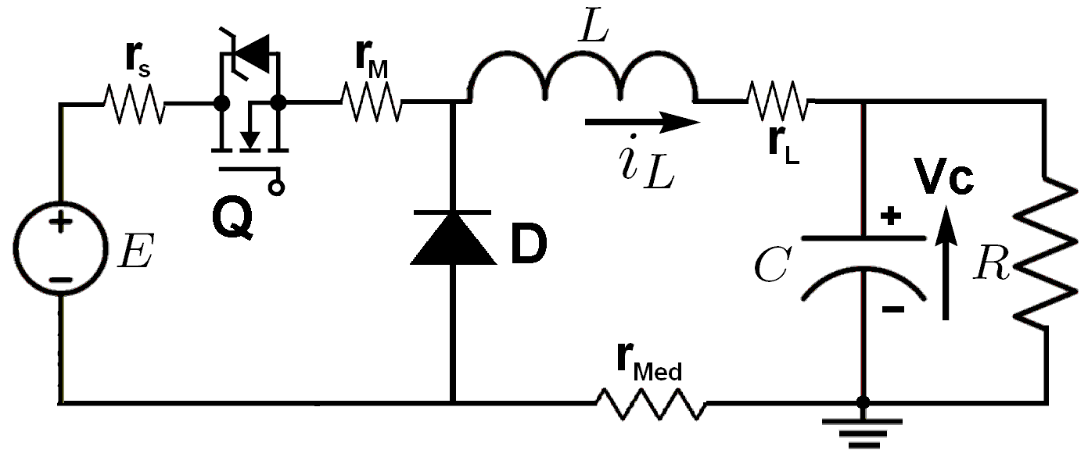
Figure 1. Buck converter model

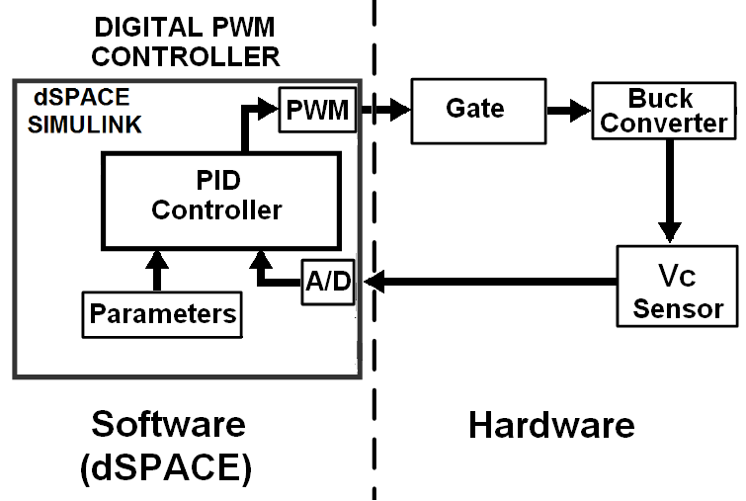
Figure 2. Block diagram of the proposed system

Figure 2 shows a block diagram of the system under study. This system is divided into two major subgroups, the hardware that includes the physical and electronic components and the software implemented on a dSPACE which performs the signal acquisition and implementation of PID control technique. The hardware consists of: a sensor measuring $V_{C}$ state variable (capacitor voltage) this are high impedance resistors connected in parallel. The converter’s switch is handled from the control and development card through the PWM, the pulse is opto-isolated through fast optocouplers. The digital part is developed in the control and development card dSPACE DS1104, where the the PID control technique is implemented. This card is programmed with Matlab/Simulink$®$ platform and has a display interface called ControlDesk. The controller is implemented in Simulink$®$ and downloaded to the DSP to operate at a given frequency. The state variable comes to the controller through the input ADC 12bits, with a sampling rate set for te experiment at 10 kHz and then 30 kHz. The controller parameters are set through variable gain blocks because they were tuned in real time. At each sampling period the controller calculates the duty cycle in real time and its equivalent in PWM control switch.

This article is intended for digital PWM approach, which presents rich nonlinear dynamics and has the following advantages: immunity to analog component variations, faster process design, low sensitivity to changes in parameters, programmable, it allows reduction or elimination of passive external components, calibration of protection algorithms, and support digital systems interface for implement nonlinear control techniques, [7], [8], [9], [10], [11], [12]. But the DPWM also has disadvantages, it is affected by two limitations: quantization effects [8], [9], and delays in the control loop [13], [14].

- BUCK CONVERTER MODEL

$$E=(r_{int}+r_{L})i_{L}+L{\dot{i}}_{L}+V_{C}$$
Where $r_{int}$ is the internal resistance of the mosfet ($r_{ _{M}}$) plus the resistance source ($r_{s}$) and the resistance coil ($r_{L}$) plus the shunt resistor’s resistance used for the current mesure ($r_{ _{Med}}$) as shown in the Figure 1. By summation of currents in the capacitor’s node, it gives:
$$C{\dot{V}}_{C}=i_{L}-\frac{V_{C}}{R}$$
Solving and simplifying, it gives:

$${\dot{i}}_{L}=-\frac{r_{in}+r_{L}}{L}i_{L}-\frac{1}{L}V_{C}+\frac{E}{L}$$

$${\dot{V}}_{C}=\frac{1}{C}i_{L}-\frac{1}{RC}V_{C}$$
Converting to matrix form, it gives:

$${\dot{i}}_{L}=-\frac{r_{in}+r_{L}}{L}i_{L}-\frac{1}{L}V_{C}+\frac{E}{L}$$

${\dot{V}}_{C}=\frac{1}{C}i_{L}-\frac{1}{RC}V_{C}$
Converting to matrix form, it gives:

$$\left[\begin{matrix}{\dot{i}}_{L} \\ {\dot{V}}_{C}\end{matrix}\right]=\left[\begin{matrix}-\frac{r_{int}+r_{L}}{L} & -\frac{1}{L} \\ \frac{1}{C} & -\frac{1}{RC}\end{matrix}\right]\left[\begin{matrix}i_{L} \\ V_{C}\end{matrix}\right]+\left[\begin{matrix}\frac{E}{L} \\ 0\end{matrix}\right]$$

$$y=\left[\begin{matrix}0 & 1\end{matrix}\right]\left[\begin{matrix}i_{L} \\ V_{C}\end{matrix}\right]$$

Converting to state variables and making $a=\frac{r_{int}+r_{L}}{L}$, $b=\frac{1}{L}$, $c=\frac{1}{C}$, $d=\frac{1}{RC}$ and maintaining sings, it gives:

$$\left[\begin{matrix}{\dot{X}}_{1} \\ {\dot{X}}_{2}\end{matrix}\right]=\left[\begin{matrix}-a & -b \\ c & -d\end{matrix}\right]\left[\begin{matrix}X_{1} \\ X_{2}\end{matrix}\right]+\left[\begin{matrix}\frac{E}{L} \\ 0\end{matrix}\right]$$

$y=\left[\begin{matrix}0 & 1\end{matrix}\right]\left[\begin{matrix}X_{1} \\ X_{2}\end{matrix}\right]$ (1)

If the switch stays off, $u=0$ the equation would be: $\dot{X}=AX$, because it doesn’t take into account the diode’s voltage.

In the case where the switch is closed you can find the transfer function using:
$$G(s)=\frac{Y(s)}{U(s)}=C(SI-A)^{-1}B$$
It, gives:
$G(s)=\frac{\frac{c}{L}E}{s^{2}+(a+d)s+(ad+bc)}$ (2)
Remember $c=\frac{1}{C}$

In the equation 2 the following values will be replaced to find the system’s response:
$E=40V$, $C=46.27µF$
$R=39.3Ω$, $r_{int}=0.688Ω$
$L=2.47mH$, $r_{L}=1.345Ω$

$G(s)=\frac{8.739e06}{s^{2}+1372s+9.192e06}$ (3)

Number 3 equation’s poles are:
$-681±j2953$
The root locus is shown in Figure 3
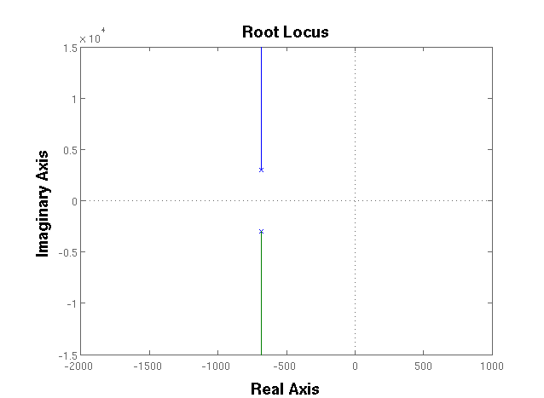
Figure 3: Root Locus

Therefore the system is stable with the values used for constants and it is underdamped. The response to step E volts can be seen in the figure 4, where we see that in fact the system is underdamped, it has an overshoot that is necessary to reduce and has a steady-state error of about 2 volts. In low power buck converters such as computers sources, it is usual to find a zener diode and transistor based regulation on converter output. This technique has the advantage of avoiding the use of control but in turn the disadvantage that increases the probability of failure on points where it handles the power output. To get the desired voltage with proper mosfet handling without adding elements that may fail in the converter output is the goal of implementing a controller.

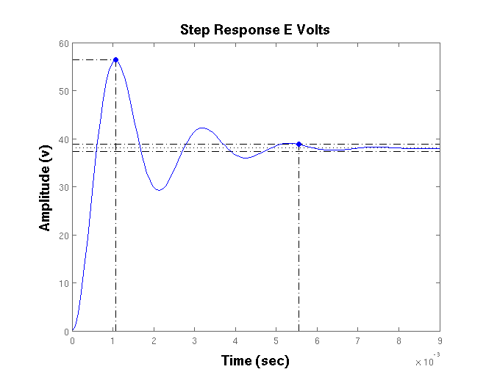
Figure 4: Step Response

The system consists an omnidirectional microphone, 2 photoresistors, 4 DC motors, lithium battery ($V_{CC}$) and electrical and electronic circuits; forming a circuit of two stages as shown in Figure 1.

- CONTINUOUS PID CONTROLLER

The used method is known as the analytical method, which start from a desired behavior, determined by the second order canonical equation, which should match to the characteristic equation of the closed loop system with PID to find the constant Kp, Kd, Ki.

3.1. Desired response
$ts=2.5ms$, $Mp=10\%=0.1$
$ζ=\sqrt{\frac{ln(Mp)^{2}}{π^{2}+ln(Mp)^{2}}}=\sqrt{\frac{ln(0.1)^{2}}{π^{2}+ln(0.1)^{2}}}=0.591$

$σ=\frac{4}{ts}=\frac{4}{2.5ms}=1600$

$σ=ζ.ω_{n}⇒ω_{n}=\frac{1600}{0.591}=2707.27$
Second order canonical equation (desired behavior):
$\frac{ω_{n}^{2}}{s^{2}+2.ζ.ω_{n}+ω_{n}^{2}}$

$\frac{2707^{2}}{s^{2}+3200.s+2707^{2}}$
Poles on:
$-1.600±j2.183$

3.1. Closed loop with unknown PID constants

Replacing the parameters in the transfer function and making a change of variables $m=8739229$, $n=1372$, $p=9191377$, you must close the loop with unknown PID.

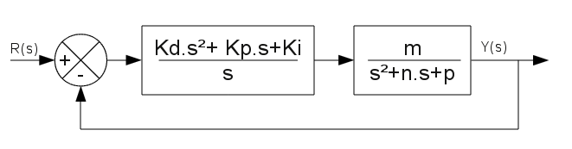
Figure 5: Block Diagram

This gives the transfer function with the unknowns constants of PID:

$Glc(s)=\frac{mKds^{2}+mKps+mKi}{s^{3}+(n+mKd)s^{2}+(p+mKp)s+mKi}$
But before matching the characteristic equations you must increase the degree of the second order characteristic equation in order to be able to match them, this is done by adding a remnant pole to the characteristic equation so as not affect the desired behavior, in this case 5 times away from the dominant poles, this modification usually affects the amplitude but the behavior of canonical system is preserved.

$(s+8000)(s^{2}+3200s+2707^{2})$
Thus it is possible to do the coefficients matching:
$(n+mKd)=11200⇒Kd=0.0011245$

$(p+mKp)=32929310⇒Kp=2.7162$

$(mKi=5)=863448e10⇒Ki=6709$
Replacing these constants in the closed loop transfer function, then the simulation is performed with a step value of E volts.
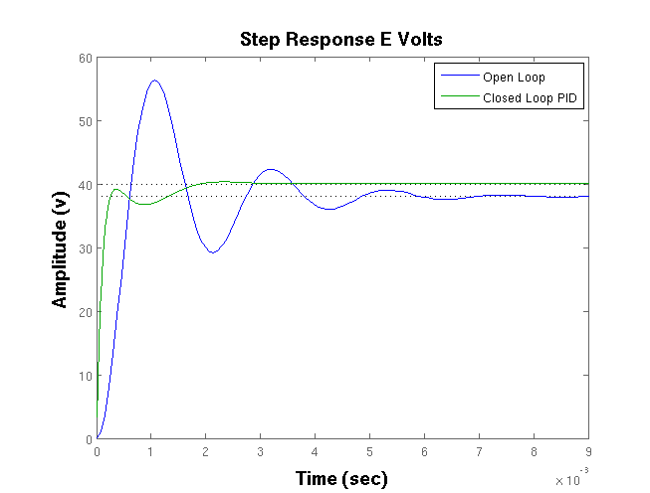
Figure 6: Comparison Open Loop and Closed Loop with PID

In Figure 6 you can see that the controlled system does not reach the desired overshoot but its normal to tune a little, it is advisable to do it when the controller is already modulated by the PWM and so avoid double tuning. The settling time and the steady-state error are the desired.

- DISCRETE TIME SYSTEM

For a continuous time system the general solution is given by:
$X(t)=e^{A(t-t_{o})}X(0)+\int_{t_{o}}^{t}{‍}e^{A(t-τ)}Bu(τ) dτ$
Therefore the solution in discrete time form is given by:
$X(k+1)T=e^{AT}X(kT)+\int_{0}^{T}{‍}e^{A(T-τ)}Bu(kT) dτ$ (4)
The solution of equation 4 is obtained as:
$X(k+1)T=e^{AT}X(kT)+(e^{AT}-I)A^{-1}Bu(kT)$
Making $Ad=e^{AT}$ y $Bd=(e^{AT}-I)A^{-1}B$, the solution can be presented as:
$Ad.X(kT)+Bd.u(kT)$ (5)

Then, the solution of $e^{AT}$ is:
$L^{-1}(SI-A)^{-1}=\left(\begin{matrix}\frac{s+d}{s^{2}+(a+d)s+(ad+bc)} & -\frac{b}{s^{2}+(a+d)s+(ad+bc)} \\ \frac{c}{s^{2}+(a+d)s+(ad+bc)} & \frac{s+a}{s^{2}+(a+d)s+(ad+bc)}\end{matrix}\right)$ (6)

From the equation 6 applying the Laplace’s anti-transformation we obtain the matrix $e^{AT}$:

$e^{AT}=\left(\begin{matrix}Term2+dTerm1 & -bTerm1 \\ cTerm1 & Term2+aTerm1\end{matrix}\right)$ (7)

Where:
$Term1=\frac{e^{-ζω_{n}t}sen(ω_{d}t)}{ω_{d}}$

$Term2=-\frac{e^{-ζω_{n}t}sen(ω_{d}t)-ϕ}{\sqrt{1-ζ^{2}}}$
and:
$ω_{d}=ω_{n}\sqrt{1-ζ^{2}}$

$ϕ=tan^{-1}\frac{\sqrt{1-ζ^{2}}}{ζ}$
At this point you can probe that $e^{AT}$ evaluated at $t=0$ is equal to the identity matrix.
Knowing $e^{AT}$ an algorithm was implemented in Matlab$®$ to produce the discrete equivalent shown in figure 7.
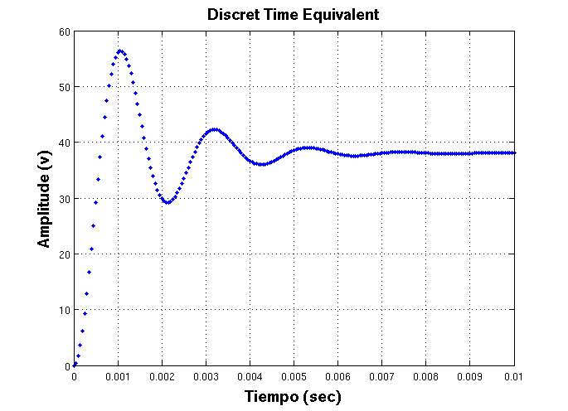
Figure 7: Discrete Time Equivalent

The continuous time system has a $Ts=5.9ms$ so we can choose a sampling rate $T=50μseg$. Initializing the necessary variables, you get the output shown in Figure 7. So you can see how the discrete equivalent is very close to the real equivalent.

- PID MODULATED BY PWM
The found constants will be used in this controller. Initializing variables and respective vectors to zero the output ($V_{C}$) (Load Voltage) shown in Figure 8.

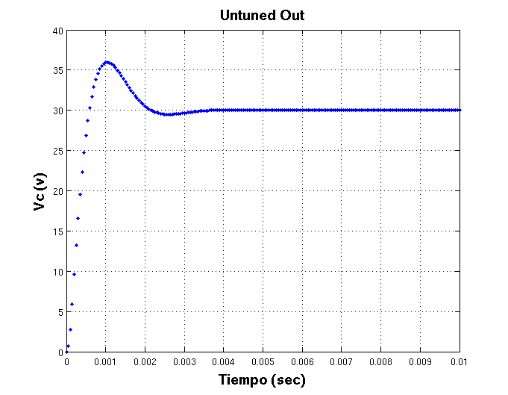
Figure 8: PID with PWM

We see then that the overshoot appears even higher than previously estimated, to reduce the overshoot you can follow the table 1 taken from [9], showing a online tuning form of PID, depending the output characteristics required by the user.

Table 1: Effects of Independent P, I and D tuning

PID | Rise Time | Overshoot | Settling Time | Steady Stage Error | Stability
$⇑$Kp | Decrease | Increase | Small Increase | Decrease | Degrade
$⇑$Ki | Small Decrease | Increase | Increase | Large Decrease | Degrade
$⇑$Kd | Small Decrease | Decrease | Decrease | Minor Change | Improve

The use of this table is valid as long as the constants to tune are calculated with a known method. Therefore from the values that we have calculated, we reduce $Ki=2400$ with which we get an overshoot close to zero as shown in Figure 9, which is very convenient for such converters.

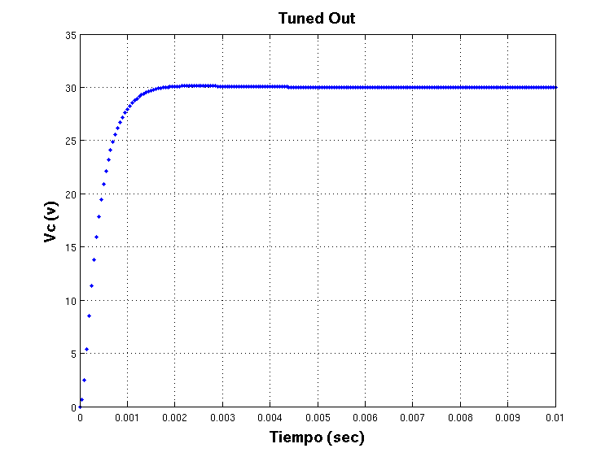
Figure 9: Tuned output ($V_{C}$) using Table 1

- BIFURCATION DIAGRAMS

The bifurcation diagrams are defined as qualitative and quantitative variations of the system’s dynamic in front of the variation of parameters, this can influence the stability of system and the characteristics at the output among other.
The bifurcation diagram is a tool for dynamic system analyzing and provides information on the stable operation limits of a dynamic system. For this system only the constant Kp has to be varied, since this affects the others.
This required the industrial form of PID.
$PID=kp(1+\frac{τ_{i}}{s}+τ_{d}s)$
6.1. $V_{C}$ and $D$ Bifurcation Diagrams With Kp Variations

Figures 10 and 11, show that the operating range of Kp has an upper limit of 19 units apx, before the system becomes chaotic.
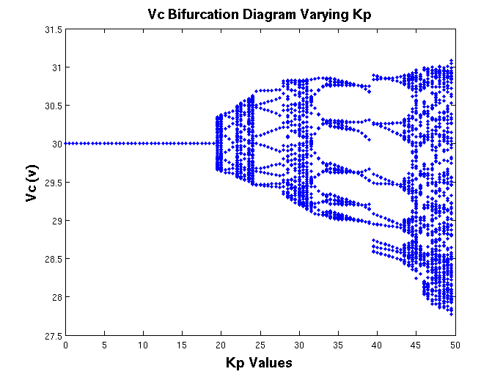
Figure 10: $V_{C}$’s Bifurcations

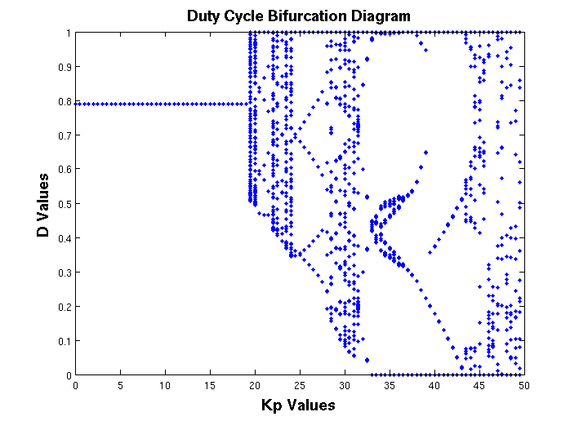
Figure 11: D’s Bifurcations

6.1. $V_{C}$ and $D$ Bifurcation Diagrams With T variations

Here you can see on figure 12 that for small values of T (sampling period) the system has a ONE periodic wave for high frequencies, but it begins to turn chaotic by increasing the sampling period that is equal to the switching period around $110μseg$.

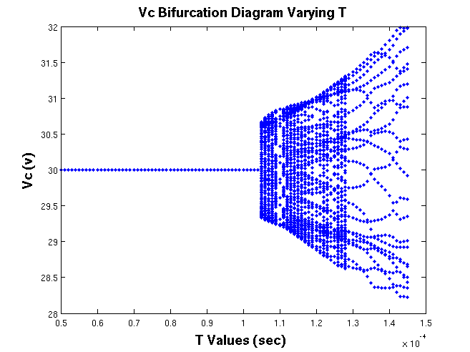
Figure 12: $V_{C}$’s Bifurcation Diagram Varying T

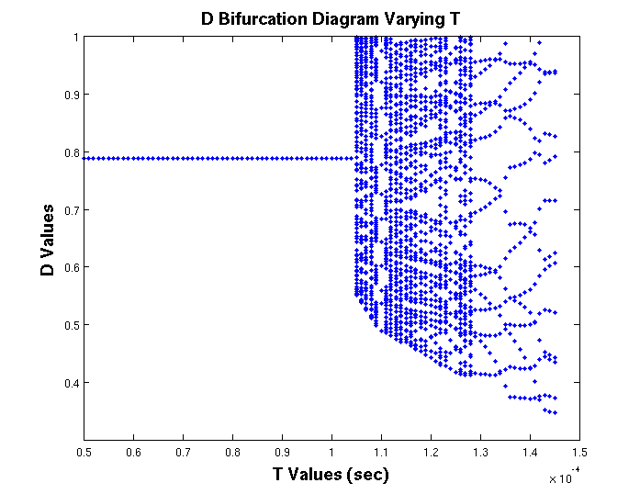
Figure 13: D’s Bifurcation Diagram Varying T

- MATLAB/SIMULINK$®$ SIMULATION
The next simulation performed in simulink get us closer to real time implementation performed in dSPACE, figures 14 and 15 show the circuit diagram and elements used:

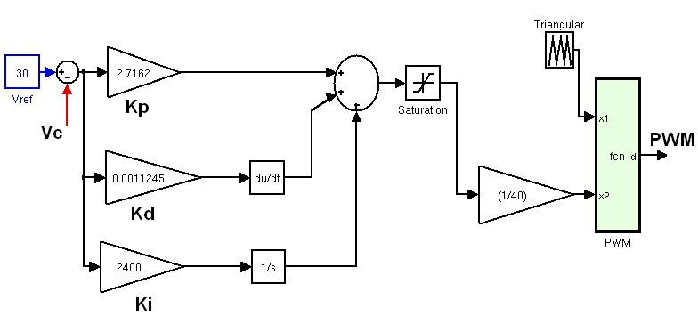
Figure 14: PID and PWM Schema

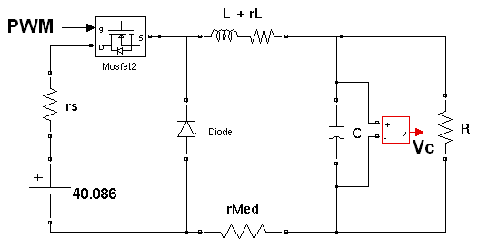
Figure 15: Buck Converter

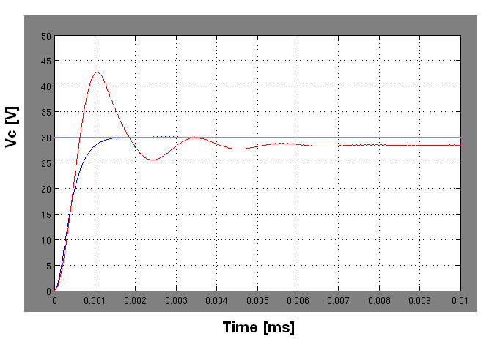
Figure 16: $V_{C}$ output, open loop and closed loop with PID

In figure 16 you can see the output in open and closed loop. Reducing the sampling rate to half, the signal loses symmetry because it gets fewer sampling points and therefore the integration process begins to have problems because it adds more than needed or rests more than needed, for the same reason, that’s why you can see those strong oscillations on figure 17. This effect is accentuated in the implementation.

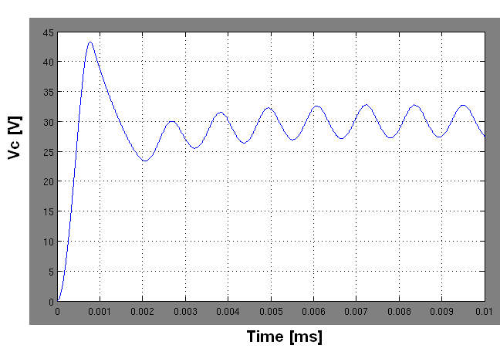
Figure 17: $V_{C}$ output with a minor sample frequency

- EXPERIMENTAL RESULT

For the real-time implementation the control and development card dSPACE was used. The converter’s PID controller was implemented in simulink, the program is shown in figure 18, it controls the controller implemented on hardware through the PWM generation block.

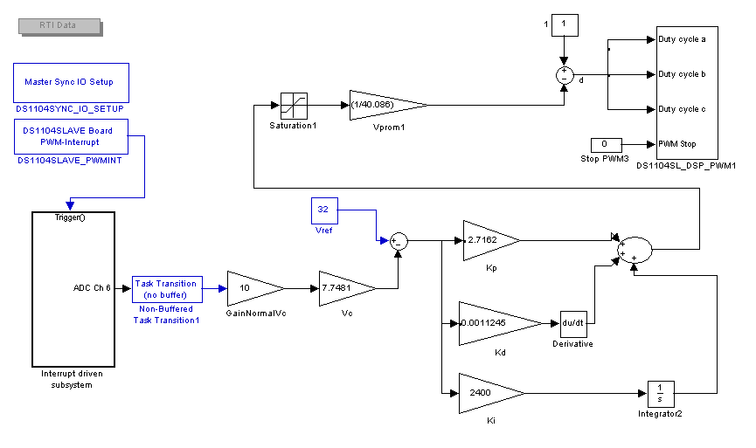
Figure 18: Rapid control prototyping to control the buck converter

The results presented in this section were obtained with the experimental prototype and the parameters defined in table 2.
Table 2: Experimental prototype data

 | Parameter | Value
$R$: | Load resistance | $$39.3 Ω$$
$C$: | Capacitance | $46.27$ and $376$ $μF$
$L$: | Inductance | $$2.473 mH$$
$r_{int}$: | Internal resistance of the source | $$0.688 Ω$$
$r_{ _{L}}$: | Internal resistance of the inductor | $$1.345 Ω$$
$E$: | Input voltage | $$40.086 V$$
$Fc$: | Switching frequency | $10$ kHz and $30$ kHz
$Fs$: | Sampling frequency | $10$ kHz and $30$ kHz
Kp: | proportional gain | $$2.7162$$
Kd: | derivative gain | $$0.0011245$$
Ki: | integral gain | $$2400$$

Making changes of reference voltage on levels 10V, 20V and 30V, and varying the sampling and switching frequency, it shows that the real system is much more sensitive to a low sampling rate. Figure 19 corresponds to a sampling frequency of 10 kHz.

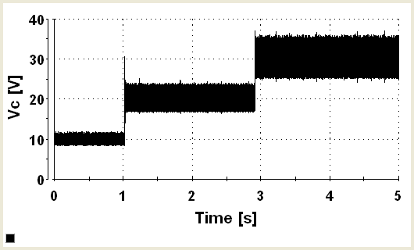
Figure 19: $V_{C}$ output with $C$= $46µF$ Vc at 10 kHz

If we increase the sampling frequency three time (30 kHz) in figure 19, it shows a little improvement in the regulated signal $V_{C}$ and especially a reduction in the sound produced by the inductor due to the switching frequency growth of the transistor.

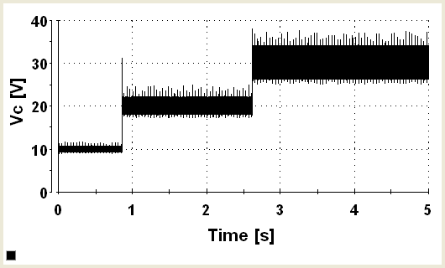
Figure 20: $V_{C}$ output with $C$= $46µF$ Vc at 30 kHz

If we improve the converter’s filtering by increasing significantly the value of the capacitor to $376μF$, we find a better answer with a lower steady-state error, even for the designed parameters shown in table 2. The reason for this, is that, more capacity filters higher frequency and therefore the regulation is better, reducing considerably the system’s chaos.
It can be seen in Figures 22 and 23 that if we make instant load changes going from $14.59Ω$ to $39.3Ω$ with a capacitor of $376μF$ and switching to 10 kHz, the system regulates too well with errors less than 2%, it shows that not only the good performance of the PID controller must be considered.

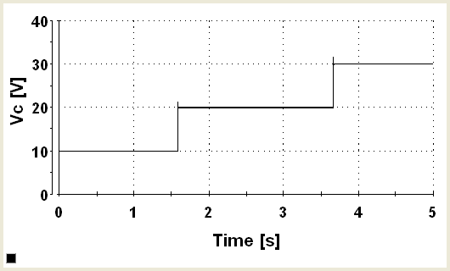
Figure 21: $V_{C}$ out with $C$=$376µF$ at 10 kHz

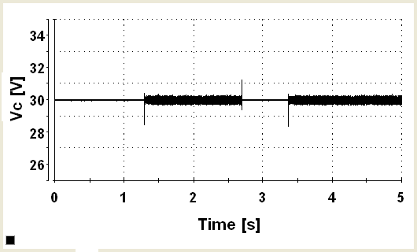
Figure 22: $V_{C}$ output with load changes $R$ with $C$=$376µF$

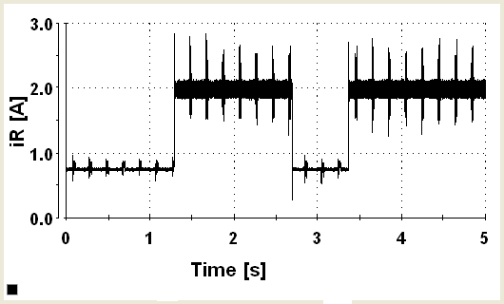
Figure 23: I load $i_{R}$ with load changes $R$ with $C$=$376µF$

- CONCLUSIONS

Since the increased value of the capacitor produced a substantial improvement in the system, it is necessary to propose a detailed study of the buck converters on the market in order to determine which and what values of its elements are most appropriate to apply different control techniques and compare results. It is likely that the implemented converter has not the best features to adequately respond to PID control. PID controller in the continuous case show good performance in terms of regulation of output voltage ($V_{C}$). In some systems a continuous PID control can react in a way and when is modulated by PWM change substantially, so we shouldn’t assume that what is found in continuous time, can apply without restrictions in discrete time. The switching and sampling frequency affect in mayor proportion the integral because it needs to adds the higher possible amount of points to successfully complete the integration process. Having a hardware that supports a high sampling and switching frequency is a very important factor when implementing a system. For the implemented converter, the PID controller did not respond in the best way. It is necessary to filter or remove the derivative, and select an appropriate sampling and switching frequency.

ACKNOWLEDGEMENTS

This work was supported by the Universidad Nacional de Colombia, Sede Medellín under the projects HERMES-34671 and HERMES-36911. The authors thank to the School of Physics for the valuable support to conduct this research.

REFERENCES

- Yousefzadeh V. Haitao Hu. and Maksimovic D. Nonuniform a/d quantization for improved dynamic responses of digitally controlled dc–dc converters. Power Electronics, IEEE Transactions on, Volume: 23 , Issue: 4, Page(s): 1998 - 2005, 2008.
- DeGusseme K. VandeSype D.M., VandenBossche A.P. DeBelie F.M.L.L., and Melkebeek J.A. Small-signal z-domain analysis of digitally controlled converters. Power Electronics, IEEE Transactions on Volume: 21 , Issue: 2, Page(s): 470 - 478, 2006.
- Maksimovic D. and Zane R. Small-signal discrete-time modeling of digitally controlled dc-dc converters. Computers in Power Electronics, 2006. COMPEL ’06. IEEE Workshops on, Page(s): 231 - 235, 2006.
- Zane R. Maksimovic D. and Erickson R. Impact of digital control in power electronics. Power Semiconductor Devices and ICs, 2004. Proceedings. ISPSD ’04. The 16th International Symposium on, Page(s): 13 - 22, 2004.
- Maksimovic D. Prodic A. and Erickson R.W. Digital controller chip set for isolated dc power supplies. Applied Power Electronics Conference and Exposition, 2003. APEC ’03. Eighteenth Annual IEEE Volume: 2, Page(s): 866 - 872, 2003.
- Peterchev A.V. and Sanders S.R. Quantization resolution and limit cycling in digitally controlled pwm converters. Power Electronics, IEEE Transactions on, Volume: 18 , Issue: 1 , Part: 2, Page(s): 301 - 308, 2003.
- Prodic A. Hao P., Maksimovic D. and Alarcon E. Modeling of quantization effects in digitally controlled dc-dc converters. Power Electronics, IEEE Transactions on, Volume: 18 , Issue: 1 , Part: 2, Page(s): 301 - 308, 2003.
- Liu C.P. Fung C.W. and Pong M.H. A diagrammatic approach to search for minimum sampling frequency and quantization resolution for digital control of power converters. Power Electronics Specialists Conference, 2007. IEEE, Page(s): 826 - 832,, 2007.
- Gregory Chong. Kiam Heong Ang. and Yun Li. Pid control system analysis, design, and technology. IEEE Transactions on control systems technology, Vol. 13, No. 4,, July 2005.
- E. Fossas and G. Olivar. Study of chaos in the buck converter. IEEE transactions on Circuits and Systems-I: Fundamental Theory and Applications, 43:13–25, 1996.
- D.C Hamill, J.H.B. Deane, and D.J Jefferies. Modeling of chaotic dc-dc converters by iterated nonlinear mappings. IEEE transactions on Power Electronics, 7:25–36, 1992.
- D. Hart. Electrónica de Potencia. Prentice Hall, Madrid, España, 2001.
- N. Mohan, T. Undeland, and W. Robbins. Power Electronics: Converters. Aplications and Design. J. Wiley, 1995.
- G. Olivar. Chaos in the Buck Converter. PhD thesis. Universidad Politécnica de Cataluña. Spain, Available at: http://www.tdx.cat/handle/10803/5841, 1997.

BIBLIOGRAPHY OF AUTHORS

 | Odair A. Trujillo: received the B.S. degree in electrical engineering and the Ph.D. degree in automatics from Universidad Nacional de Colombia, Manizales, in 2008 and 2013 respectively. His research interests include nonlinear control, nonlinear dynamics of nonsmooth systems, and power electronic converters. He is a member of the research group Perception and Intelligent Control (PCI).
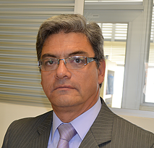 | Nicolás Toro: received the B.S. degree in electrical engineering and the Ph.D. degree in automatics from Universidad Nacional de Colombia, Manizales, in 1983 and 2012 respectively; the M.S. degree in production automatic systems from Universidad Tecnológica de Pereira, Colombia, in 2000. He is currently an Associate Professor in the Department of Electrical Engineering, Electronics, and Computer Science, Universidad Nacional de Colombia, sede de Manizales, and the Department of  Electronics and Automation, Universidad Aut´onoma de Manizales. His research interests include nonlinear control, nonlinear dynamics of nonsmooth systems, and power electronic converters. He is a member of the research group Perception and Intelligent Control (PCI).
 | Fredy E. Hoyos: electrical Engineer, MEng Industrial Automation, Ph.D on Automation. Assistant professor, Science Faculty, School of Physics, Universidad Nacional de Colombia Sede Medellín, Colombia, E-mail: fehoyosve@unal.edu.co. His research interests include nonlinear control, nonlinear dynamics of nonsmooth systems, and power electronic applications. He is an Associate Researcher in Colciencias and member of the Applied Technologies Research Group - GITA, at the Universidad Nacional de Colombia. https://orcid.org/0000-0001-8766-5192

