Mobile Robot Turned On by Sound and Directionality Controlled by an External Light Source

Luis G. Lafaurie, Jhon A. Narváez, Victor M. Tisoy, Fredy E. Hoyos *
Universidad Nacional de Colombia - Sede Medellín - Facultad de Ciencias - Escuela de Física, Calle 59 A No 63-20 Medellín, 050034, Colombia. Email: lglafauriep@unal.edu.co, jhanarvaezme@unal.edu.co, vmtisoyt@unal.edu.co, fehoyosve@unal.edu.co

Article Info |  | ABSTRACT
Article history:  Received Jun 12th, 2018  Revised Aug 20th, 201x  Accepted Aug 26th, 201x |  | In this article theoretical, numerical and experimental results are presented for a mobile robot. The system starts on the emission of a strong sound, like an applause, and the direction and speed of the vehicle is controlled by an external pulsed light source (PWM signal). The simulation is performed in Matlab-Simulink; electrical circuits and the experiment are shown in detail.
Keyword:
Mobile robot
DC motors driving
Polarizer circuit
Numerical results
Experimental results

Copyright © 201x Institute of Advanced Engineering and Science.
All rights reserved.
Corresponding Author:
Fredy E. Hoyos
Facultad de Ciencias - Escuela de Física
Universidad Nacional de Colombia - Sede Medellín
Calle 59 A No 63-20, Medellín, Colombia.
Email: fehoyosve@unal.edu.co

- INTRODUCTION

Due to the constant advancement of technology and the extensive development of automated control systems, have developed numerous ways to control devices through external physical quantities. The introduction of improve techniques allows to obtain advanced and able patterns to perform more complex task [1]. Some of these task in the field of robotics, include wheeled mobile robot navigation problems which have attracted the attention of researchers, because it is the basis of robot motion, on which, control motion automated systems are developed. In order to solve this problems, have been proposed to design complex models, including issues such as acquisition and processing sensor data [2].

In terms of motion control, one major problem is the development of how a robot can pass well and robust trajectory in different environments; but under the situation in which existing environmental information such as map and GPS cannot be used, it is necessary getting the vehicle robot to work based on the environmental information [3]. When a wheeled mobile robot is navigating in an unknown environment, it relies on sensors to recognize the outside world and then estimate the state of the robot itself to achieve the task of autonomous navigation. Commonly used sensors include the ultrasound, the laser range finder (LRF), vision sensor, light sensors among others [4].

A vehicle turned on by sound and directed by light source, can be defined as the coupling of mechanics and electronics technologies; with the implementation of transformation variables, which basically allows vehicle movement once it have detected light and sound signals and it have transformed in electric pulses [5], [6].
The technology for recognizing the location or direction of a sound-sound by using a microphone have been developed greatly until now. The technique for detecting the location and direction of a sound-source is called as the location recognition of a sound- source. In order to use the sound-source, it is required to have at least more than two sound-source obtaining devices or microphones [7], [8].

The paper is organized as follows: Section 2 describes the proposed system. Section 3 shows the description of the mathematical model of the system. Section 4 presents the numerical results. Section 5 experimental results and finally, Section 6 presents the conclusions.

- PROPOSED SYSTEM

The system consists an omnidirectional microphone, 2 photoresistors, 4 DC motors, lithium battery ($V_{CC}$) and electrical and electronic circuits; forming a circuit of two stages as shown in Figure 1.

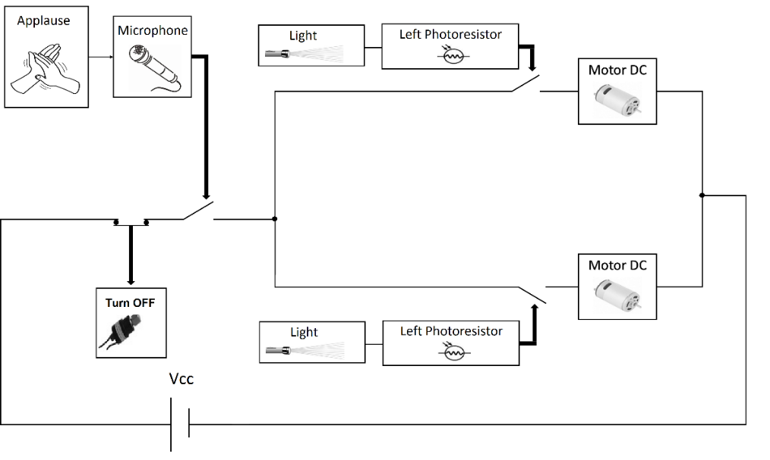

Figure 1. Proposed system

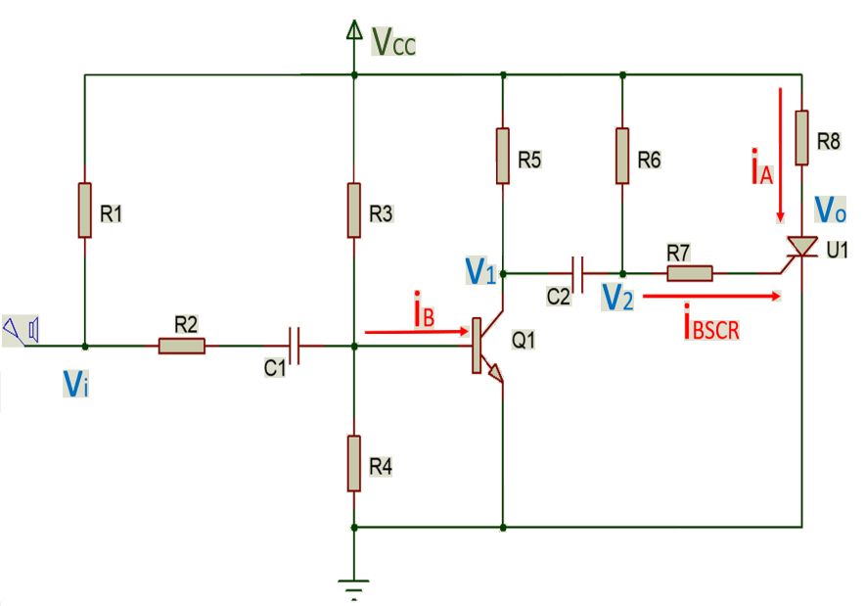

Figure 2. First stage: polarizer microphone circuit and vehicle turn on control
The first stage include a circuit for polarizing the microphone, which amplifies the signal captured by the microphone until a voltage level such that excite the thyristor and drive current through the same signal continuously as shown in Figure 2.

The second stage that only works if it have excited the thyristor; is comprised of two circuits that turn on or off the vehicle’s motors through two photoresistors; so only when the photoresistor has captured the light signal, turn on the motor it controls. Each photoresistor is controlling both wheels on one side of the vehicle; so if is excited only one of the photoresistors, the vehicle will turn toward the light source. The microphone captures the external signal, amplifying it through the polarizer inverter circuit (since the transistor $Q_{1}$ inverts the signal voltage $V_{1}$), and this amplified signal drives the thyristor SCR $U_{1}$ that enables turned on vehicle.

- MATHEMATICAL MODEL

Equation (1) is obtained from Figure 2, where $V_{i}$ is a column vector ${[\begin{matrix}1 & 0\end{matrix}]}^{T}$ in the binary space, where the logic level “1” denotes a voltage greater than zero and less than $V_{CC}$, and logic level “0” denotes a voltage around zero [9]. Thus $i_{B}$ is also a column vector whose values indicate the base current values of the transistor $Q_{1}$, in the saturation or cutting region respectively with the order of the components of $i_{B}$.

$i_{B}=\left[\begin{matrix}\frac{V_{CC}}{R_{3}}-0.7\left(\frac{1}{R_{2}}+\frac{1}{R_{3}}+\frac{1}{R_{4}}\right) \\ \frac{V_{CC}}{R_{3}}-0.7\left(\frac{1}{R_{3}}+\frac{1}{R_{4}}\right)\end{matrix}\right]$+$\left[\begin{matrix}\frac{1}{R_{2}} & 0 \\ 0 & 0\end{matrix}\right]V_{i}$ (1)

To obtain the equation (1) it is necessary to analyze the system’s behavior in the following situations:
(1) no current through the capacitor $C_{1}$.
(2) high signal frequency (Figure 6).

The above conditions are satisfied because the sound captured by microphone (applause) is a high frequency signal, so while this sound is not generated, the base current $i_{B}$ is too small. The equation (2) shows the possible values for the amplified and inverted voltage of the microphone signal, in cut and saturation region, which depends directly on $h_{FE}$, which is the current gain in the collector relative to the base current $i_{B}$.

$V_{1}=V_{CC}-h_{FE}R_{5}i_{B}$ (2)

By making a similar analysis for capacitor $C_{2}$ it follows that:
$V_{2}=V_{1}$ (3)

Thereby the current in the gate of the thyristor $SCR U_{1}$ can be calculated as shown in equation (4), where the difference $V_{CC}-V_{1}$ inverts the signal again due to the pull-up resistor $R_{6}$.
$i_{BSCR}=\frac{V_{CC}-V_{1}}{R_{6}}$ (4)
The current through the anode of the thyristor $SCR$ $U_{1}$ can be calculated using the equation (5); obtained from the two-transistors model, where $I_{CBO1}$ and $I_{CBO2}$ are leakage currents of the model’s transistors; $α_{1}$ and $α_{2}$ are collector’s current gains relative to the emitter’s current of each.
$i_{A}=\frac{α_{2}i_{BSCR}+I_{CB01}+I_{CB02}}{1-\left(α_{1}+α_{2}\right)}$ (5)
However, for practical purposes are considered negligible leakage currents, leaving the anode current of the thyristor as the product of a gain equivalent “$α$” with the gate’s flow of the thyristor $i_{BSCR}$, as shown in equation (6).
$i_{A}=αi_{BSCR}$ (6)
Thereby, the anode’s voltage $V_{O}$ (equation (7)) of the thyristor $SCR$ $U_{1}$, which turns on or off the vehicle is finally obtained.
$V_{O}=V_{CC}-R_{8}αi_{BSCR}$ (7)
The Figure (3) shows the second stage of the system, which corresponds to the controller on and off of the vehicle’s motors. This circuit is controlled by the circuit of the first stage (Figure (2)), thereby which only work when there is a difference of appreciable potential between $V_{CC}$ y $V_{O}$, which occurs only after that the microphone has captured a loud sound (applause, Figure (6)).

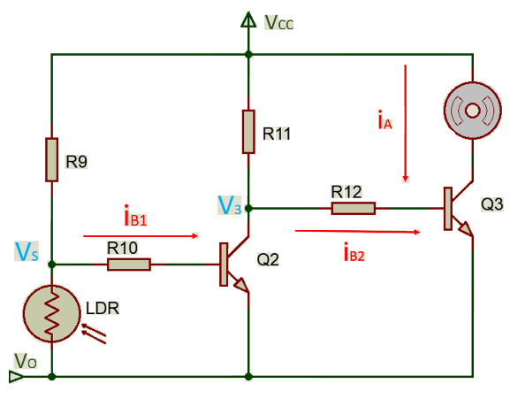

Figure 3. Effects of selecting different switching under dynamic condition Second stage: control turn on-off motor circuit.

$i_{B1}=\frac{V_{S}-V_{O}-0.7}{R_{10}}$ (8)
The equations (8), (9), (10) and (11); are easily obtained from Figure (2), in order to calculate the current through the motor at the time of have excited the photoresistor with a external light source.

$V_{1}=V_{CC}-h_{FE}R_{11}i_{B1}$ (9)

$i_{B2}=\frac{V_{3}-V_{O}-0.7}{R_{12}}$ (10)

$i_{M}=h_{FE}i_{B2}$ (11)
The motor speed is directly dependent from the current of the supply system.

- SIMULATION

The overall function system can be summarized in a truth Table as shown in the Table (1); the circuit is only turned on after sensing a sound of high intensity (applause), and the movement of motors is controlled by the sensed light intensity.
Table 1. System Truth Table
Applause | Light | System | Motor
0 | $$X$$ | 0 | 0
1 | 0 | 1 | 0
1 | 1 | 1 | 1

The signals sensed by the electret microphone, which is amplified by a polarizer circuit, transmitting a inverted signal with higher voltage; was simulated using Matlab-Simulink interface as shown in Figure (4).

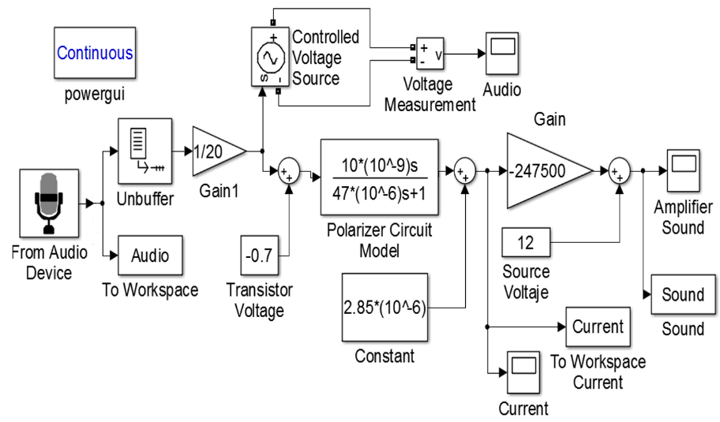

Figure 4. Simulation in Matlab-Simulink

The outcome of the simulation is shown in Figure (5), where the highest peaks are each sound amplification high external current (applause) sensed by the Simulink’s microphone; where the amplitude reaches is about $4 V$, enough to excite the thyristor and turn on the system.

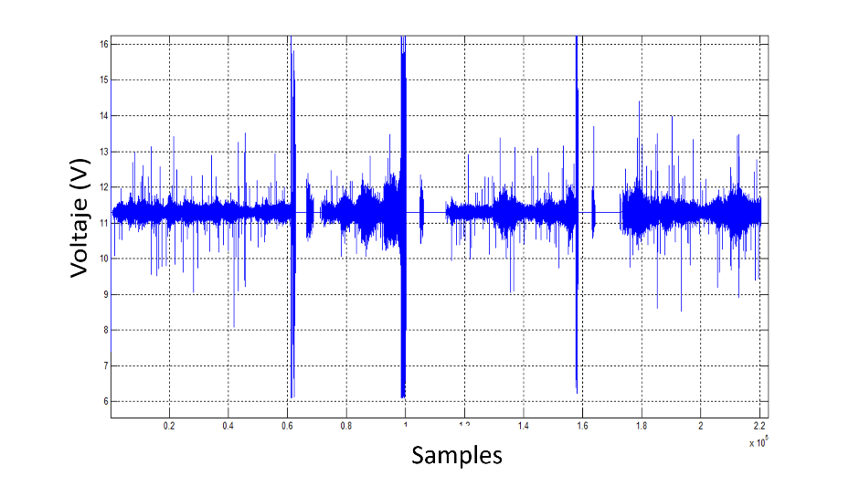

Figure 5. Amplified and inverted simulated signal

- EXPERIMENTAL RESULTS

All results were obtained using the values of resistors and capacitors as shown in Table (2).

Table 2. Parameters for simulation and experiment
Symbol | Name | Value
$$V_{CC}$$ | Supply voltage | $$12 V$$
$$R_{1}$$ | Microphone’s resistor pull-up | $$3.3 kΩ$$
$$R_{2}$$ | Microphone’s polarization base resistor | $$4.7 kΩ$$
$$R_{3}$$ | High impedance polarization resistor to $V_{CC}$ | $$2 MΩ$$
$$R_{4}$$ | High impedance polarization resistor to ground | $$250 kΩ$$
$$R_{5}$$ | Transistor collector resistor $Q_{1}$ | $$3.3 kΩ$$
$$R_{6}$$ | Pull-up resistor amplified signal | $$5.1 kΩ$$
$$R_{7}$$ | Thyristor base resistor $U_{1}$ | $$100 Ω$$
$$R_{8}$$ | Thyristor base resistor $U_{1}$ | $$200 Ω$$
$$R_{9}$$ | Pull-up resistor, photoresistor | $$100 kΩ$$
$$R_{10}$$ | Transistor base resistor $Q_{2}$ | $$1 kΩ$$
$$R_{11}$$ | Transistor colector resistor $Q_{2}$ | $$1 kΩ$$
$$C_{1}$$ | Capacitor microphone polarization | $$10 nF$$
$$C_{2}$$ | Polarization capacitor, amplified signal | $$100 nF$$

5.1. First stage: circuit of the control turning on and off vehicle.
The circuit of Figure (3), amplifies and inverts the signal sensed by the microphone, being more sensitive to sounds of higher intensity (Figure (6)); the amplification reaches an amplitude of $3 V$. The highest peaks correspond to each sound’s amplification (applause) generated externally, where can see it have a very short period, thus they are high frequency signals.

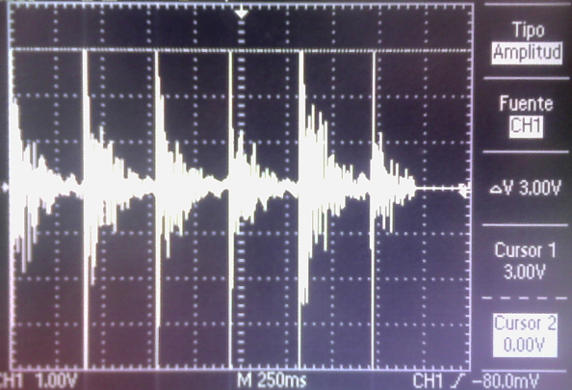

Figure 6. Amplified and inverted signal by the polarizer circuit for the microphone

In Figure (7) can observe the behavior of the thyristor, when the system is off (there has been no detection of sound), when it is turned on (it has detected a sound) and when abruptly the anode’s voltage is connected to grounded. thereby, the anode’s voltage when the system is off is $10.6 V$, so the current flowing through the anode is too small allowing the system to remain off and it is impossible that the LDR (photoresistor) turn on the motor. Moreover, when the system is on (has been detected sound), the voltage is $3.8 V$, allowing a appreciable current flow through the thyristor’s anode, feeding the motor circuit controlled by the LDR.
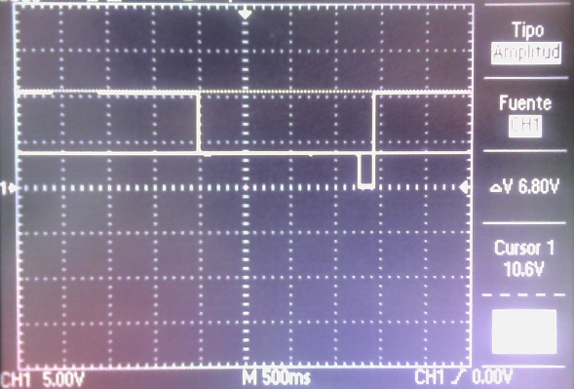

Figure 7. The anode voltage of the thyristor when there has been no sound (is off) and when the system is on

Finally, when the anode voltage of the thyristor is connected to ground, the current flow is stopped; whereby the system returns to its initial state to $10.6 V$, that is, the system is off.

5.2. Second stage: control turning on and off of the motor circuit.

In the Table (3) motor’s voltage values are shown, when the LDR detects light or not; similarly the Table (4) shows the voltages of the photoresistor when the light signal is detected or not.

This stage of instrumentation is very sensitive to changes in light intensity, as shown in the Table (4), the voltage needed to turn the motor on the photoresistor is only $0.11 V$.

Table 3. Motor voltage
Light | Voltage
$$ON$$ | $$5.32 V$$
$$OFF$$ | $$0 V$$

5.3. Vehicle.

In Figures (8) and (9) the vehicle with the implemented circuits is observed, where the electret microphone is projecting towards the top, while the LDRs are forward, allowing the vehicle to always move toward the light source.
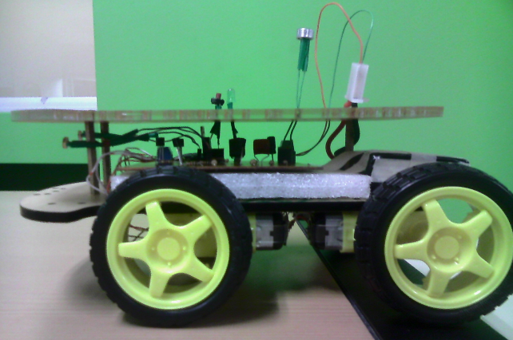

Figure 8. Vehicle with the implemented circuits

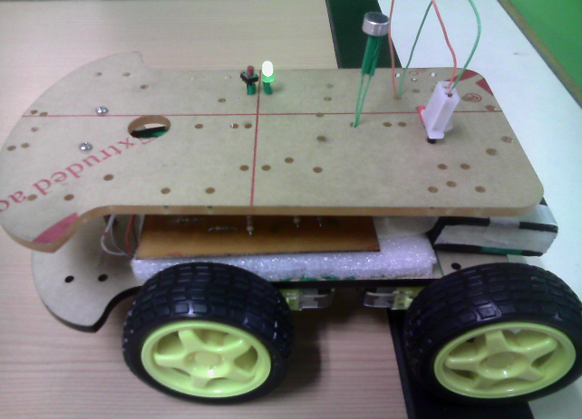

Figure 9. Vehicle ON

- CONCLUSIONS

The system implements two types of sensors to control basic functions of a vehicle, the ignition and start movement of the motors; being sensitive to high intensity signals, such as a loud noise or light from a common light bulb, the sensitivity can be adjusted simply by varying the values of the pull-up resistors of each sensor.
The circuit consumes less than $1 A$ of current, with the $4$ motors moving at full speed, therefore is a low power system that can easily be powered by lithium battery.

Vehicle speed can be controlled with a PWM signal from the external light falling on the LDR sensors (pulsed light), which is a future goal.

ACKNOWLEDGEMENTS

This work was supported by the Universidad Nacional de Colombia, Sede Medellín under the projects HERMES-34671 and HERMES-36911. The authors thank to the School of Physics for the valuable support to conduct this research.

REFERENCES

- Guilermina Morales Zapién Guillermina Morales. Análisis de Circuitos Electricos en DC. Van Nostrand Reinhold Company, 2005. ISBN 9681865448,9789681865443.
- Jong Ho Han, Jang Myung Lee, and Uk In Lee. Sound signal following control of a mobile robot with the estimation of the sound source location by a microphone array. 2005.
- Hwang, S. M. Park, and Park Y-S. Sound direction estimation using artificial ear. International Conference on control, Automation and Systems, pages 1900–1910, 2007.
- Medina Cervantes Jesús, Reyna Jiménez Jonattan, Santos Luna Joaquin, Osorio Mirón anselmo, and Juárez Rivera Victorino. Diseño y construcción de un robot seguidor de línea controlado por el pic16f84a. In 8° Congreso Nacional de Mecatrónica, pages 816–821, Nov. 2009.
- Yang-Won Jung, Hong-Goo Kang, Chung-Young Lee, and Dae-Hee youn. Adaptative microphone array system with self-delay estimator. Korea information and communications society, 30(1C):54–60, 2005.
- Deuk-Kwon Kim, Sun-Din Han, Hyun-Uk Ha, and Jang Myung Lee. An accidental position detection alforithm for high pressure equipment using microphone array. the Korean institute of electrical engineers, pages 2300–2307, 2008.
- Daisuke Nagahara, Satoru Tadahashi, Tadayuki Tanaka, and Shun’ichi Kaneko. A method of trajectory generation to vehicle robot under unknowm environment. World Automation Congress, TSI Press, 2010.
- Yin Tien Wang, Jr Syu Yang, and Chin An Shen. Calibrated kinect sensors for robot simultaneous localization and mapping. 2014.
- Adi Wibowo, Sutikno, Kushartantya, Helmie Arif Wibawa, and Ari Wibisono. Parallel cascade fuzzy interference system at the environment changes, case study: Automated guide vehicle robot using ultrasonic sensor. The International Conference on Advanced Computer Science and Information System, 2012.

BIBLIOGRAPHY OF AUTHORS

 | Luis G. Lafaurie: Engineering physics student, Science Faculty, Universidad Nacional de Colombia, Medellín, Colombia, E-mail: lglafauriep@unal.edu.co. His research interests include applied electronics and physics.
Second author’s photo(3x4cm) | Jhon A. Narváez: Engineering physics student, Science Faculty, Universidad Nacional de Colombia, Medellín, Colombia, E-mail: jhanarvaezme@unal.edu.co. His research interests include applied electronics and physics.
Thirth author’s photo(3x4cm) | Victor M. Tisoy: Engineering physics student, Science Faculty, Universidad Nacional de Colombia, Medellín, Colombia, E-mail: vmtisoyt@unal.edu.co. His research interests include applied electronics and physics.
 | Fredy E. Hoyos: electrical Engineer, MEng Industrial Automation, Ph.D on Automation. Assistant professor, Science Faculty, School of Physics, Universidad Nacional de Colombia Sede Medellín, Colombia, E-mail: fehoyosve@unal.edu.co. His research interests include nonlinear control, nonlinear dynamics of nonsmooth systems, and power electronic applications. He is an Associate Researcher in Colciencias and member of the Applied Technologies Research Group - GITA, at the Universidad Nacional de Colombia. https://orcid.org/0000-0001-8766-5192

