Visual and Surface Properties of CdTe Thin Films on CdS/FTO Glass Substrates

Ramya.K *, Yuvaraja.T **,
Assistant Professors
* Department of Electrical and Electronics Engineering, Sri Sai Ram College of Engineering, Bangalore, India.
** Department of Electrical and Electronics Engineering, Sri Sai Ram College of Engineering, Bangalore, India.

Article Info |  | ABSTRACT
Article history:  Received Jun 12th, 201x  Revised Aug 20th, 201x  Accepted Aug 26th, 201x |  | Cadmium telluride (CdTe) thin film material was deposited ontop of Cadmium Sulfide (CdS) substrate using vacuum evaporation technique. The sample was characterized using X-ray diffraction(XRD) and UV-VIS-NIR spectroscopy. XRD studies revealed that the sample was polycrystalline in nature. The SEM image showed that the sample is columnar in structure and the grains are uniform. Optical band gap of the CdTe thin film was estimated from transmittance and reflectance data and it was found 1.53eV.The structural, optical and surface properties of the film showed that the CdTe thin film materials can be used for fabrication of CdTe thin film solar cell.
Keyword:
CDTE Thin Film
Solar cell
Bandgap
Cds

Keyword:  CDTE Thin Film  Solar cell  Bandgap  Cds |  | Copyright © 201x Institute of Advanced Engineering and Science.  All rights reserved.
Corresponding Author:
Ramya.K
Department of Electrical and Electronics Engineering,
Sri Sai Ram College of Engineering,
Bangalore City, India Country
Email: ramyaj.k14@gmail.com

- INTRODUCTION

Power generation by solar energy can act as an alternative source of energy in the future. Thin-film solar cells are positioned to become the future of solar energy technology because of their less material usage and lower cost manufacturing processes. Cadmium telluride (CdTe) photovoltaic technology has the potential to become a leading energy producer in the coming decades in solar energy industry. The material can be used as an absorber layer for solar cells for its high absorption co-efficient and optimum band gap[ 1]. CdTe has favourable physical characteristics for medical applications that have been investigated in the reported paper [2].
The material is considered to be one of the most useful material for the fabrication of X-ray and γ-ray detectors operating at room temperature due to specific properties of high average atomic number, fine charge-transport properties, high resistivity and relatively large band gap energy [3].The objectives of the present work are deposition of CdTe thin film on CdS (chemical bath deposited on commercial Fluorine-doped tin oxide (FTO) glass substrates which will be reported later) and characterize the CdTe/CdS/FTO thin films to enrich knowledge about fabrication of thin film solar cell[4].

- RESEARCH METHOD

CdTe film was prepared on CdS/FTO glass substrates at high vacuum (~10⁻⁶Torr) by the thermal evaporation method.At the high vacuum, the substrate was heated with the help of radiant heater at a certain temperature called substrate temperature or deposition temperature. In the deposition of the thin film, the substrate temperature was 250°C and annealing temperature was 100°C for 60 minutes. The structural analysis of the film was performed using Philips X’pert PRO X-ray diffractometer[5]. In the experiment, CuKα radiation of wave length, λ= 1.54178 Å was used and the angle of diffraction was varied from 20° to 60°. The grain size (D) of the film was measured from Scherrer formula written below using FWHM (β) of the (111) diffraction peak[6]
Here, θ is the Bragg angle. The lattice parameter was calculated using the following equation

$$a=d\sqrt{h^{2}+k^{2}+l^{2}}$$

whereh, k and l represents the Miller indices and d is the inter planer spacing. The micro strain (ε) and dislocation density (ρ) of the film wasmeasured from the following equations[6].

The surface image of the film was taken using Scanning Electron Microscope(SEM). The optical properties like transmittance, reflectance, and absorption co-efficient and optical band gap were analysed from UV-VIS-NIR recording spectrophotometer (shimadju, UV03100, Japan) in the photon wave length range from 400 to 2500 nm. The absorption co-efficient (α) was measured from the following formula [7]
$$∝=-\frac{lnT}{t}$$
Where t is the thickness of the films and T is the transmittance of the films. The optical band gap energy (Eg) of CdTe was estimated using the following relation
(αhν)² = (hν–Eg)
- ANALYSIS OF CdTe/CdS/FTO THIN FLIM

3.1.Structural Study of CdTe/CdS/FTO Thin Film
X-ray diffraction (XRD) patterns of CdTe thin film study of different substrates and thickness are shown in figure-1. The peaks at 2θ =23.83°, 26.69°, 30.31°, 35.40°, 39.39°, 46.50°, 50.70°, 57.02° and 62.59° are found in figure-1(a). These peaks corresponds to reflection from (111), (200), (101), (220), (311), (112), (400) and (331) planes CdTe cubic structure, respectively. The figure-1(b) and figure-1(c) showed CdTe cubic structure. The results of the structural parameters of CdTe thin films have also been tabulated in table-1. The data presented in table-1 (CdTe/CdS 1000 nm and CdTe/CdS 1300 nm) are comparable with the earlier reports in table-1(CdTe 1000 nm). All peaks reflected in the XRD patterns are in good agreement with other reported paper [8]as well. The observed d values in figure-1 are well matches with standard d values [9]. The figure-1 showed that the film CdTe/CdS 1000 nm is more crystalline than CdTe 1000 nm thin film. In figure-1, the film CdTe/CdS 1000 nm showed more reflection peaks than CdTe/CdS 1300 nm thin film. The CdTe/CdS 1000 nm samples relative intensity ratio of (111), (220), (311) (400) and (331) planes are 100, 57.09, 28.44, 2.66 and 4.45 and the values are comparable to the standard value of 100, 62, 28, 5 and 9 respectively. No diffraction peak corresponding to metallic Cd, Te, or other compounds was observed. The XRD analysis revealed that the all films are polycrystalline in nature and crystalinity is improved. The lattice parameter was calculated to be 6.482 Å which is very close to the standard value of 6.481Å. The calculated values agree well with that of reported values [10]. The calculated average grain size was about 23-48 nm. This was in close agreement with that of CdTe films where a smaller average grain size (24 nm) was reported [11]. The larger grain size is an important factor to increase photovoltaic efficiency. where, hν is the incident photon energy. The thickness of the film was measured by insituFTM5 quartz crystal thickness monitor (Edwards, UK). If density of the material is known, the rate of deposition, which is different for different elements, can be controlled using the monitor[12]..

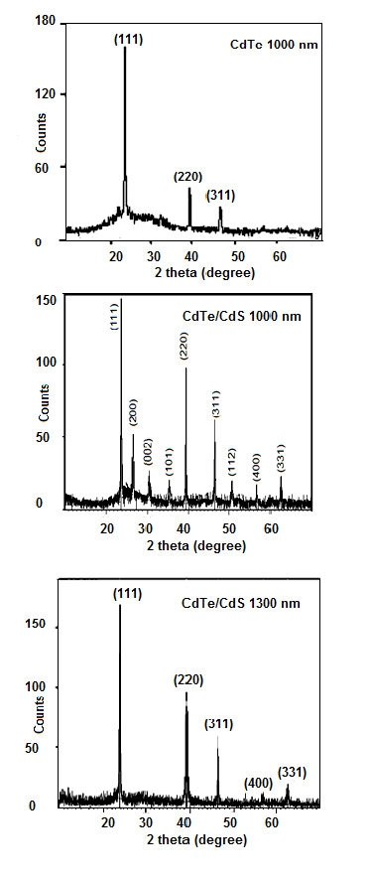
Figure 1. XRD spectra of (a) CdTe 1000 nm (b) CdTe/CdS 1000 nm (c) CdTe/CdS 1300 nm.

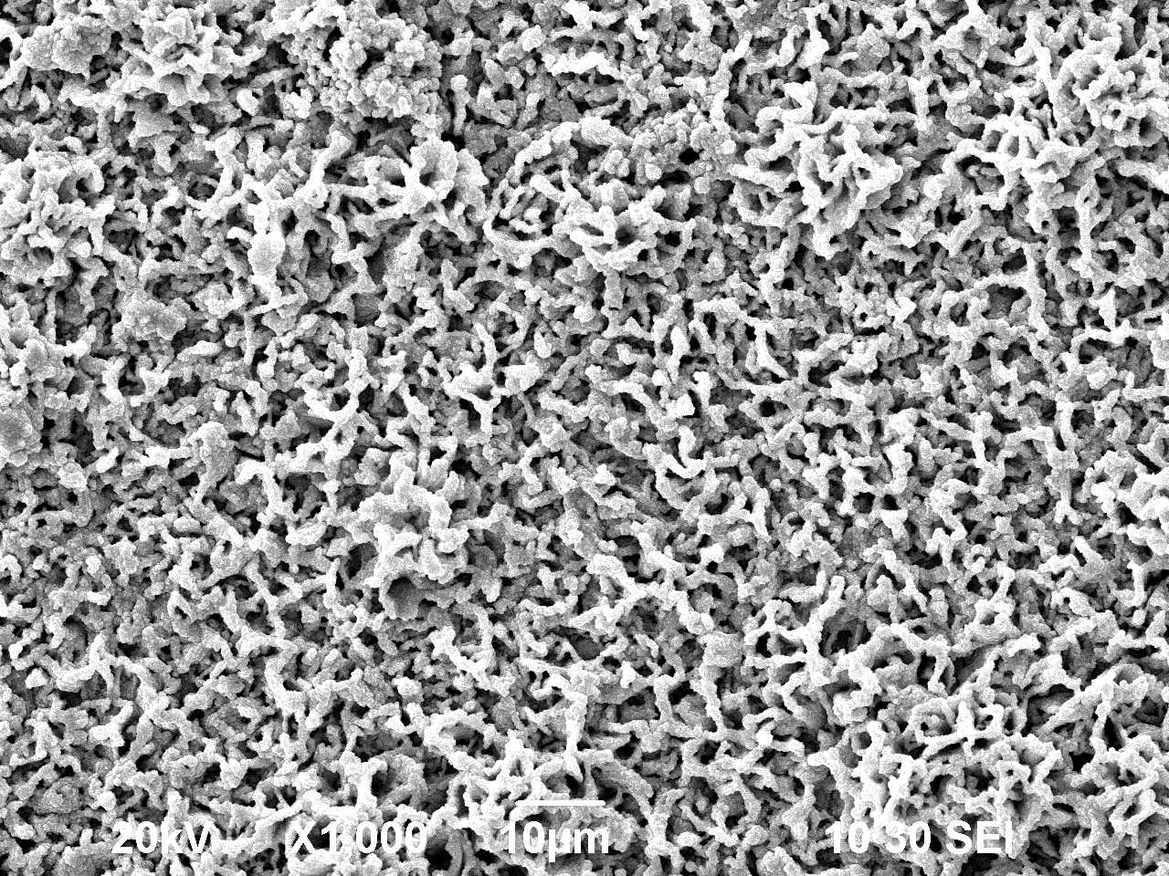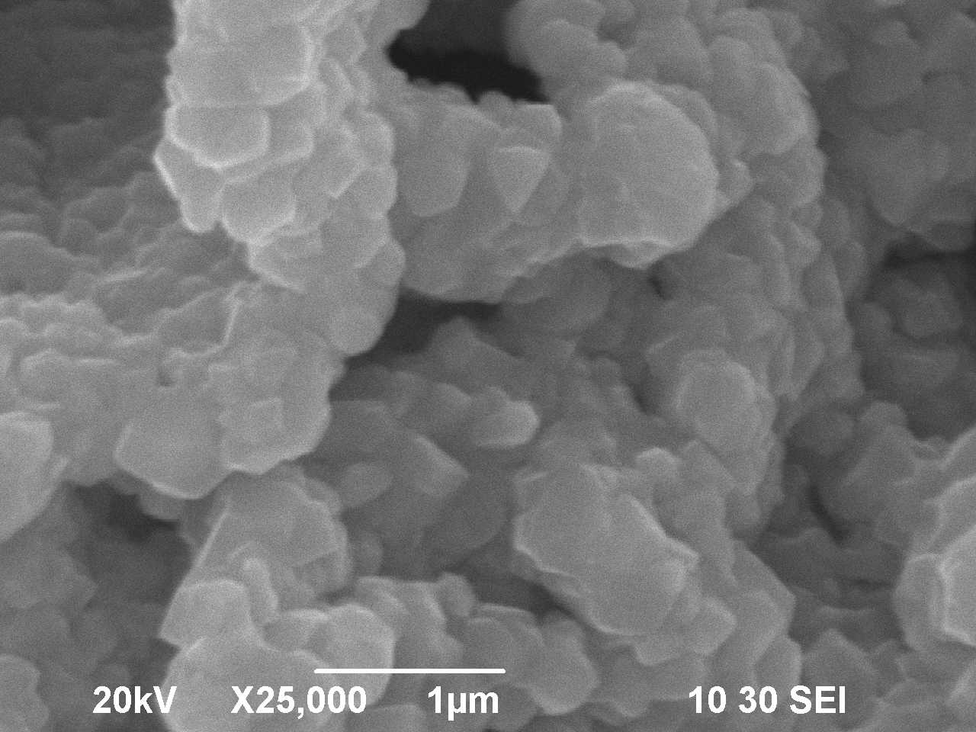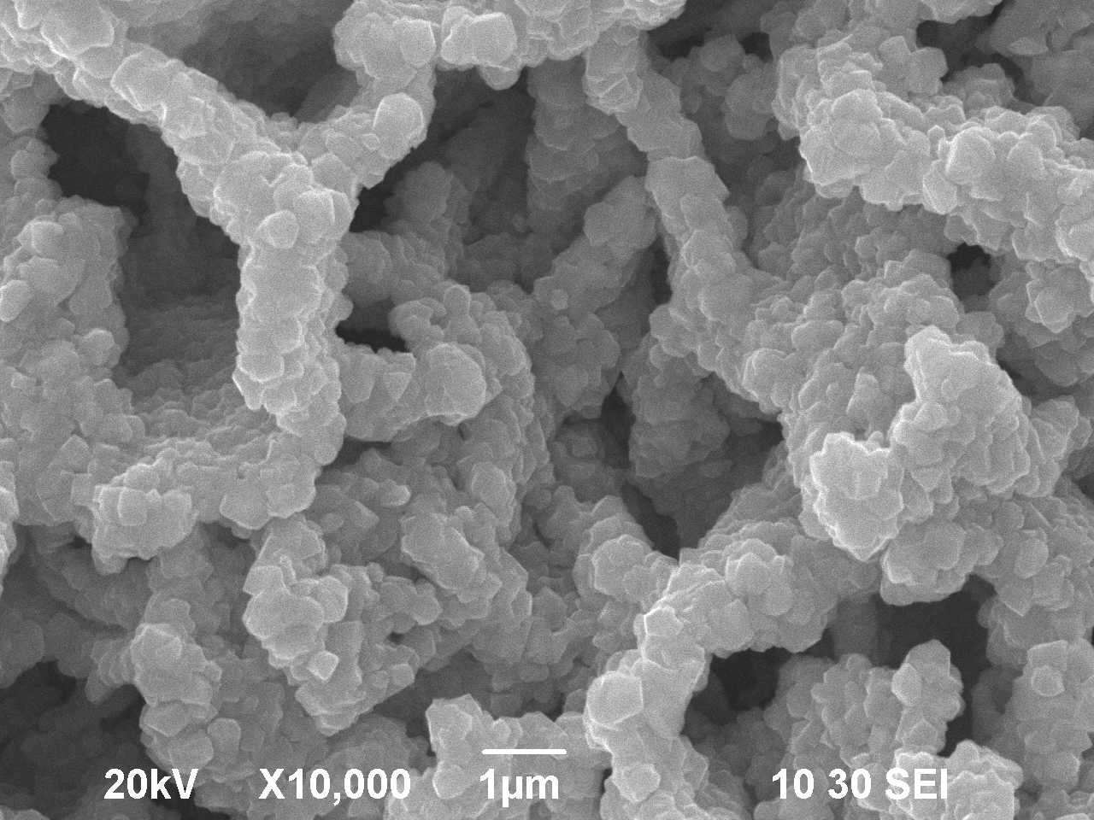

Figure 2. SEM image of CdTe thin film of thickness 1000 nm deposited on CdS thin film with magnification X25000

3.2.Surface Study of CdTe/CdS/FTO Thin Film
The surface morphology of CdTe thin film deposited on a glass substrate observed under a scanning electron microscope is shown in figure-2. The crystallites of these films are regularly spiral shaped with a typical size of about 700 nm. It is clear that the layer is not uniform and does not completely cover on the FTO substrate. As resolution (X 25000) increases a very few pinholes are observed clearly in the film. Individual grain boundary is not specifically visible rather grains are connected to one another like rope. This substrate characteristic is in agreement with the reported work [13]. The surface image suggested that CdS nucleates at these points and grow as columns normal to the substrate. The grains of the film are entangled due to deposit on top of CdS/FTO glass substrate and formed wide grain boundaries. This situation can be changed to a certain extent by using either thick CdS or CdTe layers or deposition of a buffer layer.

Table-1. Structural parameters of CdTe thin films

Sample Name | Observed 2θ  (degree) | Observed  FWHM(°2θ) | Observed (d) (nm) | Standard (d) (nm) | Relative intensity | Plane  (hkl)
 | 23.8338 | 0.1378 | 0.3734 | 0.3742 | 100 | (111)
 | 26.6871 | 0.1574 | 0.3340 | 0.3355 | 22.96 | (200)
 | 30.3131 | 0.4723 | 0.2949 | 0.2906 | 7.52 | (002)
CdTe/CdS  1000 nm | 35.3960 | 0.2362 | 0.2536 | 0.2514 | 6.09 | (101)
CdTe/CdS  1000 nm | 39.3840 | 0.1968 | 0.2288 | 0.2290 | 57.09 | (220)
CdTe/CdS  1000 nm | 46.5042 | 0.2362 | 0.1953 | 0.1954 | 28.44 | (311)
 | 50.7031 | 0.4723 | 0.1801 | 0.1812 | 4.92 | (112)
 | 57.0181 | 0.9446 | 0.1615 | 0.1619 | 2.66 | (400)
 | 62.5877 | 0.5760 | 0.1483 | 0.1488 | 4.45 | (331)
CdTe 1000 nm  [1] | 23.8525 | 0.1771 | 0.3731 | 0.3742 | 100 | (111)
CdTe 1000 nm  [1] | 39.3353 | 0.2165 | 0.2291 | 0.2290 | 23.33 | (220)
CdTe 1000 nm  [1] | 46.4827 | 0.3840 | 0.1952 | 0.1954 | 13.38 | (311)
CdTe/CdS  1300 nm | 23.819 | 0.0984 | 3.735 | 0.3742 | 100 | (111)
CdTe/CdS  1300 nm | 39.351 | 0.2362 | 2.290 | 0.2290 | 44.98 | (220)
CdTe/CdS  1300 nm | 46.488 | 0.2755 | 1.953 | 0.1954 | 24.08 | (311)
CdTe/CdS  1300 nm | 56.857 | 0.4723 | 1.619 | 0.1619 | 2.89 | (400)
CdTe/CdS  1300 nm | 62.403 | 0.3840 | 1.487 | 0.1488 | 6.47 | (331)

3.3.Optical Study of CdTe/CdS/FTO Thin Film
Figure-3 shows the variation of transmittance of CdTe thin film of thickness 1000 nm deposited on Chemical Bath Deposited-CdS with photon wavelength varying in the range between 300 nm and 1500 nm.

Figure 3. Transmittance variation of CdTe thin films with wavelength.

Figure 4. Reflectance variation of CdTe thin films.

Figure 5. Absorption coefficient variation of CdTe thin films.

Figure 6. (αhν)² vs photon energy (hν) plot of CdS/CdTe thin films.

The figure showed consistent optical transparency in the spectral region between 1200 nm to 1500 nm. High transmittance in a higher wavelength region and a sharp absorption edge is observed in the films. The absorption edge is interrelated to the optical band gap which agrees with reported work. The transmittance falls steeply with decreasing wavelength from 900 nm to about 800 nm. The decrease in transmission could arise due to the increase in absorbance associated with change in surface microstructure as reported by Chandramohanet.Figure-4 shows the variation of reflectance with photon wavelength in the range 300nm to 1500nm. From figure-4, it is observed that reflectance falls with decreasing wavelength (300-880 nm). The variation of absorption co-efficient (α) with wavelength in the range varying between 300nm - 1500nm of CdTe thin films is shown in figure-5. From figure-5, it is seen that in the shorter wavelength the absorption co-efficient exhibits higher values, these values of (α >10⁴) means there is a large probability of the allowed direct transition which agrees with the work of Mottet. Al[13]. Value of absorption co-efficient decreases steeply with increase in wavelength and remains consistent at higher wavelength. The low absorption co-efficient makes CdTe films useful for optical components in high laser window and multispectral applications, providing good imaging characteristic.
In figure-6, (αhν) ² is plotted against photon energy (hν) to find the band gap energy of CdTe thin film.The linear dependence showed by (αhν)² with photon energy (hν) indicates that the transmission is direct. The direct band gap energies of the films are determined by extrapolating the straight portion to the energy axis. Band gap is found 1.53±0.1eV by extrapolation of data point which is very close to standard value of 1.5eV. Absorption coefficient is used to describe the reduction in intensity of light in a medium as a function of distance. The energy gap in a semiconductor is responsible for the fundamental optical absorption edge.The fundamental absorption process is one in which a photon is absorbed and an electron is excited from an occupied valence band state to an unoccupied conduction band state, if photon energy is less than the gap energy, then the electron will not be absorbed. Such inter band absorption process is possible only if the photon energy is higher than the band gap energy.

- CONCLUSIONS

CdTe thin film was successfully deposited on CdS/FTO substrate using thermal evaporation method. The structural study of the film showed that the film is polycrystalline in nature and crystalinity is improved due to CdS/FTO layer. The surface image of the film concluded that the charge carrier mobilities along these columnar type materials have highest possible values and the grain boundary scattering becomes minimal during PV activity across the device structure. The films showed 42% transparency, 32% reflectance and high absorption co-efficient (α >10⁴). The optical band gap of the film was found 1.53 eV. These result revealed that CdTe layer could be suitable as absorber layer for CdTe/CdS heterojunction solar cell structure.

REFERENCES

- T.Yuvaraja, M.Gopinath " Fuzzy Based Analysis of Inverter Fed Micro Grid in Islanding Operation," International Journal of Applied Engineering Research ISSN 0973-4562 Volume 9, Number 22 (2014) pp. 16909-16916.
- [2] T.Yuvaraja, M.Gopinath " Fuzzy Based Analysis of Inverter Fed Micro Grid in Islanding Operation –Experimental Analysis International Journal of Power Electronics and Drive System (IJPEDS) Vol. 5, No. 4, April 2015, pp. 464~469
- Katlander, J., Bargholtz, Chr,, Batres-Estrada, G. and Behrooz, K. (2006)., ”Development of Methods to Use CdTe Detectors in Field Measurements”, Journal of Physics Conference Series, Vol. 41 pp 523-526.
- Lovergine, N., Prete, P., Tapfer, L., Marzo, F. and Mancin, A. I. (2005), ”Hydrogen Transport Vapor Growth and Properties of Thick CdTe Epilayers for RT X-ray Detector Applications”, Cryst Res Tech. Vol. 40 pp 1018-1023.
- K. M. A. Hussain, T. Faruqe, J.Parvin, S Ahmed, Z. H. Mahmood & Ishtiaque M. Syed, “Study of CdTe Nuclear Detector Material In Thin Film Form Using Thermal Evaporation Method, Malaysian Journal of Medical and Biological Research (MJMBR) ,Vol. 2 No. 3 ( 2015).
- K. M. A. Hussain, T. Begum, Z. H. Mahmood, Ishtiaque M. Syed, S. Ahmed, “Study of thermally deposited CdS thin films for CdTe thin film solar cell application”, International Journal of Nanoscience and Nanoengineering. 2014; 1(2): 34-38.
- Laxman Gouda, Yelameli Ramesh Aniruddha, Sheela K. Ramasesha, Correlation between the Solution Chemistry to Observed Properties of CdTe Thin Films Prepared by CBD Method. Journal of Modern Physics, 3 (2012) 1870-1877.
- A. Romeo, D.L. Batzner, H. Zogg, C. Vignali", A.N. Tiwari. Influence of CdS growth process on structural and photovoltaic properties of CdTe/CdS solar cells Solar Energy Materials & Solar Cells, 67 (2001) 311-321.
- B. Hymavathi, B. Rajesh Kumer, T. Subba Rao. Invettigations of optoelectronic properties of DC reactive magnetron sputtered CdTe thin films. Chalcogenide Letters, 10- 6 (2013) 209 – 216.
- E.R. Shaaban, N. Afify, A. El-Taher, Effect of film thickness on microstructure parameters and optical constants of CdTe thin films. Journal of Alloys and Compounds, 482 (2009) 400–404.
- S. S. Patil and P. H. Pawer.“ Effects of thickness on the structural and optical properties of thermally evaporated CdTe thin films, J. Chemical, Biological and Physical Sciences,2-2 (2012) 968-978.
- S. Chandramohan ,R. Sathyamoorthy , P. Sudhagar , D. Kanjilal , D. Kabiraj , K. Asokan ,Structural and photoluminescence properties of swift heavy ion irradiated CdS thin films. Thin Solid Films,516 (2008) 5508-5512.
- Mott M. and Davis E. Electronic Process in Non-Crystalline Materials. 2nd ed.University Press Oxford, 1979.

