Pooling Layer
Label
Fully Connected
Pooling Layer
Convolution Layer
Normalized Layer
Normalized Layer
Input Image
Convolution Layer Layer



Size 48x48

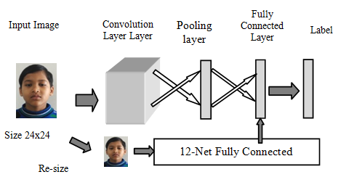

Figure 2: 24-net CNN

